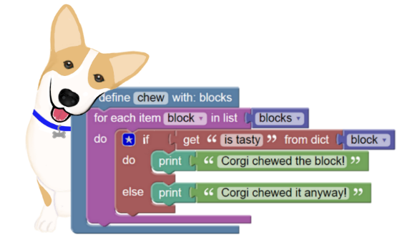**BlockPy  
*A Dual Block/Text Programming Environment for Python***

* Blocks, Text, or Both – Avoid syntax as students start off and transition them gracefully!
* Python in the Browser – Full local Python execution with Skulpt!
* Guided Feedback – Students get instant feedback every time they run their program!
* Semantic Checking – Program analysis catches more than conventional python interpreters!
* Data Science – Work with real world data and create meaningful visualizations!
* Free and Open Source – Use, extend, and change the environment to suit your needs!
* 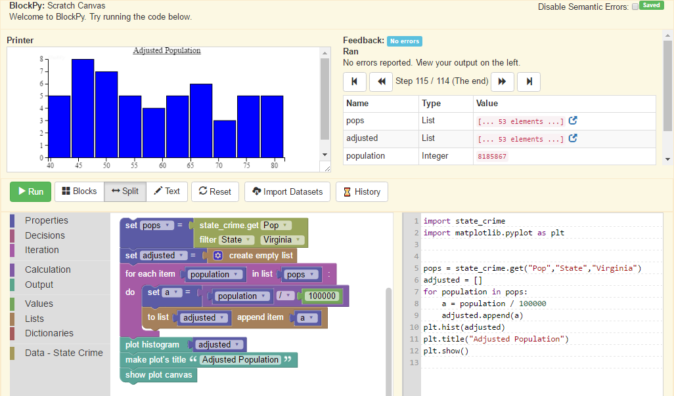Full LTI Integration – Embed in your favorite LMS with no student registration required!

Try it now at **www.blockpy.com**