Design Document

System design

Server design
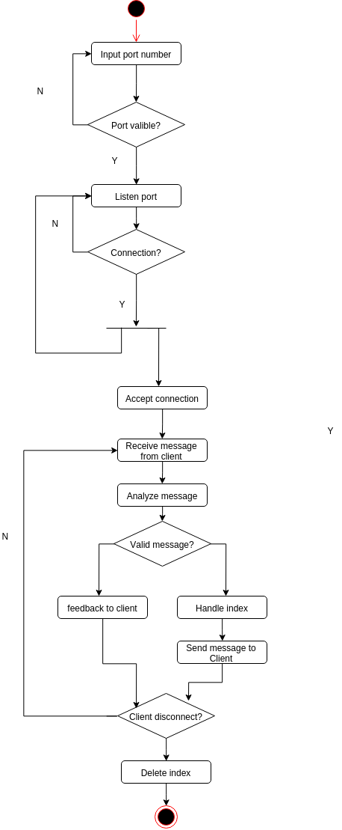

Client design
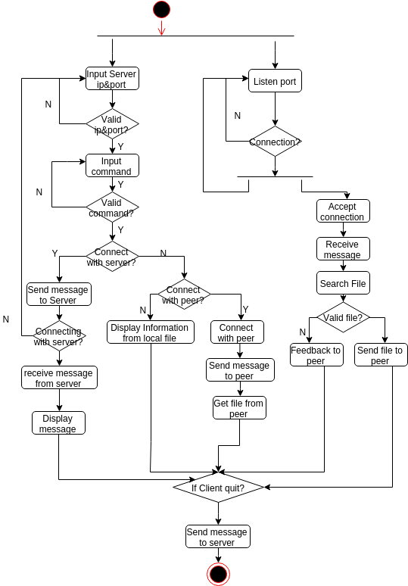

Synopsis design
- Register file: “p2p -r [filepath]”
- Search file: “p2p -f [keyword]”
- Download file: “p2p -o [ip:port] [filepath]>[savepath]”
- Help Document: “p2p -h”
- Quit client: “p2p -q”

Test synopsis
- 1000 Registration: “p2p -Rtest”
- 1000 Download: “p2p -Rdownload”

Possible improvement
- Reduce file I/O operation
- Implement resilience that could used in geographically different server.
- Avoid message lost
- Increase registration and download speed

