Manual

System requirements
Python 2.7
For server user can modify IP address and port number in file “Config” . Default addresses are:
127.0.0.1 35521
127.0.0.1 35523
127.0.0.1 35525
127.0.0.1 35527
127.0.0.1 35529
127.0.0.1 35531
127.0.0.1 35533
127.0.0.1 35535
This port is connected by server.

Server
This system assume that each key is different.

Set up server
$ python Node.py
Input Port number connected by client
Servers can connect with each other through port that is defined in “Config” file.
If client want to connect with one server, the port number is that is input by user.

Resilience
Every node hash table have a replica in next node. For example: 0 → 1, 1 → 2 , 2 → 3, 3 → 4, 4 → 5, 5 → 6, 6 → 7, 7 → 0.
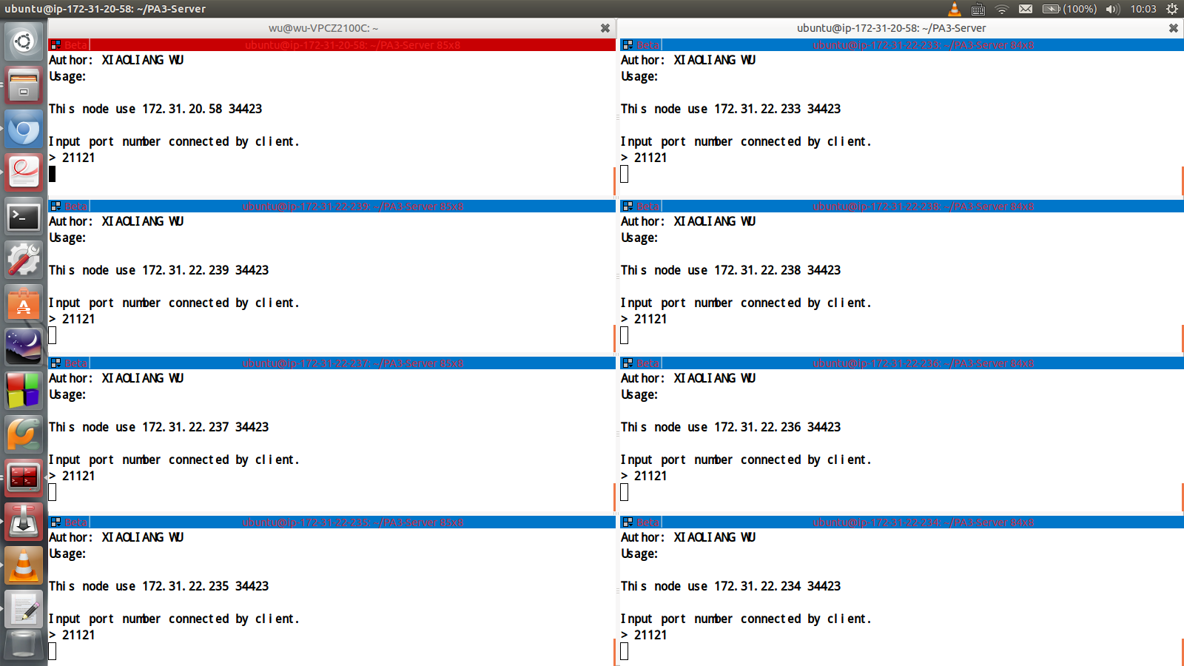

Client

Set up Client
$python Peer.py
Input port number, other client can connect to this port to download files.
Input server IP address
Input server port number for client
Input command

Register file
Register file to server.
> 0 [FILE ABSOLUTE PATH]
eg. > 0 ~/testfile
Put operation success.
Return register result

Search file
Look up files that name is KEYWORD.
> 1 [KEYWORD]
eg. > 1 testfile
172.31.31.0:6666/home/ubuntu/testfile
Return file URL

Download file
Download file according URL.
> 2 [FILE URL]
eg. > 2 172.31.31.0:6666/home/ubuntu/testfile
Return download result
FILE URL from look up obtain

10K register operations
10K register operation
> Test_register
eg. > Test_register
Return time.

10K look up operations
Use this command after using Test_register
10K look up operation
> Test_lookup
eg. > Test_lookup
Return time.

10K obtain opeartions
Use this command after using Test_register
10K obtain time, each file less 10KB
> Test_obtain [URL]
eg. > Test_obtain 172.31.31.0:6666/home/ubuntu
Return time.

Help document
Print guideline
> Peer –help

Exit
Exit system.
> 3

