一、下载Apache Tomcat源码
1.安装git
step1.访问git官网：https://git-scm.com/
step2.下载安装包
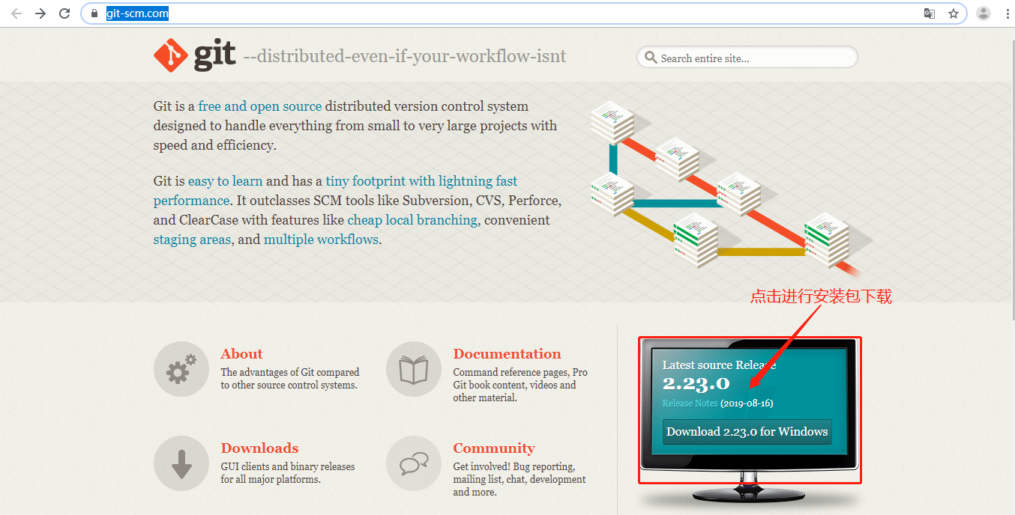
step3.双击安装包进行安装
step4.进行验证
安装完成后在任意文件夹或桌面右击鼠标，出现下述图标表示安装成功，可以进行使用
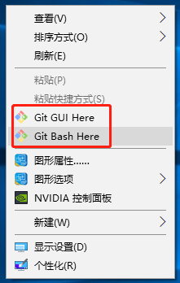
2.寻找Tomcat源码
step1.访问github官网：https://github.com/
step2.搜索tomcat关键字
step3.找到apache/tomcat(列表第一个)
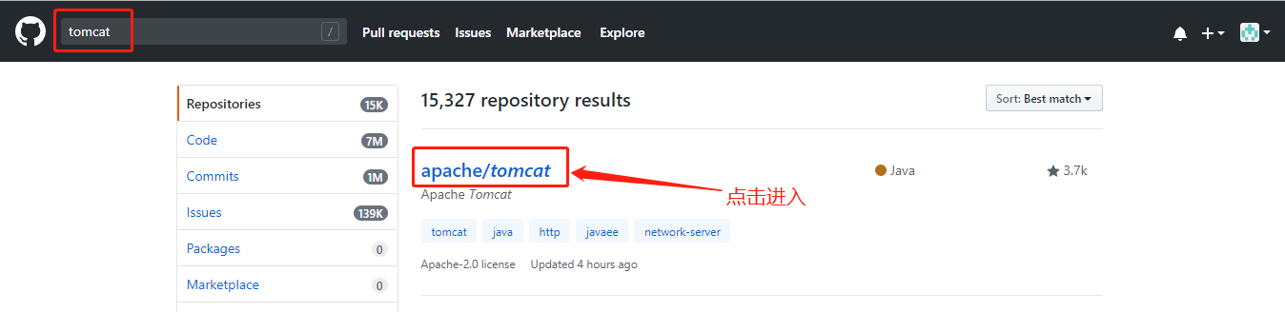
step4.进入apache/tomcat查看，这里便是Apache Tomcat的github仓库展示界面
3.下载源码
step1.复制仓库访问地址
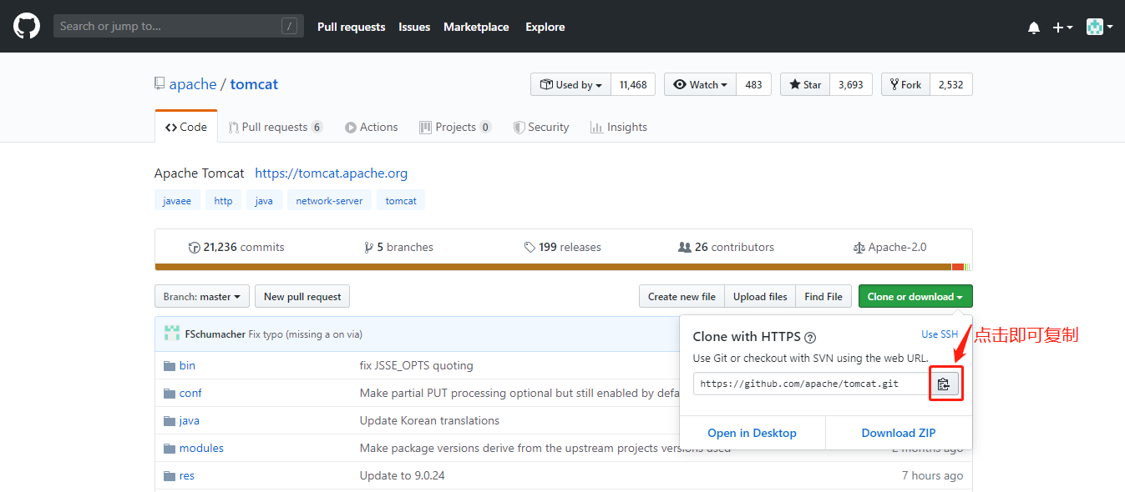
step2.在想要存放tomcat源码的目录打开git bash(本人喜欢命令行操作git)，鼠标右击=>点击“Git Bash Here”即可进入
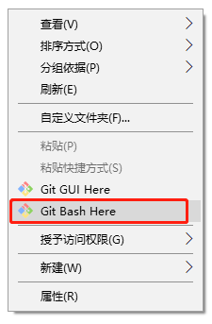
step3.执行git clone下载Tomcat源码
git clone https://github.com/apache/tomcat.git #step1复制的地址
step4.下载完成后可在当前目录看到tomcat目录，此即为tomcat源码
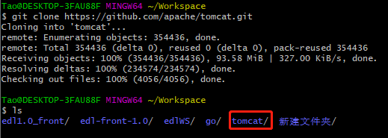
4.切换到想要的版本7.0.96
step1.进入tomcat源码目录(接着上述过程执行下述命令)
cd tomcat
step2.查找当前版本，发现7.0.96为仓库的一个tag
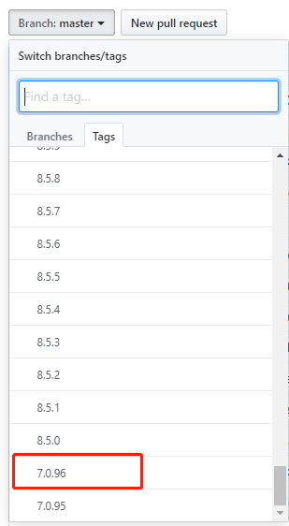
step3.将代码切换到7.0.96这个tag
参考链接：https://blog.csdn.net/DinnerHowe/article/details/79082769
# 切换到分支7.0.96
git checkout 7.0.96
# 如果要在tag代码的基础上做修改，需要一个分支
git checkout -b myread7.0.96 7.0.96
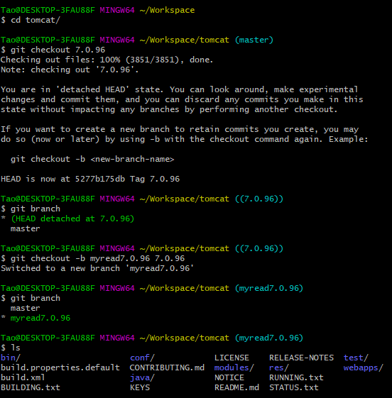
二、安装IDEA
由于专业版需要收费，破解有需要花额外的时间，本人选择安装社区版
step1.访问官网：https://www.jetbrains.com/
step2.找到安装包下载安装
三、配置Apache Ant项目管理工具（略过此过程）
参考链接：https://www.jianshu.com/p/42df9d545e88
step1.访问Apache Ant官网：https://ant.apache.org/
step2.找到下载链接，下载安装包
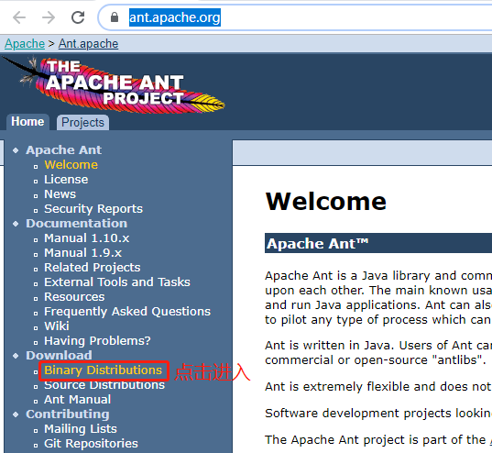
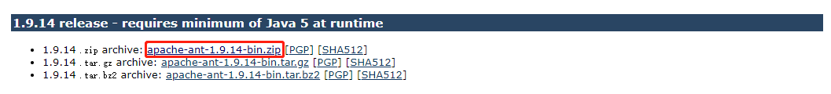
step3.解压安装包，配置环境变量
将安装包解压至指定目录，本人为：C:\Users\Tao\AppData\Local
环境变量配置过程：鼠标移至“我的电脑”==>点击右键==>选择“属性”==>点击“系统高级设置”==>点击“环境变量”==>系统变量中找到Path项==>双击进入==>点击“新建”==>添加ant bin目录(本人为：C:\Users\Tao\AppData\Local\apache-ant-1.9.14\bin)==>保存退出
step4.进入Tomcat源码根目录，本人为：C:\Users\Tao\Workspace\tomcat，执行ant命令
Tao@DESKTOP-3FAU88F MINGW64 ~/Workspace/tomcat (myread7.0.96)
$ ant
四、将Tomcat源码导入IDEA并运行成功
1.转为maven工程导入
step1.安装maven，配置环境变量(过程略)
step2.进入tomcat源码根目录，创建pom.xml文件，写入如下代码，注意更改java版本
<?xml version="1.0" encoding="UTF-8"?>
<project xmlns="http://maven.apache.org/POM/4.0.0"
xmlns:xsi="http://www.w3.org/2001/XMLSchema-instance"
xsi:schemaLocation="http://maven.apache.org/POM/4.0.0 http://maven.apache.org/xsd/maven-4.0.0.xsd">

<modelVersion>4.0.0</modelVersion>
<groupId>org.apache.tomcat</groupId>
<artifactId>Tomcat7.0.96</artifactId>
<name>Tomcat7.0.96</name>
<version>7.0</version>

<properties>
<java.version>1.8</java.version>
</properties>

<dependencies>
<dependency>
<groupId>ant</groupId>
<artifactId>ant</artifactId>
<version>1.7.0</version>
</dependency>
<dependency>
<groupId>ant</groupId>
<artifactId>ant-apache-log4j</artifactId>
<version>1.6.5</version>
</dependency>
<dependency>
<groupId>ant</groupId>
<artifactId>ant-commons-logging</artifactId>
<version>1.6.5</version>
</dependency>
<dependency>
<groupId>wsdl4j</groupId>
<artifactId>wsdl4j</artifactId>
<version>1.6.2</version>
</dependency>

<!-- easymock -->
<dependency>
<groupId>org.easymock</groupId>
<artifactId>easymock</artifactId>
<version>3.4</version>
<scope>test</scope>
</dependency>

<dependency>
<groupId>javax.xml.rpc</groupId>
<artifactId>javax.xml.rpc-api</artifactId>
<version>1.1</version>
</dependency>
<dependency>
<groupId>org.eclipse.jdt.core.compiler</groupId>
<artifactId>ecj</artifactId>
<version>4.5.1</version>
</dependency>
<dependency>
<groupId>junit</groupId>
<artifactId>junit</artifactId>
<version>4.12</version>
<scope>test</scope>
</dependency>
</dependencies>

<build>
<finalName>Tomcat7.0</finalName>
<sourceDirectory>java</sourceDirectory>
<resources>
<resource>
<directory>java</directory>
</resource>
</resources>
<plugins>
<plugin>
<groupId>org.apache.maven.plugins</groupId>
<artifactId>maven-compiler-plugin</artifactId>
<version>3.5</version>
<configuration>
<encoding>UTF-8</encoding>
<source>${java.version}</source>
<target>${java.version}</target>
</configuration>
</plugin>
</plugins>
</build>
</project>
step3.将源码导入到IDEA中
step4.配置启动入口
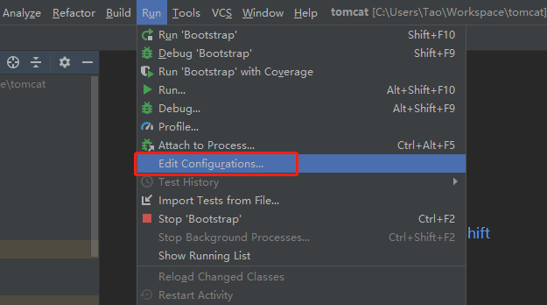
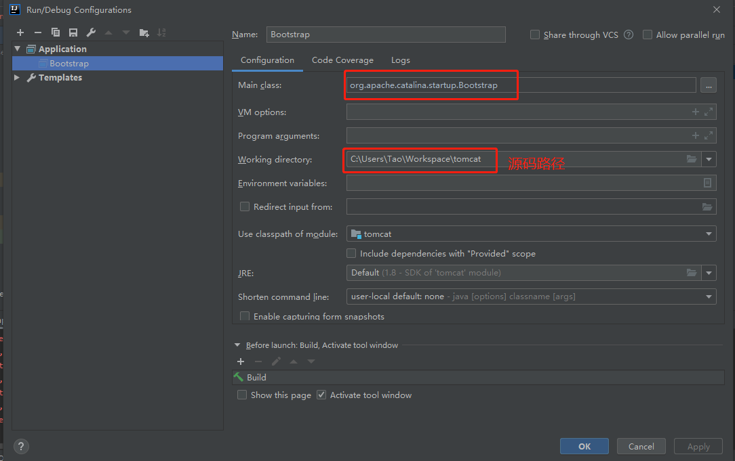
step5.启动Tomcat
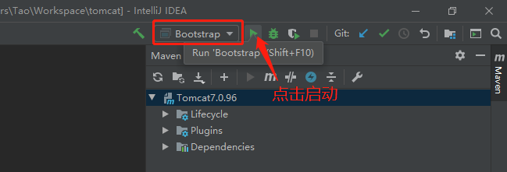
step6.启动过程报错，提示缺少test/util/TestCookieFilter中缺少CookieFilter类
step7.百度后发现是由于缺少test/util/CookieFilter代码造成的，进行添加
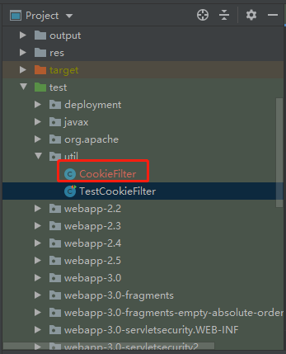
/*
* Licensed to the Apache Software Foundation (ASF) under one or more
* contributor license agreements. See the NOTICE file distributed with
* this work for additional information regarding copyright ownership.
* The ASF licenses this file to You under the Apache License, Version 2.0
* (the "License"); you may not use this file except in compliance with
* the License. You may obtain a copy of the License at
*
* http://www.apache.org/licenses/LICENSE-2.0
*
* Unless required by applicable law or agreed to in writing, software
* distributed under the License is distributed on an "AS IS" BASIS,
* WITHOUT WARRANTIES OR CONDITIONS OF ANY KIND, either express or implied.
* See the License for the specific language governing permissions and
* limitations under the License.
*/
package util;

import java.util.Locale;
import java.util.StringTokenizer;

/**
* Processes a cookie header and attempts to obfuscate any cookie values that
* represent session IDs from other web applications. Since session cookie names
* are configurable, as are session ID lengths, this filter is not expected to
* be 100% effective.
*
* It is required that the examples web application is removed in security
* conscious environments as documented in the Security How-To. This filter is
* intended to reduce the impact of failing to follow that advice. A failure by
* this filter to obfuscate a session ID or similar value is not a security
* vulnerability. In such instances the vulnerability is the failure to remove
* the examples web application.
*/
public class CookieFilter {

private static final String OBFUSCATED = "[obfuscated]";

private CookieFilter() {
// Hide default constructor
}

public static String filter(String cookieHeader, String sessionId) {

StringBuilder sb = new StringBuilder(cookieHeader.length());

// Cookie name value pairs are ';' separated.
// Session IDs don't use ; in the value so don't worry about quoted
// values that contain ;
StringTokenizer st = new StringTokenizer(cookieHeader, ";");

boolean first = true;
while (st.hasMoreTokens()) {
if (first) {
first = false;
} else {
sb.append(';');
}
sb.append(filterNameValuePair(st.nextToken(), sessionId));
}

return sb.toString();
}

private static String filterNameValuePair(String input, String sessionId) {
int i = input.indexOf('=');
if (i == -1) {
return input;
}
String name = input.substring(0, i);
String value = input.substring(i + 1, input.length());

return name + "=" + filter(name, value, sessionId);
}

public static String filter(String cookieName, String cookieValue, String sessionId) {
if (cookieName.toLowerCase(Locale.ENGLISH).contains("jsessionid") &&
(sessionId == null || !cookieValue.contains(sessionId))) {
cookieValue = OBFUSCATED;
}

return cookieValue;
}
}
step8.重新运行tomcat代码，执行成功
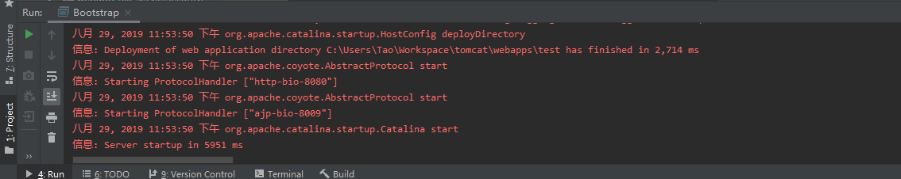
step9.浏览器访问 http://127.0.0.1:8080 成功
2.直接以ant工程导入

附注
在IDEA中完成Tomcat源码导入及运行之后，本人尝试在Eclipse下通过导入maven工程的方式对tomcat源码进行导入，亦可执行成功！！！

