Designing and Evaluating a Split RIR Reverberation System
Xiaoyi Xu
Music Technology Program
New York University
New York, NY
xx2644@nyu.edu

Abstract—This paper presents a hybrid reverb system for real-time audio. The proposed system splits a stereo room impulse response into early reflections and a late reverberation tail, using convolution for early reflections and feedback delay networks for late tail. This paper also compares the hybrid reverb system with full convolution system, evaluating their computation speeds, accuracy and perceptual similarities and shows the potentiality and future improvements of the hybrid reverb system.
Keywords—room impulse response, early reflections, late reverberation, convolution reverb, feedback delay network.

I. Introduction
Reverberation is important in spatial audio, game audio, virtual reality, and music production. Room impulse response convolution can reproduce the sound of a real space, so it often gives a strong sense of realism. However, a full room impulse response can be several seconds long. Direct convolution with a long impulse response has a high computational cost. This is a problem for real-time audio systems, where low latency is important.
This project implements a split RIR hybrid reverberation system. The idea is based on a useful acoustic observation. That is, early reflections are important for localization, distance, and the first impression of the room, whereas the late reverb tail is more diffuse and more statistical. Therefore, the system keeps the early part of the RIR for convolution, while the late tail is approximated by an algorithmic reverb network. This can keep important spatial cues and reduces the computation cost of long convolution.

II. Literature review
Room reverberation simulation has developed from simple algorithmic structures to physically informed, data-driven, and neural approaches. Early artificial reverberation was strongly shaped by Schroeder’s work, which introduced a practical structure based on parallel comb filters followed by all-pass filters [1]. The main goal of this design was not to reproduce an exact physical room, but to generate a perceptually dense and natural-sounding decay with low computational cost. Moorer later extended this line of work by separating early reflections from late reverberation using tap delay lines and by introducing frequency-dependent decay control [2]. These early systems established a basic artificial reverberation principle that remains influential, but were still at a relatively empirical level, and their interpretability through mathematical expression and acoustic theory is relatively insufficient.
Feedback Delay Networks (FDNs) became a more general and mathematically controllable framework for artificial reverberation. Instead of using a small number of independent comb filters, FDNs connect multiple delay lines through a feedback matrix, allowing the system to create dense, diffuse late reverberation. Jot and Chaigne’s work was especially important because it connected delay lengths, feedback matrices, absorption filters, and target reverberation time into a unified design method [3]. Later, Rocchesso and Smith further analyzed special feedback matrix structures, such as circulant and elliptic matrices, showing that FDNs could be studied as systematic delay-network models rather than purely empirical audio effects [4]. More recent work on lossless FDNs has also strengthened the theoretical foundation of stability and energy preservation in these structures [5].
A different branch of research focuses on convolution reverberation, where a dry signal is convolved with a measured or simulated room impulse response (RIR). This method can reproduce a specific acoustic space more accurately than traditional algorithmic reverberations, but it is computationally expensive for long impulse responses. Allen and Berkley’s image-source method provided a classic way to simulate small-room impulse responses by modeling mirror reflections from room boundaries [6]. Farina’s swept-sine technique later became highly influential for measuring high-quality impulse responses in real spaces [7]. For real-time use, Gardner’s low-latency convolution and later partitioned convolution methods made long impulse response convolution more practical by combining time-domain and frequency-domain processing [8].
Because full convolution is accurate but expensive, hybrid reverberation methods that combine convolution for early reflections with parametric or recursive models for late reverberation were developed. This approach is especially relevant for real-time audio and game audio. Väänänen et al. proposed a system that analyzes measured RIRs and resynthesizes room acoustics using parametric reverberation [9]. Stewart and Murphy later formalized a hybrid artificial reverberation algorithm in which the early part of an RIR is convolved with the source, while the late tail is generated using a recursive model [10]. This idea directly supports systems that split the RIR into perceptually important early reflections and a cheaper late reverberation tail.
Another important direction is geometrical and interactive room acoustics. While image-source methods are effective for early reflections, more advanced systems attempt to simulate sound propagation in interactive environments. Scattering Delay Networks (SDNs), for example, approximate room acoustics by combining geometrical reflection paths with delay network structures [11]. Compared with pure FDNs, SDNs preserve more physical interpretation; compared with full wave simulation, they are much cheaper. In game audio and virtual reality, systems such as GSound and related interactive propagation methods further extend this idea by using ray tracing, source clustering, and hybrid rendering to support dynamic scenes with many sound sources [12].
With the rise of machine learning and deep learning, recent neural and differentiable approaches try to learn reverberation behavior from data rather than designing every parameter manually. Image2Reverb predicts plausible RIRs from visual room images, showing that room acoustics can be estimated from cross-modal cues [13]. Differentiable artificial reverberation makes traditional reverberator structures trainable inside neural networks, allowing parameters to be optimized from audio examples [14]. More recent data-driven FDN models learn delay-line and feedback parameters directly from target impulse responses and can generate FDNs from per-trained models [15]. These methods do not completely replace classical DSP structures; instead, they often combine neural optimization with interpretable reverberator models. Overall, the field has moved from low-cost perceptual simulation toward hybrid systems that balance realism, control, computational efficiency, and learnability.

III. Methodology
The proposed system is designed as a hybrid reverberation framework that combines convolution-based early reflection and algorithmic late reverberation synthesis. Instead of convolving the input signal with the full-length stereo RIR, the system first analyzes the RIR and separates it into an early reflection component and a late reverberation component. The early component is processed using block-based RFFT convolution, while the late component is modeled by a feedback delay network controlled by parameters extracted from the original room impulse response. This design aims to preserve important spatial and temporal cues while reducing the computational cost of full convolution.

A. Input and Sample-Rate Unification
The system uses a mono dry signal and a stereo room impulse response as input. All signals are resampled to 44.1 kHz. If the original sampling rate is different, the system uses polyphase resampling. After that, the stereo RIR is separated into left and right channels for analysis.

B. Direct Sound and Early/Late Split Estimation
The system first estimates the direct sound arrival time. Instead of only looking for the largest peak, it uses a short-window RMS energy detector. The RIR is normalized, and a sliding RMS curve is calculated. The beginning 100 ms of the signal is treated as the noise floor. The threshold is calculated from the estimated noise floor as:
T = μ + kσ, | (1)
where μ and σ are the mean and standard deviation of the noise floor respectively, and k is a scaling factor. The first point above this threshold is taken as the direct sound arrival.
The end of the early reflections is estimated with a sliding-window kurtosis analysis:
$$κ_{i}=\frac{1}{N}\sum_{n=0}^{N−1}{{\left(\frac{x_{i}[n]−μ_{i}}{σ_{i}}\right)}^{4}}−3$$ | (2)
K is kurtosis value after Gaussian normalization, μ and σ are the mean and standard deviation for samples in each windowed signal x. The system computes a normalized kurtosis curve and smooths it with an exponential moving average. To explain, late reverberation is closer to a Gaussian distribution, while early reflections contain more isolated reflection peak. The split point is chosen from the strongest drop in the curve and from the point where the curve approaches the tail’s noise level [16]. A small time margin is added to keep the transition more stable.

C. Early Reflection Convolution
The early part is processed with block-based RFFT convolution. The input signal is divided into fixed-size blocks. Each block is convolved with the left and right early impulse responses, and the results are accumulated with overlap-add. Because the early impulse response is much shorter than the full RIR, this part is much cheaper than full convolution in computation. It still keeps the direct sound and early reflections, which are important for spatial detail.

D. Late Reverberation Tail Generation
The late tail is generated with a feedback delay network (FDN). The system first computes the energy decay curve with Schroeder backward integration [17]:
$$E[n]=\sum_{m=n}^{N−1}{h^{2}}[m]$$ | (3)
Where h[m] is the late part of the room impulse response and N is the length of the late RIR. And then the energy is converted to dB scale. It then fits a straight line between -5 dB and -35 dB with a slope s, and RT60 is estimated from the slope:
$$RT₆₀=−\frac{60}{s}$$ | (4)
In this project, RT60 is mainly used as a control parameter for the algorithmic tail. It is not treated as a perfect physical measurement of the room.
The system uses a 4 by 4 FDN to balance real-time cost, echo density, and stereo diffusion. That is because, a 2 by 2 FDN is cheaper but the tail can be too sparse, whereas an 8 by 8 FDN can create a denser tail but needs more delay lines, filter states, and sample-by-sample feedback computation, which is less suitable for the real-time goal of this project. A 4 by 4 FDN also gives four independent feedback paths which can be divided into two channels. I also use a Hadamard feedback matrix with scaling value 0.5. This matrix is simple and helps spread energy in a stable way.
The decay gain of each feedback path is determined by the estimated RT60 and by the delay length of that path. If the total delay length is n, the sampling rate is f_{s}, and the estimated reverberation time is RT60, the feedback gain g is:
$$g_{i}=10^{\frac{−3D_{i}}{RT_{60}f_{s}}}$$ | (5)
This makes the feedback signal decay according to the target RT60. The system also estimates low-frequency and high-frequency decay from the low-passed and high-passed late RIR. If high frequencies decay faster than low frequencies, the damping in the feedback path becomes stronger. The damping is calculated by the delta between low-frequency RT60 and high-frequency RT60:
$d=d_{min}+\left(d_{max}−d_{min}\right)\left(1−e^{−ΔRT_{60}}\right)$, | (6)
where d_{min} and d_{max} is predetermined minimum and maximum value of damping.
The system also estimates stereo width with a mid-side energy ratio and imbalance compensation by left-right energy:
$$width=\frac{E_{S}}{E_{M}+E_{S}}\left(1−\left|\frac{E_{R}−E_{L}}{E_{L}+E_{R}}\right|\right)$$ | (7)
This width controls the diffusion state of the FDN. When the width is small, the simplified network is used. When the width is larger, extra all-pass filters and delay lines are added. This increases diffusion and left-right difference. In this way, the generated tail can reflect not only the decay time, but also the frequency response and stereo width of the original RIR.

E. Early/Late Mixing Ratio Calculation
The final output is not made by simply adding the early convolution and the synthesized late tail at the same level. Instead, the system uses the energy balance of the original RIR. It first measures the energy of the early IR and the late IR. And then it counts target early energy ratio and late energy ratio of total energy. These ratios describes the balance between early reflections and late reverberation in the original room impulse response.
During mixing, the early convolution output and the FDN late tail may not already match those target ratios of the original room impulse response. Therefore, the system measures the current energy of the early output and the late tail, and converts the target energy ratio into amplitude gains, both for the early and late output:
$$g=\sqrt{\frac{r}{E+ε}}$$ | (8)
E is current energy of the output, r is target ratio of the output and ε is a small constant added to avoid division by zero. Since energy is proportional to the square of amplitude, the gain uses a square-root conversion. The left and right channels are calculated separately, so the stereo difference of the original RIR can be kept. After mixing, the detected direct sound arrival time is added back as pre-delay, and the output is normalized to avoid clipping.

IV. Results & analysis
The system is evaluated from three views: subjective listening, computational performance, and parameter estimation accuracy.

A. Subjective Listening Test
A small subjective listening test was designed to compare the hybrid method with full convolution. The test used a 5-point Likert scale. A score of 1 means completely different, and a score of 5 means almost indistinguishable. The full convolution result was used as the reference. The hybrid result was used as the test audio.
There were five participants with three audio major students and two non-professional people. Each participant listened to three audio groups. Each group had one reference audio and one hybrid test audio. The rating dimensions were stereo width, clarity, reverberation tail length, tail smoothness, frequency response, and overall similarity. The results are represented by a bar chart in Fig. 1.
The average scores of all dimensions were above 3.5. This suggests that the hybrid method can be perceptually close to full convolution. Tail length and tail smoothness received the highest scores, both around 4.0. This shows that the system can reproduce the general decay length and smoothness of the late tail. The frequency response score was around 3.93, which suggests that the spectral character was mostly preserved. The overall similarity score was around 3.60. This is lower than several single-dimension scores. This means that small errors in different dimensions can add together and become audible in the overall impression.
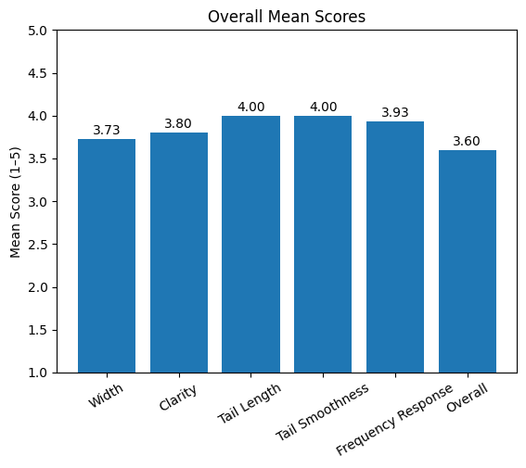
Fig. 1. Overall results of the subjective listening test.
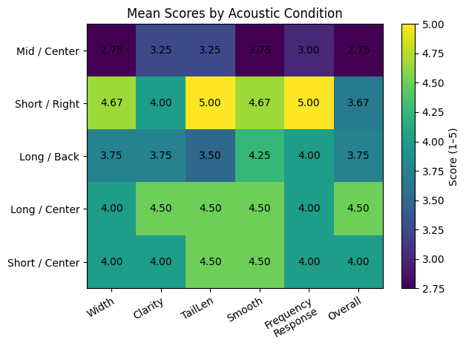
Fig. 2. Results of individual RIRs with different conditions.
The results also changed across different RIR conditions, which can be seen clearly in the Fig. 2. The system performed best in the long and centered condition, where the overall similarity was about 4.50. It performed worst in the mid-length and centered condition, where the score was about 2.75. This shows that the result is affected not only by RT60, but also by the empirical FDN parameters and by the structure of each IR. The current FDN design was mainly balanced on long and short IRs, so it is less adapted to mid-length IRs. Also, all participants heard the mid-length centered sample as the first group. This may have introduced listening adaptation or fatigue effects.

B. Computational Performance
The experiment used a 44.1 kHz sampling rate and a block size of 256 samples. Therefore, the theoretical block duration is 0.0058 s. The notebook recorded the following average processing times per block of one example: early convolution only, 0.0004 s; late tail synthesis, 0.004 s; hybrid total, 0.004 s; and full convolution, 0.0202 s. The results show that hybrid method fulfills the latency requirement of the above systems, and is much cheaper in computation cost than full convolution.
The wider evaluation shows that the speed advantage is strongest for long RIRs. In the long RIRs’ conditions, the speed-up was about 25 times. In the mid-length RIR condition, the speed-up was about 11.8 times, which is still useful. In the Short / Center condition, the speed-up was about 4.3 times. In the Short / Right condition, the method was even slower, with a speed-up of about 0.3 times. This means the hybrid method is most useful for long RIRs. However, for short RIRs, the extra cost of parameter estimation and FDN synthesis can remove the benefit.
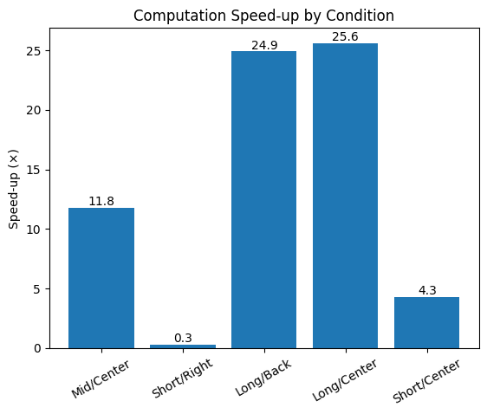
Fig. 3. Computation speed-up of RIRs with different conditions.

C. Parameter Estimation and Accuracy Analysis
This section evaluates three parameters: direct sound arrival time, the early reflection boundary, and RT60. These parameters have different meanings and use different reference standards.
For direct sound arrival time, this paper follows the idea from ISO 3382 [18]. Direct sound is the sound that travels from the source to the receiver through the shortest path, without reflections. Following this principle, the evaluation focuses on identifying the earliest distinct energy arrival that exceeds the noise floor.
The results show that direct sound arrival time was detected reliably in all test conditions. The accuracy reached 1.00. This means the short-window RMS threshold method is reliable for direct sound detection.
For the boundary between early reflections and late reverberation, ISO 3382 [18] does not give one strict universal definition. However, ISO 3382-1 [18] defines clarity indices C50 and C80 with 50 ms and 80 ms time limits. These limits are commonly used to separate early and late energy in speech and music contexts. Therefore, this paper uses the 50 to 80 ms range as a practical reference for the early reflection boundary.
The early reflection boundary was generally accurate, with accuracy between about 0.75 and 1.00. The estimate became worse when the sound field was complex or when the kurtosis curve was not smooth.
For RT60, the reference value is measured with pyroomacoustics.experimental.measure_rt60() [19]. RT60 error is defined as the relative error between the estimate and the reference. RT60 accuracy is then defined as 1 minus RT60 error.
RT60 accuracy dropped in longer or more complex IR conditions. In the long RIRs’ conditions, RT60 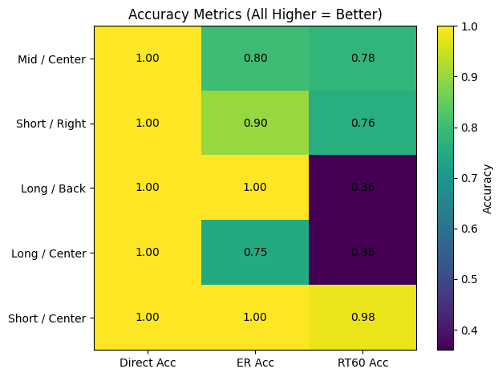Fig. 4. Accuracy Metrics of individual RIRs with different conditions.
accuracy dropped to about 0.36. In the Short / Center condition, where the energy decay curve was closer to a single slope, RT60 accuracy reached about 0.98. This shows that a single T30 fit works well for simple decay curves, but it cannot fully describe multi-slope decay or non-ideal diffuse fields. The Fig. 4. shows accurate values of all evaluated parameters above.
Overall, the system is quite stable for direct sound and early reflection estimation. This gives a reliable basis for the early convolution stage. The late reverberation part is more condition-dependent. RT60 estimation and late tail synthesis are still the main sources of error.

V. Conclusion
This paper implemented a split RIR hybrid reverb system. The system separates a room impulse response into early reflections and a late reverberation tail. The early part uses RFFT block convolution to preserve important spatial cues. The late part uses a feedback delay network controlled by RIR parameters to reduce computational cost. The results show that the hybrid method can run below the system’s latency at 44.1 kHz with a 256-sample block size. It can also be much faster than full convolution, especially for long RIRs. The subjective listening test shows good similarity in tail length, tail smoothness, and frequency response, but the overall similarity is still limited by late reverberation modeling accuracy.
The results also show a clear trade-off between efficiency and accuracy. The hybrid system is most effective for long RIRs, where it can reduce computational cost while maintaining reasonable perceptual quality. However, the current system is still limited by RT60 estimation errors, especially when the energy decay curve has multiple slopes or when the sound field is not ideally diffuse.
Future work should improve late tail modeling through multi-band decay estimation, better diffusion design, and partitioned convolution for stronger real-time performance. Machine learning methods could also be used to reduce empirical parameter tuning and make the FDN late tail more adaptive to different room responses.

Acknowledgment
The author would like to thank professors Agnieszka Roginska, Mason Mann, and the New York University Music Technology Program for their guidance and for providing the course and experimental environment that made this project possible.

References
[1] M. R. Schroeder, “Natural sounding artificial reverberation,” J. Audio Eng. Soc., vol. 10, no. 3, pp. 219–223, 1962.
[2] J. A. Moorer, “About this reverberation business,” Comput. Music J., vol. 3, no. 2, pp. 13–28, 1979.
[3] J.-M. Jot and A. Chaigne, “Digital delay networks for designing artificial reverberators,” in Proc. Audio Eng. Soc. 90th Conv., Paris, France, Feb. 1991, Preprint 3030.
[4] D. Rocchesso and J. O. Smith, “Circulant and elliptic feedback delay networks for artificial reverberation,” IEEE Trans. Speech Audio Process., vol. 5, no. 1, pp. 51–63, Jan. 1997.
[5] S. J. Schlecht and E. A. P. Habets, “On lossless feedback delay networks,” IEEE Trans. Signal Process., vol. 65, no. 6, pp. 1554–1564, Mar. 2017.
[6] J. B. Allen and D. A. Berkley, “Image method for efficiently simulating small-room acoustics,” J. Acoust. Soc. Am., vol. 65, no. 4, pp. 943–950, 1979.
[7] A. Farina, “Simultaneous measurement of impulse response and distortion with a swept-sine technique,” in Proc. Audio Eng. Soc. 108th Conv., Paris, France, Feb. 2000, Preprint 5093.
[8] W. G. Gardner, “Efficient convolution without input-output delay,” J. Audio Eng. Soc., vol. 43, no. 3, pp. 127–136, 1995.
[9] R. Väänänen, V. Välimäki, J. Huopaniemi, and M. Karjalainen, “Efficient and parametric reverberator for room acoustics modeling,” in Proc. Int. Comput. Music Conf. (ICMC), Thessaloniki, Greece, Sep. 25–30, 1997, pp. 200–203.
[10] R. Stewart and D. T. Murphy, “A hybrid artificial reverberation algorithm,” in Proc. Audio Eng. Soc. 122nd Conv., Vienna, Austria, May 5–8, 2007, Conv. Paper 7021.
[11] E. De Sena, H. Hacıhabiboğlu, Z. Cvetković, and J. O. Smith, “Efficient synthesis of room acoustics via scattering delay networks,” IEEE/ACM Trans. Audio, Speech, Lang. Process., vol. 23, no. 9, pp. 1478–1492, 2015.
[12] C. Schissler and D. Manocha, “Interactive sound propagation and rendering for large multi-source scenes,” ACM Trans. Graph., vol. 36, no. 4, Art. no. 114c, 2017.
[13] N. Singh, J. Mentch, J. Ng, M. Beveridge, and I. Drori, “Image2reverb: Cross-modal reverb impulse response synthesis,” in Proc. IEEE/CVF Int. Conf. Comput. Vis. (ICCV), 2021, pp. 286–295.
[14] S. Lee, H. S. Choi, and K. Lee, “Differentiable artificial reverberation,” IEEE/ACM Trans. Audio, Speech, Lang. Process., vol. 30, pp. 2541–2556, 2022.
[15] A. I. Mezza, R. Giampiccolo, E. De Sena, and A. Bernardini, “Data-driven room acoustic modeling via differentiable feedback delay networks with learnable delay lines,” EURASIP J. Audio, Speech, Music Process., vol. 2024, no. 1, Art. no. 51, 2024.
[16] R. Stewart and M. Sandler, “Statistical measures of early reflections of room impulse responses,” in Proc. 10th Int. Conf. Digit. Audio Effects (DAFx-07), Bordeaux, France, Sep. 2007, pp. 59–62.
[17] M. R. Schroeder, “New method of measuring reverberation time,” J. Acoust. Soc. Am., vol. 37, no. 3, pp. 409–412, 1965.
[18] Acoustics—Measurement of room acoustic parameters—Part 1: Performance spaces, ISO 3382-1:2009, 2009.
[19] R. Scheibler, E. Bezzam, and I. Dokmanić, “Pyroomacoustics: A Python package for audio room simulation and array processing algorithms,” in Proc. IEEE Int. Conf. Acoust., Speech Signal Process. (ICASSP), Calgary, AB, Canada, Apr. 15–20, 2018, pp. 351–355.

