1. **實驗日期:** 2017/03/30

**2.**  **實驗名稱:**

1.      Riverbed Modeler: RIP: Routing Information Protocol

2.      Riverbed Modeler: OSPF: Open Shortest Path First

**3.  問題與答案:**

實驗一

1. Obtain and analyze the graphs that compare the sent RIP traffic for both scenarios. Make sure to change the draw style for the graphs to Bar Chart.

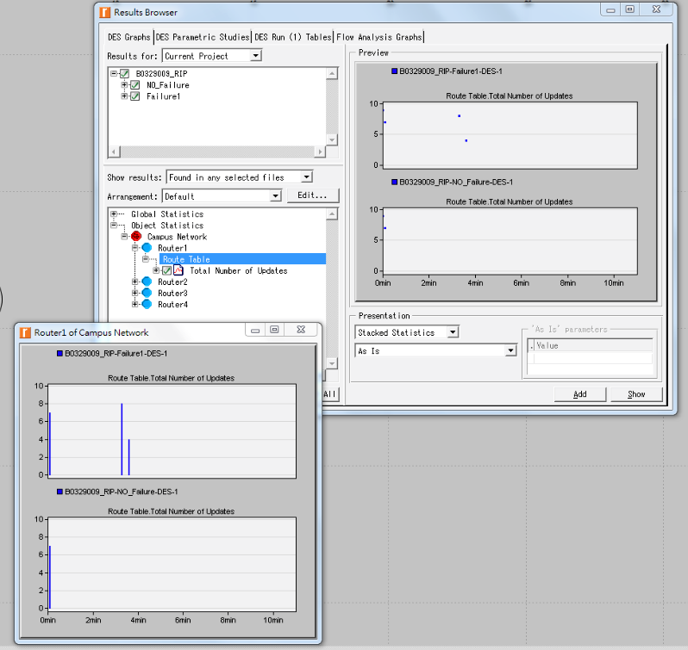

上突圍failure，下突圍no failure。可以看出在failure的情況下，在所設定的時間後RIP修改了route table。

1. Describe and explain the effect of the failure of the link connecting Router1 to Router2 on the routing tables.

他會先讓Router1和Router2之間連線fail，200秒後重新連線，所以在200秒後會發現routing table多出的bar chart就是router1和router2連線造成的。

1. Create another scenario as a duplicate of the Failure scenario. Name the new scenario Q3_Recover. In this new scenario have the link connecting Router1 to Router2 recover after 400 seconds. Generate and analyze the graph that shows the effect of this recovery on the Total Number of Updates in the routing table of Router1. Check the contents of Router1‘s routing table. Compare this table with the corresponding routing tables generated in the NO_Failure and Failure scenarios.

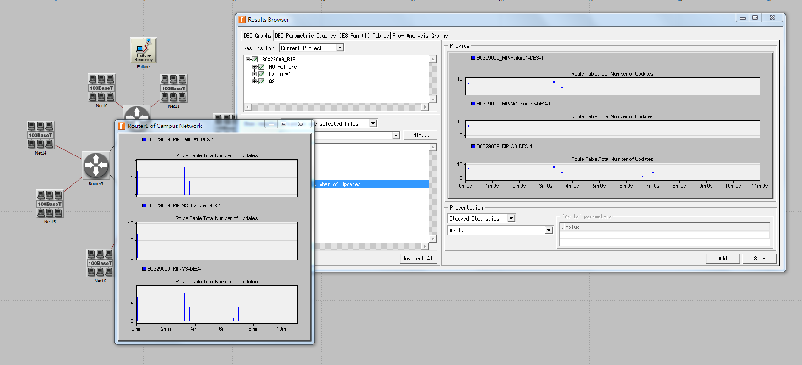

表圖上中下分別為failure、no failure、Q3。

在Q3中200秒做有的bar chart是routing1和routing2恢復連線，400秒是指routing1和routing2更新連線，所產生的routing table更新。

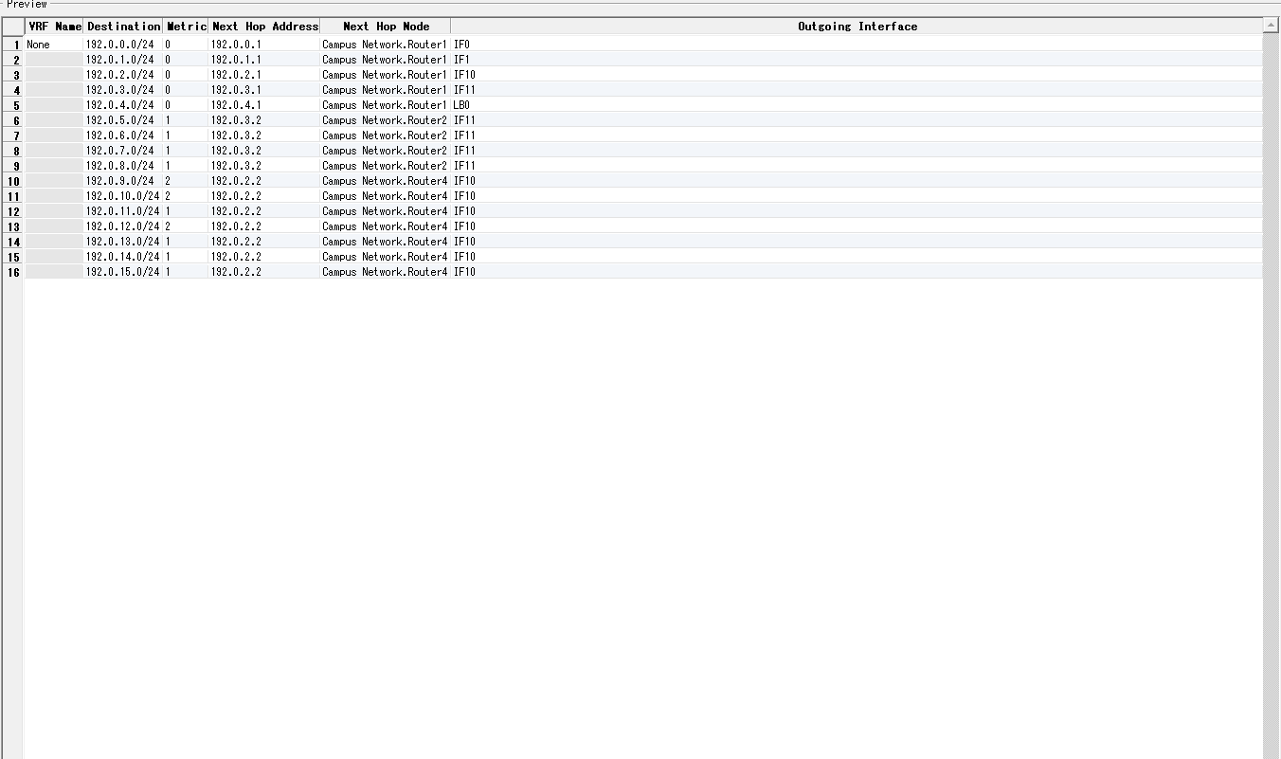

Routing table

實驗二

1. Explain why the Areas and Balanced scenarios result in different routes than those observed in the No_Areas scenario, for the same pair of routers.

在no area部分它的最小路徑是ADEC，cost為15。

area部分是因為router A,B,C三個是一個區域網路，所以最短路徑就是AC，cost為20。

Balanced的部分，它會選擇最佳路由，並在這些路由之間平衡流量與負載。

1. Using the simulation log, examine the generated routing table in RouterA for each of the three scenarios. Explain the values assigned to the Metric column of each route.

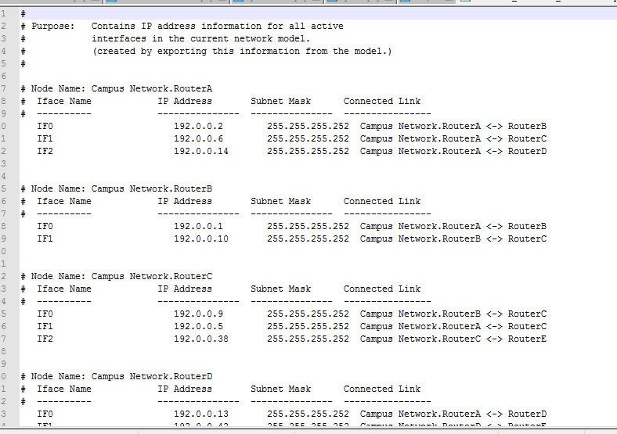

No Areas的routing table。

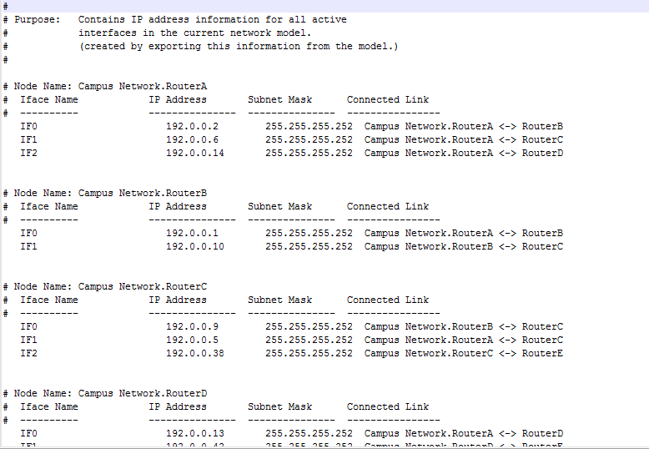

Areas的routing table。

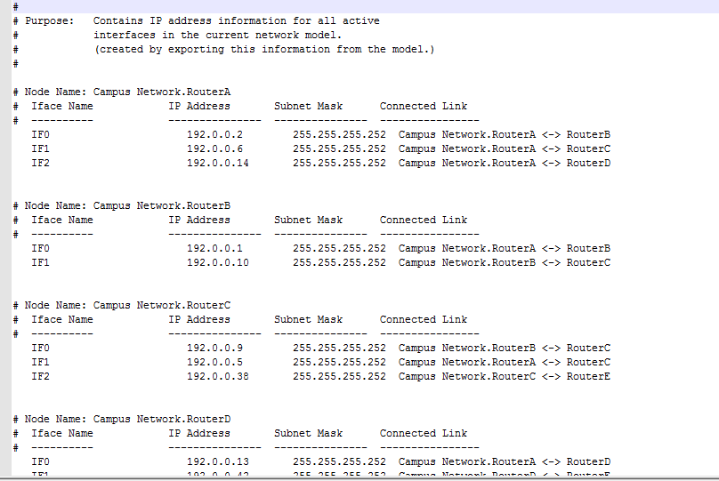

Balanced的routing table。

1. Modeler allows you to examine the link-state database that is used by each router to build the directed graph of the network. Examine this database for RouterA in the No_Areas scenario. Show how RouterA utilizes this database to create a map for the topology of the network and draw this map (This is the map that will be used later by the router to create its routing table.)

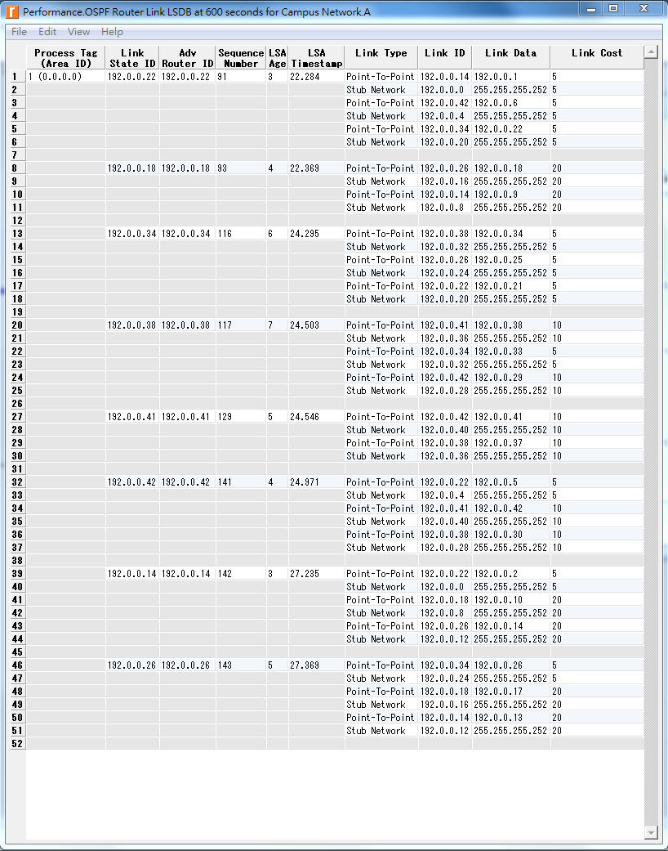

1. Create another scenario as a duplicate of the No_Areas scenario. Name the new scenario Q4_No_Areas_Failure. In this new scenario simulate a failure of the link connecting RouterD and RotuerE. Have this failure start after 100 seconds. Rerun the simulation. Show how that link failure affects the content of the link- state database and routing table of RouterA. (You will need to disable the global attribute OSPF Sim Efficiency. This will allow OSPF to update the routing table if there is any change in the network.)

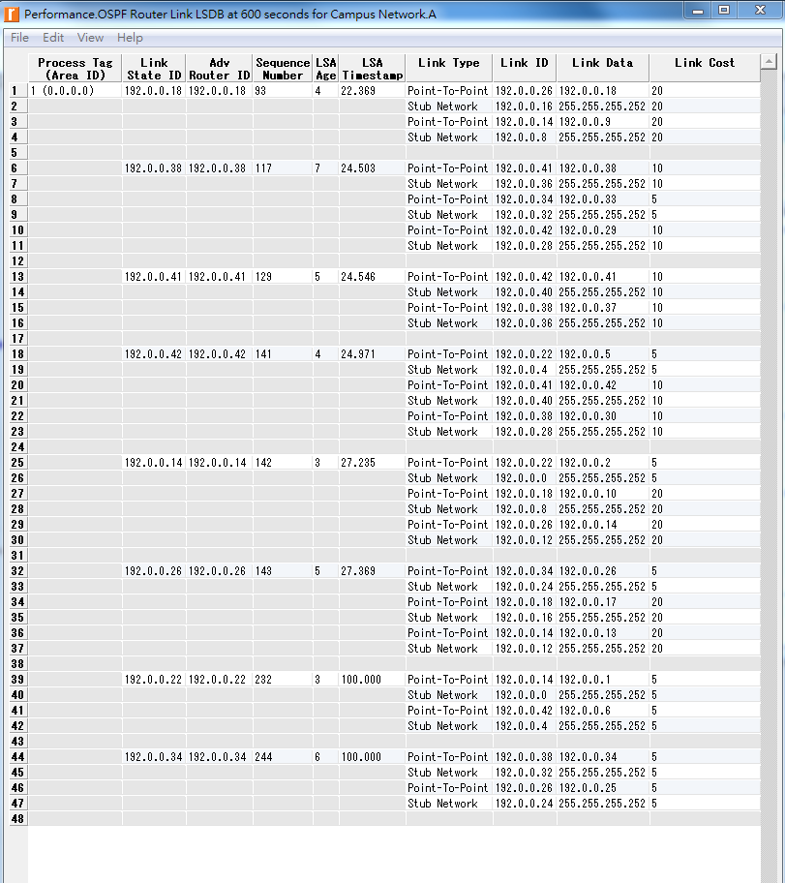

1. For both No_Areas and Q4_No_Areas_Failure scenario, collect the Traffic Sent (bits/sec) statistic (one of the Global Statistics under OSPF). Rerun the simulation for those two scenarios and obtain the graph that compares the OSPF’s Traffic Sent (bits/sec) in both scenarios. Comment on the obtained graph.

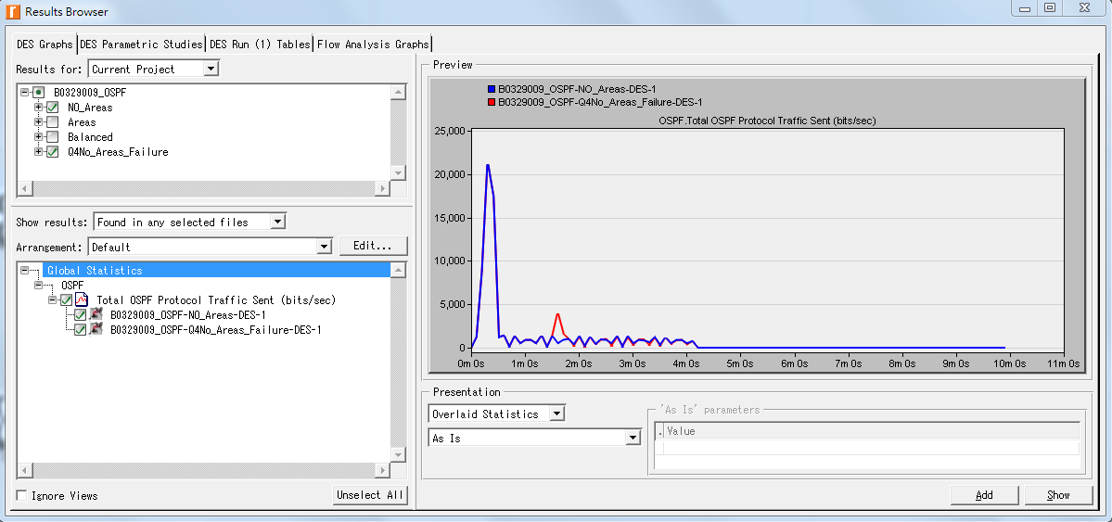

4.  結果討論:

實作RIP和OSPF網路協定

實驗一



Failure(上)與No Failure(下)的更新數目。

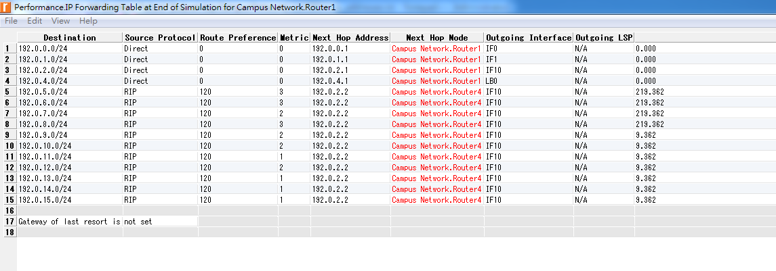

Failure Routing Table

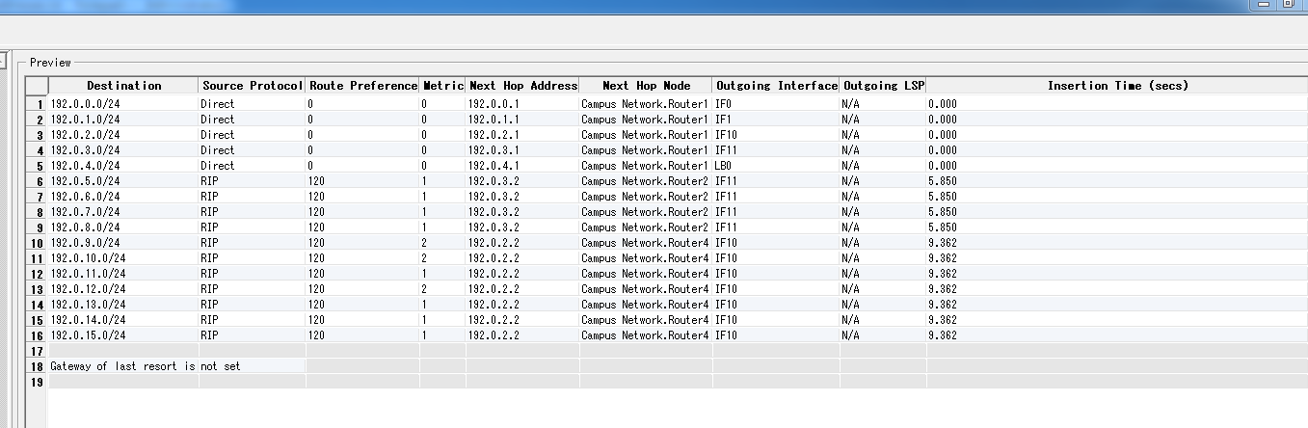

No Failure Routing Table

實驗二

No Area

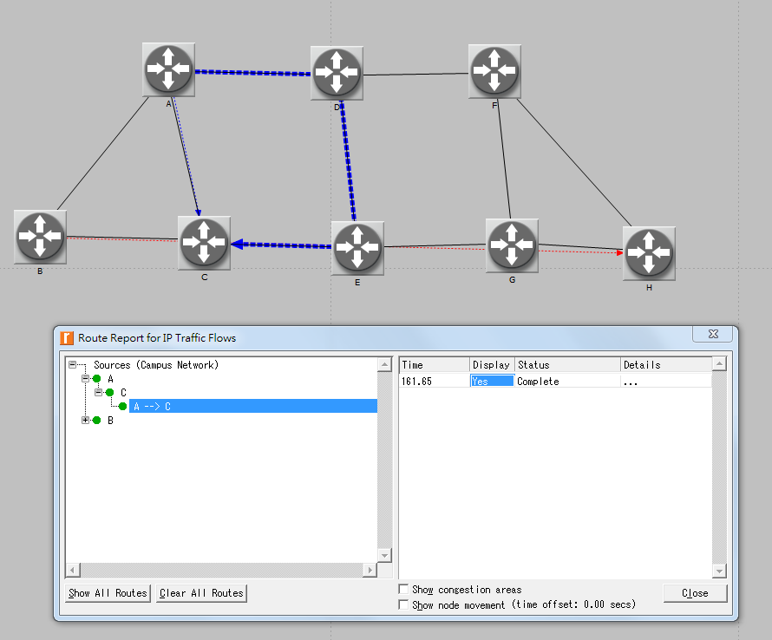

RouterA to RouterC

選擇最少Cost(15)走。

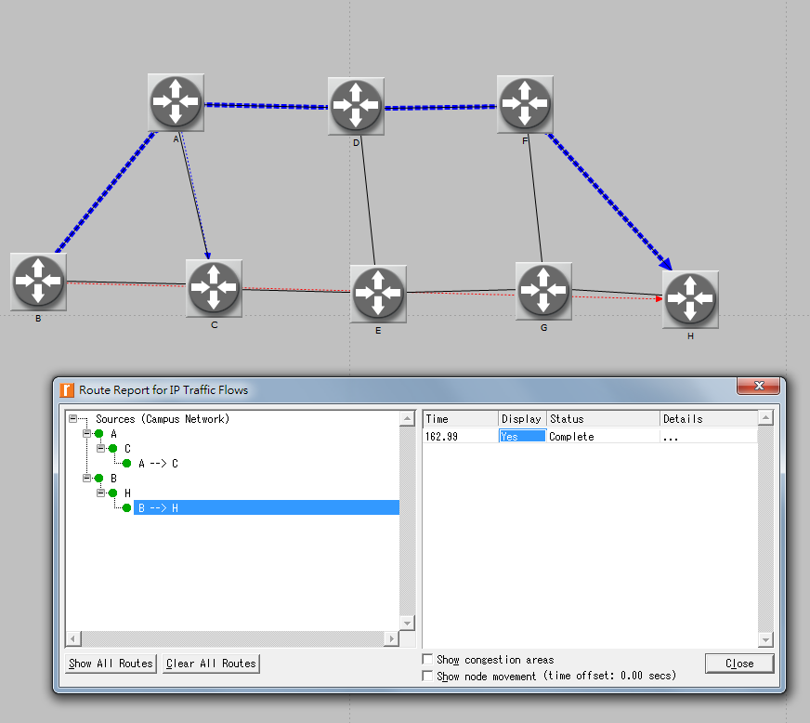

RouterB to RouterH

路徑BADFH和BCEGH兩條路Cost皆為40，所以選擇兩條中的一條走。

Area

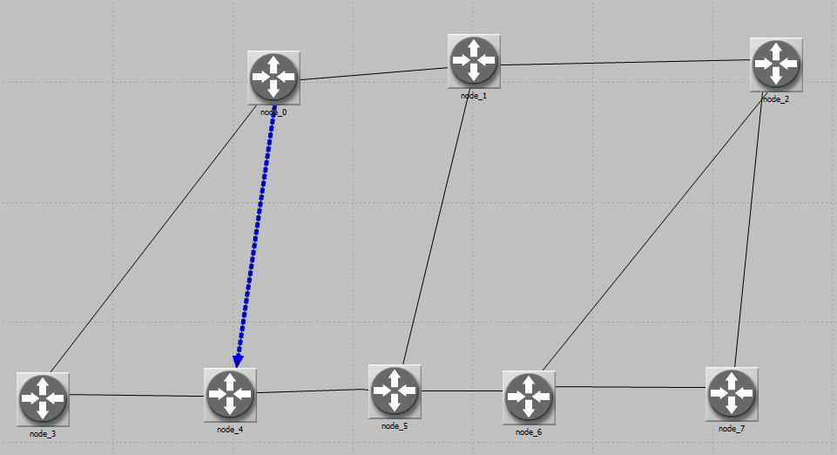

RouterA to RouterC

Router A,B,C為區網，所以RouterA就直接到RouterC。

Balanced

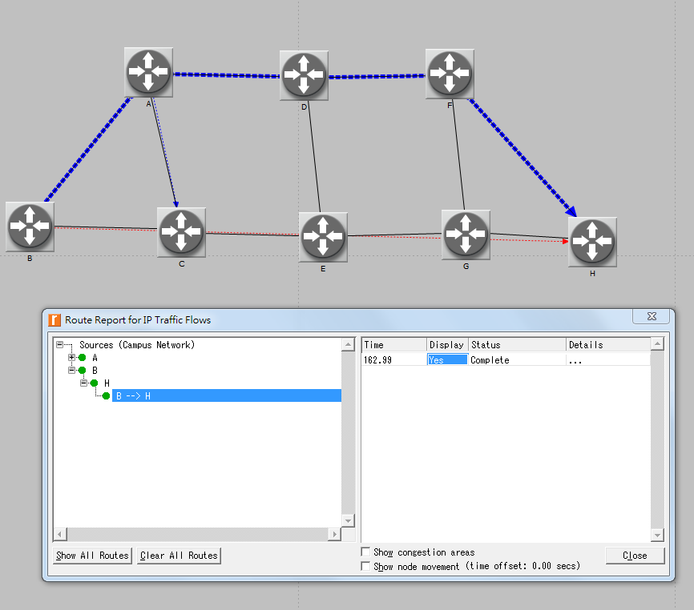

RouterB to RouterH

路徑BADFH和BCEGH皆為最小成本路徑。

這次實驗真的是做到心情很不好，大部分是因為自己還不是很熟悉RiverBed的操作，做得比較慢，要一步一步看著操作手冊做，還有對於OSPF實驗中的Area部分有滿多問題的，一直做不出從A直接到C的路徑，每條路的cost和區網的設定都反覆做過好多次，但跑出來的路徑都還是ADEC，也不知道為甚麼會這樣。最後整個project重作五六次才做出來。