1. **實驗日期:** 2017/6/15

**2.**  **實驗名稱:**

Riverbed Modeler: Queuing Disciplines

**3.  問題與答案:**

實驗一

1. Analyze the graphs we obtained and verify the overlap of the Voice Packet End- to-End Delay and Voice Packet Delay Variation graphs. Compare the three queuing disciplines and explain their effect on the performance of the three applications.

根據end to end 和delay兩個圖形來說，FIFO是這三種方法中最差的一種，他不管檔案大小或重要性，先到的就先傳，這對於一些比較重要的封包來說是很不利的，非常有可能在佇列中被丟包，相對於另外兩種，PQ和WFQ，對於佇列排成都擁有不錯的效果。

1. In the implemented project, edit the Queues object and check the profiles assigned to the FIFO, PQ, and WFQ disciplines. For each profile answer the following questions:
2. How many queues are associated with each discipline?

FIFO : 1

PQ : 4

WFQ : 8

1. In this lab, we used ToS to identify the priority and weight for the PQ and WFQ disciplines respectively. What are the other parameters that can be used to identify the priority and weight?

不同的協定、PORT、DSCP都會影響權重。

1. In PQ, how are queues configured to serve different ToS values?

|  |  |  |
| --- | --- | --- |
| Low | Best Effort(0),Background(1) | 80 |
| Normal | Standard(2),Excellent(3) | 40 |
| Medium | Steaming Multimedia(4),Interactive Multimedia(5) | 60 |
| High | Interactive Voice(6),Reserved(7) | 20 |

1. In WFQ, how are queues configured to serve different ToS values?

|  |  |  |
| --- | --- | --- |
| 0 | 1 | Best Effort |
| 1 | 10 | Background |
| 2 | 20 | Standard |
| 3 | 30 | Excellent Effort |
| 4 | 40 | Streaming Multimedia |
| 5 | 50 | Interactive Multimedia |
| 6 | 60 | Interactive Voice |
| 7 | 70 | Reserved |

1. For all scenarios, choose the “queuing delay <--“statistic for the link that connects East Router and West Router. Rerun the simulation and generate the graph that compares that queuing delay for all queuing disciplines (scenarios). Analyze this graph.

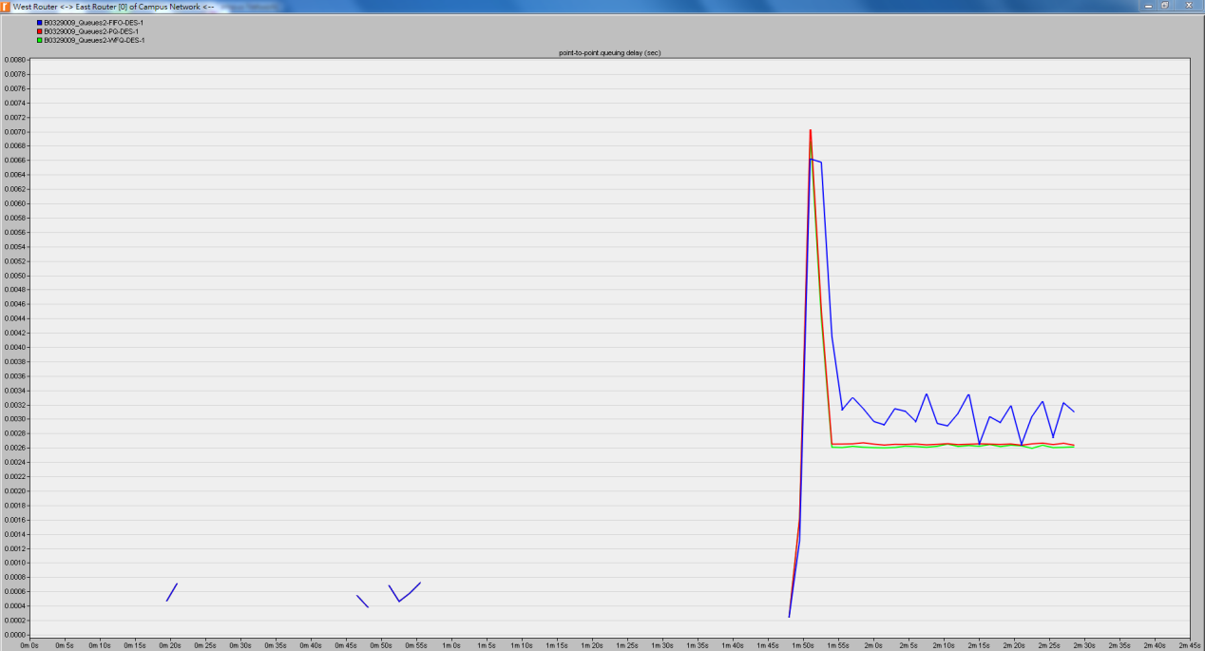

**4.  結果討論:**

實驗一

IP Traffic Dropped(packets/sec)

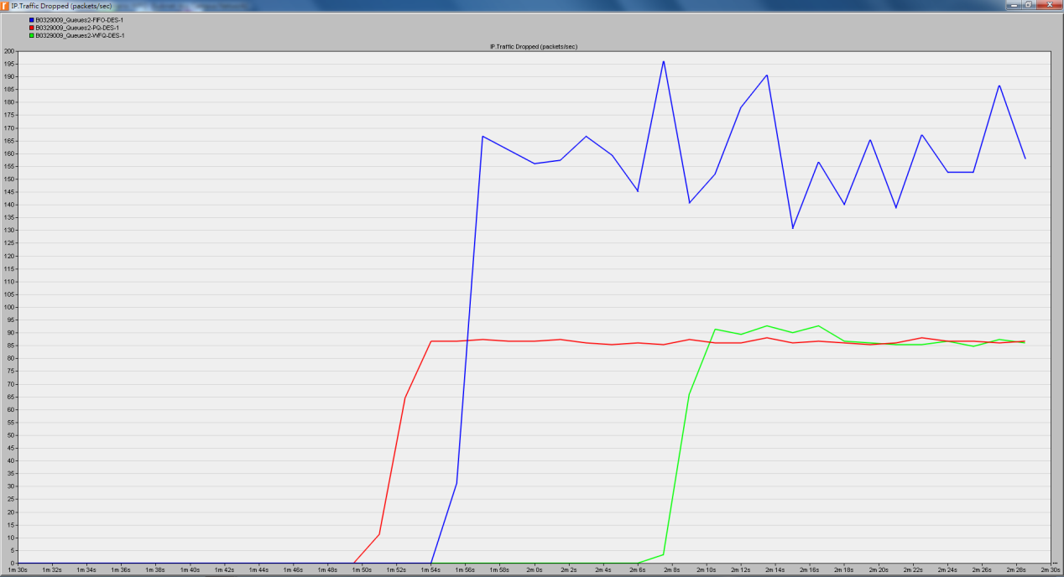

Video Conferencing Traffic Received(bytes/sec)

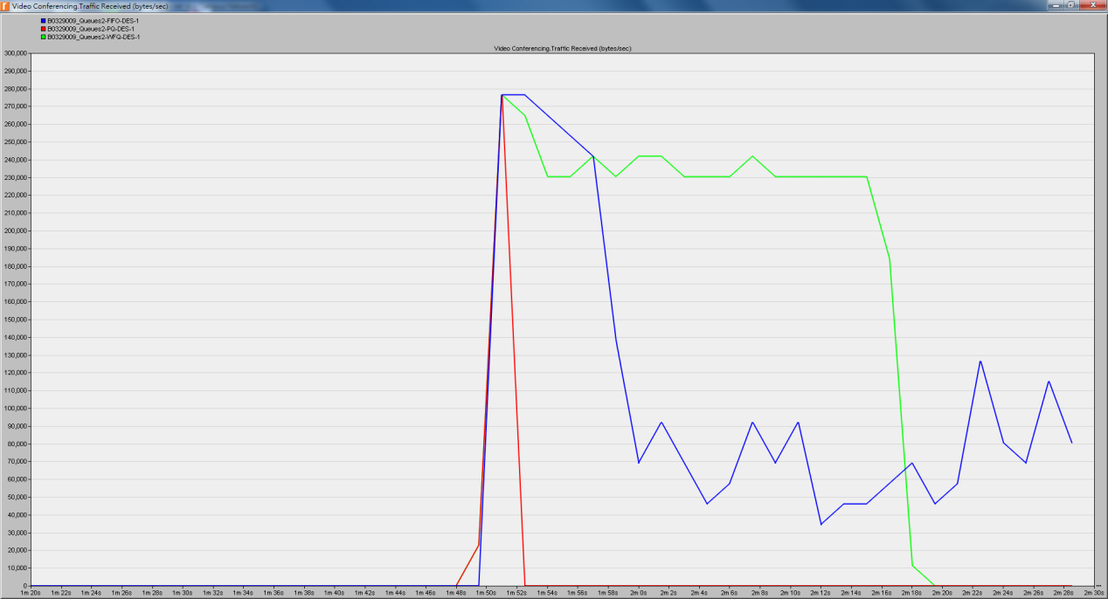

Voice Traffic Received(bytes/sec)

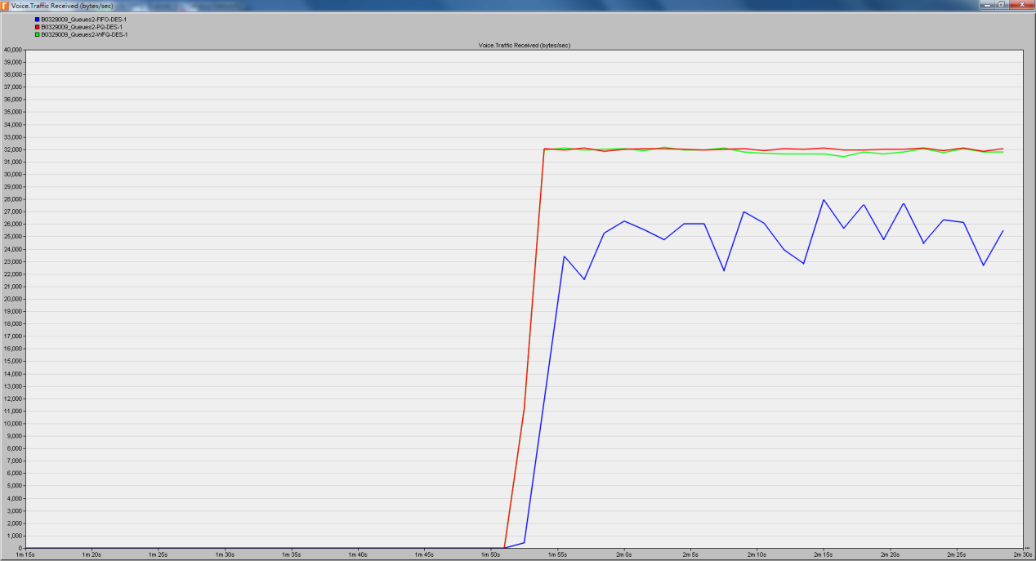

Voice Packet End-to-End Delay(sec)

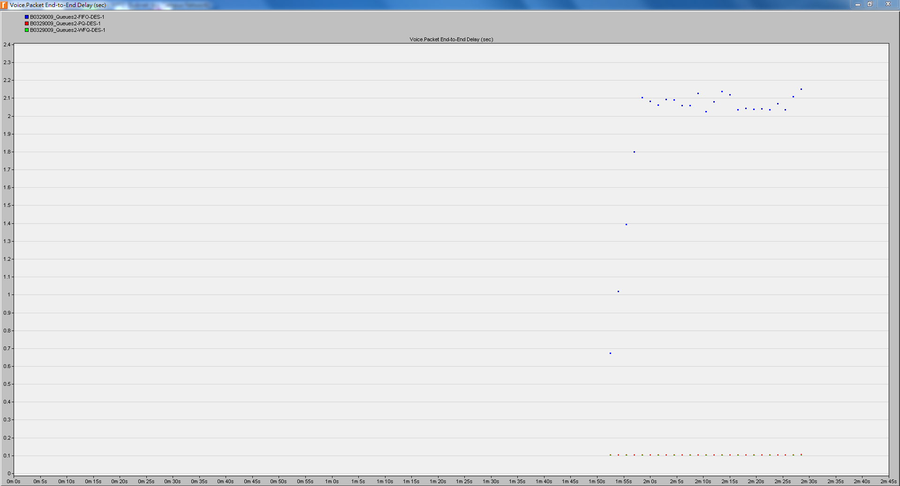

Voice Packet Delay Variation

