1. 實驗日期:

2020/3/19

1. 實驗名稱:

* Riverbed Modeler: Ethernet
* Riverbed Modeler: Switched LANs

1. 問題與答案:

**Lab1 Ethernet**

Q1

explain the graph we received in the simulation that shows the relationship between the received (throughput) and sent (load) packets. Why does the throughput drop when the load is either very low or very high?

顯示出在大概約500 packets/second 的負載下發生了最大的吞吐量。只要一超過500個數據包，網路將變得擁塞並且發生高衝突，一旦發生的數據包不斷增加，接收到的數據包數量就會開始減少。

* **Throughput v.s Offered Load**

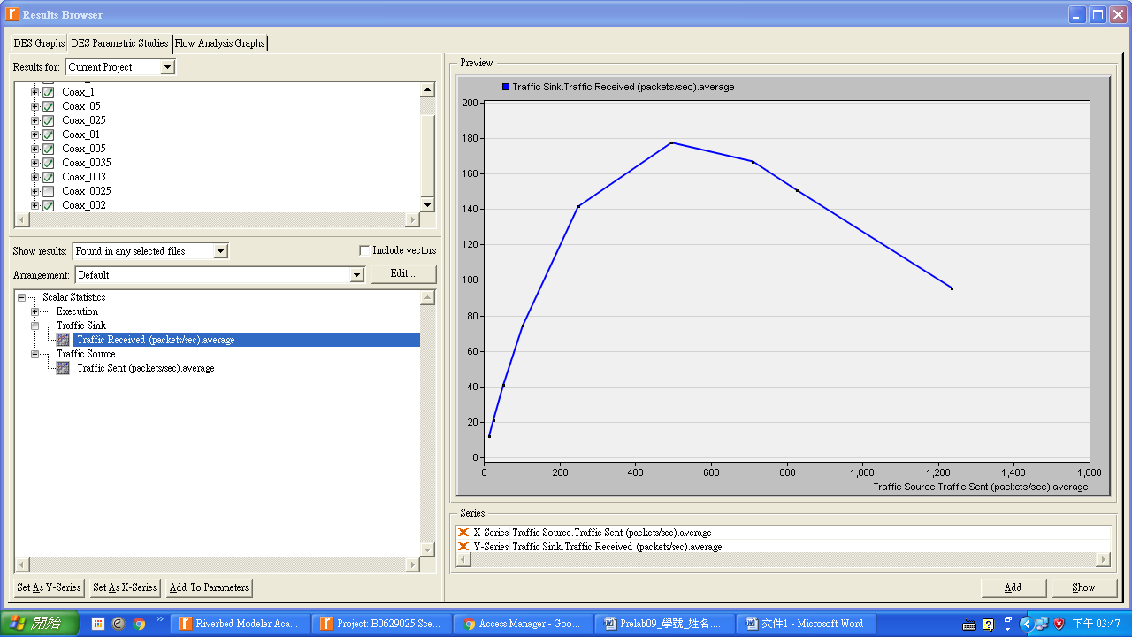

Q2

Use three duplicates of the simulation scenario implemented in this lab named Coax_01, Coax_005, and Coax_0025. Make sure that the Interarrival Time attribute of the Packet Generation Arguments for all nodes in the scenarios are as follows:

-Coax_01 scenario: exponential(0.1)

-Coax_005 scenario: exponential(0.05)

-Coax_0025 scenario: exponential(0.025)

Choose the following statistic for node 0: Node Statistics-Ethcoax-Collision Count. Make sure that the following global statistic is chosen: Global Statistics-Traffic Sink-Traffic Received (packet/sec).

Run the simulation for all three scenarios. Get two graphs: one to compare node 0's collision counts in these three scenarios and the other graph to compare the received traffic from the three scenarios. Explain the graphs and comment on the results.

顯示了當越多的碰撞次數，會有較小的指數。當指數越小，封包傳送的平方數量會比以前更大。同時，大量的其他的機器嘗試發送自己的封包，結果，就會發生更多的碰撞。

* **Collision Count**

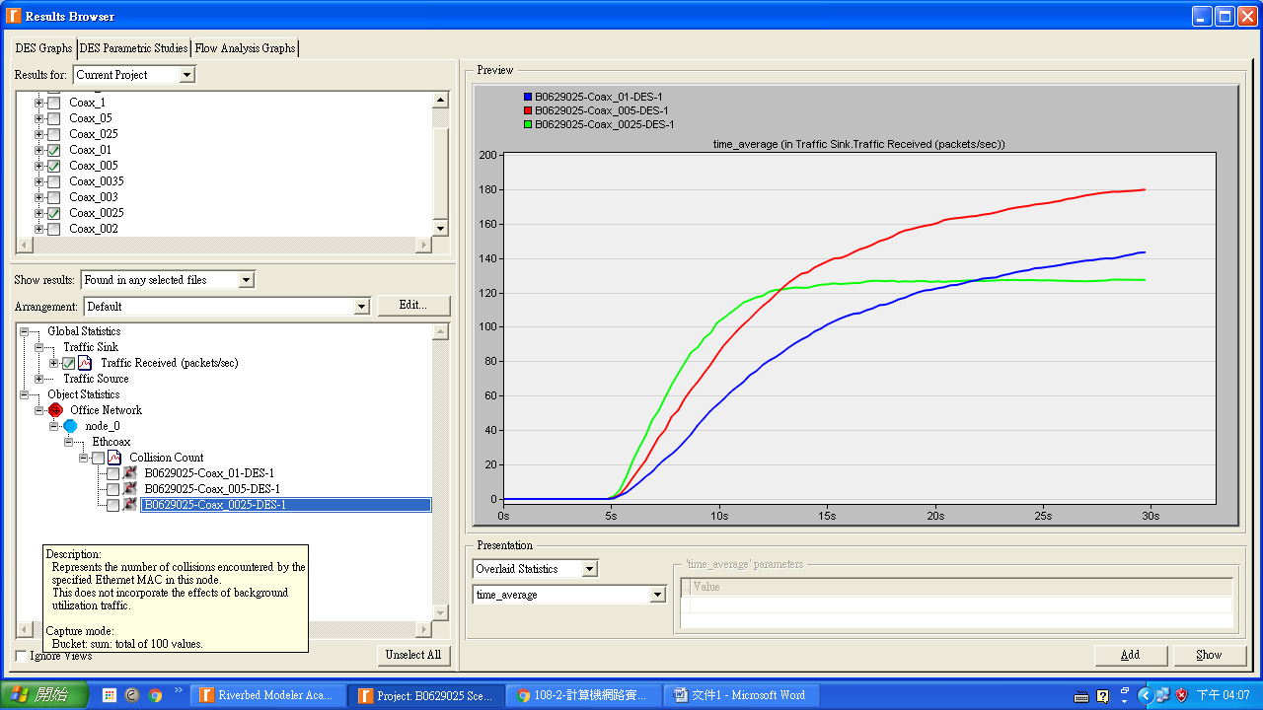

* **Received Traffic v.s Time**

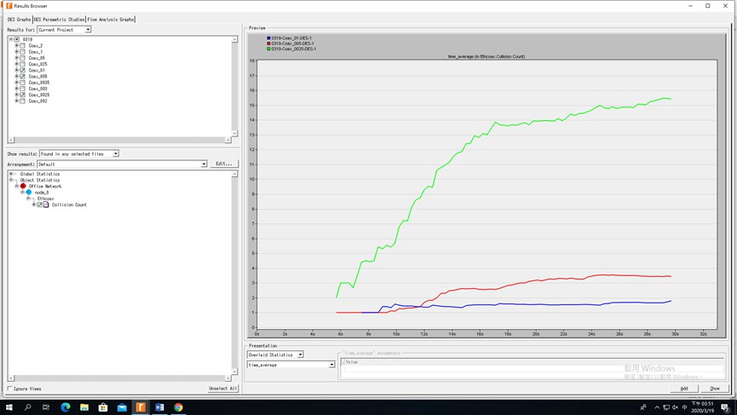

Q3

To study the effect of the number of stations on Ethernet segment performance, create a duplicate of the Coax_0025 scenario. Name the new scenario Coax_Q3. In the new scenario, remove the odd-numbered nodes, a total of 15 nodes. Run the simulation for the new scenario. Create a graph that compares node 0's collision counts in scenarios Coax_0025 and Coax_Q3. Explain the graph and comment on the results.

Coax_Q3節點的數目是Coax_Q0025的一半。由於越少的電腦會減少碰撞，因此我們可以在圖中看到，該碰撞次數有更多節點是大的。

* **Collision Count**

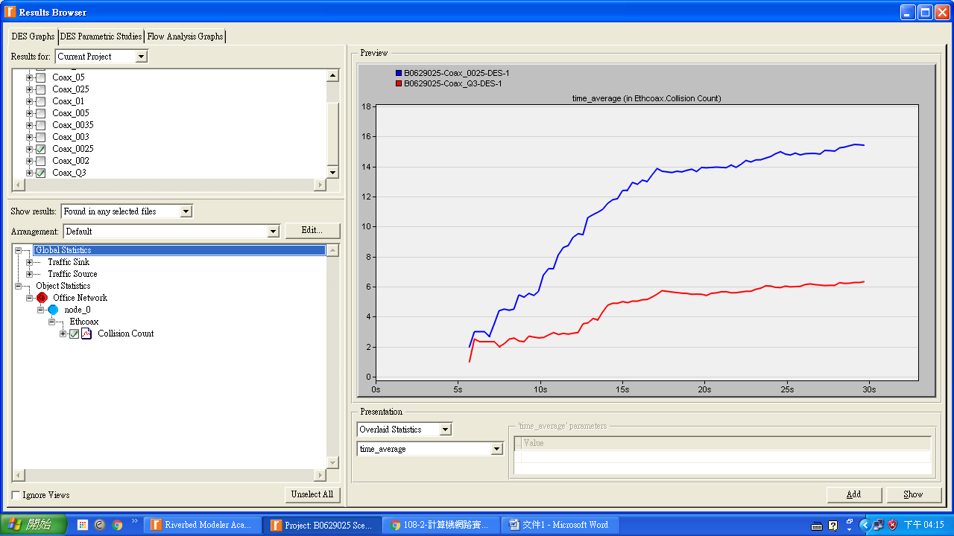

Q4

In the simulation a packet size 1024 bytes is used. To study the effect of the packet size on the throughput of the created Ethernet network, create a duplicate of the Coax_0025 scenario. Name the new scenario Coax_Q4. In the new scenario use a packet size of 512 bytes (for all nodes). For both Coax_0025 and Coax_Q4 scenarios, choose the following global statistic:

Global Statistics-Traffic Sink-Traffic Received (bits/sec). Return the simulation of Coax_0025 and Coax_Q4 scenarios. Create a graph that compares the throughput as packets/sec and another graph that compares the throughput as bits/sec in Coax_0025 and Coax_Q4 scenarios. Explain the graphs and comment on the results.

* **Throughput as Packets/Second**

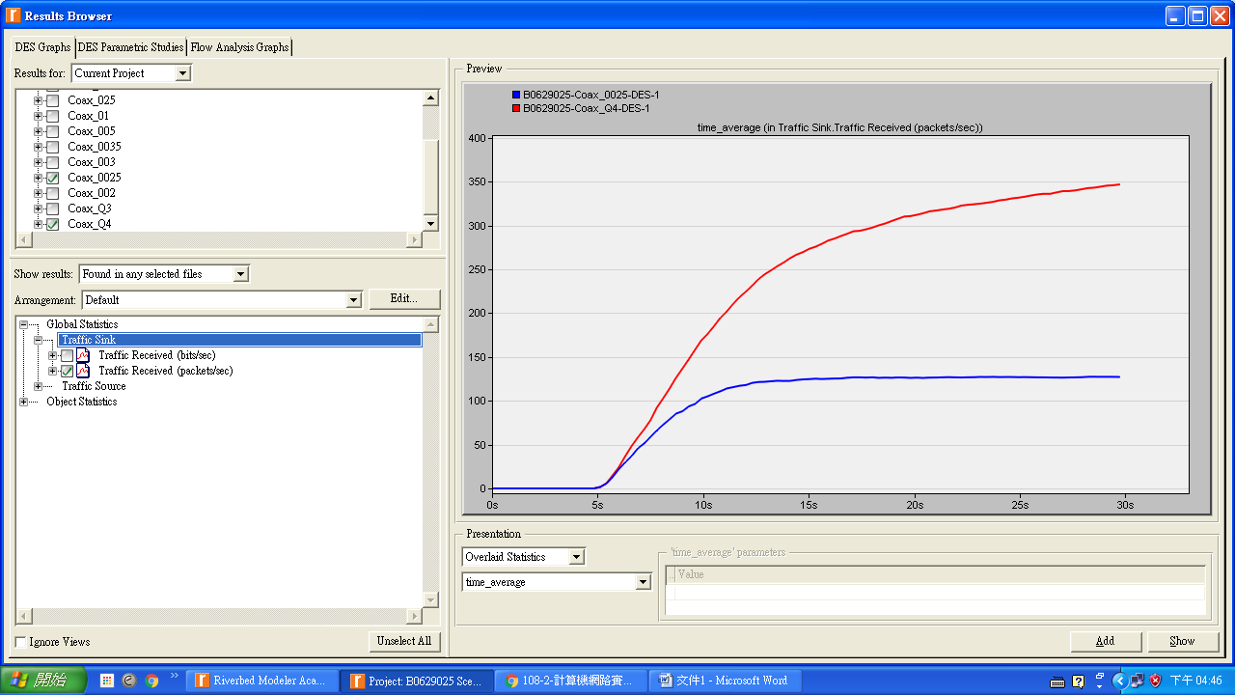

* **Throughput as Bits/Second**

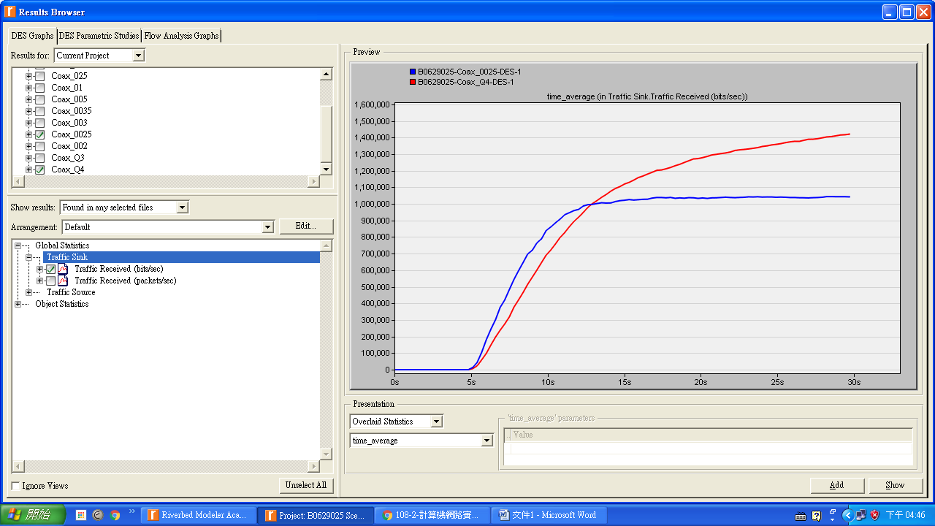

圖中顯示了接收的速度。較小的網路封包(512bytes)在一開始有較小的速度。然而，隨著時間過去，速度保持一定的值，大於網路（Coax_Q4）更大的封包。這是因為封包數量的差異的。當更多的封包傳送，時間效率變得更差。因此，較小時網路負載較輕。隨著網路負荷上升，網路傳送更多的封包會更有效率。因為越小的封包會使碰撞降低。

**Lab3 Switched LANS**

Q1

Explain why adding a switch makes the network perform better in terms of throughput and delay.

因為交換機不會將廣播發送到整個網絡，而只會發送到具有相關IP的端口（假設它已經知道該IP）

* **Traffic Sent v.s Time**

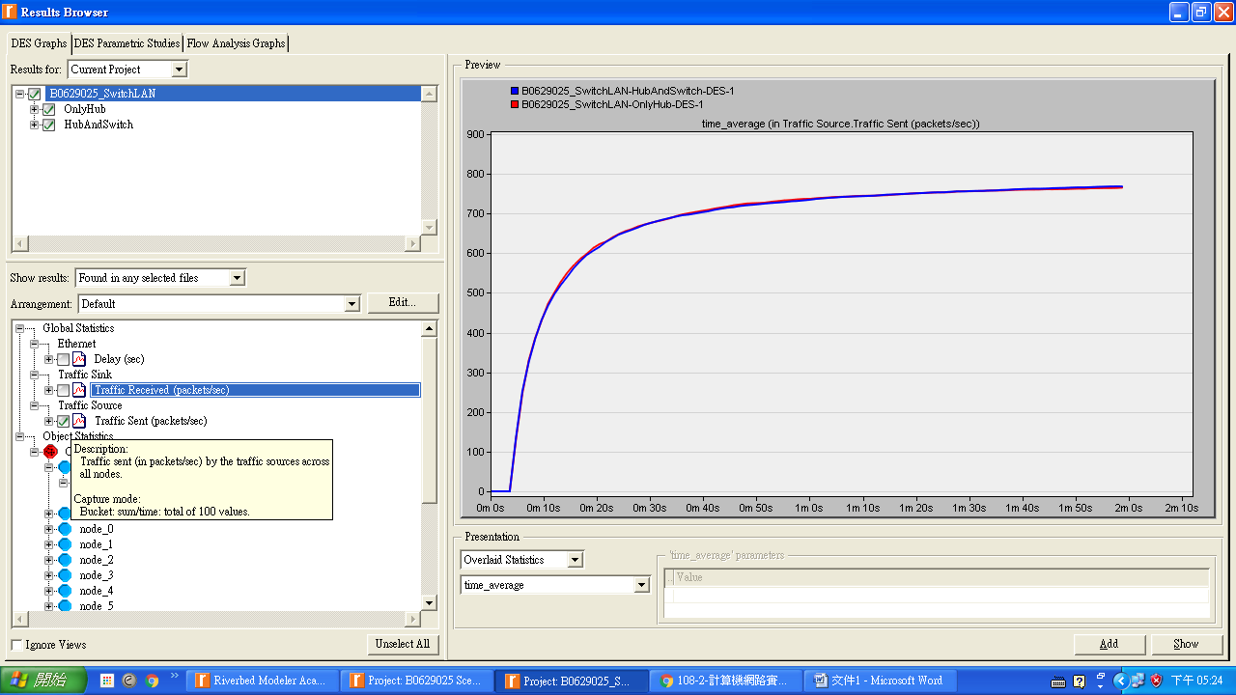

* **Traffic Received v.s Time**

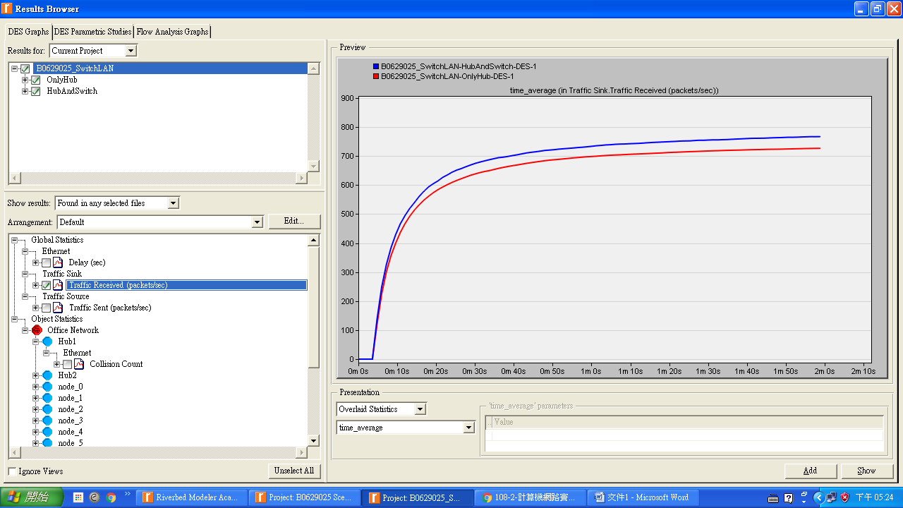

* **Delay v.s Time**

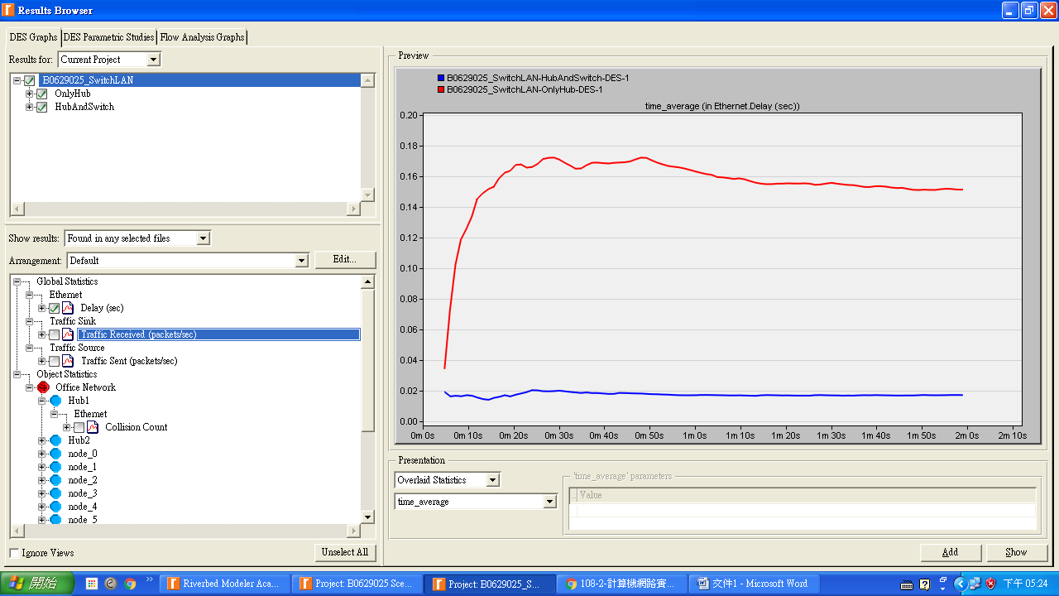

* **Collision Count v.s Time**

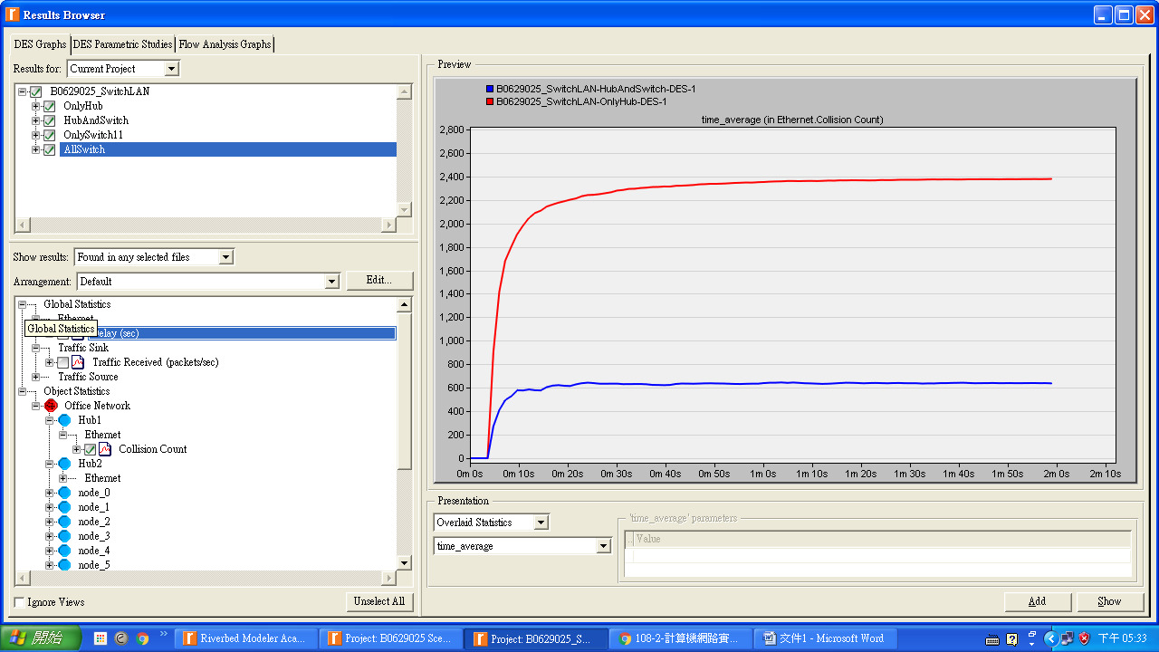

Q2

We analyzed the collision counts of the hubs. Can you analyze the collision count of the "Switch"? Explain your answer.

不行，我沒有辦法分析交換機的衝突計數，因為交換機會對幀進行緩衝並根據地址表正確發送它們。 所以開關沒有碰撞

Q3

Create two new scenarios. The first one is the same as the OnlyHub scenario but replace the hub with a switch. The second new scenario is the same as the HubAndSwitch scenario but replace both hubs with two switches, remove the old switch, and connect the two switches you just added together with a 10BaseT link. Compare the performance of the four scenarios in terms of delay, throughput, and collision count. Analyze the results.

Ans：

第一張所示，每個方案的延遲時間為：OnlyHub> HubAndSwitch> ALLSwitches> OnlySwitch1。

第二張圖中表示，使用switch實施的方案的吞吐量幾乎相同，這比僅方案要大有一個樞紐。 由於交換機中沒有衝突，因此無法獲得ALLSwitches和OnlySwitch1的衝突計數。

* **Delay v.s Time**

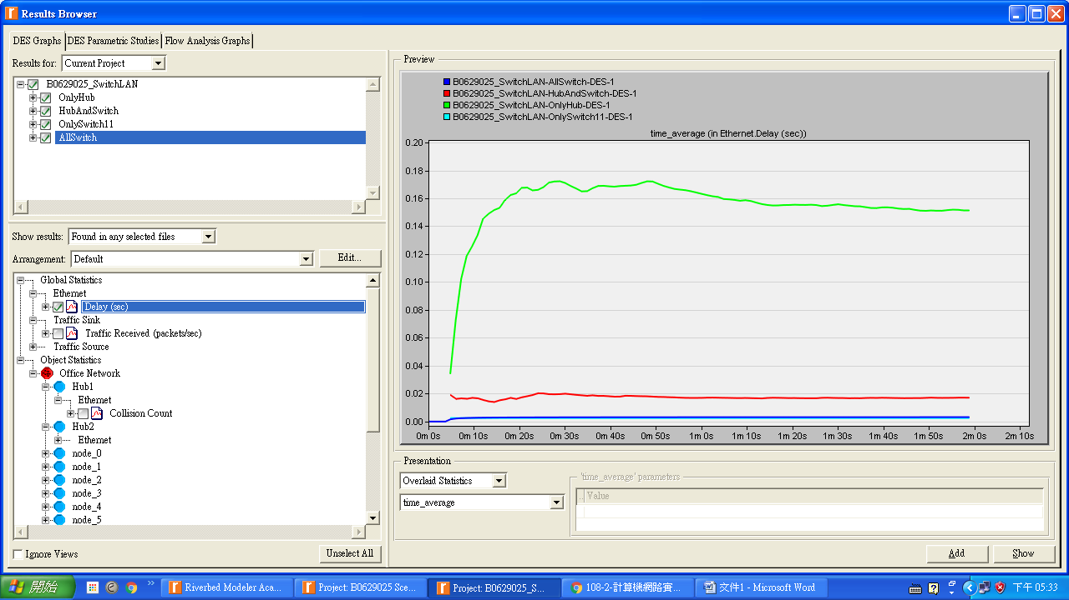

* **Throughput v.s Time**

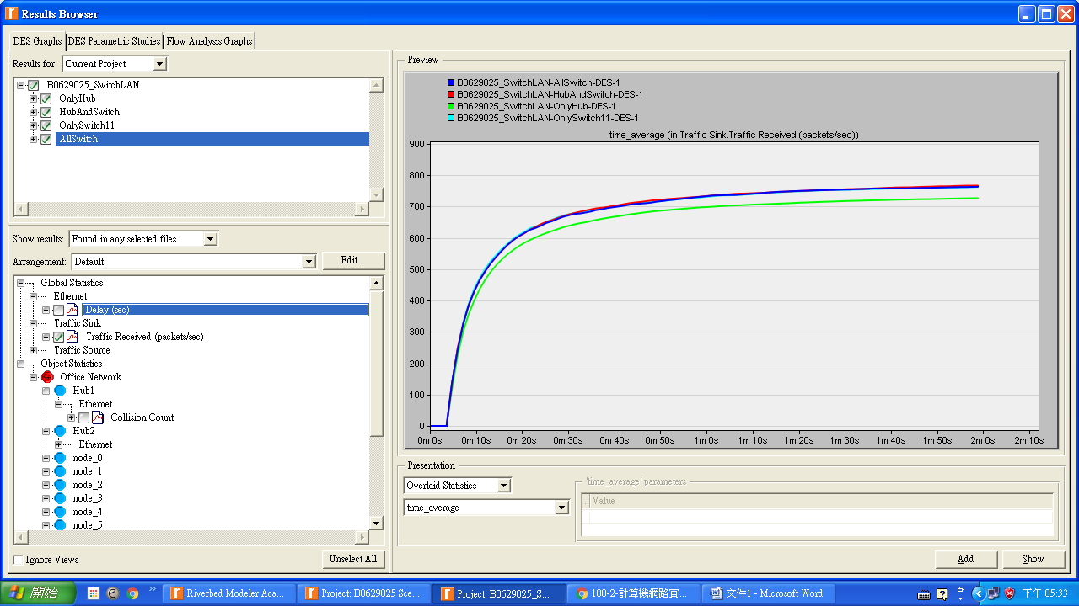

1. 結果討論::

這次實驗做得頗緩慢，手冊是英文要一步一步照著做，任何一個遺漏都可能造成重做。這次實驗了解接受數據包與傳授數據包在不同情況，會有不一樣的情形發生，在做些圖與圖的比較時更加了解了。

1. 補充資料:

<https://www.slideshare.net/nafaa1/opnet-lab-1>

<https://www.coursehero.com/file/p6q55tq/Q2-We-analyzed-the-collision-counts-of-the-hubs-Can-you-analyze-the-collision/>

<https://answers.yahoo.com/question/index;_ylt=AwrtFmBnHnpeQFkAwRZr1gt.;_ylu=X3oDMTEyM2RxaG84BGNvbG8DdHcxBHBvcwMyBHZ0aWQDQjkwMTFfMQRzZWMDc3I-?qid=20071007105906AAUiPTS>

實驗室的參考書Riverbed實驗手冊