**實驗日期:**

2020/04/23

**2.   實驗名稱:**

1.      Riverbed Modeler: RIP: Routing Information Protocol

2.      Riverbed Modeler: OSPF: Open Shortest Path First

**3.   問題與答案:**

Lab 6 : RIP

1. Obtain and analyze the graphs that compare the sent RIP traffic for both scenarios. Make sure to change the draw style for the graphs to **Bar Chart**.

圖中表格上方為failure而下方為no failure。在上方圖failure的情況下，可以看出在所設定的時間後RIP修改了route table，因為連結有所錯誤，router沒有在預期時間內收到封包，所以取而代之的是在發送封包告訴對發無法傳送，並要求更新router。上方failure圖中多的兩個bar 就是更新後路由所產生的。

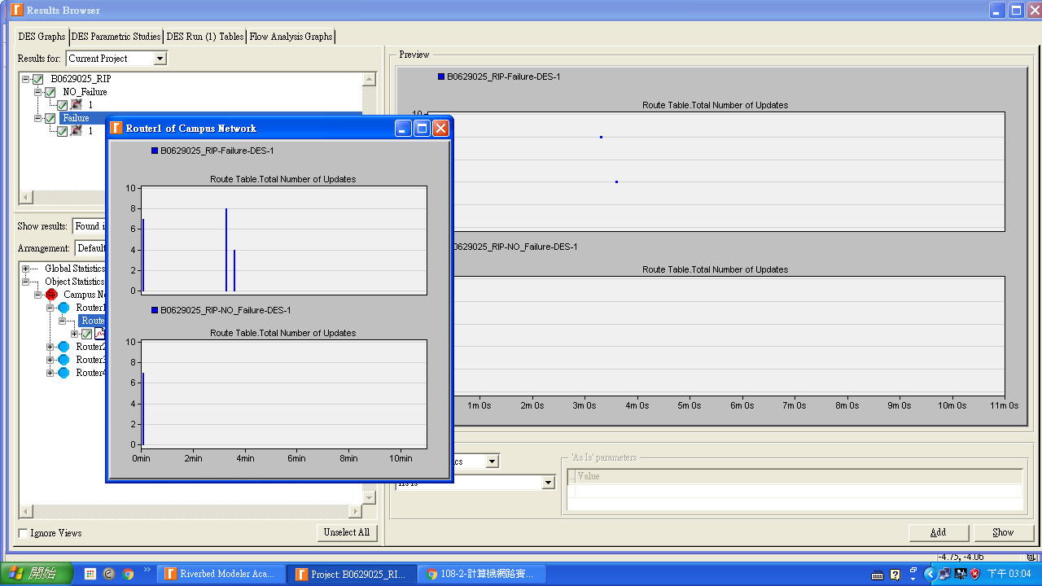

1. Describe and explain the effect of the failure of the link connecting **Router1** to **Router2** on the routing tables.

封包在傳送過程中找不到下一個確切的點，會先使router1 和 router2 之間連結錯誤，當200秒過後便會重新連線，所以在200秒後會發現routing table 會有多出的bar chart 就是因為 router1 和 router2 連線造成的。

1. Create another scenario as a duplicate of the **Failure** scenario. Name the new scenario **Q3_Recover**. In this new scenario have the link connecting **Router1** to **Router2** recover after 400 seconds. Generate and analyze the graph that shows the effect of this recovery on the **Total Number of Updates** in the routing table of **Router1**. Check the contents of **Router1**’s routing table. Compare this table with the corresponding routing tables generated in the **NO_Failure** and **Failure** scenarios.

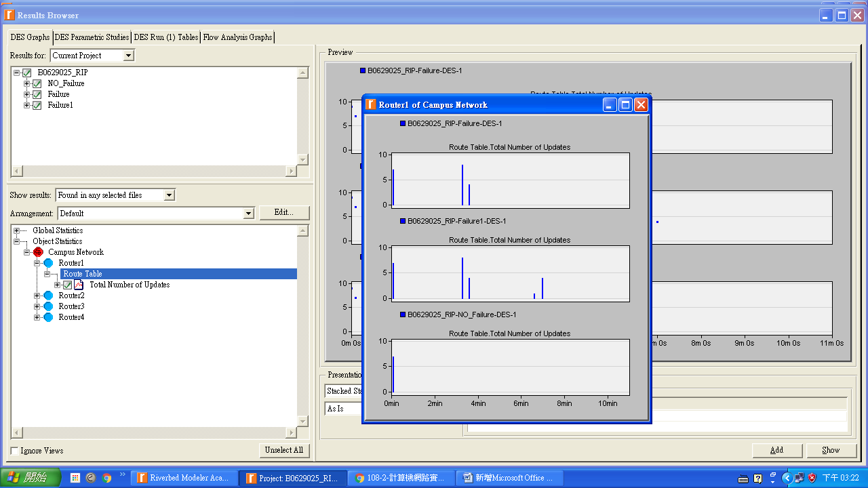

圖中表格由上而下分別為failure、Q3、no failure。圖Q3中200 秒的bar chart 是router1 與 router2 恢復連線， 而在400 秒時 router1 和 router2 之間的連結被修復，因而產生router 使 routing table 更新。

Lab 7 : OSPF

1. Explain why the **Areas** and **Balanced** scenarios result in different routes than those observed in the **NO_Areas** scenarios, for the same pair of routers.

Area

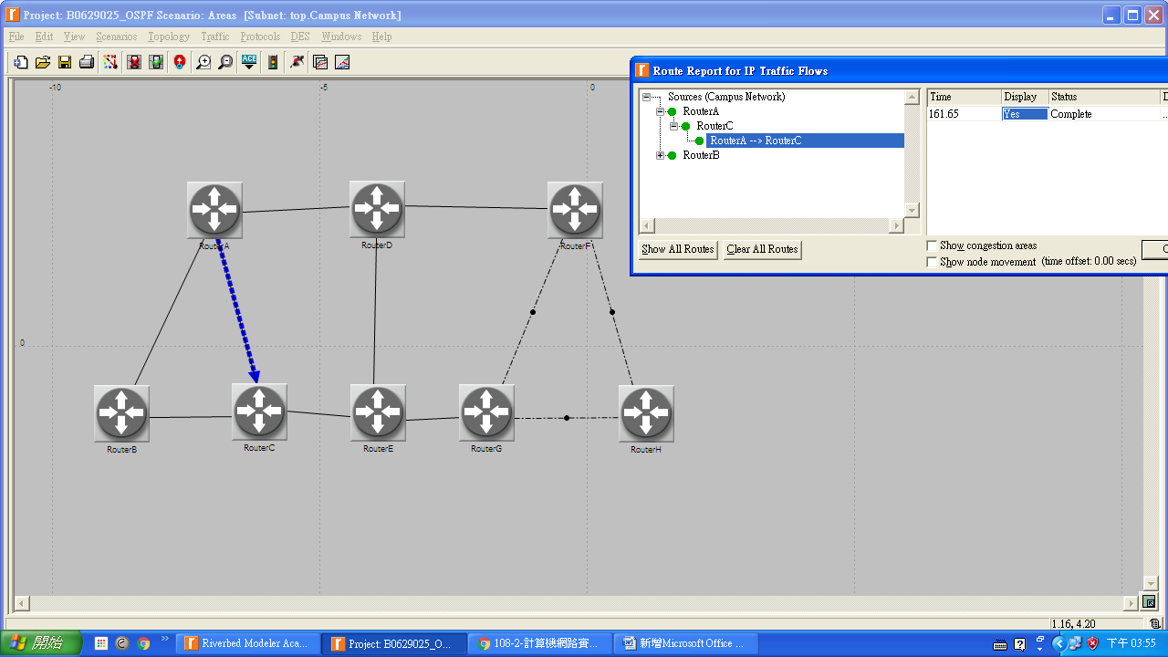

Balanced

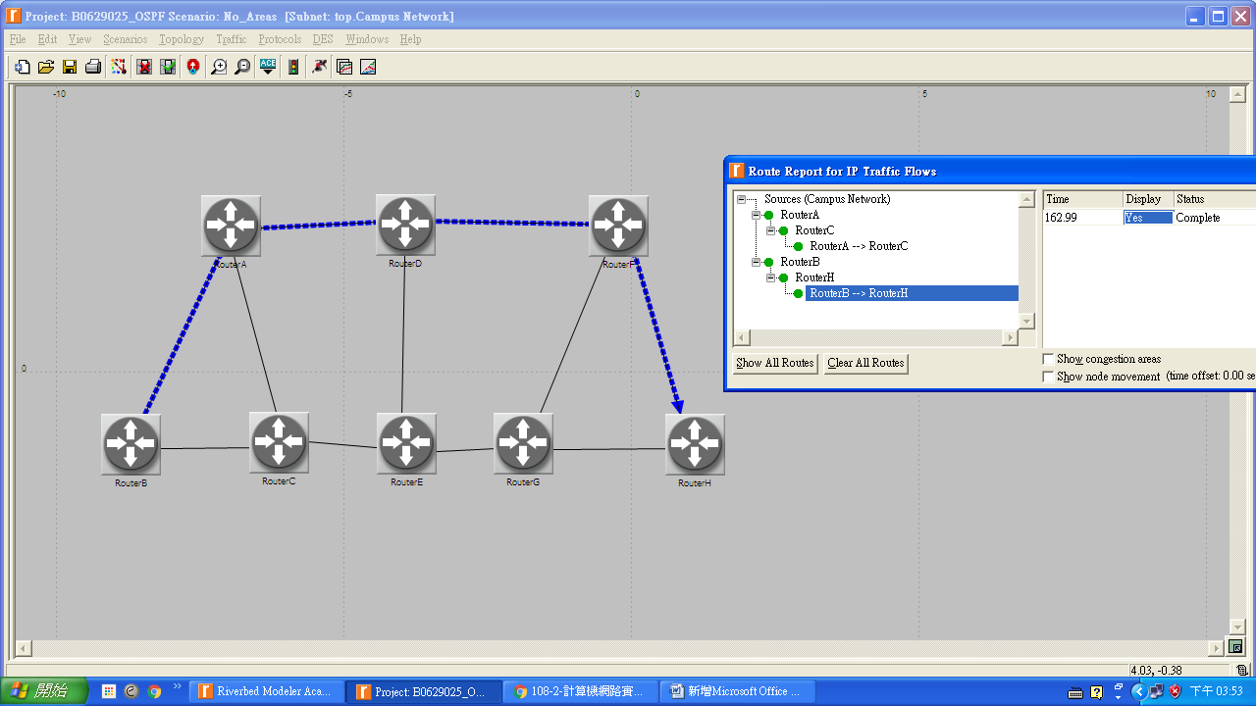

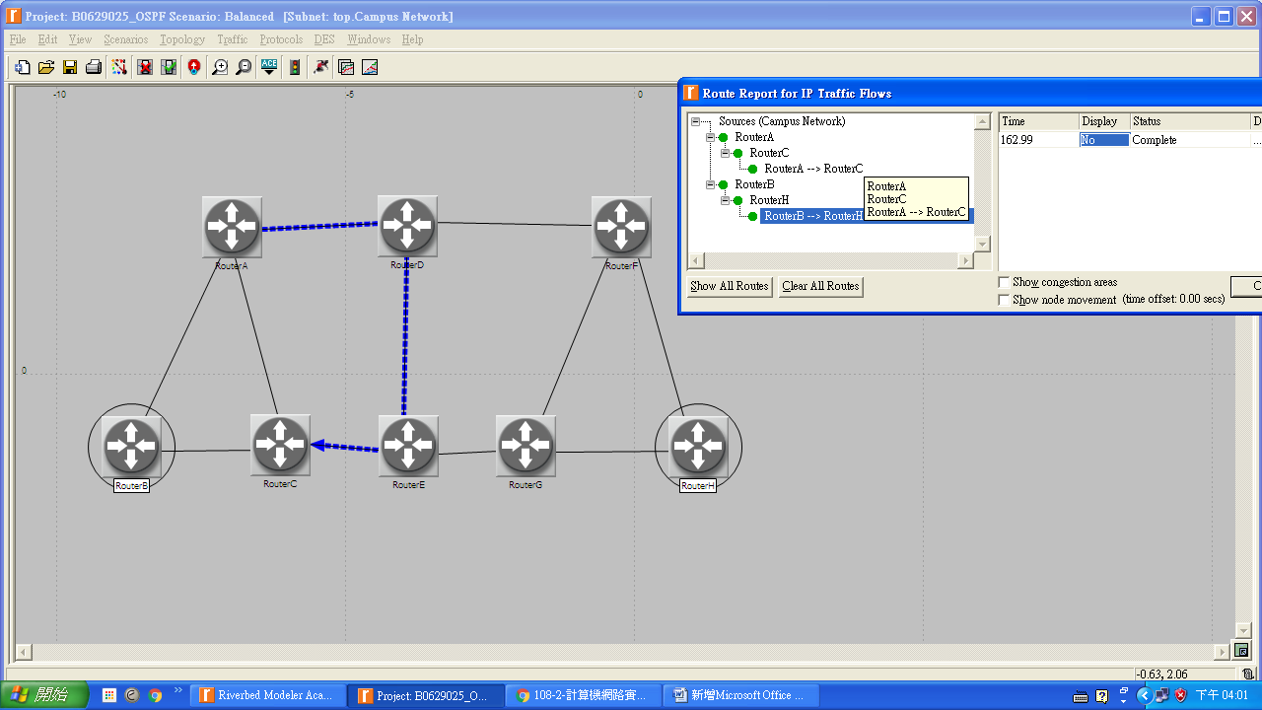

NO_Areas

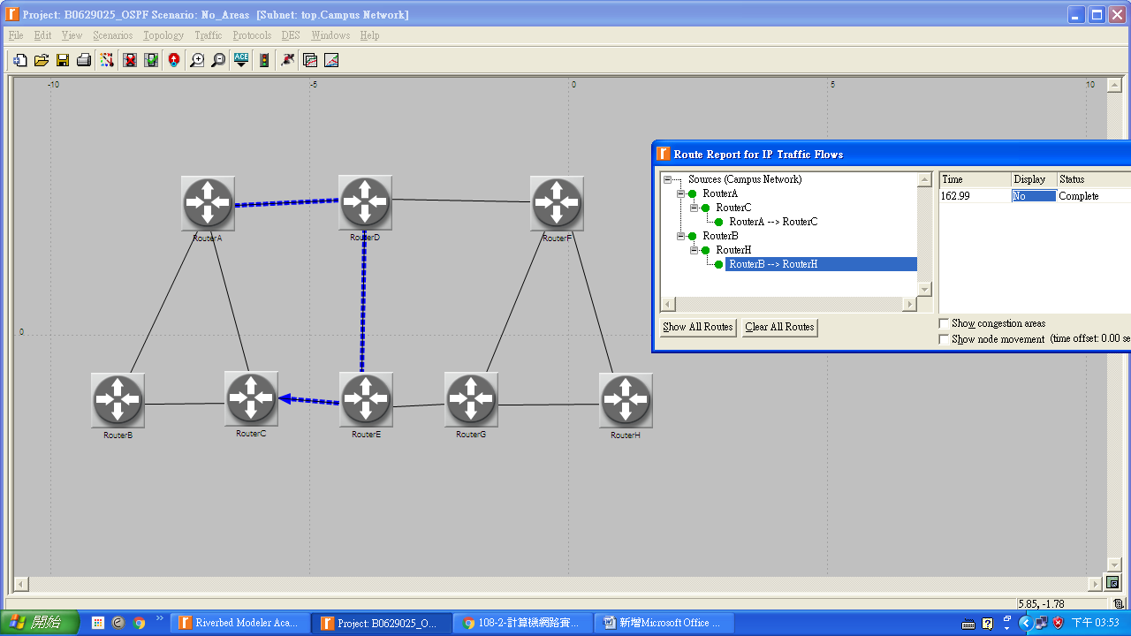



1. Using the simulation log, examine the generated routing table in **RouterA** for each of the three scenarios. Explain the values assigned to the Metric column of each route.

Hint：

- Refer to the *View Results* section in Lab 6 for information about examining the routing tables. You will need to set the global attribute **IP Interface Addressing Mode** to the value **Auto Addressed/Export** and return the simulation.

- To determine the IP address information for all interfaces, you need to open the *Generic Data File* that contains the IP addresses and associated with the scenarios.

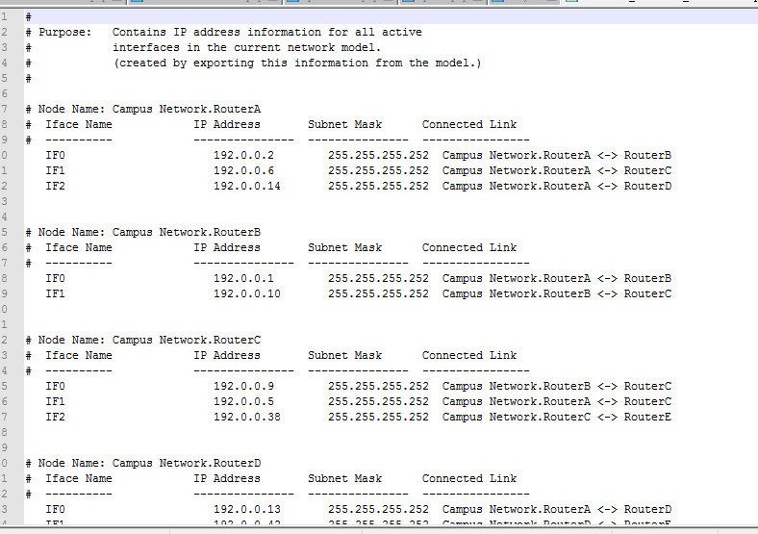

No area 的 routing table

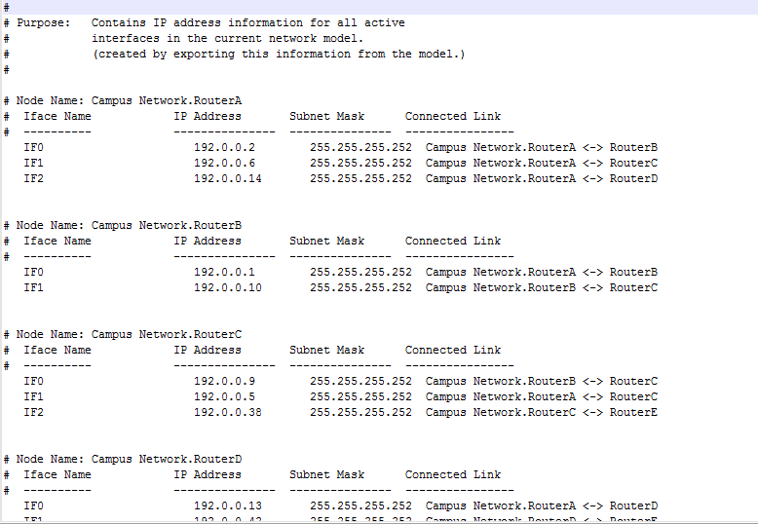

Area 的 routing table



Balanced 的 routing table

1. Modeler allows you to examine the link-state database that is used by each router to build the directed graph of the network. Examine this database for **RouterA** in the **No_Areas** scenario. Show how **RouterA** utilizes this database to create a map for the topology of the network and draw this map (This is the map that will be used later by the router to create its routing table.)

Hint：

- To export the link-state database of a router, Edit the attributes of the router and set the **Link State Database Export** parameter (one of the **OSPF Parameters**, under **Reports**) to **Once at End of Simulation**. You will need to set the global attribute **IP Interface Addressing Mode** to the value **Auto Addressed/Export**. This will allow you to check the automatically assigned IP addresses to the interfaces of the network. (Refer to the notes of question 2 above.)

- After rerunning the simulation, you can check the link-state database by opening the simulation log (from the **Results** menu). The link-state database is available in **View Results** → **DES Run Tables**.

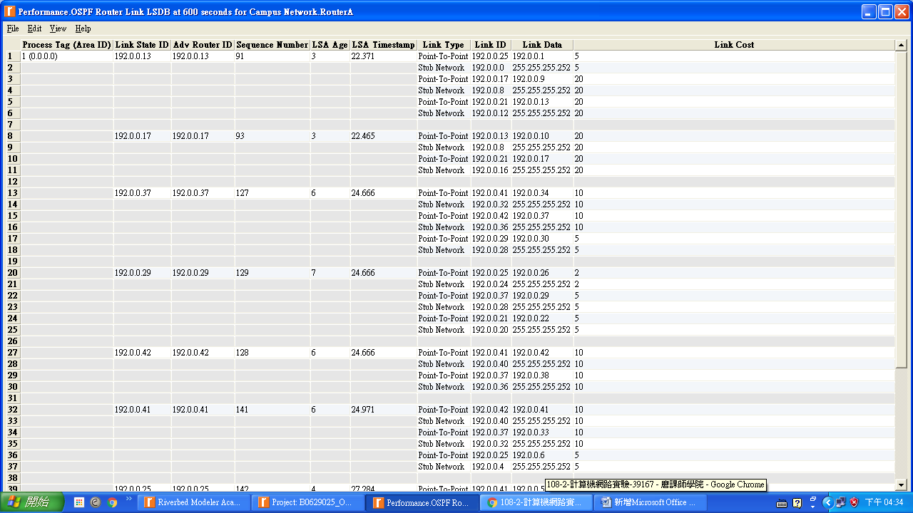

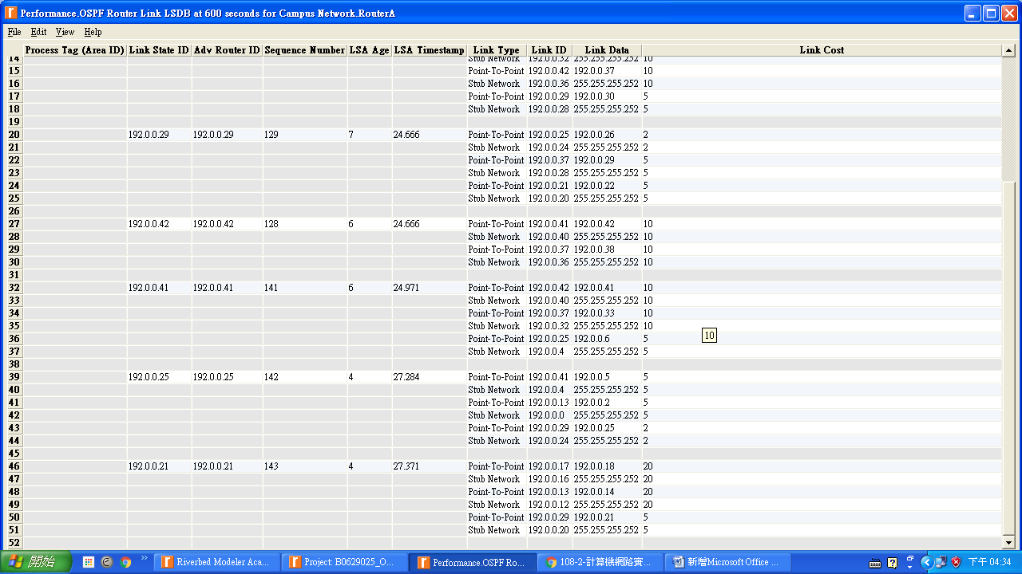

1. Create another scenario as a duplicate of the **No_Areas** scenario. Name the new scenario **Q4_No_Areas_Failure**. In this new scenario simulate a failure of the link connecting **RouterD** and **RouterE**. Have this failure start after 100 seconds. Rerun the simulation. Show how that link failure affects the content of the link-state database and routing table of **RouterA**. (You will need to disable the global attribute **OSPF Sim Efficiency**. This will allow OSPF to update the routing table if there is any change in the network.)





1. For both **No_Areas** and **Q4_No_Areas_Failure** scenarios, collect the **Traffic Sent (bits/sec)** statistic (one of the **Global Statistics** under **OSPF**). Rerun the simulation for those two scenarios and obtain the graph that compares the OSPF’s **Traffic Sent (bits/sec)** in both scenarios. Comment on the obtained graph.

