2015 通訊系統

1. What are the three steps in the pulse code modulation (PCM) encoder if we want to do analog-to-digital conversion?

**ANS**：取樣(Sampling)、量化(Quantizing)、編碼(Encoding)

1. What is the spread spectrum used for? Please illustrate the difference between the DSSS and FHSS and give an example of technology we use today to each one of them.

**ANS**：

(a) 展頻的目的主要是要抗干擾(人為刻意干擾或者自然的電磁波干擾)。

(b) **Frequency Hopping Spread Spectrum(FHSS)**：跳頻展頻，在軍事用途上有使用過跳頻來竊聽。(每隔一段週期換一次頻率，以此來抗干擾，如藍芽)

**Direct Sequence Spread Spectrum(DSSS)：**直接序列展頻，IEEE 802.11協定中有採用直接序列展頻。(把多個通道當成一個bit傳送，即使一個通道有干擾也不會有太多影響，如Wi-Fi)

1. Use two-dimensional parity-check encoding to encode 1011011, 1100111, 0101000, 0111000.

**ANS：**

**1 0 1 1 0 1 1** 1

**1 1 0 0 1 1 1** 1

**0 1 0 1 0 0 0** 0

**0 1 1 1 0 0 0** 1

0 1 0 1 1 0 0 1

1. Find the minimum Hamming distance of the codeword 00000, 01011, 10101, and 11110?

**ANS：**(兩兩做比較，有幾個不同的bit)

(00000⊕01011)=>3, (00000⊕10101)=>3, (00000⊕11110)=>4

(01011⊕10101)=>4, (01011⊕11110)=>3, (10101⊕11110)=>3

所以minimum Hamming distance = 3

1. If we want to design a 100×100 switch (N = 100), we have to use 10,000 crosspoints inside the switch. However, the use of 10,000 crosspoints inside a switch will greatly increase the cost of the switch. One way to decrease the points of crosspoints is to use a three-stage switch design to implement the switch. Please illustrate how you design the three-stage switch if we want to reduse the number of crosspoints under 1200 crosspoints. Hint : $2kN+k{(\frac{N}{n})}^{2}$, where k represents the number of crossbars and n is the number of lines of a crossbar. To fulfill this question you have to draw your design as well as show your calculation process.

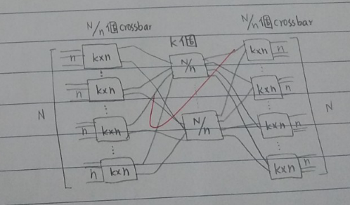**ANS**：

$2kN+k{(\frac{N}{n})}^{2}$ ≦ 1200

N = 100, let n = 10

∴2*k*100 + k ${(\frac{100}{10})}^{2}$* = 300k

→ k ≦ 4

(**注：**要形成一個Three-stage switching array，而input switch的埠數n先預設為N的平方根)

1. Suppose you are using the cyclic redundancy check (CRC) to encode a dataword 10110011. The divisor 1011 is chosen. Please show the division in CRC encoder if you want to encode the dataword. What is your codeword finally? Your calculation process is needed.

**(答案太長在下一頁，參考網站：**<https://dangerlover9403.pixnet.net/blog/post/202592421-%5B%E6%95%99%E5%AD%B8%5D-%E5%BE%AA%E7%92%B0%E5%86%97%E9%A4%98%E7%A2%BC(cyclical-redundancy-check)>**)**

**ANS：**

1 0 0 0 0 0 1 1

1011 1 0 1 1 0 0 1 1 0 0 0

1 0 1 1

---------------------

0 0 0 0

0 0 0 0

---------------------

0 0 0 0

0 0 0 0

---------------------

0 0 0 1

0 0 0 0

---------------------

0 0 1 1

0 0 0 0

-----------------------------------

0 1 1 0

0 0 0 0

-----------------------------------

1 1 0 0

1 0 1 1

----------------------------------------

1 1 1 0

1 0 1 1

--------------------------------------------------------

1 0 1

所以 CRC code=101(餘數)

the CodeWord : 10110011101(被除數+餘數)