2013 通訊系統-考古題

1. Illustrate four kind of digital-to-analog conversion scheme

電腦撥放音樂、電腦輸出影像、數位麥克風、數位電話

1. What is the main purpose of spread spectrum use for? Illustrate two famous spread spectrum technologies and give an example of these two spread spectrum schemes each.

(a)

展頻的目的主要是要抗干擾(人為的刻意干擾或是自然的電磁波干擾)

**(b)**

**Frequency Hopping Spread Spectrum (FHSS)**

**跳頻展頻**

**在軍事用途上有使用過跳頻展頻來逃避竊聽**

**Direct Sequence Spread Spectrum Synchronous (DSSS)**

**直接序列展頻**

**IEEE 802.11協定中有採用直接序列展平**

1. Explain the spectrum utilization of technology asymmetric DSL (ADSL)

(Hint: voice, idle, upstream, data and control, and downstream data and control)

分頻多工 Discrete multitone technique （DMT）

voice：通道0

idle：通道1-5不使用，提供語音和數據之間的間隙

data：信道26-108和138-1104

upstream data and control（4kHz的/通道）

通道6至30個（25個信道）用於上行

一個信道用於控制和24個信道進行數據傳輸

帶寬：24x4000x15=1.44 Mbps的

downstream data and control

渠道31到255（225頻道）

一個信道是用於控制和224信道是用於數據傳輸

帶寬：224x4000x15=13.4 Mbps的

1. If we want to design a 200 x 200 switch (N=200), we have use 40,000 crosspoints inside the switch. However, the use of 40,000 crosspoints inside a switch will greatly increase the cost of the switch. One way to decrease the points of crosspoints is to use a three-stage switch design to implement the crosspoints under 5,000 crosspoint (Hint: 2kN+k()2,where k represent the number of crossbars and n is the number of line of a ccrossbar).

2kN+k()2<5000

N=200, let n=40, k=5

Crosspoints = 2,125

1. Find the minimum Hamming distance of the codeword 00000, 01011, 10101, and 11110?

d(00000, 01011)=3 d(00000, 10101)=3 d(00000, 11110)=4

d(01011, 10101)=4 d(01011, 11110)=3 d(10101, 11110)=3

dmin is this case is 3

1. Show the result if we use two-dimensional parity-check code to encode 1101011, 0011000, 0101100, and 1101101.

1 1 0 1 0 1 1 | 1

0 0 1 1 0 0 0 | 0

0 1 0 1 1 0 0 | 1

1 1 0 1 1 0 1 | 1

~~|~~

0 1 1 0 0 1 0 | 1

1. Use the CRC-4 encoder to the dataword 1101001 with the divisor 1011. Your computational process is needed. Also show the hardware implementation of the CRC encoder.

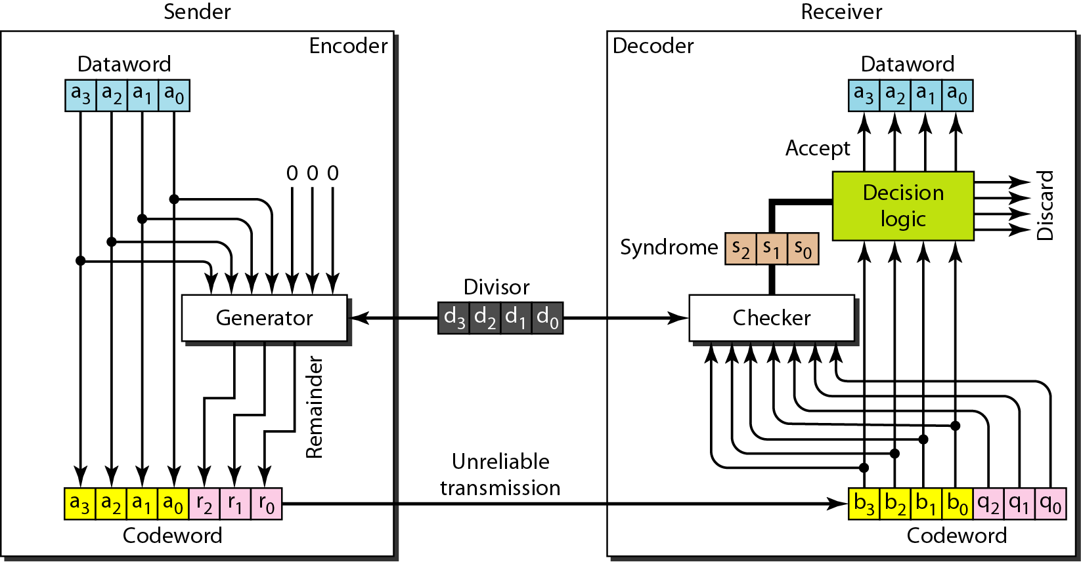

1 1 1 1 0 0 0

1011 | 1 1 0 1 0 0 1 0 0 0

1 0 1 1

---------------------

0 1 1 0 0

1 0 1 1

---------------------

0 1 1 1 0

1 0 1 1

---------------------

0 1 0 1 1

1 0 1 1

---------------------

0 0 0 0 0 0 0