What is Software?

Instructions、Data structures、Documentation

-----------------------------------------------------------------------------------

Framework Activities

Communication、Planning、Modeling、Construction、Deployment

-----------------------------------------------------------------------------------

The Unified Process (UP) Phases

Inception、Elaboration、Construction、Transition

-----------------------------------------------------------------------------------

What is Agility?

有效的應對改變

1. 針對客戶的需求開發軟件
2. 強調建構的行為
3. 提出多個 software increments
4. 適應變化的發生

-----------------------------------------------------------------------------------

Extreme Programming (xp)

XP planning、Design、Coding、Testing



-----------------------------------------------------------------------------------

Pair Programming

**Pair programming** is an agile software development technique in which two programmers work together at one workstation. One, the driver, writes code while the other, the observer, pointer or navigator,[1] reviews each line of code as it is typed in. The two programmers switch roles frequently.

**結對程式設計**（英語：Pair programming）是一種敏捷軟體開發的方法，兩個程式設計師在一個電腦上共同工作。一個人輸入代碼，而另一個人審查他輸入的每一行代碼。輸入代碼的人稱作駕駛員，審查代碼的人稱作觀察員（或導航員）[1]。兩個程式設計師經常互換角色。

-----------------------------------------------------------------------------------

Requirements Engineering Steps

Inception、Elicitation、Elaboration、Negotiation、Specification、Validation、Requirements managerment

-----------------------------------------------------------------------------------

UML Diagram

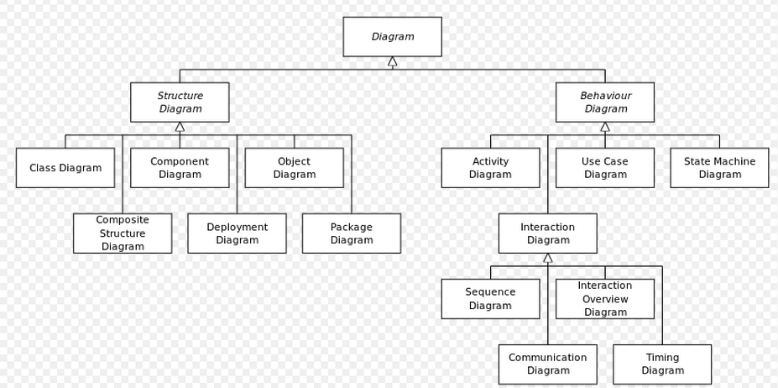

Class、Object、Use case、Sequence、Collaboration Statechart、Activity、Component、Deployment

-----------------------------------------------------------------------------------

What is Object-oriented?

物件指的是[類別](http://zh.wikipedia.org/wiki/%E7%B1%BB_(%E8%AE%A1%E7%AE%97%E6%9C%BA%E7%A7%91%E5%AD%A6))的例項。它將[物件](http://zh.wikipedia.org/wiki/%E7%89%A9%E4%BB%B6_(%E9%9B%BB%E8%85%A6%E7%A7%91%E5%AD%B8))作為[程式](http://zh.wikipedia.org/wiki/%E7%A8%8B%E5%BA%8F)的基本單元，將程式和[資料](http://zh.wikipedia.org/wiki/%E6%95%B0%E6%8D%AE)[封裝](http://zh.wikipedia.org/wiki/%E5%B0%81%E8%A3%9D_(%E7%89%A9%E4%BB%B6%E5%B0%8E%E5%90%91%E7%A8%8B%E5%BC%8F%E8%A8%AD%E8%A8%88))其中，以提高軟體的重用性、靈活性和擴充功能性。

-----------------------------------------------------------------------------------

Four kinds of UML things:

Structural、Behavior、Grouping 、Annotational things

-----------------------------------------------------------------------------------

process flow

