Day14

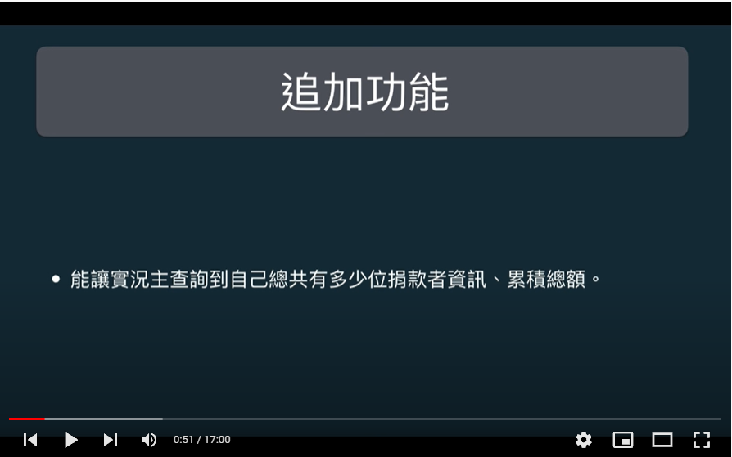

pragma solidity ^0.4.25;

contract Donation {

struct DonorInfo {

address[] donors;

mapping (address => uint) ledger;

}

mapping (address => DonorInfo) DonationHistory;

event LogDonate(

address streamer, address donor, string nickname,

uint value, string message);

// 在捐獻的功能裡把觀眾的暱稱＆訊息＆錢送到 log 上面，永留青史。

function donate(address _streamer, string _nickname, string _message)

public payable {

require(msg.value > 0);

_streamer.transfer(msg.value);

if (DonationHistory[_streamer].ledger[msg.sender] == 0) {

DonationHistory[_streamer].donors.push(msg.sender);

}

DonationHistory[_streamer].ledger[msg.sender] += msg.value;

emit LogDonate(

_streamer,

msg.sender,

_nickname,

msg.value,

_message);

}

function getDonorList() public view returns (address[]) {

return DonationHistory[msg.sender].donors;

}

event LogListDonorInfo(address streamer, address user, uint value);

function listDonorInfo() public {

for (uint i = 0; i < DonationHistory[msg.sender].donors.length; i++) {

address user = DonationHistory[msg.sender].donors[i];

emit LogListDonorInfo(msg.sender, user, DonationHistory[msg.sender].ledger[user]);

}

}

}