Contents
STM 2
What I want 2
Families: 2
144 pins my comparison: 3
Board Comparisons 5
comparing F series: 5
Comparing H series: 5
1-24: 6
Others: 6
30 144 pin NUCLEO boards comparison: 6
Other boards: 6
STM32 Reddit: 6
Final Choice: 8
Purchase Boards: 8

STM

What I want
At least 3 LED
I want 144 pins
Supports DSP and FPU

Families:
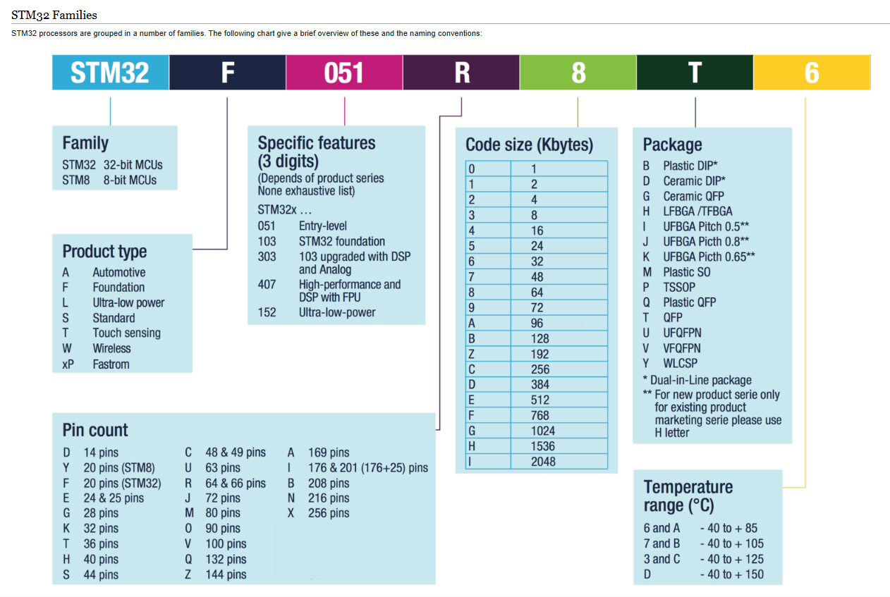
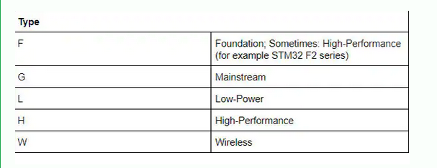
https://www.digikey.com/en/maker/blogs/2020/understanding-stm32-naming-conventions

144 pins my comparison:
ID | Product | price | about
1 | NUCLEO-F207ZG | £18.96 | LED: 3  Ethernet: Y  Debug connectors: SWD Driver
2 | NUCLEO-F303ZE | £15.76 | LED: 3  Ethernet: N  Debug connectors: SWD Driver
3 | NUCLEO-F412ZG | £15.76 | LED: 3  Ethernet: N  Debug connectors: SWD Driver
4 | NUCLEO-F413ZH | £15.76 | LED: 3  Ethernet: N  Debug connectors: SWD Driver
5 | NUCLEO-F439ZI | £18.99 | LED: 3  Ethernet: Y  Debug connectors: SWD Driver
6 | NUCLEO-F446ZE | £15.76 | LED: 3  Ethernet: N  Debug connectors: SWD Driver
7 | NUCLEO-F722ZE | £15.76 | LED: 3  Ethernet: N  Debug connectors: SWD Driver
8 | NUCLEO-F756ZG | £18.99 | LED: 3  Ethernet: Y  Debug connectors: SWD Driver
9 | NUCLEO-F767ZI | £18.99 | LED: 3  Ethernet: Y  Debug connectors: SWD Driver
10 | NUCLEO-H563ZI | £23.58 | LED: 3  Ethernet: Y  Debug connectors: SWD MIPI10 Receiver
11 | NUCLEO-H723ZG | £23.78 | LED: 3  Ethernet: Y  Debug connectors: SWD MIPI10 Receiver
12 | NUCLEO-H753ZI | £22.19 | LED: 3  Ethernet: Y  Debug connectors: SWD MIPI10 Receiver
13 | NUCLEO-H755ZI-Q | £23.78 | LED: 3  Ethernet: Y  Debug connectors: SWD MIPI10 Receiver
14 | NUCLEO-H7A3ZI-Q | £23.78 | LED: 3  Ethernet: N  Debug connectors: SWD MIPI10 Receiver
15 | NUCLEO-H7S3L8 | £28.70 | LED:3  Ethernet: Y  Debug connectors: SWD MIPI20 Receiver
16 | NUCLEO-L496ZG | £15.76 | LED:3  Ethernet: N  Debug connectors: SWD Driver
17 | NUCLEO-L496ZG-P | £16.57 | LED:3  Ethernet: N  Debug connectors: SWD Driver
18 | NUCLEO-L4A6ZG | £15.76 | LED:0  Ethernet: N  Debug connectors: SWD Driver
19 | NUCLEO-L4P5ZG | £15.94 | LED:3  Ethernet: N  Debug connectors: SWD Driver
20 | NUCLEO-L4R5ZI | £15.76 | LED:3  Ethernet: N  Debug connectors: SWD Driver
21 | NUCLEO-L4R5ZI-P | £16.58 | LED:0  Ethernet: N  Debug connectors: SWD Driver
22 | NUCLEO-L552ZE-Q | £16.58 | LED:3  Ethernet: N  Debug connectors: SWD MIPI20 Receiver
23 | NUCLEO-N657X0-Q | £46.32 | LED:3  Ethernet: Y  Debug connectors: SWD MIPI20 Receiver
24 | NUCLEO-U5A5ZJ-Q | £27.06 | LED: 2  Ethernet: N  Debug connectors: SWD MIPI20 Receiver
25 | NUCLEO-WB05KZ | £16.35 | LED: 3  Ethernet:  Debug Connectors: STLINK-V3EC  Bluetooth: Y

Board Comparisons

comparing F series:
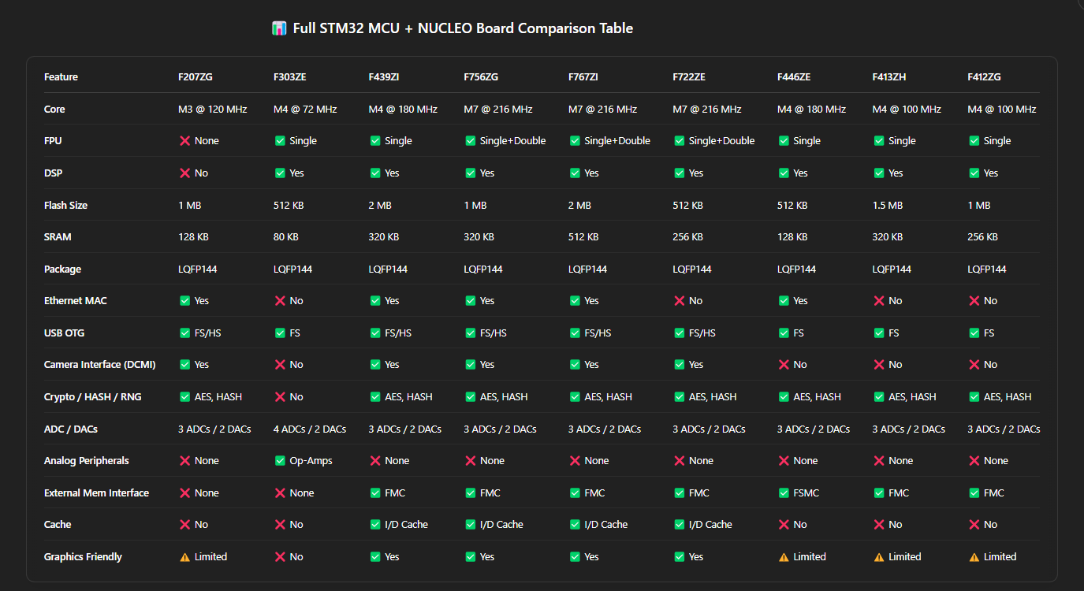

Comparing H series:
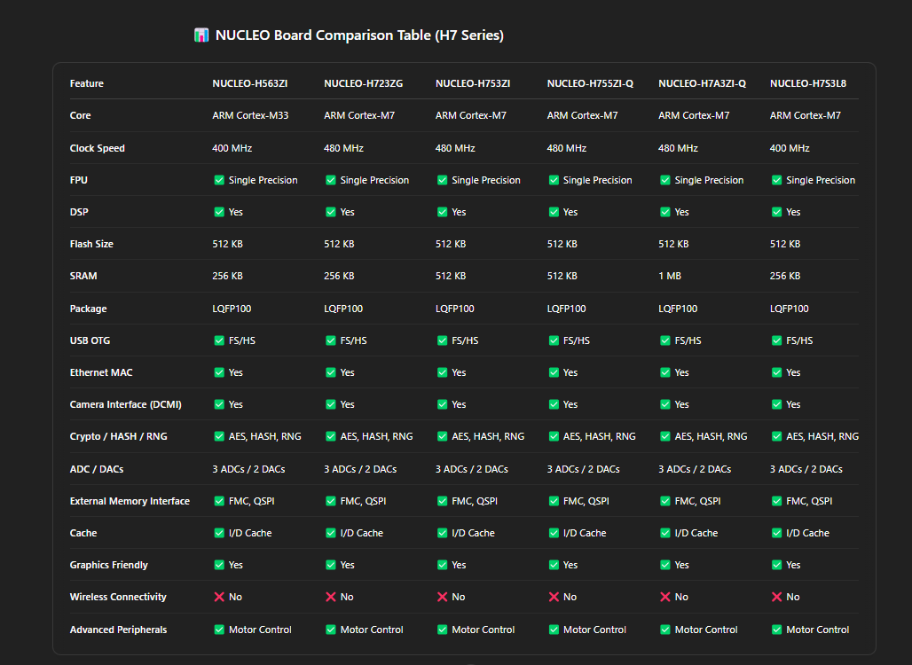

1-24:
https://www.st.com/en/evaluation-tools/stm32-nucleo-boards/products.html?querycriteria=productId=LN1847$$1574=Nucleo-144&aggOrder=0%7C1%7C2%7C3%7C4%7C5%7C6%7C7%7C8%7C9%7C10%7C11%7C12%7C13%7C14%7C15%7C16%7C17%7C18%7C19%7C20%7C21

Others:
https://www.mouser.co.uk/Compare/

30 144 pin NUCLEO boards comparison:
https://www.st.com/resource/en/data_brief/nucleo-l496zg-p.pdf

Other boards:
https://www.st.com/resource/en/data_brief/nucleo-l496zg-p.pdf

STM32 Reddit:
https://www.reddit.com/r/stm32/comments/16143rm/which_nucleo_board_should_i_buy_to_start_learning/

https://www.reddit.com/r/embedded/comments/1g5t2wd/stm32_which_is_better/

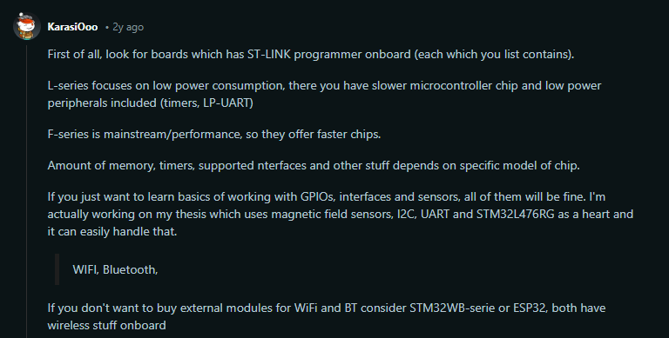
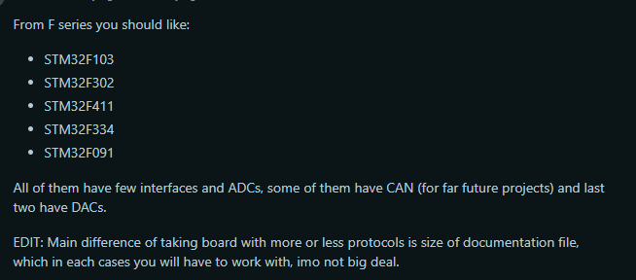
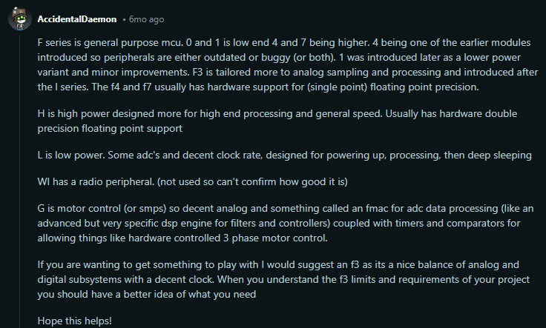

Final Choice:
NUCLEO-H7A3ZI-Q
NUCLEO-F767Z

Purchase Boards:
https://www.mouser.co.uk/c/?q=nucleo

