

PANABO CITY SENIOR HIGH SCHOOL

Brgy. New Visayas, Panabo City, Davao Del Norte

Snack Attack



"Keep your friends close and your snacks closer"

In Partial fulfillment of the Requirements In Entrepreneurship

Submitted by:

Sario, Kent Joshua L.

Lomalio, Raven A.

Albofera, Janice C.

Bagoyo, Michelle Anne O.

Landuay, Sweet Angel A.

Submitted to:

Janet Molo Mula Garcia, LPT

June 2022



ADDRESS: PANABO CITY SENIOR HIGH SCHOOL

Contact #: 09635722657 (TNT)

FB Page: Snack Attack

**Table of Contents**

Page

**I. Executive Summary** **1**

**II. Opportunity** **2**

**2.1 Market Opportunities and Advantage** **2**

**2.2 Solution** **2**

**2.3 Target Market** **2**

**2.4 Competition** **3**

**2.5 Competitive Advantages** **3**

**III. Execution** **4**

**3.1 Vision** **4**

**Mission** **4**

**Goals** **4**

**Objectives** **4**

**3.2 Marketing Plans** **5**

**Marketing Plan A** **5**

**Products** **5**

**Features and Benefits** **6**

**Place** **6**

**Marketing Plan B** **7**

**Price** **7**

**Promotion** **7**

**3.3 Operations Process Flow** **7**

**Location & Facilities** **8**

**Location Map** **8**

**Personnel** **9**

**Suppliers** **9**

**Equipment & Tools** **9**

**IV. Company** **13**

**4.1 Overview** **13**

**4.2 Organizational Structure** **13**

**Management Team** **15**

**4.3 Advisors** **15**

**V. Financial Plan** **16**

**5.1 Capitalization** **16**

**5.2 Daily Expenses** **16**

**5.3 Projected Cost and Revenue** **17**

**5.4. Income Statement** **18**

**5.5 Statement of Changes in Owner’s Equity** **19**

**5.6 Balance Sheet** **20**

# **I. Executive Summary**

Snack Attack is optimistic in serving the needs of the market in providing convenience and satisfaction of our products that are carefully planned to offer with the initiative of the business owners. The business that is proposed will have to acquire a total capital worth of Php122 to operate smoothly as a jumpstart. Our business name will render the finest refreshments that perfectly suit the changes of moods of the people in Brgy. Cebulano, Carmen, Davao del Norte. These people nowadays need to drink refreshments such as mango tapioca. This means that there is a high demand for this kind of product not just because it is trending but because of its palatable taste. Our leading strategy is to satisfy the needs of our customers. Snack Attack is managed by 5 students of Grade 11 Athenian. We are well aware of the existence of other competitors that serve the same type of snack that we have, but there’s assurance that our wholeheartedly made products will stand out, not just because of its delicious flavor but also the satisfaction of customers because of its way of serving. The said company will be located at Brgy. Cebulano, Carmen, Davao del Norte where this particular area will be a great place to accommodate customers and a perfect place for a company to build its booth for this place is accessible for the potential buyer or customers.

# 

# **II. Opportunity**

# **2.1 Market Opportunities and Advantage**

Everyone in Brgy. Cebuano, Carmen, Davao del Norte, requires reasonable food, and the population of Barangay Cebulano is about. Due to the huge population of Barangay Cebulano, Carmen, Davao del Norte, the demand for food is increasing. And because we witnessed these developments, our team decided to start a business that sells wonderful food and beverages at a reasonable price that will satisfy our customers.

# **2.2 Solution**

We sell our product because we all know that faster, easier and efficient ways of consuming food are essential. Snack food producers are positioned to help meet the nutritional needs of busy consumers. This leads to an opportunity for food manufactures to connect with consumers with a wide array of product types and marketing approaches.

# **2.3 Target Market**

Middle-Aged Adults: Due to the strong demand for food, this age group is likely to be interested in our products.

Teenagers: Our product line appeals to this demographic because of the low cost and high quality of each product they eat.

Kids: Our products have the potential to reach these people due to their ability to eat little portions and their attractiveness.

|  |  |
| --- | --- |
| Target Market | Population |
| Middle-Aged Adults | 3,000 |
| Teenagers | 2,000 |
| Kids | 1,500 |
| **TOTAL** | **6,500** |

# **2.4 Competition**

Having this kind of business, our competitors sell the same with us such as food business. We assure you that we offer and provide an affordable product and give refreshment to our customers.

|  |  |
| --- | --- |
| Competitors | Address |
| PinayPie | Villa Rosa, New Visayas, Panabo City |
| Sister's Restaurant | Prk.3 Brgy. Quezon Panabo City Davao del Norte |
| The Five Fillas | Kinamayan Sto. Tomas Davao del Norte |

# **2.5 Competitive Advantages**

The advantages of our products over other products are the brand name and its cleanliness, because we can give them access to food and they can get that at an affordable price. We offer the customer’s needs and wants. We’re creating new recipes that can pass to their taste buds, to make our customers and consumers satisfied.

# **III. Execution**

# **3.1 Vision**

Our vision is to be a global food service brand known for expectedly, good food, convenience and simplicity with a presence that adds value to communities we serve.

# **Mission**

We will serve comfort food that is consistently excellent in quality appealing to generations of families across culture.

We will pleasantly surprise our customers with our speed and personalized service.

# **Goals**

* Our goal is to grow our business.
* Getting a high income in order to get our desired income
* Be the most successful business

# **Objectives**

* To give the pancake more excitement and taste and varieties.
* To give satisfaction to the future patrons by giving the best and low-price pancake delicacies.
* To educate that pancake are not only for breakfast but also for snacks and other gatherings
* To promote the value of pancakes as a treat for any type of occasion.

# **3.2 Marketing Plans**

# **Marketing Plan A**

Many people have little access to delicious foods so we created our product the pancakes and nestea juice to satisfy their needs and also our products serve in small servings so that many people would love it. Now we are planning to make it where we sell it with a good quality and also at an affordable price all over the Brgy. Cebulano, Carmen, Davao del Norte.

# **Products**

|  |  |
| --- | --- |
| Product | Ingredients |
| Pancakes | * Eggs * Food coloring * Powdered milk * Yeast * Margarine * White sugar * Baking powder * Flour * Cooking oil * Brown sugar |
| Nestea Juice | * Water * Nestea * Ice |

Snack Attack depends on one factor to get feedback; our customer's feedback is to improve, add, and change our products depending on their changing needs and desires.

# **Features and Benefits**

Pancakes - It can make our customers satisfied or full stomach and taste delicious at a very affordable price.

Nestea Juice - To make their pancakes much better, our customers can drink Nestea juice to make our customers satisfied and refreshed for a long day of any work.

# **Place**

Our place is located in Brgy. Cebulano, Carmen, Davao del Norte . This is a good location where the people can have access to delicious and affordable products and have an engagement for potential consumers.

# **Marketing Plan B**

# **Price**

Our price is strategically and mathematically precise to make our products affordable and can be profitable without compromising the taste, the amount of ingredients needed, and the quality of our products.

# **Promotion**

The Snack Attack Company will be using these following strategies to gain and earn profit:

House to house selling - this strategy is used to make our products sell faster and to persuade customers to purchase our products.

Social media - We will use the Internet to promote our business like Facebook, Instagram etc.

# **3.3 Operations Process Flow**

**Pancakes Procedure**

|  |  |  |  |
| --- | --- | --- | --- |
| Step 1  Prepare all of the ingredients. | Step 2  Add flour, egg and milk to a bowl. | Step 3  Whisk the ingredients together then,  pour some of the mixture into the pan. | Step 4  Cook until browned then flip,once the other side is brown leave to cool. |

**Nestea Juice Procedure**

|  |  |  |  |
| --- | --- | --- | --- |
| Step 1  Prepare all of the ingredients | Step 2  Mix 1 tablespoon (13)kg Nestea powder in a glass | Step 3  Stir well. Add 4 Ice-cubes. | Step 4  1 glass of Nestea iced tea is ready. |

# **Location & Facilities**

The Snack Attack is located at Brgy. Cebulano, Carmen, Davao del Norte . We ensure that the exact location is very clean, safe, accessible and convenient for all customers to easily transact and serve them well. The day to day operation of our pancake and nestea juice business include a focus on providing the customer services as well as a delicious snack of all. We know that the people today love to eat a snack so we prepared an affordable, delicious and satisfying snack.

# **Location Map**

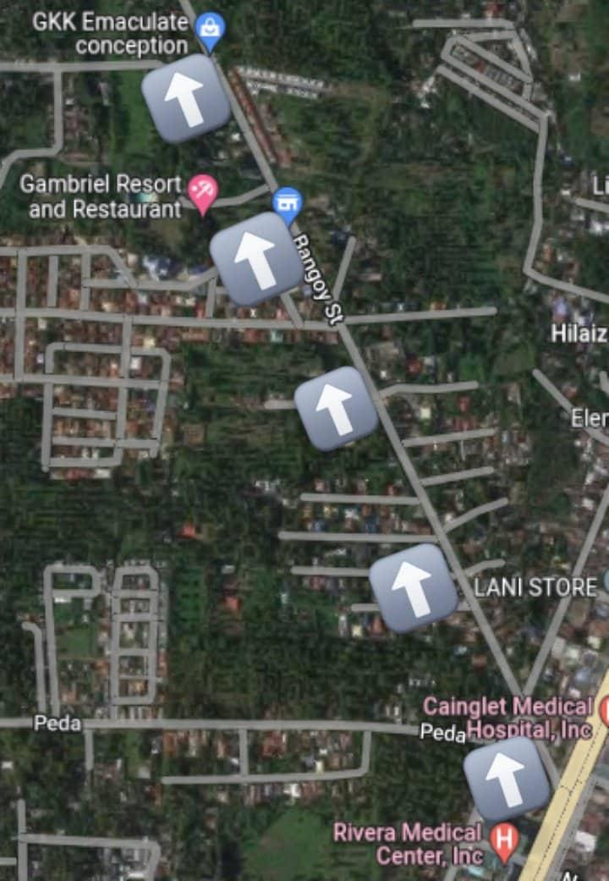 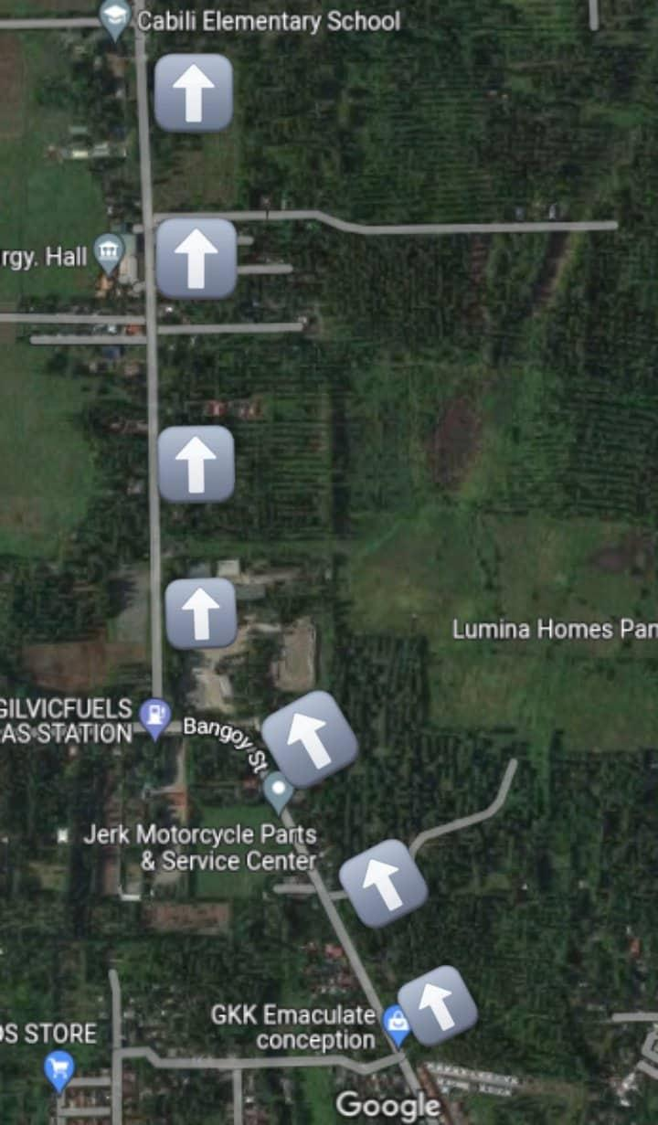

Figure 1. Figure 2.

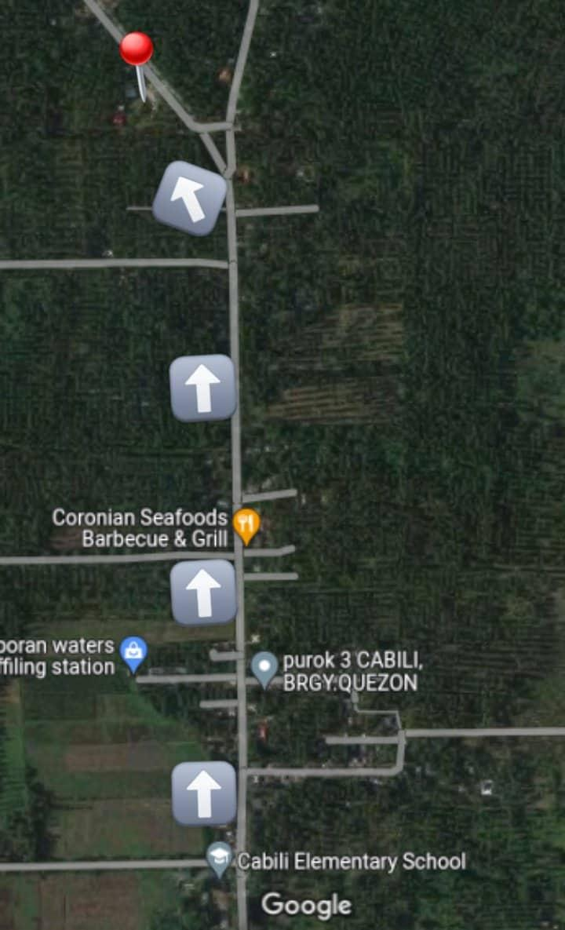

Figure 3.

# **Personnel**

The owner of the business is a group of GAS Grade 11 ATHENIAN students of Panabo City Senior High School. This business operated by the personnel follows: Manager, Assist. Manager, Bookkeeper, Secretary, Head Sales Staff, Sales Staff, Head Kitchen Staff and Kitchen Staff.

# **Suppliers**

|  |  |
| --- | --- |
| Suppliers | Address |
| Sari- Sari Store | Brgy.Salvacion, Panabo City |
| Lasya Store | Brgy. Gredu, Panabo City |
| Panabo Public Market | Aguinaldo St. Panabo City |

# **Equipment & Tools**

|  |  |
| --- | --- |
| Nonstick Skillet | Consider a good nonstick skillet one of the best kitchen tools you can invest in, and not just for flipping flapjacks. Eggs, frozen gnocchi, and scallops are just a few of the foods that benefit from a nonstick surface. |
| Griddle | Our expert product tester named Presto's 19-inch Tilt-n-Fold electric griddle the best on the market. It browns pancakes more evenly than its competition — a major selling point here. But you can take advantage of it to cook meats, too, tilting its surface to drain excess grease. |
| Spatula | OXO's Silicone Flexible Spatula won't damage your skillet's nonstick surface as its pliable head effortlessly flips food. Not to mention, this dishwasher-safe spatula withstands temperatures up to 600 degrees F. |
| Whisk | This OXO whisk's stainless steel wires can stand up to even the thickest pancake batter. And when you're whipping up a big batch of 'cakes, you'll really appreciate its comfy teardrop-shaped handle. If you'd rather a whisk that's safe to use on nonstick surfaces, grab the red silicone version. |
| Mixing Bowl | These pancake-approved mixing bowls feature hardwearing stainless steel interiors and nonslip bases. |
| Cookie Scoop | A cookie scoop is the secret to ending up with a uniform stack of pancakes every time. OXO's large Good Grips Cookie Scoop holds three tablespoons of batter. While you could go with a pancake dispenser, this gadget is all you really need to transport batter from the mixing bowl to the skillet. |
| Pancake Pen | If you fancy yourself a batter artist, this open-tip pancake pen will be the brush to your brunch masterpiece. You can mix the pancake batter right in the bottle (or pour in if you prefer to whisk in a bowl), and then draw shapes with the tip. |
| Dry Measuring Cups and Spoons | Cuisipro designed these measuring cups and spoons with oval heads and long handles to make scooping dry ingredients easier, whether that's flour from a bulk-size bag or cinnamon from a narrow jar. |
| Liquid Measuring Cup | Pyrex glass measuring cups are a kitchen staple, and, according to our expert product tester, the best for measuring liquids. |
| Cast Iron Skillet | Cooking pancakes in the cast iron skillet or making a Dutch baby takes even less effort than on the stovetop or griddle. Consider Lodge's eight-inch chef-style cast iron skillet the right pan for the job. |

# 

# **IV. Company**

# **4.1 Overview**

Food industry has been expanding continuously these days due to ever increasing demands of convenience, food trends and social activities. It may

be in a small form of stall and prefer food that is ready to eat.

Snack Attack is a corporation wholly owned and operated by Kent Joshua Sario, Raven Amandog Lomalio, Michelle Anne Bagoyo, Janice Alboafera, and Sweet Angel A. Landuay . These students will aim and do their jobs as company owners to earn profit and at the same time we will value our customers by giving them satisfaction on how delicious and beneficial our product is.

# **4.2 Organizational Structure**



**Manager**

Kent Joshua L. Sario



** **

**Secretary**

Sweet Angel A. Landuay

**Assistant Manager**

Sweet Angel A. Landuay

 

**   **

**Head Sales Staff**

Michelle Anne O. Bagoyo

**Bookkeeper**

Raven A. Lumalio

**Kitchen Staff**

Janice C. Albofera

**Head Kitchen Staff**

Michelle Anne O. Bagoyo





**Sales Staff**

Janice C. Albofera

# **Management Team**

|  |  |
| --- | --- |
| Manager | Responsible for leading and managing the operation of the business and the staff, overseeing the food quality, developing menu, marketing strategies and as well as greeting and serving the guest. |
| Assistant Manager | Plays the role of the manager in its absence. |
| Secretary | Assists the manager to handling the papers |
| Bookkeeper | In charge of finance receipts and other related stuff. |
| Head Sales Staffs | Responsible for managing all sales for business, drafting sales reports and estimating sales profit for products. |
| Sales Staffs | In charge of sales related. And Responsible for promoting the products as well as entertaining the Customers. |
| Head Kitchen Staff | Plan menus and ensure uniform serving sizes and quality of food |
| Kitchen Staff | To assist all the tasks with the other kitchen related workers. |

# **4.3 Advisors**

Developing products and having a strategy to maintain in position in order to cope up with the trend and the advancement of technology is needed for this business. Packaging technique, labeling, product innovation, etiquettes and marketing strategies and other forms of strategies are needed in order to compete with other competitors and to attract more customers to the product. This certification and advisory will be sought from our subject teacher, Janet Molo Mula Garcia through his entrepreneurial knowledge and skills can lead us to have a successful business.

# **V. Financial Plan**

# **5.1 Capitalization**

Snack Attack business initial capital is Php122.00. There will be five(5) members, each member shall contribute around Php25.00.

# **5.2 Daily Expenses**

|  |  |  |  |
| --- | --- | --- | --- |
| **Variable Cost** | **Quantity** | **Unit Cost** | **Total Cost** |
| Pancake | | | |
| Eggs | 2 pcs. | ₱8.00 | 16.00 |
| Food coloring | 2 tbsp | ₱1.00 | 2.00 |
| Powdered milk | 1 sachet | ₱10.00 | 10.00 |
| Yeast | 1 tbsp | ₱1.00 | 1.00 |
| Margarine | 1 sachet | ₱15.00 | 15.00 |
| White sugar | ¼ pack | ₱15.00 | 15.00 |
| Baking powder | 1 tbsp | ₱1.00 | 1.00 |
| Flour | 2 pack | ₱5.00 | 10.00 |
| Cooking oil | 1 sachet | ₱10.00 | 10.00 |
| Brown Sugar | ¼ kilo | ₱15.00 | 15.00 |
| **Total** |  |  | **95.00** |
| Nestea Juice | | | |
| Water | ½ cup | 5.00 | 5.00 |
| Nestea | 1 sachet | 20.00 | 20.00 |
| Ice | 1 | 2.00 | 2.00 |
| **Total** |  |  | **27.00** |
| **Total Cost** |  |  | **122.00** |

# **5.3 Projected Cost and Revenue**

| Type of Product | Costing | Projected  Daily Volume | Daily Revenue | Projected Monthly Volume | Monthly Revenue | Yearly Revenue |
| --- | --- | --- | --- | --- | --- | --- |
| Pancake | C = ₱3.52  M = ₱0.48  S.P. = ₱4.00 | 27 | C = ₱95.00  S.P. = ₱108.00 | 837 | C = ₱2,445.00  S.P. =  ₱3348.00 | C = ₱29,340.00  S.P. = ₱40,176.00 |
| Nestea Juice | C = ₱2.70  M = ₱0.30  S.P.= ₱3.00 | 10 | C = ₱27.00  S.P. = ₱30.00 | 310 | C = ₱837.00  S.P. = ₱930.00 | C = ₱10,044.00  S.P. = ₱11,160.00 |
|  | **TOTAL** |  | C = ₱122.00  S.P. = ₱138.00 |  | C = ₱3,282.00  S.P. = ₱4,278.00 | C = ₱39,384  S.P. = ₱51,336.00 |

**Legend : Cost-C Mark-up- M Selling Product- S.**

# 

# **5.4. Income Statement**



Snack Attack Income Statement for the Week Ended,

**June 11, 2022**

|  |  |
| --- | --- |
| **Sales** | 966.00 |
| **Cost** | 854.00 |
| **Gross Profit** | 112.00 |
| Less: Operational Expenses |  |
| **Net Income** | **112.00** |

# **5.5 Statement of Changes in Owner’s Equity**



Snack Attack Changes in Owner’s Equity,

**June 11,2022**

|  |  |
| --- | --- |
| **Beginning Capital** | **122** |
| Add: Net Income | 112 |
| **Total** | **234** |
| Less: Withdrawal | _ |
| **Capital End** | **234** |
| **Return of Investment** | **91.80%** |

# **5.6 Balance Sheet**



Snack Attack Balance Sheet as of **June 11, 2022**.

|  |  |
| --- | --- |
| **Assets** |  |
| Cash | 234 |
| **Total Assets** | **234** |
| **Liabilities** | _ |
| Owner’s Equity | 234 |
| **Total Liabilities & OE** | **234** |

**REFLECTION**

**Lomalio, Raven A.**

I'm Raven A. Lomalio the book keeper of Snack Attack. Our/my experiences are not easy, because making a business plan is hard, but thanks to making groupmates we make it and i learn that to make things easier we must work as a team not as an individual. And thank you Ma'am for teaching us how to make a business plan. We appreciate you. I hope you're always in good health. Thank you.

In this activity, our target is sell an affordable food to our consumers. Our experiences as a Entrepreneurs is not easy because we face sometimes a problem like misunderstanding etc.

We start in buying our ingredients to make our product. Buying the ingredients is quite easy because there are so many sari sari stores out there around the City. After we buy all of the ingredients, we prepare it to our groupmates house. We start preparing around 1 p.m i guess and our preparation is 30 mins only. After the preparation we go to the said location to sell our products.

Selling our products is quite frustrating because the sun is burning our skins and there's no people approaching us to buy our products. We waited 10 mins i guess, and finally there is one little boy buy our product. As of 3 p.m our product is sold out and we are happy because we survive.

As a beginner in business isn't easy specially when you face something challenging. Our experiences was fun and we are happy because we meet a lot of youth like us.

I'm very thankful to my groupmates Kent Joshua L. Sario for being our Manager, Sweet Angel A. Landuay for being our Assistant Manager and

**REFLECTION**

Secretary ,and Janice C. Albofera for being our Sales Staff and Kitchen Staff, Michelle Anne O. Bagoyo dor being The head kitchen staff and also the head sales staff. We learned a lot of things in this course,but I think the most important lesson I learned is that it's not easy to be an entrepreneur. Thank you.

**Landuay, Sweet angel A.**

First of all I want to thank God for guiding us even thoough making this business plan is hard and challenging. He gives me inspiration to focus together with my teammates.

What we experienced was not as easy as we thought because the process is not that easy, so you will do it with full effort.

We choose Pancake and Nestea juice as our main product for this activity, because pancake and Nestea juice are one of the delicious snacks that are saleable products of any type of consumers, it can keep you cool and refreshing.

**Bagoyo, Michelle Anne O.**

**"**Do your best and God will do the rest"

A pleasant day to all of us I'm Michelle Anne Bagoyo,from Panabo City Senior High School.The head kitchen staff and also the head sales staff of Snack Attack business.Snack Attack came from our product which is pancakes and nestea juice.As a head kitchen of Snack Attack we use the equipment & tools like whisk,spatula,mixing bowl,etc.

Though starting and maintaining your own business is not easy but each member has own work to do the business plan to finish ourbusiness proposal and also it is hard to find the definition of each business information.The life of entrepreneur is not so easy you face sometimes a heavy problem like can't gathered an enough money to get back your capital and sometimes you experience unexpected obstacles.But being an entrepreneur also is more fun it's because you can make your rules,you can create also a greater wealth and you are helping your community,if you are entrepreneur you are needed to have a good attitude like I said earlier ago you need to learn how to adjust your costumer, you are also a problem solver and there's a long patience to yourself you need also more more confident to yourself.

It is hard but I always think that I can finish it and probably this may cause stress and lack of sleep to me but I have God that always giving knowledge and understanding of this business.I would like to thank my groupmates,Kent Joshua L. Sario for being our Manager,Sweet Angel A. Landuay for being our Assistant Manager and Secretary,Raven A. Lumalio for being our bookkeeper,and Janice C. Albofera for being our Sales Staff and Kitchen Staff. We learned a lot of things in this course,but I think the most important lesson I learned is that it's not easy to be an entrepreneur.

I am very thankful that I have know experience on this having a business and actually I am just truly said that having a business is very difficult but if we had a self motivation that you can earn more confidence to become a better entrepreneur, trusting your ability to manage your business,be a good seller for your business, patience, determination to success your business,be mistaken because it is good to having mistakes of your business so that you can learn more about the mistake of your busines,and be a passion for your business that will help you to find motivation when you are discouraged and it will drives you forward and this is will help you become a better entrepreneur.It forces you to face up to the realities of starting a business,your true financial situation and the feasibility of your success.It does not matter how slowly you go as long as you do not stop.

Again I'm Michelle Anne O. Bagoyo,from Snack Attack and I do believe the sayings that Teamwork makes the dream work and I thank you.

**REFLECTION**

**Albofera, Janice C.**

"Anytime is a Good time to start a Company"

We Grade 11 Athenian, In the school of Panabo City Senior High School have its own subject which is Entrepreneurship, and in order to past our subject we must become an entrepreneurs for a week selling our business and running services. In order to run our business, We must makebour logo first and decided to make the name of our business called Snack Attack.

Entrepreneurship is not just a Subject but also a big part of our life, because even in a small group we can cope up with a large amount of money, and that money can start a small business for individuals. It requires the individual to process certain intellectual and physical skills along with having strong emotional skills so that the business which is Snack Attack can be intended in a successful manner.

So our team planned to create a business that sells a healthy snack that is affordable for any students and can give them the satisfaction of our product which is pancakes and Nestea a d that was proven and tested. We provide better customer service in a friendly way and also the majority of the people can afford the price.

As a kitchen staff of Snack Attack we used the equipment/tools like Spatula, mixing bowl and other materials.

Time passed We managed to make our business plan even though there is another subject that is needed to give attention which is Practical Research and I think it is enough to balance the both two subjects depending on its priority.

Being an entrepreneur is not easy job because you don't know whether your customers will like your business, whether it is a service or selling product. When you decided to become entrepreneur you must take a risk in order to run your business smoothly.

It is not easy to create a business plan because all of the words and idea comes by on your own thoughts. It takes time when making business plan you need to be patient.

All of us are busy making our part sometimes they find some grammatical errors and some sentences that are not constructed directly, but it's okay because we are helping each other. The life of entrepreneur is not easy, you face sometimes a heavy problem like can't gathered a enough money to get back your Capita and sometimes you experience unexpected obstacles. But being entrepreneur also is more fun its because you can make your own rules, you can create a Greater wealth and you're helping your community. If you are entrepreneur you are needed to have a good attitude, you need to learn how to adjust your customer, and you need also more confident to yourself.

One of my favorite things to do is inspire others to achieve their goals and build their business. Whether they be young or old or a student. I want to encourage them to grow their business and achieve their dreams. For deep understanding what is entrepreneur, Entrepreneur is someone who create and runs a business or a person. For me its easy for you to run your business gratefully if you have love what you doing.

As what I stated here and before anything else, I would like to take this chances to introduce myself, I am Janice Albofera, one of the owners of Snack Attack.

**Sario, Kent Joshua L.**

In this project, led by all of our groupmates, I am really thankful for everything.

During our planning, my group mates have a decent amount of ideas that comes with their mind and with a small voting on what ideas that are gonna be accepted, we started a plan. Well at first it was a smooth as planned

**REFLECTION**

but after many hour gone by, we hit a roadblock, the activeness of the group. They spend 1 hour per day just to plan the necessities like purchasing raw materials wisely, planning of the location , etc. We had a slowdown at this part but we continue on what we are doing.

The purchasing of raw materials and transporting it to the cooking place. The time it takes for this to happen is almost 18 hours since our group mates are really far from each others’ residences. The egg that we transport is really hard to deliver without cracks because we rode bicycles at that time and we needed to get there fast because of the fast moving vehicles. After a minute of tirelessly bicycling, we successfully delivered the materials that make that product.

Making that product is so easy at the start but as we get more and more quantities, it slowly becomes somewhat difficult but after a few hours of watching youtube and permoring our product, we finally make it and sell it to the customer that we have planned.

When we are selling the product s kinda hard because we have to go house to house to just to sell much faster. And any kid would come and buy some pancakes and nestea juices. We receive a huge feedback from the customer themselves like to add new type of juice and new type of snack to munch into we are so really happy about the result. And after a long day of selling, we proceed to do our document of our business plan.

When we are in the making of document of the business plan, we are struggling to keep up with the time left to finish but fortunately with the help of our teacher and the coordination of my groupmates, we finished it as fast and clean as possible.

**REFLECTION**

In this whole project that is led by myself and my groupmates, the project is somewhat difficult. We tried our best to make this business plan possible but I actually enjoy it as we learn from our mistakes and failures. The business owners coordination and participation are making this project much more memorable. The experiences that have shown us in this project tells me that if you have to learn something that you do not have knowledge for, you are learning it through the journey. As we continue along the project, we are meeting roadblocks along the way but we have found a way to solve it.. From preparation to document editing, our group mates finished this project with our teamwork. I am really thankful for my groupmates, classmates, customers who purchased our product and our teacher for making this business plan possible and making it memorable.