Imam Abdulrahman Bin Faisal University
College of Computer Science and Information Technology

CYS 538: Web Technology and Security
Academic Year (2025-2026) – 2nd Semester
Project Report
CoffeeShop Web Application – Weak Session IDs Vulnerability

Section: 10FY02
Group: 1
No. | Student Name | ID
1 | Albatool Alwadai | 2210002412
2 | Sughiah Naqi | 2220001824
3 | Nouf Alshuaibi | 2210003117
4 | Aryam Hadi Alyami | 2220001144
5 | Sarah Alotaibi | 2220006836

Submission Date: 30 May 2026

Table of Contents
1. Introduction 3
2. Website Implementation 3
2.1 Technology Stack 3
2.2 Website Pages 4
3. Database and Connection 6
4. Security Implementation 7
4.1 Secure Password Storage 7
4.2 Session Management 7
4.3 Prepared Statements 7
4.4 Input Validation and Sanitization 8
5. Vulnerability: Weak Session IDs 8
6. Attack Implementation – Session Hijacking 9
7. Countermeasures 10
7.1 Use of Prepared Statements 10
7.2 Input Validation and Sanitization 11
7.3 Hardening Session Management 11
8. Conclusion 12
9. References 13
Appendix A – GitHub Repository 13

Table of Figures
Figure 1: CoffeeShop login page (admin login screen). 3
Figure 2: Drinks menu (public page reading from database). 4
Figure 3: Food menu (public page reading from database). 4
Figure 4: Admin panel – product management view. 5
Figure 5: Admin panel – customer orders view. 5
Figure 6: Add New Product form (page that sends data to the database). 5
Figure 7: User session view of the menu after login. 6
Figure 8: phpMyAdmin – coffeeshop_db users table with hashed passwords. 6
Figure 9: PHPSESSID exposed via document.cookie in the browser console. 9
Figure 10: Admin panel reached using a hijacked session ID. 10

1. Introduction
Modern web applications handle sensitive operations such as user authentication, product management, and financial transactions. Because they are exposed to anyone on the network, they are also a frequent target of attackers exploiting weaknesses in authentication, session management, and input handling [1], [10]. This project, completed for CYS 538 (Web Technology and Security), gives the team the opportunity to design a small but realistic web application, deploy it on a LAMP stack, and then audit it against a chosen class of vulnerabilities.
The application built for this project is CoffeeShop, an online ordering website for a fictional café. It allows customers to browse drinks and food items, register and log in, place orders, and lets an administrator manage products and view incoming customer orders. The site is implemented using HTML and JavaScript on the client side, PHP on the server side, and MySQL for persistent storage. It is served by Apache2 on an Ubuntu virtual machine configured as a LAMP web server [9].
The vulnerability selected for analysis is Weak Session IDs, listed by OWASP as part of category A07: Identification and Authentication Failures [1] and reflected in the CWE catalogue as CWE-384 Session Fixation [3] and CWE-330 Use of Insufficiently Random Values [4]. Sessions are at the heart of every authenticated workflow in CoffeeShop, so any weakness in how session identifiers are generated, transmitted, or protected has a direct impact on the security of customer and administrator accounts [2]. The remainder of this report describes the website, explains the vulnerability, demonstrates a session-hijacking attack against the initial implementation, and then presents the countermeasures applied to mitigate it.

2. Website Implementation

2.1 Technology Stack
CoffeeShop follows a classic LAMP architecture. The client side is built with HTML5 and CSS for layout and JavaScript for client-side validation and small interactive components. The server side uses PHP for request handling, authentication, and database access [5], [6]. Persistent storage is provided by a MySQL database (coffeeshop_db) accessed through the MySQLi extension with prepared statements [7]. The application is hosted on Ubuntu with the Apache2 web server [9], and source code is managed in a Git repository (see Appendix A).

2.2 Website Pages
The site is split into a public area, an authenticated user area, and an admin area. Each area enforces its own access rules based on the value stored in the user session. The screenshots below show the most important pages of the application.
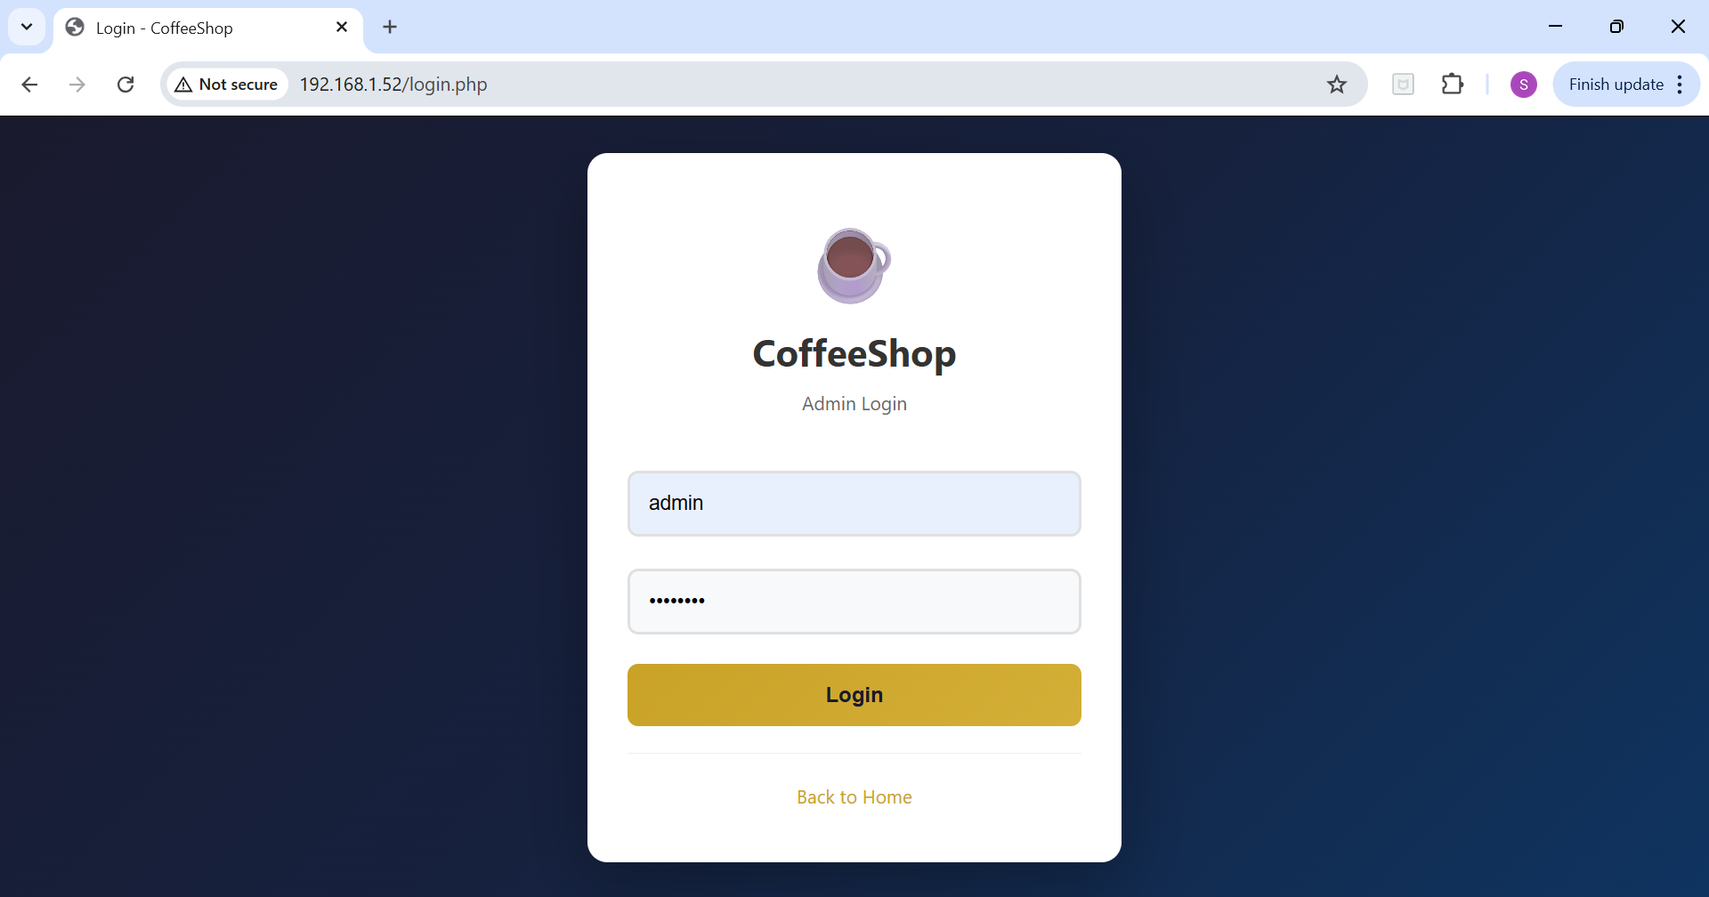
Figure 1: CoffeeShop login page (login.php). The same form is used for customers and the administrator.
The login page (login.php) collects a username and a password and submits them over POST to the server. The server looks up the user, verifies the password hash with password_verify() [6], and stores the user identifier and role in the PHP session [5]. The login form maintains the session for the logged-in user, so any page accessed after login can use $_SESSION to identify the visitor. After a successful login the administrator is redirected to admin.php and a customer to the public menu pages.
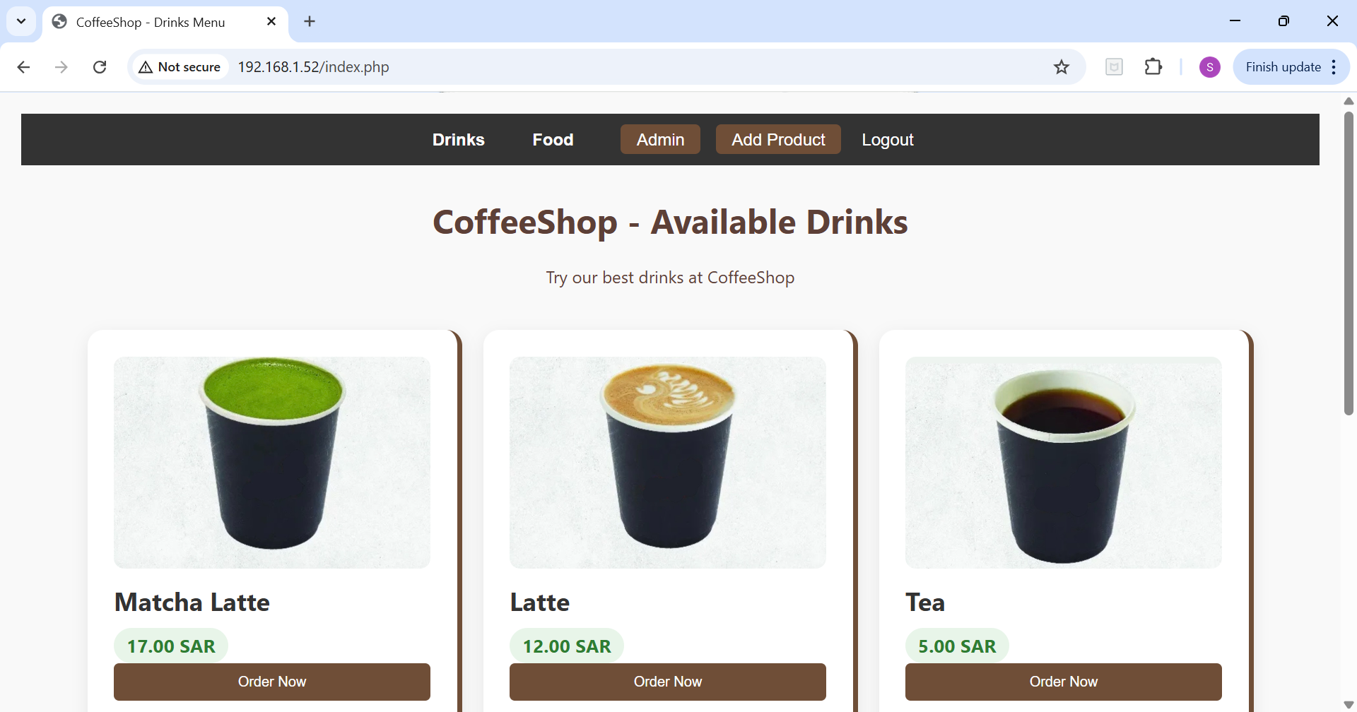
Figure 2: index.php – the Drinks menu. Products are fetched from the products table.
The Drinks menu (index.php) is a public page that lists every product whose category is Drink. Products are not hard-coded in the HTML; instead they are pulled from the products table at request time. Each product card shows the name, price, an image, and an Order Now button. When the visitor is authenticated the navigation bar shows Logout and the order button stores the user identifier in the orders table on submission.
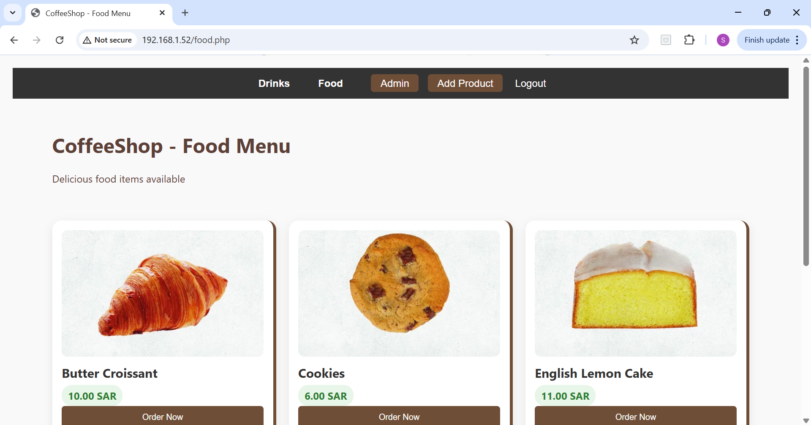
Figure 3: food.php – the Food menu, also rendered from the database.
The Food menu (food.php) follows the same template as the Drinks menu but filters the products table by category Food. Sharing a single template and a single database table for products keeps administration simple: when the admin adds a new item, it appears automatically on the right menu page.
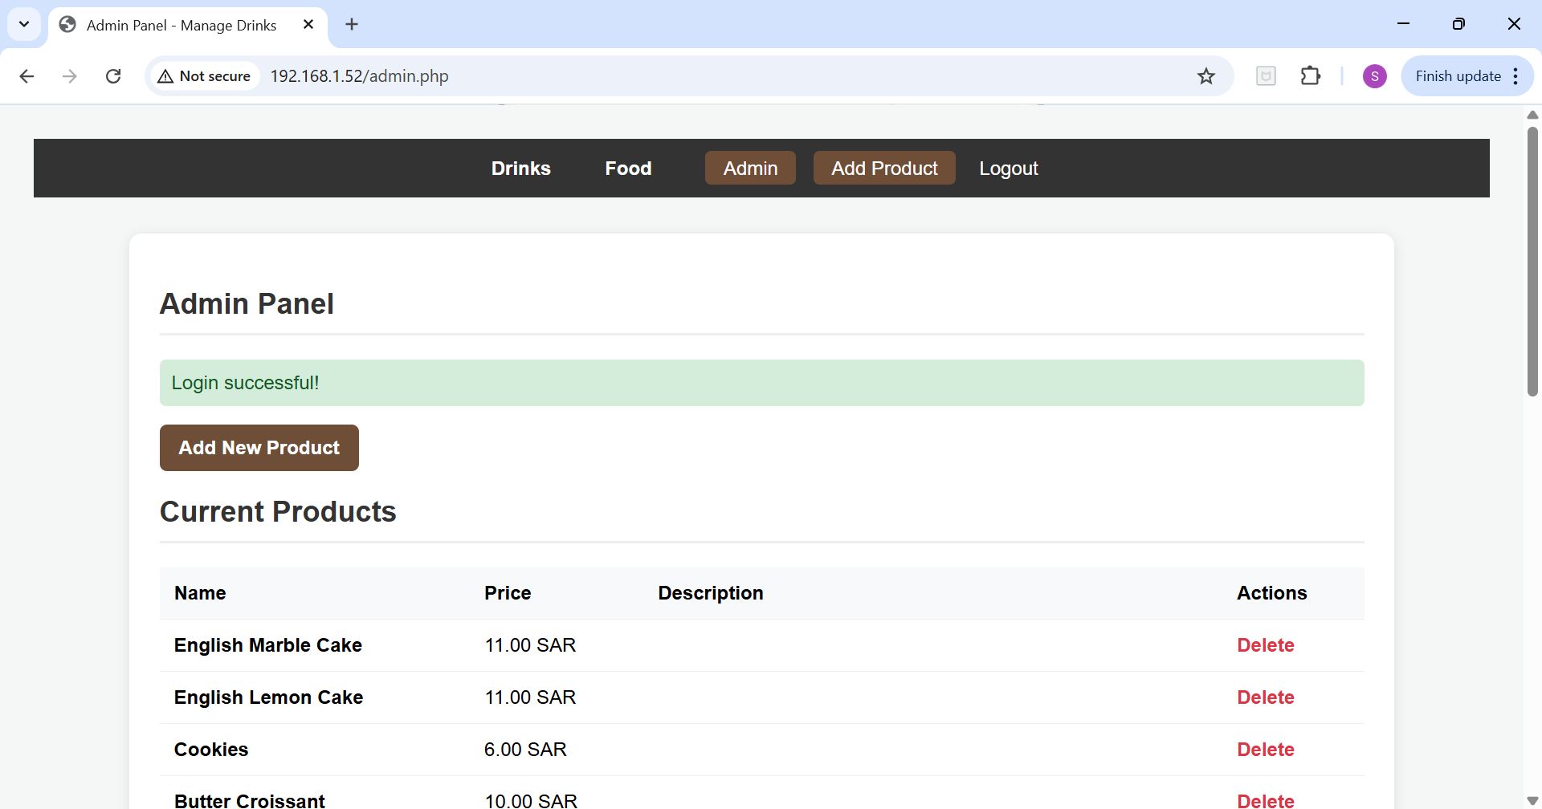
Figure 4: admin.php – the Admin Panel showing current products with a Delete action.
The Admin Panel (admin.php) is the only page that is restricted to a single role. The page begins by checking that the session contains a valid user and that the role stored in the session equals admin; any other request is redirected to the login page. The admin can add new products, delete existing ones, and review every order placed by customers.
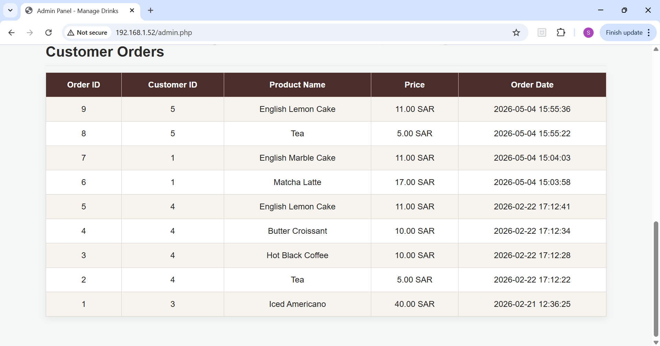
Figure 5: admin.php – the Customer Orders table populated by SELECT from the orders table.
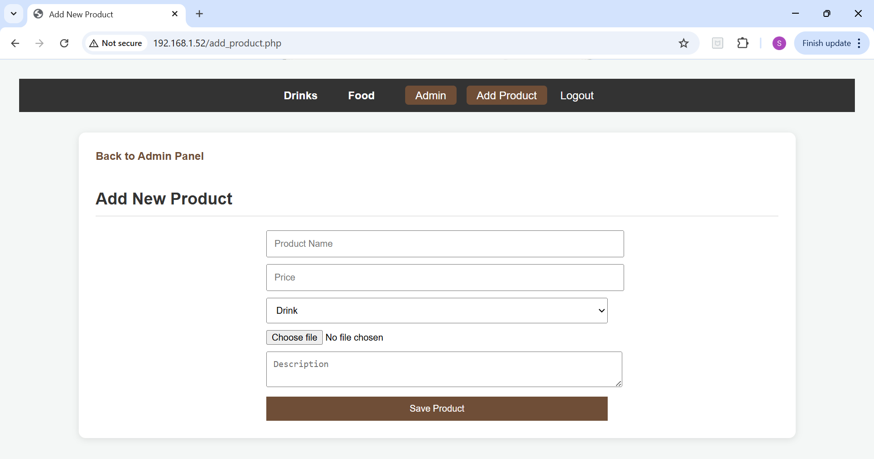
Figure 6: add_product.php – the page that sends a new product to the database.
The Add New Product form (add_product.php) is the canonical example of a page that sends data to the database. It collects the product name, price, category, description, and an image file. Client-side checks (required attributes, numeric input for price, accepted image extensions) filter obvious mistakes before the form is submitted, and server-side checks repeat the same validation and sanitize values before they are inserted via a prepared statement [7].
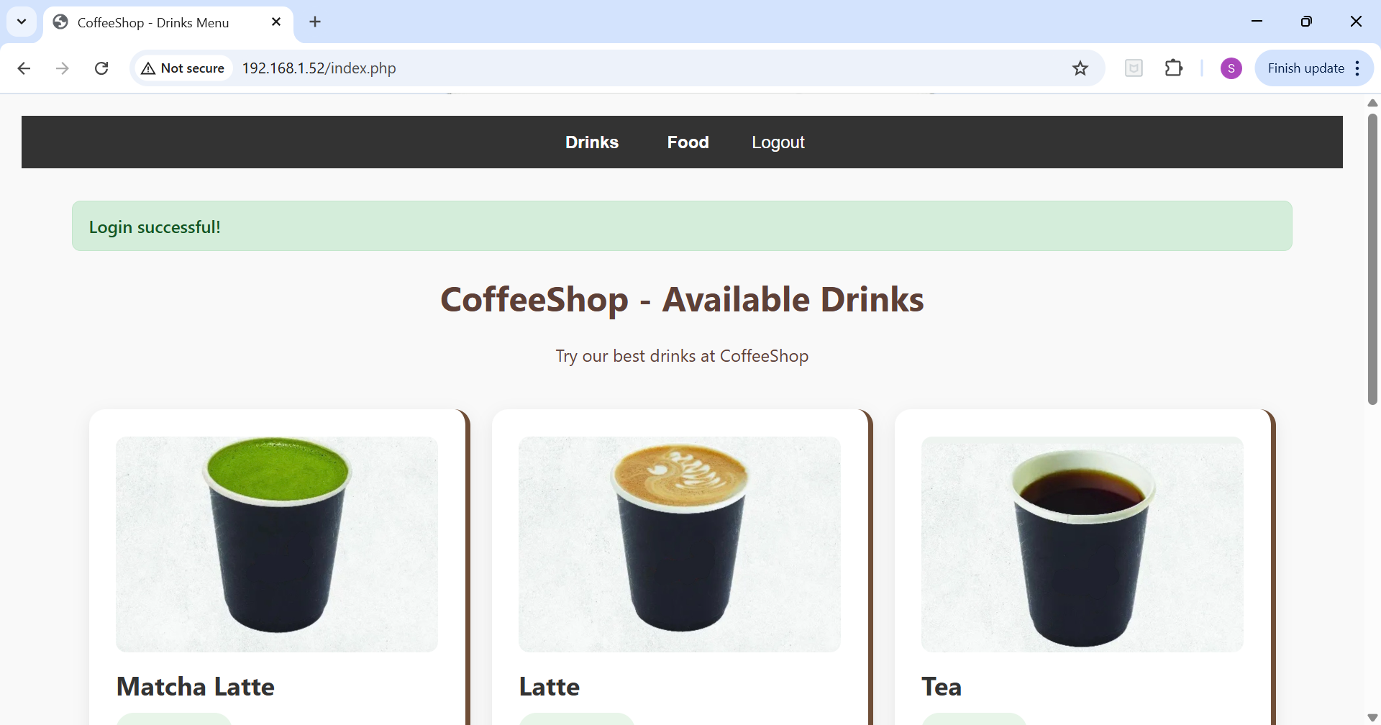
Figure 7: A customer’s view of the Drinks menu after a successful login.

3. Database and Connection
The database coffeeshop_db is created in MySQL and contains three application tables: users, products, and orders. The users table stores the username, the hashed password [6], and the role (admin or user). The products table stores the menu items consumed by index.php and food.php, and the orders table records every Order Now click together with the customer identifier, product, price and timestamp. The schema is summarised in Table 1.
Table | Key Columns | Purpose
users | id (PK), username, password (hash), role | Authentication and role checks for login.php and admin.php.
products | id (PK), name, price, category, description, image | Stores menu items shown on index.php and food.php and edited in admin.php.
orders | id (PK), customer_id (FK), product_id (FK), price, order_date | Stores every order created by the Order Now button.
Table 1: Logical schema of coffeeshop_db.
Connections to MySQL are made through a single file (db.php) that is included by every page that talks to the database. The file uses the MySQLi extension and exposes a $conn object that is reused by login.php, admin.php, add_product.php, food.php, index.php and the order handler [7]. The credentials are kept out of the document root and the connection is closed automatically when the request terminates.
<?php
// db.php – single point of database access
$DB_HOST = 'localhost';
$DB_USER = 'coffeeshop';
$DB_PASS = '********';
$DB_NAME = 'coffeeshop_db';
$conn = new mysqli($DB_HOST, $DB_USER, $DB_PASS, $DB_NAME);
if ($conn->connect_error) {
die('Database connection failed.');
}
$conn->set_charset('utf8mb4');
?>
Listing 1: db.php – MySQLi connection wrapper (adapted from [7]).
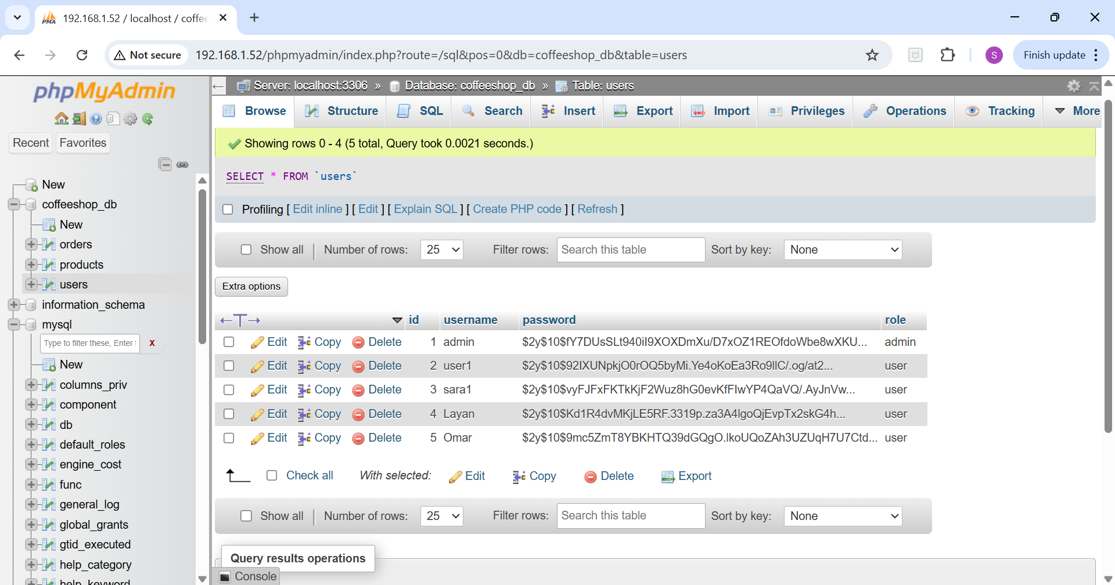
Figure 8: phpMyAdmin view of the users table. Passwords are stored only as bcrypt hashes, never in plain text.

4. Security Implementation

4.1 Secure Password Storage
Passwords are never stored in clear text. Whenever a new account is created or a password is changed, the value supplied by the user is passed through PHP’s password_hash() function with the default algorithm (bcrypt) before being persisted [6]. The hash includes a random per-user salt and a configurable work factor that slows down brute-force attacks. At login, the candidate password is verified against the stored hash with password_verify(), so the application never has to compare raw passwords [6]. Figure 8 shows the stored hashes have the expected $2y$10$ bcrypt prefix.
// On registration
$hash = password_hash($plainPassword, PASSWORD_DEFAULT);
$stmt = $conn->prepare('INSERT INTO users (username, password, role) VALUES (?, ?, "user")');
$stmt->bind_param('ss', $username, $hash);
$stmt->execute();
// On login
if (password_verify($plainPassword, $row['password'])) {
$_SESSION['user_id'] = (int)$row['id'];
$_SESSION['role'] = $row['role'];
}
Listing 2: Hashing and verifying passwords with bcrypt (PHP API per [6]).

4.2 Session Management
After a successful login, the user’s id and role are stored in the PHP $_SESSION superglobal so that protected pages such as admin.php can recognise the visitor on every request. The browser is identified through the PHPSESSID cookie that PHP attaches automatically when session_start() is called [5]. This is the mechanism that maintains the session for the logged-in user across multiple page loads. The security of every authenticated workflow therefore depends on the secrecy and unpredictability of PHPSESSID – exactly the area covered by the chosen vulnerability [1], [2].

4.3 Prepared Statements
Every SQL statement that includes user-supplied data uses MySQLi prepared statements with bound parameters [7]. Strings are never concatenated into the query. As a result, even if a malicious value such as ' OR 1=1 -- is supplied in the login form, the database engine treats it as a literal string and not as part of the SQL grammar [10].

4.4 Input Validation and Sanitization
Validation is applied twice: once on the client and once on the server. Client-side rules are expressed with HTML5 attributes (required, type, min, max, pattern, accept) and short JavaScript checks that block obviously malformed submissions before they reach the network. These rules are convenient for the user but cannot be trusted, so the same checks are repeated on the server in PHP [10]. Server-side code rejects values of the wrong type or length, sanitizes free-text fields with htmlspecialchars() before they are echoed back to the page, and limits image uploads to a whitelist of MIME types and extensions.

5. Vulnerability: Weak Session IDs
Weak Session IDs cover any flaw that allows an attacker to obtain or predict the identifier that binds a browser to a server-side session [2]. In PHP applications this identifier is the PHPSESSID cookie [5]. If an attacker can read, guess, or reuse a victim’s PHPSESSID, the server will treat any request that carries that cookie as if it came from the victim – without ever having to know the victim’s password. This class of issue is documented as CWE-384 Session Fixation [3] and CWE-330 Use of Insufficiently Random Values [4], and falls under the OWASP Top 10 category A07: Identification and Authentication Failures [1].
Common conditions that lead to weak session identifiers in a PHP/Apache application include [2], [5], [8]:
- The PHPSESSID cookie is set without the HttpOnly flag, so JavaScript running in the page can read it through document.cookie [8].
- The cookie is sent over plain HTTP without the Secure flag, so any device on the same network can capture it [8].
- session.use_strict_mode is disabled, so PHP accepts any session id sent by the client, including one chosen by the attacker (session fixation) [3], [5].
- session_regenerate_id() is not called after authentication or privilege change, so the same identifier survives the login and can be replayed [2], [5].
- Sessions are kept alive indefinitely with no idle or absolute timeout, so a stolen identifier remains valid long after the legitimate user has stopped using it [2].
- The session id is exposed in URLs, log files, or referrer headers [2].
In the initial version of CoffeeShop several of these conditions were present. The Apache and PHP defaults were used as-is [5], [9]: the PHPSESSID cookie was created without HttpOnly or Secure, no identifier was regenerated after login, and no SameSite policy was configured [8]. Figure 9 was captured during this stage and demonstrates the first weakness directly.
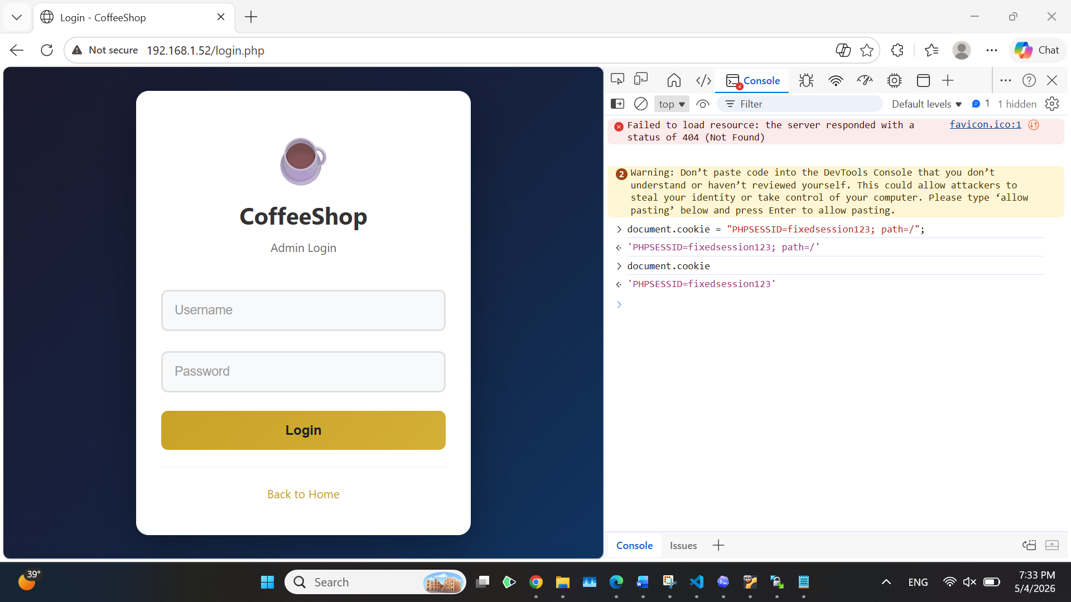
Figure 9: document.cookie returns the PHPSESSID value because the cookie was set without HttpOnly.

6. Attack Implementation – Session Hijacking
To prove that the vulnerability had a real impact we carried out a session-hijacking attack against the unhardened version of CoffeeShop, following the methodology described in [10] and the test guidance in [2]. Two machines were used inside the same VirtualBox host-only network: a victim machine running the administrator’s browser, and an attacker machine running a second browser. The web server (192.168.1.52) was reachable from both.
Step 1: The administrator logs in normally on the victim machine.
The admin opens login.php, submits valid credentials and is redirected to admin.php. The browser now holds an authenticated PHPSESSID cookie.
Step 2: The attacker reads the session identifier.
Because the cookie was set without the HttpOnly flag [8], any script with access to the page can read it. In a real engagement this would be delivered through a stored XSS payload, a malicious browser extension, or shoulder-surfing [10]. For the demonstration we opened the developer console on the same machine and typed:
> document.cookie
"PHPSESSID=mim2va1h02193m1icjcov5018s"
Step 3: The attacker imports the cookie into their own browser.
On the attacker machine, the attacker visits the same site as an anonymous visitor, opens the developer console, and assigns the captured value to document.cookie:
document.cookie = "PHPSESSID=mim2va1h02193m1icjcov5018s; path=/";
Step 4: The attacker reloads admin.php.
Because session.use_strict_mode is disabled and the identifier is still valid on the server [5], Apache accepts the request and renders the page. The attacker now sees the same Admin Panel as the legitimate administrator, with full access to products and customer orders – Figure 10. No password was ever transmitted.
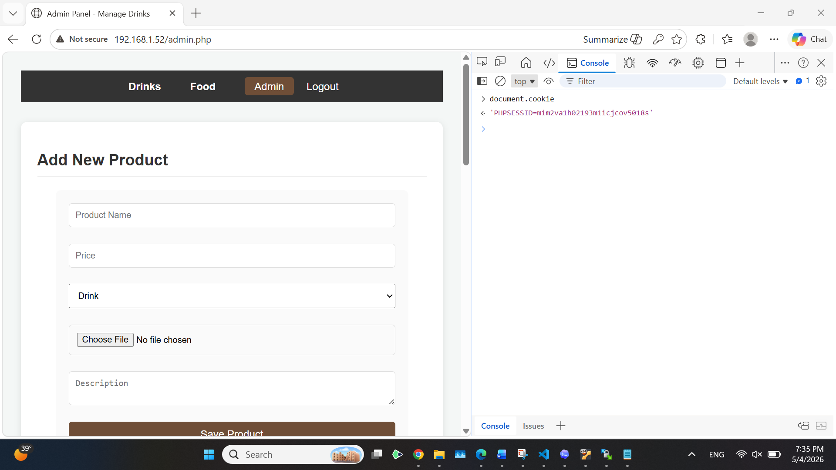
Figure 10: The Admin Panel rendered in the attacker’s browser after injecting the stolen PHPSESSID.
Result: The attack was successful in the initial configuration. The lack of HttpOnly [8] made the cookie readable from JavaScript, the lack of session_regenerate_id() [2], [5] meant the captured identifier remained valid after login, and the lack of a strict same-site or IP binding meant a second machine could use the cookie unchallenged [8]. These three findings define the minimum set of countermeasures we then applied.

7. Countermeasures
The course brief requires two countermeasures to be explained and practically implemented: the use of prepared statements [7], and input validation and sanitization on both the client and the server [10]. Because the chosen vulnerability is Weak Session IDs we also describe a third group of controls – session hardening – which directly defeats the attack performed in Section 6 [2], [5], [8].

7.1 Use of Prepared Statements
All SQL statements in CoffeeShop are issued through MySQLi prepared statements with parameter binding [7]. The query template is compiled by the database before any user value is supplied, and the supplied values are then bound by type. Even if an attacker supplies SQL meta-characters in the form, the engine treats them as literal text [10]. The login handler is shown below.
// login.php – authentication with a prepared statement
$stmt = $conn->prepare('SELECT id, password, role FROM users WHERE username = ?');
$stmt->bind_param('s', $username);
$stmt->execute();
$result = $stmt->get_result();
if ($row = $result->fetch_assoc()) {
if (password_verify($password, $row['password'])) {
session_regenerate_id(true);
$_SESSION['user_id'] = (int)$row['id'];
$_SESSION['role'] = $row['role'];
header('Location: admin.php');
exit;
}
}
Listing 3: Login with a prepared statement, password_verify() and session regeneration (per [5], [6], [7]).
Practical test: We submitted the classic SQL-injection payload admin' OR '1'='1 in the username field [10]. With the prepared statement in place the database engine searched for a user whose username literally equals admin' OR '1'='1, found no match, and returned an empty result set. The login was rejected, confirming that prepared statements neutralise the payload [7], [10].

7.2 Input Validation and Sanitization
Validation runs in two layers. The browser enforces the rules first with HTML5 attributes and a small JavaScript helper, which gives the user immediate feedback. Because client-side rules are trivial to bypass [10], the server then repeats the same checks before any value is used in SQL or echoed back into a page.
Client side (HTML and JavaScript):
<form id="productForm" method="POST" action="add_product.php"
enctype="multipart/form-data" onsubmit="return validateProduct();">
<input name="name" required pattern="^[A-Za-z0-9 \-]{2,40}$">
<input name="price" required type="number" min="0" step="0.01" max="9999">
<input name="image" required type="file" accept="image/png,image/jpeg">
<textarea name="description" maxlength="200"></textarea>
<button type="submit">Save Product</button>
</form>
<script>
function validateProduct() {
const name = document.forms.productForm.name.value.trim();
if (!/^[A-Za-z0-9 \-]{2,40}$/.test(name)) { alert('Invalid product name.'); return false; }
const price = parseFloat(document.forms.productForm.price.value);
if (isNaN(price) || price < 0) { alert('Price must be ≥ 0.'); return false; }
return true;
}
</script>
Listing 4: Client-side validation with HTML5 attributes and JavaScript.
Server side (PHP):
// add_product.php – server-side validation and prepared insert
$name = trim($_POST['name'] ?? '');
$price = filter_input(INPUT_POST, 'price', FILTER_VALIDATE_FLOAT);
$category = in_array($_POST['category'] ?? '', ['Drink','Food']) ? $_POST['category'] : null;
$description = htmlspecialchars(trim($_POST['description'] ?? ''), ENT_QUOTES, 'UTF-8');
if (!preg_match('/^[A-Za-z0-9 \-]{2,40}$/', $name) || $price === false
|| $price < 0 || $category === null) {
http_response_code(400);
exit('Invalid input.');
}
$stmt = $conn->prepare(
'INSERT INTO products (name, price, category, description) VALUES (?, ?, ?, ?)');
$stmt->bind_param('sdss', $name, $price, $category, $description);
$stmt->execute();
Listing 5: Server-side validation, sanitization and prepared insert (per [7], [10]).
Practical test: After the controls were deployed we submitted a stored-XSS attempt by typing <script>alert(document.cookie)</script> in the Description field [10]. The client-side maxlength and the server-side htmlspecialchars() escaped the angle brackets, so the value rendered on the page as harmless text instead of executing. Combined with the HttpOnly cookie introduced in Section 7.3 [8], the payload could no longer read the session id even if it had executed.

7.3 Hardening Session Management
The dedicated control for the chosen vulnerability is to harden the way PHP creates, transports and rotates session identifiers [2], [5]. The following snippet is placed at the top of every page that calls session_start():
// session_bootstrap.php – include before session_start()
ini_set('session.use_strict_mode', '1'); // reject unknown ids
ini_set('session.use_only_cookies', '1'); // never accept ids in the URL
ini_set('session.cookie_httponly', '1'); // hide cookie from JavaScript
ini_set('session.cookie_secure', '1'); // only over HTTPS
ini_set('session.cookie_samesite', 'Strict');// no cross-site sending
ini_set('session.gc_maxlifetime', '900'); // 15-minute idle timeout
session_start();
// Regenerate the id on every privilege change (login, role upgrade, logout)
if (!empty($_SESSION['just_authenticated'])) {
session_regenerate_id(true);
unset($_SESSION['just_authenticated']);
}
// Bind the session to the user agent and a hashed remote address
$fingerprint = hash('sha256', $_SERVER['HTTP_USER_AGENT'] . '|' . $_SERVER['REMOTE_ADDR']);
if (!isset($_SESSION['fp'])) {
$_SESSION['fp'] = $fingerprint;
} elseif (!hash_equals($_SESSION['fp'], $fingerprint)) {
session_destroy();
header('Location: login.php');
exit;
}
Listing 6: Hardened session bootstrap (settings per [5], [8]; fingerprinting per [2]).
What each setting achieves:
- HttpOnly [8]: document.cookie no longer returns PHPSESSID, neutralising the read step performed in Section 6.
- Secure + SameSite=Strict [8]: the cookie is sent only over HTTPS and never on cross-site requests, blocking network sniffing and CSRF-style replay.
- use_strict_mode [3], [5]: PHP refuses to accept a session id that it did not issue, so the attacker cannot fix a value of their own choice.
- session_regenerate_id(true) after login [2], [5]: a captured pre-login identifier becomes invalid the moment the victim authenticates.
- Idle timeout and fingerprint binding [2]: a stolen identifier stops working after 15 minutes of inactivity or as soon as it appears on a different IP/User-Agent.
Practical test: We repeated the attack from Section 6 against the hardened build. document.cookie now returned an empty string for PHPSESSID, so the attacker could no longer read the identifier from JavaScript [8]. We also tried setting an arbitrary PHPSESSID manually and reloading admin.php; PHP rejected the unknown identifier and the request was redirected to the login page [5]. The attack failed at every step.

8. Conclusion
Building CoffeeShop and then attacking it showed how much of a web application’s security depends on the small defaults that PHP and Apache choose for the developer [5], [9]. With the out-of-the-box configuration, an attacker who could observe the page even for a moment was able to copy the PHPSESSID cookie and obtain administrator access without ever knowing the password [1], [2]. The fix was not a single line of code but a combination of measures: prepared statements [7] stopped data from ever becoming part of a query, layered input validation [10] prevented hostile values from being stored or reflected, and tightened session settings [5], [8] made the cookie itself useless to anyone other than the legitimate browser. The same attack that succeeded in Section 6 was blocked in Section 7. The exercise reinforced that secure web development is about choosing safe defaults and applying defence in depth, not about reacting to incidents after they happen.

9. References
[1] OWASP Foundation, "OWASP Top 10:2021 – A07 Identification and Authentication Failures," 2021. [Online]. Available: https://owasp.org/Top10/A07_2021-Identification_and_Authentication_Failures/
[2] OWASP Foundation, "Session Management Cheat Sheet," OWASP Cheat Sheet Series. [Online]. Available: https://cheatsheetseries.owasp.org/cheatsheets/Session_Management_Cheat_Sheet.html
[3] The MITRE Corporation, "CWE-384: Session Fixation," Common Weakness Enumeration. [Online]. Available: https://cwe.mitre.org/data/definitions/384.html
[4] The MITRE Corporation, "CWE-330: Use of Insufficiently Random Values," Common Weakness Enumeration. [Online]. Available: https://cwe.mitre.org/data/definitions/330.html
[5] PHP Group, "PHP Manual – Sessions Configuration," php.net. [Online]. Available: https://www.php.net/manual/en/session.configuration.php
[6] PHP Group, "PHP Manual – password_hash and password_verify," php.net. [Online]. Available: https://www.php.net/manual/en/function.password-hash.php
[7] PHP Group, "PHP Manual – mysqli::prepare," php.net. [Online]. Available: https://www.php.net/manual/en/mysqli.prepare.php
[8] Mozilla Developer Network, "Set-Cookie HTTP header (HttpOnly, Secure, SameSite)," MDN Web Docs. [Online]. Available: https://developer.mozilla.org/en-US/docs/Web/HTTP/Headers/Set-Cookie
[9] Apache Software Foundation, "Apache HTTP Server Version 2.4 Documentation." [Online]. Available: https://httpd.apache.org/docs/2.4/
[10] D. Stuttard and M. Pinto, The Web Application Hacker’s Handbook: Finding and Exploiting Security Flaws, 2nd ed. Indianapolis, IN: Wiley, 2011.

Appendix A – GitHub Repository
The full source code of CoffeeShop – including the LAMP configuration notes, the database schema, all PHP files used in the report, and the screenshots taken during testing – is available in the following Git repository:
<INSERT GITHUB REPOSITORY LINK HERE>
Replace the placeholder above with the public URL of the team repository before final submission.

