Apex Options Engine
Advanced Quantitative Teardown and Upgrade Roadmap
Prepared for stakeholder review · Repository: xxankitxx/Apex23rdBackup
5 November 2026
Review of architecture, specifications and selected source files. All charts are explanatory illustrations using synthetic or stated example data; none are market results or performance claims.
Contents
Executive summary 3
Introduction: what Apex is and what it must solve 4
1. What was found in the repository 5
1.1 The strongest existing components 5
1.2 Some sophisticated features have already failed testing 5
1.3 Current champion and recent experiments 6
2. The biggest mathematical weaknesses 7
2.1 Predict premium behaviour, not just directional continuation 7
2.2 The dealer gamma model has an identification problem 8
2.3 The Greeks need a higher-order valuation engine 8
2.4 The lag-cheapness model is promising but incomplete 10
3. Advanced mathematical models worth serious consideration 11
Tier 1: models that can materially improve Apex 11
Tier 2: advanced derivatives and volatility mathematics 15
Tier 3: advanced microstructure mathematics 17
Tier 4: advanced machine learning and probability engineering 19
Tier 5: mathematics beyond conventional trading systems 22
4. The most important missing model: an opportunity about to disappear 23
5. Redesigning the decision architecture 25
6. Improvements to the existing learning engine 27
6.1 Repeated observations are not independent 27
6.2 Repeated strategy selection creates false discoveries 27
6.3 Winning trades are not necessarily the best trades 28
6.4 A feature-ablation laboratory 28
7. Specific problems in the current specifications 29
7.1 A better option-premium forecast 29
8. The most important engineering issue: data quality 31
9. Recommended implementation priority 32
9.1 How each upgrade earns its place 33
10. Final assessment 34
The five additions to prioritise above everything else 34
Change the fundamental question Apex asks 34
Appendix A. Independent reviewer notes 35
Appendix B. Glossary 36

Executive summary
Apex is a tick-level Nifty options-buying engine. It detects a market event, identifies which instruments are responding, judges whether the move has continuation potential, and decides whether buying an option is worthwhile. This review assesses the architecture and specifications in the repository and recommends a prioritised path for the next generation of the engine.
Headline conclusions
- The architecture is sophisticated and pointed in the right direction. Multi-instrument impulse detection, futures order-book analysis, premium tracking, a candidate ledger and parallel paper books are strong foundations.
- The central question needs to change. The engine should stop asking “will Nifty move?” and ask instead: “Which available Nifty option has the highest probability of producing a meaningful, relatively immediate premium gain before an unacceptable adverse move?” Predicting the option premium, not index direction, should become the final authority for entry.
- More indicators are not the answer. Several sophisticated ideas (OI walls, PCR, regime gates, Greek timing filters) have already failed as entry triggers in the 29 October research. The next gains come from measuring which information adds incremental predictive value.
- Statistical validation must be strengthened before any strategy is promoted. Seven to twelve sessions are not enough to establish a durable edge, correlated candidates inflate apparent sample sizes, and paper fills at LTP ignore slippage and charges.
- Data quality is as important as mathematics. Every model input should carry freshness and quality metadata, with exchange, broker, receipt and processing timestamps separated.
Top five recommended additions
Priority | Addition | What it contributes
1 | Hawkes process | Detects when buying or selling becomes self-reinforcing
2 | Hidden semi-Markov model | Infers the hidden market state and how long it is likely to last
3 | Competing-risk survival model | Estimates whether, and how quickly, the target beats the adverse barrier
4 | Higher-order Greeks and full repricing | Predicts what the option premium will actually become
5 | Bayesian meta-labelling | Separates detecting opportunities from deciding which to trade
Scope and status. This is an assessment of architecture, documentation and selected source files: the README, the three quantitative specifications, greeks.py, flow.py, config.py, learning.py, the changelog and the strengthening documentation. It is not a line-by-line audit, the test suite was not executed, and none of the qualitative ratings are measured performance. All charts and diagrams in this document are explanatory illustrations built on synthetic or stated example data, not market results.

Introduction: what Apex is and what it must solve
The architecture described in the repository includes:
- Tick-by-tick Nifty options monitoring.
- A ten-contract ATM ±2 CE/PE ladder.
- Futures impulse and multi-stock basket synchronisation.
- Order-book pressure, liquidity depletion and replenishment.
- Option-chain OI walls, gamma exposure and gamma flip.
- Straddle theta-adjusted movement and gamma-leg detection.
- Multiple independent trading advisors.
- Market-regime classification.
- Candidate tracking, including opportunities rejected by the system.
- Parallel paper books and a self-learning mechanism.
- Statistical testing before promoting a challenger strategy.
Initial assessment. The most interesting part of Apex is not any individual indicator. It is the attempt to detect a market event, identify which instruments are responding to it, determine whether the move has sufficient continuation potential, and then decide whether buying an option is worthwhile. That is the correct direction for a sophisticated options-buying system.
However, three different objectives must be distinguished:
- Opportunity recall: don’t miss genuine profitable moves.
- Entry precision: don’t enter moves that are already exhausted, false, or unlikely to continue.
- Option profitability: even when the Nifty direction is correct, ensure that the selected option actually appreciates enough to overcome theta, IV changes, spread and execution costs.
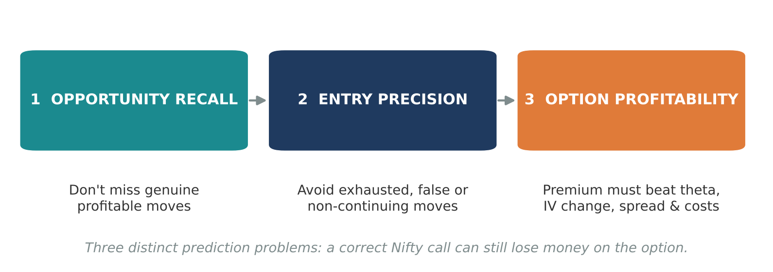
Figure 1. The three distinct prediction problems an options-buying engine must solve.
These are three different prediction problems. A system can be excellent at predicting Nifty direction and still lose money buying options.
One important qualification: the README describes the architecture and intended behaviour. This review distinguishes documented functionality from mathematical validity and demonstrated profitability, rather than assuming that an implemented feature necessarily has an edge.

1. What was found in the repository
There are two important layers:
- The running Apex engine: its Python implementation, trading books, trigger logic, Greeks, flow analysis and learning mechanism.
- The newer quantitative specifications: PREMIUM_CONTINUATION_ENGINE_SPEC.md, CHEAPNESS_AND_REGIME_SPEC.md and OI_ACCELERATION_VWAP_SPEC.md.
These should not be treated as equivalent. A mathematical technique described in a specification is not necessarily active in the trading decision.

1.1 The strongest existing components
Component | Assessment | Why it matters
Multi-instrument impulse | Strong concept | Detects index moves originating in heavyweight constituents
Futures order-book analysis | Strong | Attempts to identify liquidity removal, absorption and pressure
Options premium tracking | Very strong | Focuses on the actual instrument being purchased
Gamma and theta analysis | Valuable | Helps estimate whether a directional move can translate into premium appreciation
Straddle monitoring | Interesting | Detects movement beyond expected theta decay
Candidate ledger | Excellent research foundation | Reveals missed opportunities and incorrectly rejected opportunities
Parallel paper books | Excellent architecture | Allows controlled comparisons between competing approaches
Self-learning | Promising, but statistically vulnerable | Provides a mechanism for selecting better-performing strategies
The repository’s README documents these features, including the ten-contract ladder, five advisors, ten parallel books, gamma mapping and candidate outcomes.

1.2 Some sophisticated features have already failed testing
The changelog records that the following ideas were rejected as entry triggers in the 29 October research:
- OI quadrants.
- OI walls.
- PCR.
- OI acceleration combined with VWAP.
- Buyers-versus-sellers queues.
- Greek timing filters.
- Regime gates.
- Waiting for a dip.
It also records that 16 observer cards were added to the dashboard, but these cards were not connected to the champion’s trading decisions.
This distinction is critical. Several techniques that might otherwise be suggested as new additions have already been tried, and some were not useful in historical replay.
Recommendation: do not simply add more indicators. The next improvement should identify which information provides incremental predictive value after accounting for everything the existing engine already knows.

1.3 Current champion and recent experiments
The changelog identifies c20_9x as the champion on 30 October. It also records:
- c20_9s: a stale-impulse pullback veto.
- c20_9y: IV-rich and OI-wall entry vetoes.
- Several unsuccessful exit experiments.
- A seven-day replay result for an earlier champion comparison.
- A twelve-day comparison for the newer shadow variant.
These are useful experiments, but 7–12 sessions are insufficient to establish that a strategy has a durable edge across different volatility regimes, expiry conditions and market structures. A strategy should not be promoted solely on those results.

2. The biggest mathematical weaknesses
These matter more than adding another dozen indicators.

2.1 Predict premium behaviour, not just directional continuation
The PCE specification already recognises five traps:
- False breakouts.
- Late entries.
- Premium failing to respond.
- Absorption.
- Misinterpreted option-chain positioning.
It also introduces competing-barrier outcomes, MFE and MAE. That is good quantitative design. The next step is to predict three separate distributions for every candidate:
$$P\left(\text{Nifty move}∣X_{t}\right)$$
$$P\left(\text{Option premium move}∣X_{t}\right)$$
$$P\left(\text{Target before adverse barrier}∣X_{t}\right)$$
The first predicts the underlying. The second predicts the actual option. The third predicts whether the opportunity is tradable.
Why this matters: suppose Nifty is likely to rise 25 points, the ATM CE has delta 0.55, IV is expected to fall, theta is consuming premium, and the spread is relatively wide. The directional forecast can be correct while the option fails to generate the required 10% return.
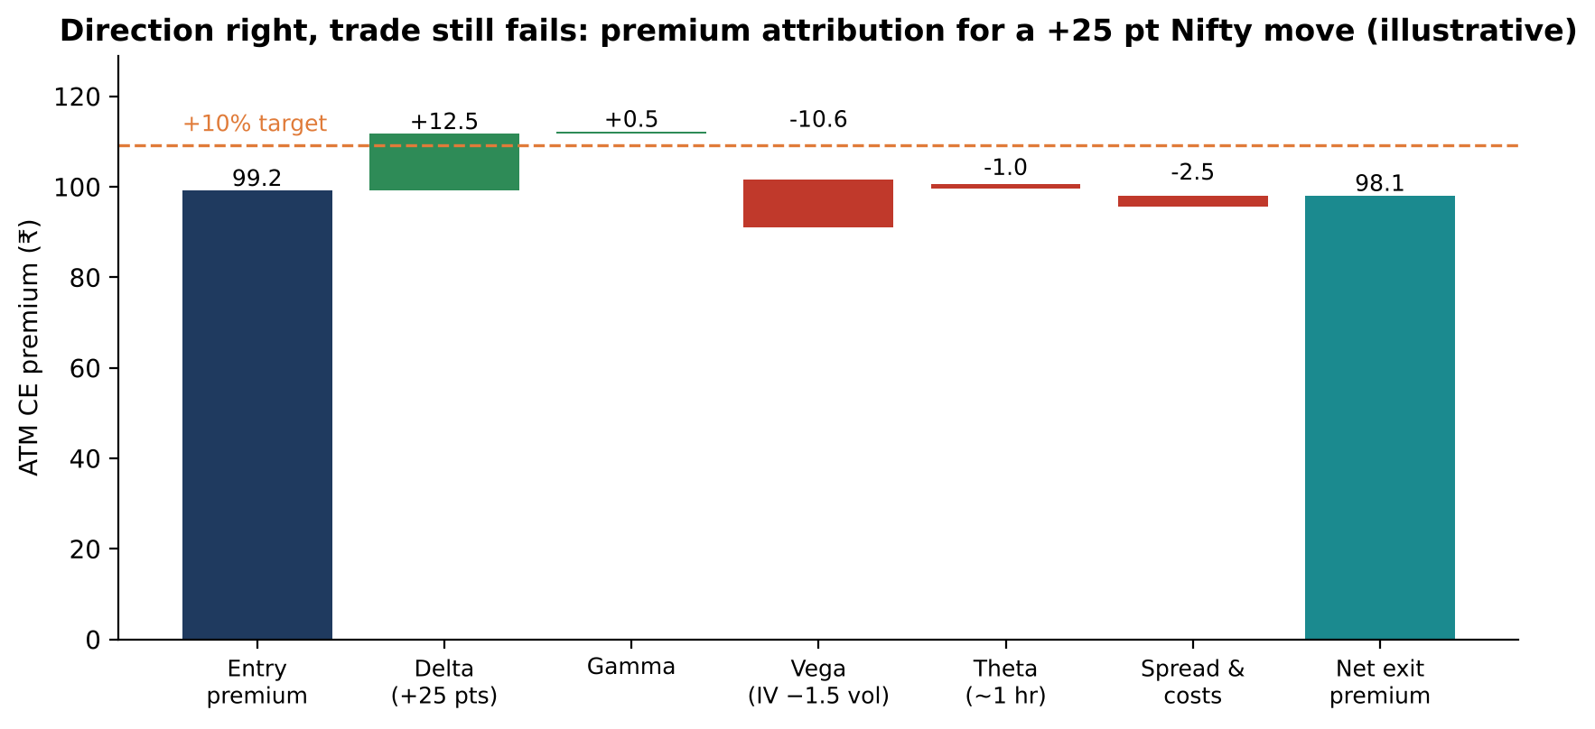
Figure 2. A correct +25 point directional call that still fails to reach a +10% premium target once IV, theta and costs are included (illustrative Black-76 attribution).
The directional model must not overpower the premium model. The premium outcome model should be the ultimate authority for entry.

2.2 The dealer gamma model has an identification problem
The GEX calculation uses:
$$GEX_{k}=Γ_{k}×OI_{k}×\text{LotSize}×S^{2}×0.01$$
The README itself acknowledges that the dealer-positioning assumption may be wrong. The fundamental issue is that OI does not reveal who is long or short. Every open contract has both a buyer and a seller, so dealer inventory cannot be established conclusively from total OI. Consequently:
- Positive calculated GEX does not prove dealers are long gamma.
- Negative calculated GEX does not prove dealers are short gamma.
- A gamma flip based on assumed positioning may be misplaced.
- A call wall does not necessarily mean that dealers will defend that strike.
What to implement instead: maintain three parallel gamma scenarios.
Scenario | Positioning assumption
GEX-A | Dealers long calls and short puts
GEX-B | Dealers short calls and long puts
GEX-C | Positioning inferred probabilistically from observed order flow
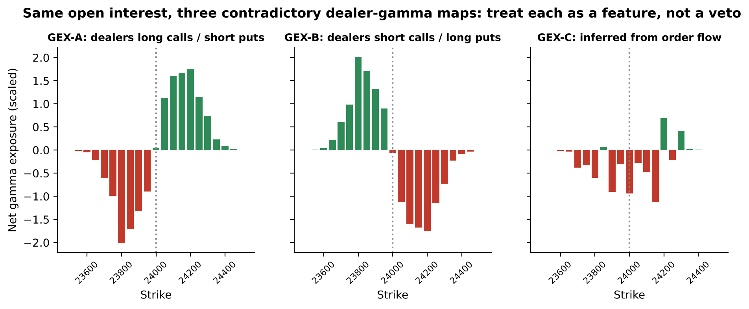
Figure 3. The same open interest produces contradictory gamma maps depending on the positioning assumption (synthetic data).
Use all three as features, then measure which scenario actually predicts subsequent realised Nifty movement and option-premium continuation. Do not make one assumed dealer-positioning scenario a hard entry veto.

2.3 The Greeks need a higher-order valuation engine
apex/greeks.py implements Black-76, a bisection IV solver, and an approximation to the normal CDF. Using a forward price rather than raw spot is sensible. Several improvements are worth making.
The PCE specification uses:
$$ΔV≈Δ⋅ΔS+1/2Γ{\left(ΔS\right)}^{2}+\text{Vega}⋅Δσ+Θ⋅Δt$$
This is a useful first approximation, but it is not sufficient for a fast-moving weekly option near expiry. The next level is:
$$ΔV≈Δ⋅ΔF+1/2Γ{\left(ΔF\right)}^{2}+\text{Vega}⋅Δσ+Θ⋅Δt+\text{Vanna}⋅ΔF Δσ+1/2\text{Vomma}{\left(Δσ\right)}^{2}+\text{Charm}⋅ΔF Δt+…$$
The important additional Greeks are:
- Vanna: how delta changes when IV changes.
- Vomma / Volga: how vega changes when IV changes.
- Charm: how delta changes as time passes.
- Speed: how gamma changes when the underlying moves.
- Color: how gamma changes with time.
- Ultima: how vomma changes with volatility.
But the engine should not stop at a Taylor expansion. For the actual decision, implement a full repricing engine:
- Forecast the Nifty forward price.
- Forecast the volatility surface at the future timestamp.
- Calculate remaining time to expiry.
- Reprice the option using the full Black-76 formula.
- Evaluate executable bid/ask rather than just the theoretical mid-price.
- Calculate the probability of reaching the required premium.
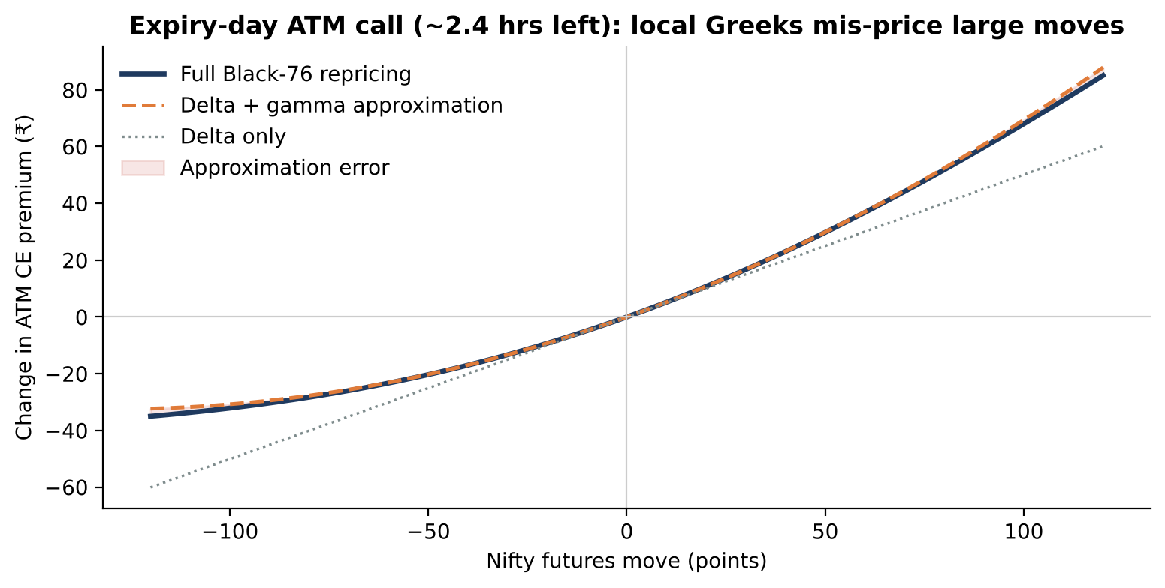
Figure 4. For an expiry-day ATM call, delta and delta-gamma approximations diverge materially from full repricing on larger moves.
This avoids relying on a local approximation when the option is undergoing a substantial move.
Two implementation details need particular attention:
- The current Black-76 pricing function does not explicitly include the discount factor $e^{−rT}$. For a short intraday horizon the numerical difference may be small, but the convention should be consistent across pricing, IV and parity.
- years_to_expiry() imposes a 600-second floor on expiry day and 60 seconds otherwise. This stabilises the numerics, but it can misrepresent actual time remaining. The system should distinguish a numerical solver floor from the real contract expiry clock.

2.4 The lag-cheapness model is promising but incomplete
The specification calculates:
$$LAG=V_{\text{expected}}−V_{\text{ask}}$$
where the expected premium incorporates delta, gamma, vega and theta. This is one of the most interesting concepts in the repository. It should be upgraded into a dynamic premium dislocation detector:
$${\text{Residual}}_{t}=V_{\text{market},t}−V_{\text{model},t}$$
$$Z_{\text{residual}}=\frac{{\text{Residual}}_{t}−μ_{\text{residual}}}{σ_{\text{residual}}}$$
Standardise against the historical residual distribution for the same strike or moneyness, similar expiry time, similar IV regime, similar spread and similar time of day. Also calculate the residual’s rate of convergence.
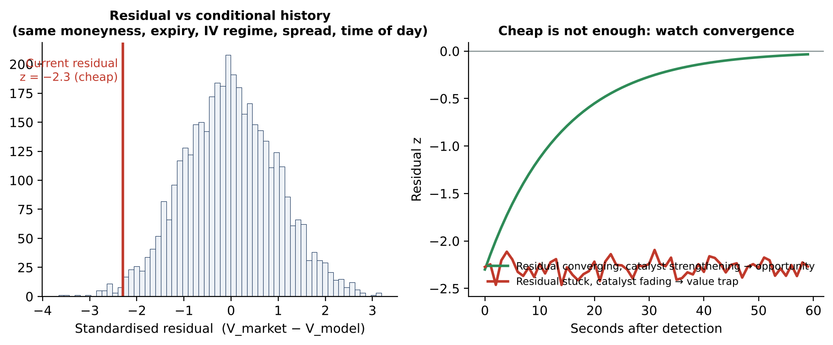
Figure 5. A residual z-score identifies relative cheapness; its convergence path distinguishes an opportunity from a value trap (synthetic).
A cheap option is not necessarily an opportunity. It could be cheap because the market has correctly anticipated that the underlying move will not continue. What the engine wants is a temporarily under-responsive option whose underlying catalyst is still strengthening. That distinction is extremely important.

3. Advanced mathematical models worth serious consideration
This section deliberately includes techniques beyond conventional technical analysis, standard Greeks, RSI, MACD, VWAP and basic machine learning. These are research candidates, not claims that every technique will improve results.

Tier 1: models that can materially improve Apex
High priority. Implement and test first.

3.1 Hidden Markov and hidden semi-Markov models
This is one of the strongest recommendations. The current regime framework considers direction, trend quality, volatility, participation, dealer gamma and option-market stress, and the specification already recognises that market regime is multidimensional.
The problem is that market regimes are not directly observable. Prices, volatility, order flow and option premiums are observed; the underlying state must be inferred. An HMM models this as:
$$P\left(Z_{t}∣X_{1},…,X_{t}\right)$$
where $Z_{t}$ is the hidden market state and $X_{t}$ the observed market features. Apex should start with six latent states:
State | Interpretation | Preferred behaviour
S1 | Directional expansion | Strong continuation candidate
S2 | Directional exhaustion | Avoid chasing
S3 | Range compression | Prepare for expansion
S4 | Volatile mean reversion | Avoid premature breakout entries
S5 | Liquidity-driven breakout | Look for continuation
S6 | Shock / abnormal volatility | Special handling
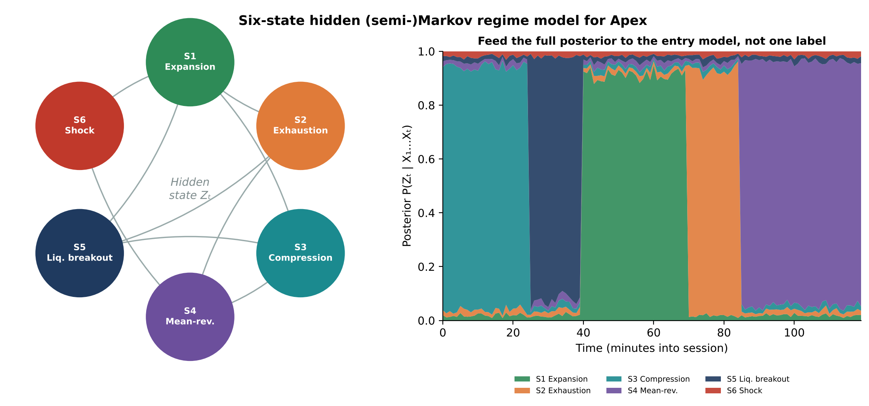
Figure 6. Six-state regime model: transition structure (left) and the posterior probability stream the entry model should consume (right, synthetic).
Why HSMM rather than just HMM? An ordinary HMM has geometrically distributed state durations. An HSMM explicitly models how long a regime tends to persist. A directional expansion lasting 30 seconds and one lasting 8 minutes should not necessarily be treated identically.
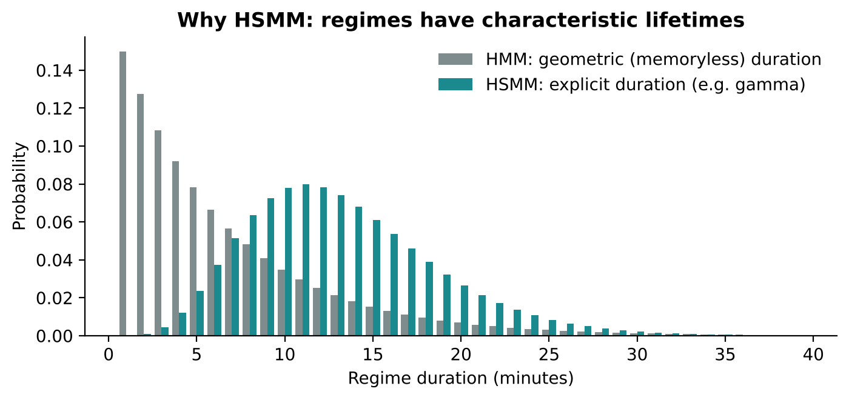
Figure 7. HMM durations are memoryless; HSMM durations capture a regime’s characteristic lifetime.
Apex implementation: feed the posterior probabilities of all six states into the entry model. Do not simply output TREND_UP or TREND_DOWN. The probability distribution is more informative than one categorical label.

3.2 Kalman filter and dynamic state estimation
The heavyweight domino model tries to estimate which stocks lead Nifty and how much lag remains. Static lag estimates should be replaced with a dynamic state-space model:
$$x_{t}=Ax_{t−1}+w_{t}$$
$$y_{t}=Hx_{t}+v_{t}$$
The latent state can contain the true underlying directional impulse, latent momentum, estimated heavyweight contribution, expected Nifty response and estimated lead/lag. The Kalman filter continuously updates these estimates as new observations arrive. A more advanced extension, the Unscented Kalman Filter, handles nonlinear relationships better than the conventional linear filter.
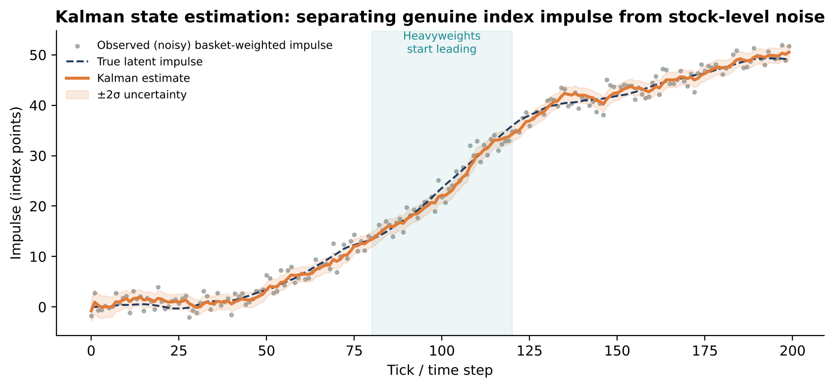
Figure 8. A Kalman filter recovers the latent index impulse and its uncertainty from noisy constituent-weighted observations (simulated).
Why this matters: suppose ICICI Bank and HDFC Bank start moving upward, followed by Reliance and Infosys. The model should estimate whether this is a genuine developing index impulse or unrelated stock-level movement, and the estimate should update as the other constituents respond. This could substantially improve entry timing.

3.3 Hawkes process: self-exciting order-flow detection
Particularly relevant to Apex. A Hawkes process models events whose occurrence increases the probability of further events. For example: aggressive buyers sweep the futures ask; more aggressive buyers arrive; sellers withdraw; more buyers arrive again; the move accelerates. This is not ordinary momentum. It is clustered event activity.
λt=μ+ti<t​αe−βt−ti
where $μ$ is the baseline event intensity, $α$ the excitation strength, $β$ the decay speed and $λ\left(t\right)$ the expected event intensity.
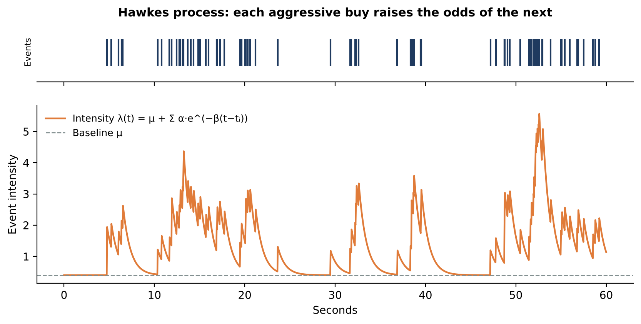
Figure 9. Simulated Hawkes process: clustered events push intensity well above baseline before decaying.
Build a multivariate Hawkes model with separate event streams:
- Aggressive futures buying.
- Aggressive futures selling.
- Ask liquidity withdrawal.
- Bid liquidity withdrawal.
- CE buying pressure.
- PE buying pressure.
- Heavyweight impulse events.
The most useful output would be $P\left(\text{buying intensity continues over next 30 s}\right)$, together with the corresponding bearish probability. This helps distinguish a one-off price spike from a developing chain reaction.
Important: estimate the model on actual timestamped events. Periodic snapshots are not equivalent to exchange-level event data.

3.4 First-passage probability and competing-risk survival models
This is arguably the most directly useful addition for the entry objective. The existing PCE already asks whether the target is reached before the adverse barrier; this should become a proper time-to-event model. Define $T_{G}$ as the time to reach the target, $T_{L}$ the time to reach the adverse barrier and $T_{H}$ the end of the holding horizon, and estimate:
$$P\left(T_{G}<T_{L}, T_{G}≤T_{H}∣X_{t}\right)$$
Go beyond binary classification. Use competing-risk survival analysis to estimate the probability of reaching the target within 1, 3, 5, 10 and 15 minutes, and of hitting the adverse barrier first.
Prediction | Probability
Target in 1 minute | 12%
Target in 3 minutes | 39%
Target in 5 minutes | 63%
Target in 10 minutes | 79%
Adverse barrier first | 14%
Illustrative numbers, not market results.
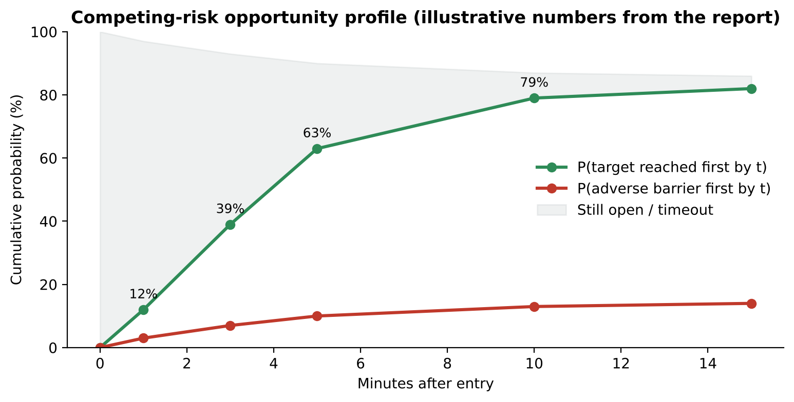
Figure 10. A time-dependent opportunity profile from a competing-risk model (illustrative values above).
The system can then distinguish between a trade likely to move immediately, a trade likely to move eventually, and a trade whose opportunity is already disappearing. That is directly aligned with the requirement to avoid non-riding trades.

Tier 2: advanced derivatives and volatility mathematics
High research priority.

3.5 Stochastic volatility models: Heston and SABR
The current approach uses IV, IV change, skew and volatility forecasts. A stochastic volatility framework is worth investigating. The Heston model assumes:
$$dS_{t}=μS_{t} dt+\sqrt{v_{t}} S_{t} dW_{1}$$
$$dv_{t}=κ\left(θ−v_{t}\right) dt+ξ\sqrt{v_{t}} dW_{2}$$
Volatility itself evolves as a stochastic process. This models volatility clustering, mean reversion in volatility, the correlation between Nifty movements and volatility changes, and the impact of changing volatility on option prices. For Nifty calls and puts, the leverage effect and skew are particularly important. SABR can also be investigated for modelling the implied-volatility smile.
Recommendation: use a calibrated volatility surface and a short-horizon IV-change forecast, rather than Heston or SABR as an independent buy/sell signal. They are valuation and scenario-generation tools, not directional predictors.

3.6 Volatility surface dynamics: SVI and surface residuals
The specifications already propose fitting IV against log-moneyness and eventually implementing SVI. This should go considerably further, with a continuously updated surface:
$$σ=σ\left(k,T\right), k=ln\left(K/F\right)$$
Track ATM volatility, put skew, call skew, smile curvature, term structure, surface displacement, and surface steepening and flattening. Then calculate the residual between observed market IV and fitted surface IV.
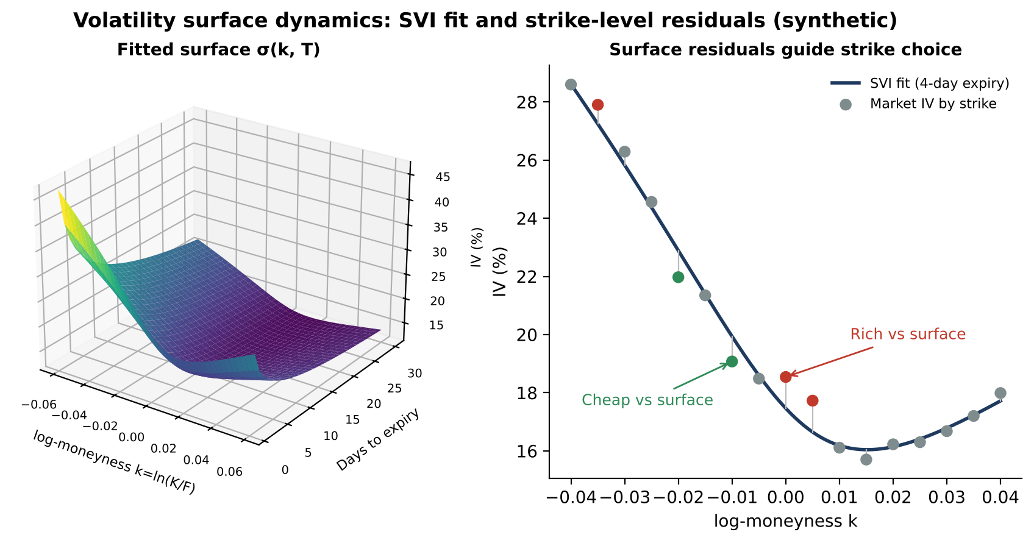
Figure 11. A fitted SVI surface (left) and strike-level residuals against it (right): rich and cheap strikes at the same expiry (synthetic).
An ATM option can be relatively expensive while an adjacent ITM option is relatively cheap. Strike selection should consider not just delta and premium but the option’s position on the volatility surface. This can improve strike selection even when the directional forecast is unchanged.

3.7 Rough volatility models
This is genuinely advanced. Traditional stochastic volatility models often fail to capture the extremely rough behaviour of short-horizon realised volatility. Rough volatility models describe volatility with fractional Brownian-type processes with low Hurst exponents. A simplified representation:
$$v_{t}=ξ_{0}\left(t\right)exp​\left(η\int_{0}^{t}{{\left(t−s\right)}^{H−\frac{1}{2}}} dW_{s}\right)$$
Apex trades short-duration weekly options, where volatility can change sharply over very short intervals, and a rough-volatility framework may model this better than a simple EWMA. However, it should sit behind a properly calibrated HAR-RV and Heston benchmark. Rough volatility is computationally demanding and may not add value for a 10–15 minute holding horizon.

3.8 Jump diffusion and jump detection
An ordinary volatility model assumes continuous price movement, but Nifty frequently moves abruptly. Implement Merton jump diffusion, bipower variation, realised jump variation, CUSUM change-point detection and sequential probability ratio tests. For example:
$$RV=BV+JV$$
where $RV$ is realised variance, $BV$ the continuous variation estimate and $JV$ the jump variation estimate.
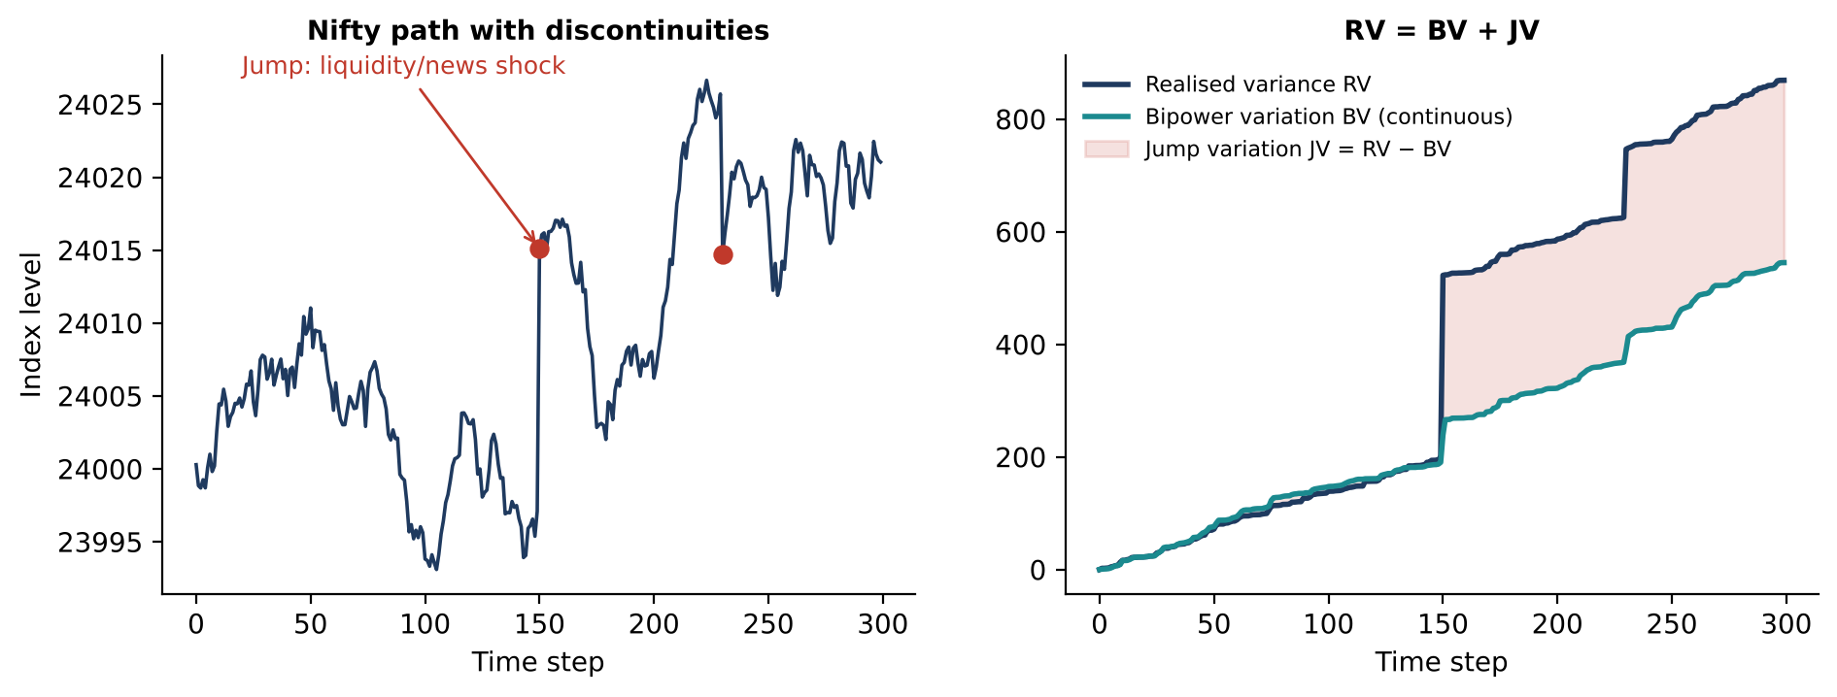
Figure 12. Separating continuous variation from jumps: bipower variation is robust to jumps, so the gap to realised variance isolates them (simulated).
The system should know whether a sudden 20-point Nifty move is part of an established trend, a liquidity-driven jump, a temporary news shock, or an isolated price discontinuity. This is especially important for avoiding entries immediately after an exhausted jump.

Tier 3: advanced microstructure mathematics
Potentially very valuable.

3.9 Kyle’s lambda and price-impact estimation
PCE already has a Kyle-lambda-style absorption detector. It should be expanded. The fundamental idea is:
$$ΔP=λQ+ϵ$$
where $ΔP$ is the price change, $Q$ the signed aggressive order flow and $λ$ the price impact per unit of signed flow. Estimate lambda over multiple rolling horizons.
Observation | Meaning
Rising lambda with buying pressure | Buy flow is having increasing price impact
Falling lambda with buying pressure | Buying is being absorbed or liquidity is replenishing
High volume, low price movement | Potential absorption
Low liquidity, rapidly rising lambda | Potentially fragile breakout
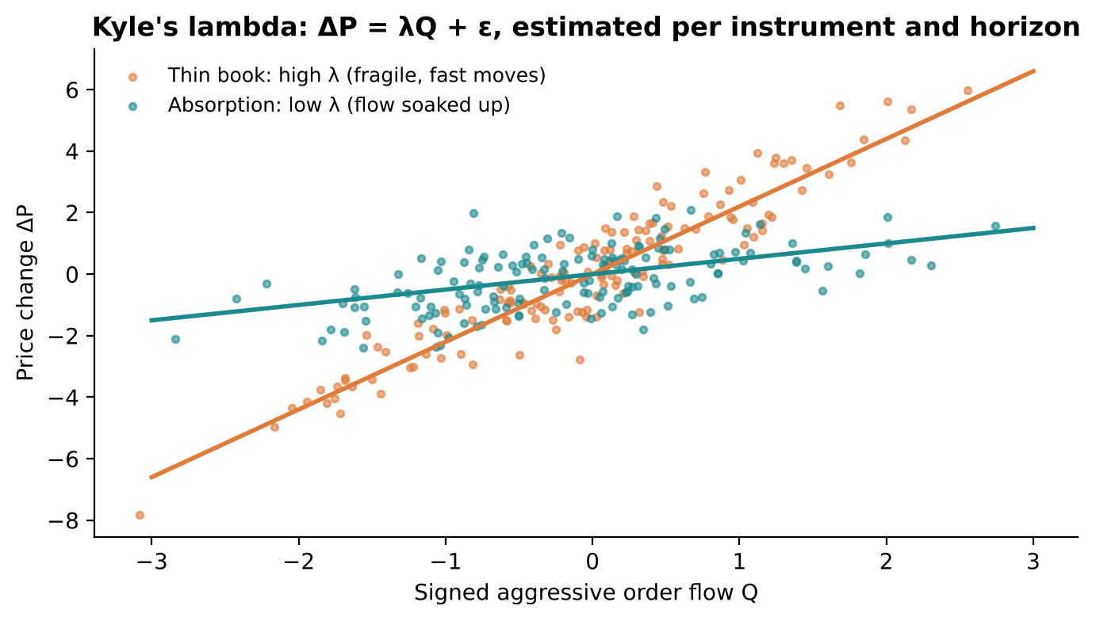
Figure 13. Two price-impact regimes: a thin book (steep λ) versus absorption (flat λ) (simulated).
The critical addition is to estimate lambda separately for Nifty futures, the ATM CE, the ATM PE and individual heavyweight futures. The aim is to know where aggressive orders are actually moving prices.

3.10 Order-book resilience and liquidity replenishment
flow.py already calculates quantity imbalance, order-count imbalance, withdrawal classes and a book-leads-price score. Add an explicit liquidity resilience model. After a sweep, measure:
$$R_{L}=\frac{\text{Liquidity replenished after sweep}}{\text{Liquidity consumed or withdrawn}}$$
Also estimate replenishment speed, cancellation intensity, average queue lifetime, repeated wall replenishment and price impact per unit of consumed liquidity.
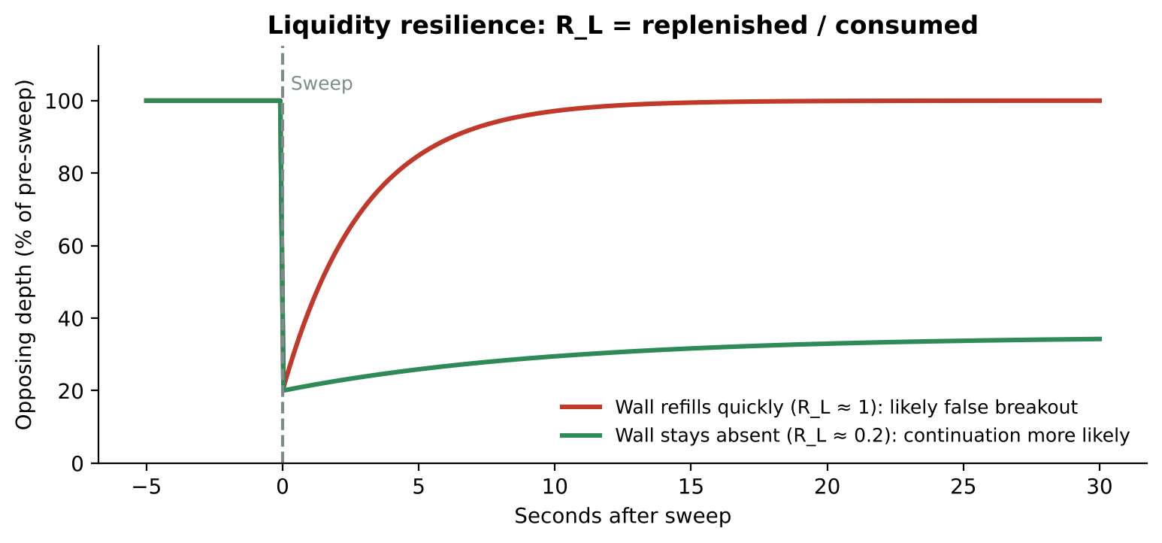
Figure 14. A wall that refills immediately and one that stays absent are very different events (illustrative).
A wall disappearing is not enough. A wall disappearing and immediately reappearing is a very different event from a wall disappearing and remaining absent. This could improve breakout continuation and false-breakout discrimination.

3.11 Multivariate lead-lag network
The current heavyweight model uses weighted impulses and rolling cross-correlations, but cross-correlation alone can produce misleading lead-lag relationships. Investigate Granger causality, transfer entropy, partial correlations, sparse vector autoregression, dynamic conditional correlation and directed information-flow networks.
Build a network of Nifty futures, BankNifty futures, FinNifty futures, the major Nifty constituents, the ATM CE, the ATM PE and the synthetic forward. Then estimate which instruments provide genuinely incremental information about future Nifty returns.
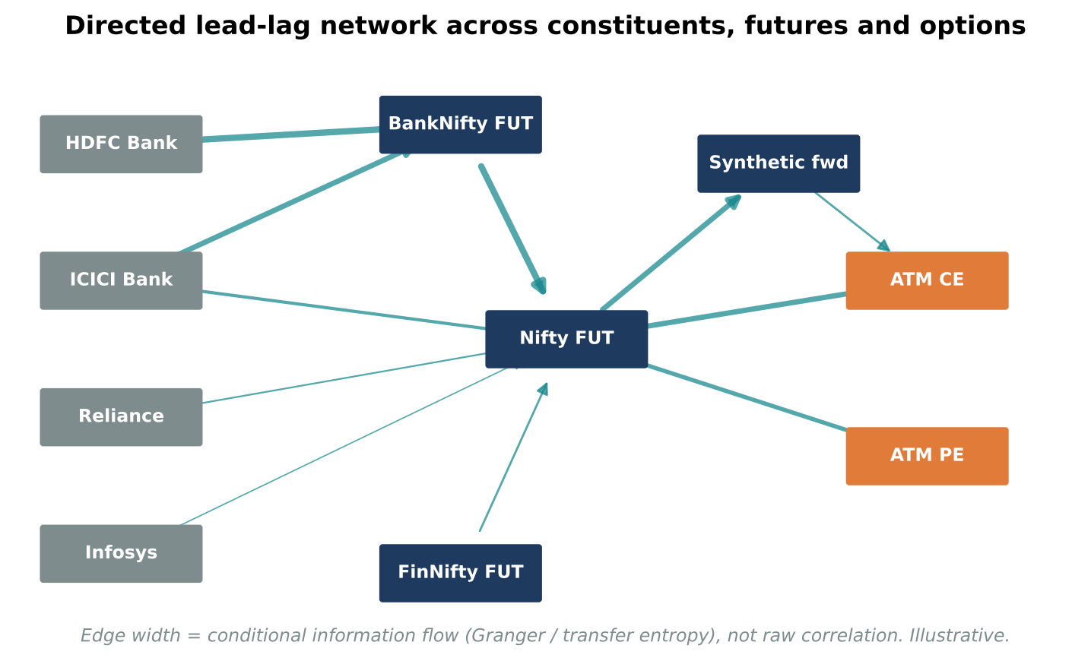
Figure 15. A directed lead-lag network weighted by conditional information flow rather than raw correlation (illustrative).
Particularly important: use conditional relationships rather than simple correlation. Reliance and Nifty may move together because both are reacting to the same market-wide event; that does not mean Reliance is leading Nifty. Transfer entropy can help investigate nonlinear directional information flow, although it requires substantial data and careful statistical validation.

Tier 4: advanced machine learning and probability engineering
These techniques could turn Apex from a collection of indicators into a genuinely predictive system.

3.12 Gradient boosting with meta-labelling
The PCE specification already proposes logistic regression and LightGBM with probability calibration. A slightly different approach is recommended: build two models.
- Model A, opportunity detector: identifies every potentially tradable opportunity, prioritising recall.
- Model B, trade-quality classifier: determines which detected opportunities have a sufficiently high probability of producing a profitable premium move, prioritising precision.
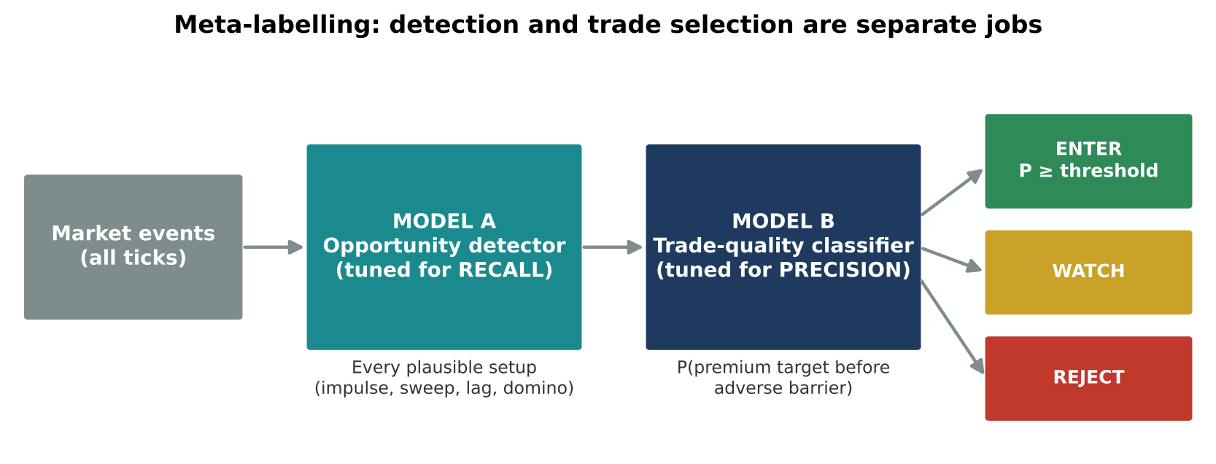
Figure 16. Meta-labelling separates a high-recall detector from a high-precision trade selector.
Opportunity | Model A | Model B | Decision
Strong futures impulse | Detected | 91% | Enter candidate
Weak breakout | Detected | 42% | Reject
CE premium lag | Detected | 86% | Enter candidate
Heavyweight synchronisation | Detected | 78% | Watch
False breakout | Detected | 13% | Reject
The opportunity detector does not need to become excessively restrictive just because the quality classifier is cautious. This is particularly important for the objective of not missing large moves.

3.13 Bayesian probability updating
Instead of treating the five advisors as independent yes/no votes, implement Bayesian evidence accumulation. Start with a prior probability $P\left(H\right)$, where $H$ represents a successful trade, and update it as evidence arrives:
$$P\left(H∣E\right)=\frac{P\left(E∣H\right) P\left(H\right)}{P\left(E\right)}$$
Suppose the futures impulse is positive, heavyweight synchronisation is strong, the option premium is lagging, liquidity is being withdrawn from the opposing side, and IV is not excessively rich. Each observation changes the probability.
There is a critical complication: these observations are correlated. Futures OFI, futures price acceleration and heavyweight impulse may all reflect the same underlying event, and treating them as independent evidence would exaggerate confidence. Use a Bayesian network or hierarchical probabilistic model to account for dependencies. The output should be:
- Probability of success.
- Probability of immediate adverse movement.
- Probability of delayed continuation.
- Probability of volatility-related premium failure.
- Uncertainty around each probability.

3.14 Conformal prediction
Machine-learning models can be confidently wrong when market conditions change. Conformal prediction constructs prediction sets with statistically controlled coverage under suitable exchangeability assumptions. Instead of merely predicting $P\left(\text{success}\right)=0.86$, the system could report: predicted success probability 86%, estimated uncertainty high, prediction set {SUCCESS, TIMEOUT}. In that case the model should not treat 86% as unquestionable evidence.
Use rolling, regime-conditional conformal calibration with explicit monitoring for distribution shift. This helps prevent excessively confident trades when the market starts behaving differently from the training data.

3.15 Online learning with contextual bandits
The existing parallel paper books are an excellent starting point for a contextual bandit. Suppose Apex has five entry approaches: futures impulse, heavyweight domino, liquidity sweep, premium lag and gamma-leg continuation. The best approach may depend on market state. A contextual bandit learns a policy:
$$a_{t}=π\left(X_{t}\right)$$
where $X_{t}$ is the current market context and $a_{t}$ the selected strategy. In a directional expansion regime, futures impulse might work best; in a compression-to-expansion transition, liquidity sweeps; in a high-IV regime, premium-lag opportunities.
Run this entirely in shadow mode first. Do not let an online learner experiment with unrestricted live decisions; use pre-registered actions, logged propensities and controlled exploration.

3.16 Change-point detection and CUSUM
A particularly useful addition is detecting when an existing market relationship stops working: heavyweights stop leading Nifty, futures OFI stops predicting price, CE premium stops responding to positive Nifty movement, or gamma walls stop acting as barriers. CUSUM detects persistent shifts:
$$S_{t}=max\left(0, S_{t−1}+x_{t}−k\right)$$
If $S_{t}$ exceeds a threshold, the system flags a possible structural change.
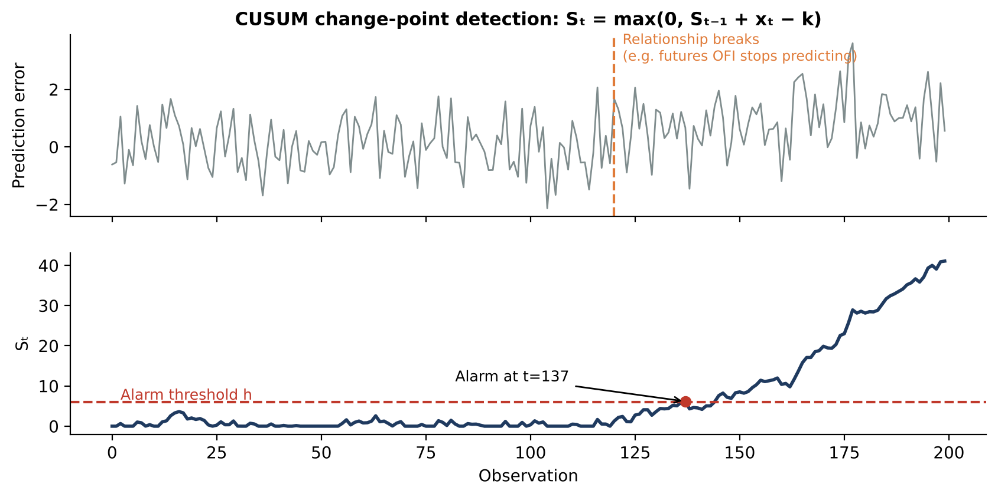
Figure 17. CUSUM accumulates evidence after a relationship breaks and raises an alarm once it crosses the threshold (simulated).
This is more useful than knowing whether an indicator is currently bullish or bearish: it tells Apex when its previously reliable assumptions are breaking down.

Tier 5: mathematics beyond conventional trading systems
To investigate only after the preceding layers have been validated.
Technique | What it could do in Apex | Priority
Fractional Brownian motion | Model long-memory and rough short-term volatility | Medium
Multivariate Hawkes processes | Detect cascading buying/selling across instruments | Very high
Hidden semi-Markov models | Estimate market states and their expected duration | Very high
Unscented Kalman filter | Estimate latent momentum and changing lead-lag | High
Transfer entropy | Identify nonlinear information transmission between instruments | High
Neural stochastic differential equations | Model nonlinear market dynamics | Experimental
Deep temporal convolutional networks | Learn temporal patterns in tick and order-flow sequences | Experimental
Transformer-based time-series models | Learn interactions between multiple market streams | Experimental
Optimal stopping theory | Decide when an opportunity has deteriorated enough to abandon | High
Extreme value theory | Model unusually large adverse moves and sudden shocks | High
Rough volatility | Model rapidly changing volatility at short horizons | Medium
Particle filters | Estimate nonlinear, non-Gaussian hidden market states | Medium
Dynamic Bayesian networks | Model how market events influence one another | High
A word of caution: neural networks and transformers should not be the first move. With a limited number of independent trading sessions, a sophisticated deep-learning architecture can easily learn historical noise. First establish that simpler models (logistic regression, gradient boosting, HMMs and Hawkes processes) provide measurable improvements.

4. The most important missing model: an opportunity about to disappear
The existing system detects impulse, liquidity movement, heavyweight synchronisation, gamma-leg activity and premium lag. It should also explicitly model the remaining lifetime of an opportunity: the Opportunity Decay Model (ODM).
Suppose an event begins at $t_{0}$. As time passes, the underlying has already moved, the option premium begins catching up, the remaining liquidity decreases, the initial order-flow imbalance may weaken, and the distance to resistance shrinks. The opportunity is gradually consumed. Calculate:
$$O_{t}=P\left(\text{target reached before adverse barrier}∣X_{t}\right)$$
$$D_{t}=−\frac{dO_{t}}{dt}$$
A rapidly declining $O_{t}$ indicates the opportunity is deteriorating. An opportunity may be deteriorating for different reasons, and the model should identify which:
- Its directional catalyst is disappearing.
- Its premium has already repriced.
- The opposing liquidity has replenished.
- The move is approaching an opposing structural level.
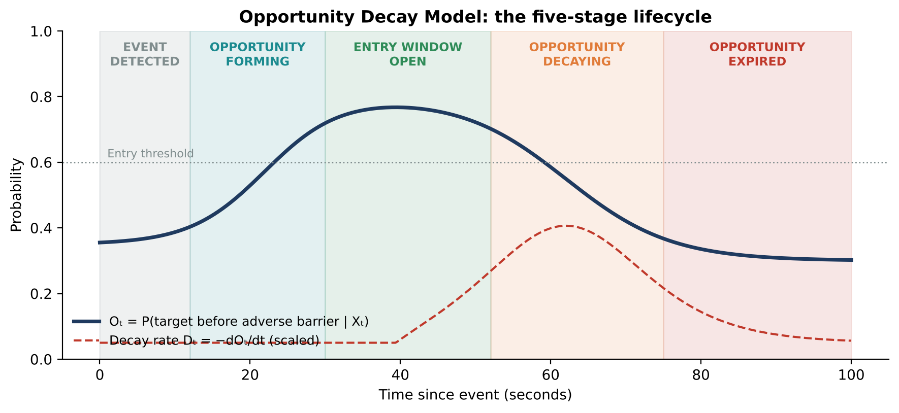
Figure 18. The proposed five-stage opportunity lifecycle with continuation probability and decay rate (illustrative).
Proposed Apex opportunity lifecycle
Stage | Meaning
1. Event detected | An unusual impulse, liquidity sweep or heavyweight synchronisation occurs
2. Opportunity forming | The catalyst is strengthening, but the option has not fully repriced
3. Entry window open | Expected premium appreciation is sufficient and continuation probability is high
4. Opportunity decaying | Premium catches up, the catalyst weakens or opposing liquidity returns
5. Opportunity expired | The original setup no longer offers a favourable expected outcome
This is more useful than having dozens of indicators independently announcing BUY or SELL.

5. Redesigning the decision architecture
The existing Apex engine should not be discarded. Instead, a new quantitative intelligence layer should sit above it: the APEX Quantitative Intelligence Engine.
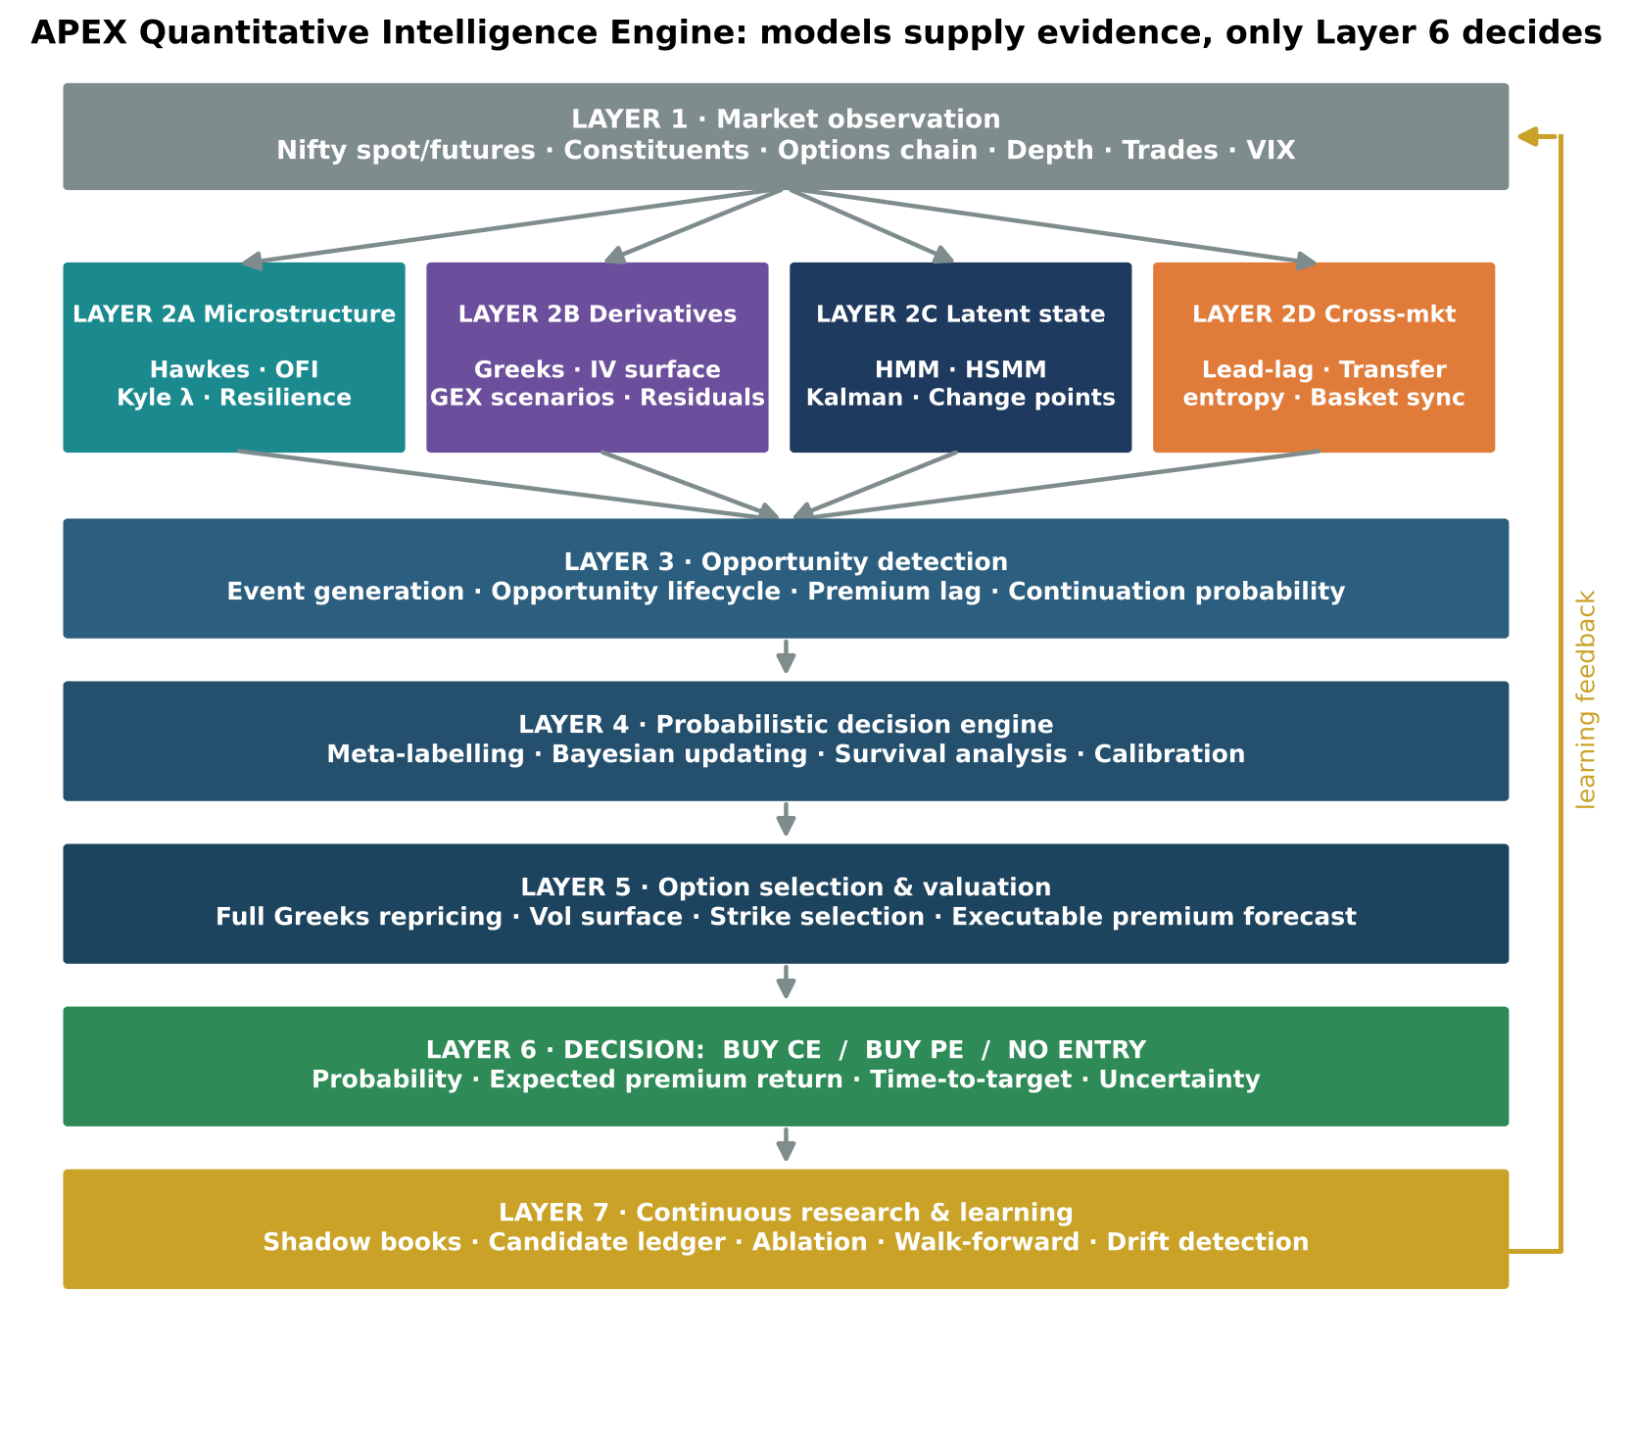
Figure 19. The seven-layer APEX Quantitative Intelligence Engine.
Layer | Responsibility | Components
1. Market observation | Raw data | Nifty spot/futures, constituents, options chain, depth, trades, VIX
2A. Microstructure | Order-flow evidence | Hawkes, OFI, Kyle lambda, liquidity resilience
2B. Derivatives intelligence | Premium feasibility | Greeks, IV surface, GEX scenarios, premium residuals
2C. Latent market state | Regime evidence | HMM, HSMM, Kalman, change points
2D. Cross-market intelligence | Leadership evidence | Lead-lag, transfer entropy, basket synchronisation
3. Opportunity detection | Candidate generation | Event generation, opportunity lifecycle, premium lag, continuation probability
4. Probabilistic decision engine | Evidence fusion | Meta-labelling, Bayesian updating, survival analysis, calibration
5. Option selection and valuation | Instrument choice | Full Greeks repricing, volatility surface, strike selection, executable premium forecast
6. Decision | BUY CE / BUY PE / NO ENTRY | Probability, expected premium return, time-to-target, uncertainty
7. Continuous research and learning | Improvement loop | Shadow books, candidate ledger, ablation, walk-forward validation, drift detection
The key architectural principle is that each layer has a distinct responsibility. The Hawkes model should not independently issue a BUY signal; it provides evidence about order-flow continuation. The volatility model should not independently issue a BUY signal; it provides information about premium feasibility. The final decision combines these inputs.

6. Improvements to the existing learning engine
This determines whether Apex actually becomes better over time. apex/engine/learning.py already makes several good decisions:
- Parallel books operate on identical data.
- RAW provides a control for advisor evaluation.
- Random-entry, futures-only and premium-momentum controls exist.
- Strategy promotion is based on statistical comparisons.
- Leave-one-day-out checks are used.
- Changes take effect on the next session rather than intraday.
The statistics should be strengthened considerably.

6.1 Repeated observations are not independent
If the same Nifty impulse generates five candidate opportunities within 30 seconds, those are not five independent market events. Training on them as independent examples makes the model overconfident. Introduce:
- Event-level grouping.
- Session-level clustering.
- Purged walk-forward validation.
- Embargo periods.
- Effective sample-size calculations.
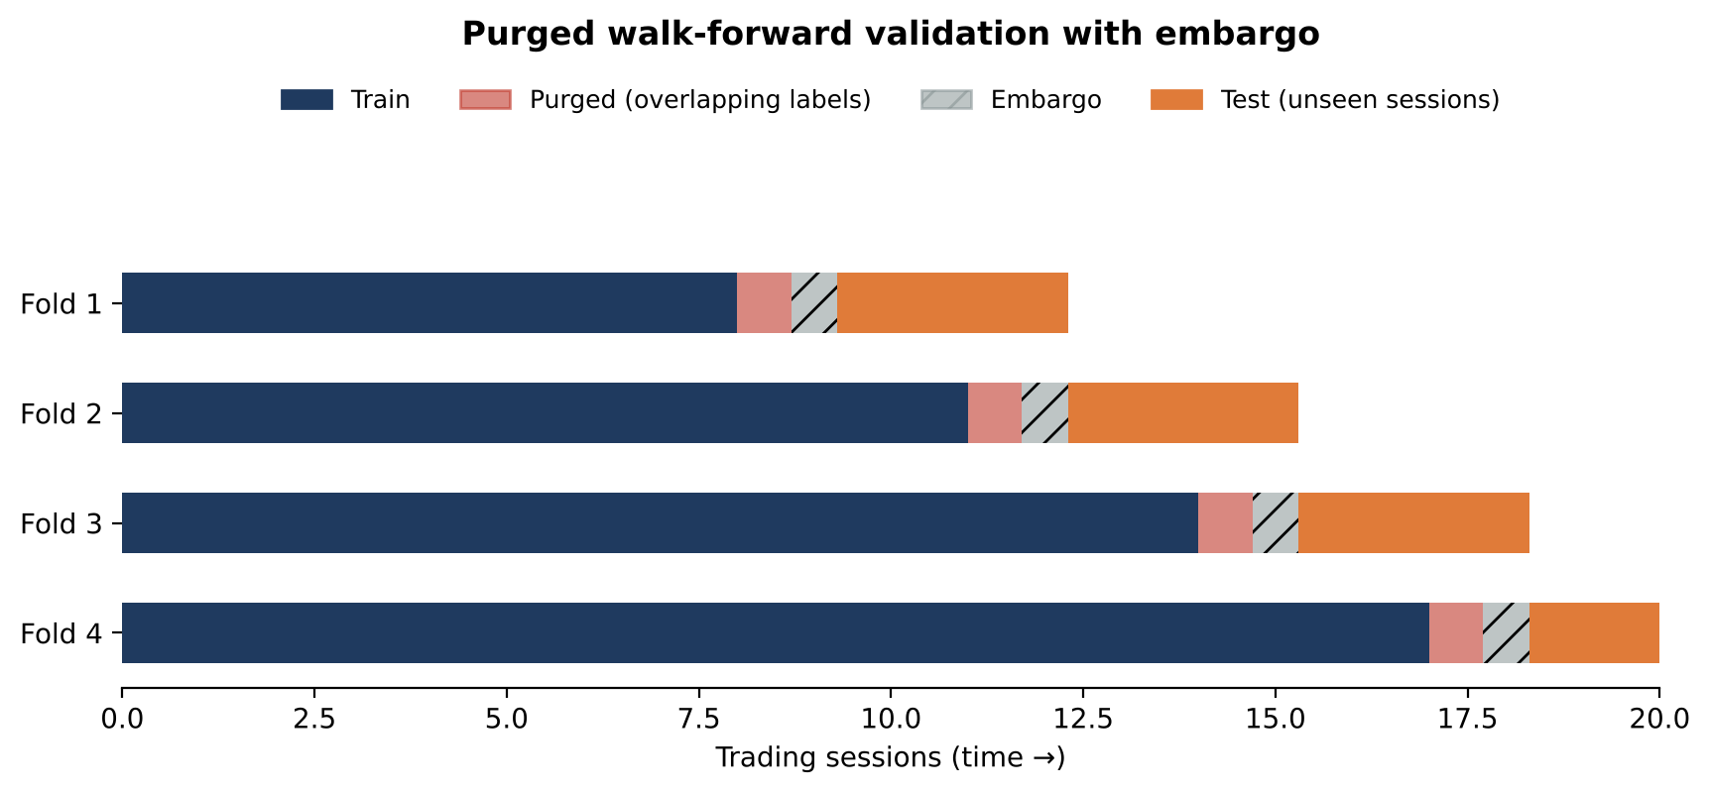
Figure 20. Purged walk-forward validation: overlapping labels are purged and an embargo separates training from unseen test sessions.

6.2 Repeated strategy selection creates false discoveries
Bonferroni correction is a useful start, but repeated nightly testing and promotion decisions introduce additional selection bias. Investigate:
- Deflated Sharpe Ratio.
- Probability of Backtest Overfitting (PBO).
- Combinatorially Symmetric Cross-Validation.
- White’s Reality Check.
- Hansen’s Superior Predictive Ability test.
These are particularly useful when many strategy variants are being compared.

6.3 Winning trades are not necessarily the best trades
The learning engine evaluates compounded returns, which suits the account-level objective, but the opportunity model needs additional measurements:
Metric | What it tells you
Target-first probability | Whether the target wins the race
MFE | Maximum available profit
MAE | Maximum adverse movement
Time to MFE | How quickly the trade runs
Time to target | How quickly the opportunity pays
Initial adverse excursion | Whether the entry was clean
Premium capture ratio | How much of the available move was captured
Opportunity rejection cost | Profitability of rejected opportunities
Calibration error | Whether predicted probabilities are trustworthy
Incremental feature value | Whether a new model adds information

6.4 A feature-ablation laboratory
This is essential. Suppose the champion has 40 input features and Hawkes intensity is introduced. It must be established whether Hawkes adds anything once the existing 40 features are considered. Run:
- Champion without Hawkes.
- Champion with Hawkes.
- Champion with Hawkes but without futures OFI.
- Champion with futures OFI but without Hawkes.
- Champion with both, with event-level controls.
Measure the difference on unseen sessions, using conditional permutation importance or grouped feature ablation rather than ordinary feature importance. This prevents a new technique from receiving credit for information that another feature already provides.

7. Specific problems in the current specifications
These are subtle issues that could undermine otherwise sophisticated mathematics.
Existing approach | Problem | Recommended correction
OI falling = writer covering | OI reduction alone cannot identify which side is closing | Combine OI changes with aggressor flow and price response
Maximum OI = resistance/support | OI does not establish who controls the position | Treat as probabilistic positioning evidence
Synthetic future leading spot | Quote noise, skew and stale quotes can create false leadership | Calculate synchronised, executable-side parity and compare with actual futures
Delta/gamma premium forecast | Higher-order effects omitted | Full option repricing under simulated future states
IV percentile | Can mislead around expiry and event shocks | Condition on time-to-expiry, moneyness and time of day
Fixed probability threshold of 80% | A probability can be poorly calibrated | Require demonstrated out-of-sample calibration
500 candidate labels | Correlated candidates may represent far fewer independent events | Measure effective sample size and use event-level splits
OI acceleration | Exchange OI updates can be discontinuous | Model actual update events, not repeated snapshots
One additional problem: the specification suggests that a PE on a support break may benefit from rising IV, while a CE on a bounce may suffer from falling IV. That is a useful market hypothesis, but it must not become a fixed rule. The relationship depends on the contemporaneous volatility surface, skew changes, moneyness, and the direction and speed of the underlying move. Let the model estimate these effects separately for each opportunity.

7.1 A better option-premium forecast
Go beyond estimating one expected premium. For every eligible CE and PE, generate a scenario distribution:
Scenario | Nifty movement | IV movement | Premium outcome
Bullish continuation | Strong upward | Stable | CE repricing
Bullish continuation | Strong upward | Falling | CE repricing after IV loss
Bearish continuation | Strong downward | Rising | PE repricing
Directional failure | Reversal | Falling | Premium loss
Sideways | Minimal | Falling | Theta/IV-related loss
Then calculate:
$$E\left[\text{Premium Return}∣X_{t}\right]$$
$$P\left(\text{Premium Return}≥10\%∣X_{t}\right)$$
$$P\left(\text{Premium Return}≤−\text{adverse threshold}∣X_{t}\right)$$
and finally:
$$EV=P\left(W\right) E\left[W\right]−P\left(L\right) E\left[L\right]−E\left[C\right]$$
where $C$ includes transaction costs and execution impact. This is a more complete decision criterion than asking whether the option is statistically cheap.

8. The most important engineering issue: data quality
Apex is unusually dependent on microstructure data. flow.py classifies trades against previous quotes, tracks liquidity changes at high frequency and explicitly handles stale depth. Introduce a formal data-quality score for every instrument:
$$Q_{t}=f\left(\text{quote age}, \text{sequence continuity}, \text{spread}, \text{missing updates}, \text{timestamp consistency}\right)$$
More importantly, separate and measure the delay between:
- Exchange event time.
- Broker timestamp.
- Local receipt time.
- Engine processing time.
A 100 ms processing interval does not mean the system receives genuine exchange updates every 100 ms. Also measure out-of-order events, duplicate events, missing updates, quote changes without corresponding trades, abnormal bid/ask crossings, and instrument-specific update frequency.
Why this matters. Suppose the model sees ask quantity disappearing, buyer pressure increasing and premium rising, but the ask quantity was actually withdrawn 800 ms before the system received the update. The model may interpret the sequence incorrectly. For a system entering within a narrow opportunity window, timestamp correctness is as important as the mathematical model itself.
No advanced predictive model should consume data without receiving its freshness and quality metadata.

9. Recommended implementation priority
Implementing all of these techniques simultaneously would make it extremely difficult to identify which changes actually improve Apex. Follow this order:
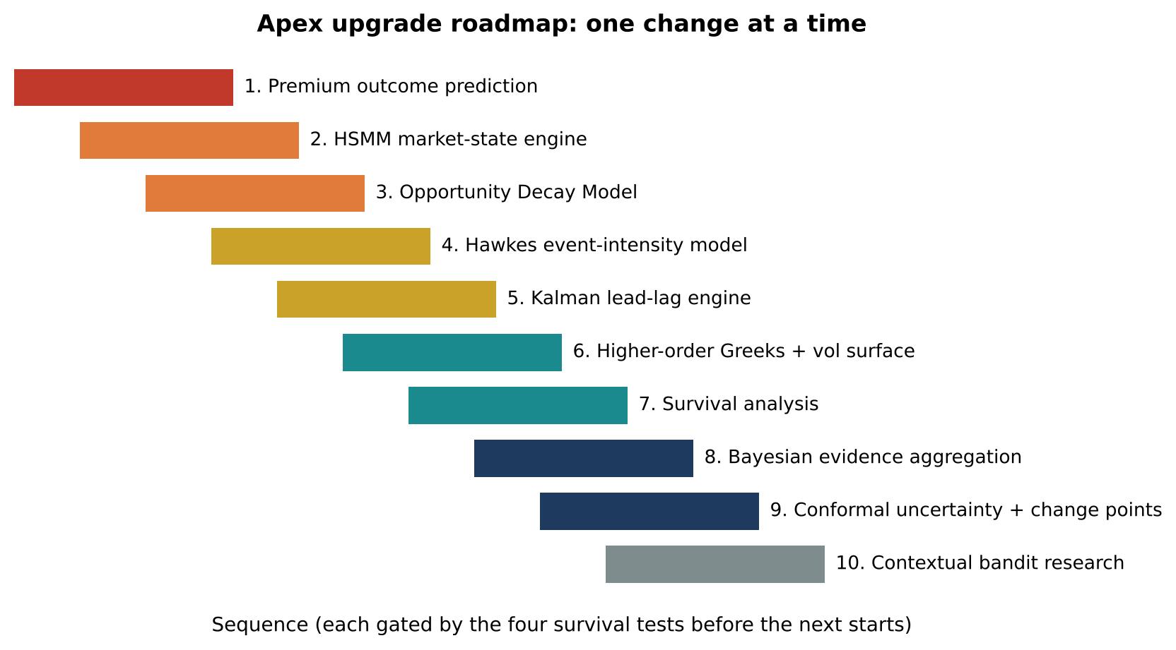
Figure 21. Apex upgrade roadmap, sequenced so each change can be evaluated in isolation.
Step | Upgrade | Purpose
1 | Premium outcome prediction (highest priority) | Separate Nifty-direction prediction from actual CE/PE premium prediction; full repricing and competing-risk labels
2 | HSMM market-state engine | Infer latent regimes and their expected duration; feed probabilities to the decision model
3 | Opportunity Decay Model | Estimate how quickly each opportunity is losing potential
4 | Hawkes event-intensity model | Identify self-reinforcing buying/selling across futures and options
5 | Kalman-based lead-lag engine | Improve heavyweight-to-Nifty impulse estimation
6 | Higher-order Greeks and volatility surface | Vanna, Vomma, Charm, Speed and full Black-76 repricing under volatility scenarios
7 | Survival analysis | Target-first probabilities at multiple horizons
8 | Bayesian evidence aggregation | Combine correlated observations without double-counting
9 | Conformal uncertainty and change-point detection | Detect when model confidence is no longer justified
10 | Contextual bandit research | Learn which pre-registered entry method works best in each state

9.1 How each upgrade earns its place
Every new technique must pass four tests.
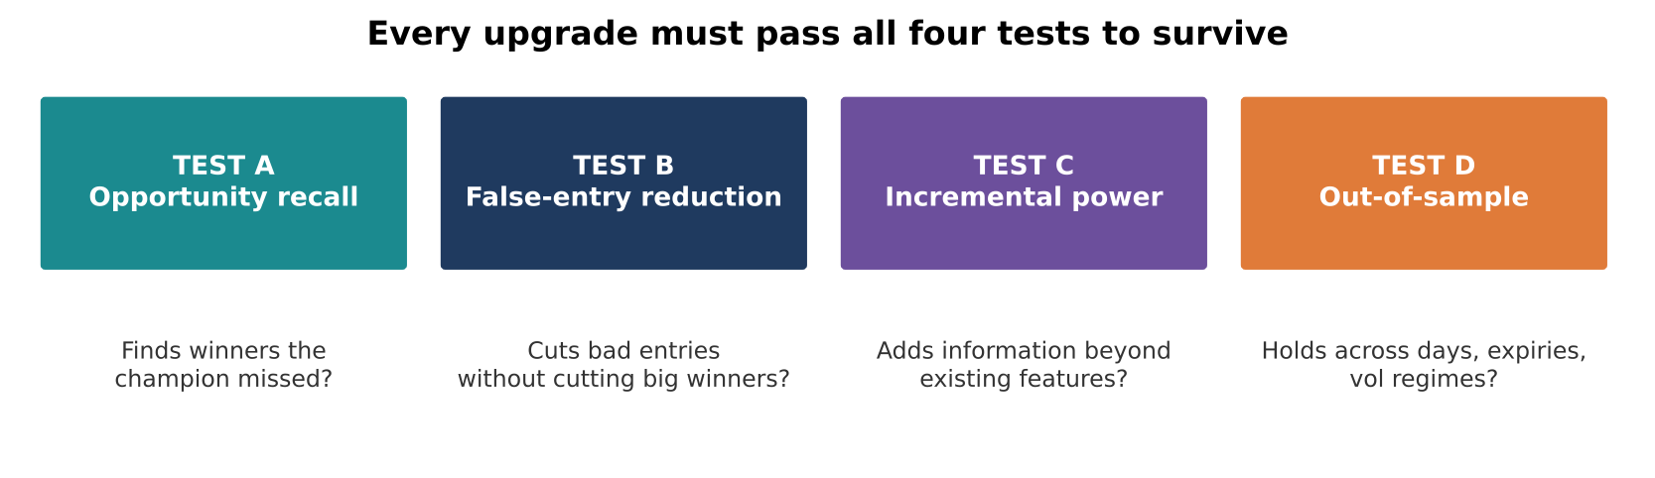
Figure 22. The four survival tests for any upgrade.
- Test A, opportunity recall: did it help identify profitable moves the existing champion missed?
- Test B, false-entry reduction: did it eliminate bad entries without eliminating the large winners?
- Test C, incremental predictive power: did it improve prediction beyond the existing features?
- Test D, out-of-sample consistency: did it work across different days, expiry conditions, volatility regimes and market structures?
Maintain four standing performance measurements:
Measurement | Objective
Good-opportunity recall | Maximise
Bad-entry rate | Minimise
Missed-winner rate | Minimise
Net expected premium return | Maximise
Execution caveat: the README states that paper-trading execution currently fills at LTP and ignores slippage and charges. Even a statistically successful signal cannot yet be treated as evidence of executable profitability.

10. Final assessment
Area | Assessment
Market data collection | Strong foundation
Microstructure intelligence | Advanced
Derivatives mathematics | Good foundation, room for substantial improvement
Opportunity detection | Promising
Premium prediction | Needs to become the central intelligence layer
Regime modelling | Good starting point
Self-learning architecture | Very promising
Statistical validation | Needs stronger protection against selection bias
Research extensibility | Excellent
These are qualitative assessments of the architecture, not measured performance scores.

The five additions to prioritise above everything else
- Hawkes process: detect when buying or selling activity is becoming self-reinforcing, rather than simply observing that prices have moved.
- Hidden semi-Markov model: identify the hidden market state and estimate how long it is likely to persist.
- Competing-risk survival model: estimate whether the target will be reached before the adverse barrier, and how quickly.
- Higher-order Greeks and full repricing: predict what the option premium should become after underlying movement, volatility changes and time decay.
- Bayesian meta-labelling: separate detecting opportunities from deciding whether they are good enough to trade.

Change the fundamental question Apex asks
Move away from “Is Nifty likely to move upward or downward?”, and even from “Is the CE or PE likely to appreciate?” The central question should be:
“Given everything happening in the market right now, which available Nifty option has the highest probability of producing a meaningful, relatively immediate premium appreciation before experiencing an unacceptable adverse move?”
That question combines market microstructure, derivatives mathematics, volatility modelling, probability theory, statistical learning, market-state estimation and time-to-event modelling, and it is much closer to the actual problem being solved.
One mathematical reality should remain explicit: no model can guarantee that it will never miss a winner or never take a losing trade. The objective is to maximise opportunity capture while reducing false entries, with statistically demonstrated improvements.
The strongest recommendation is to build the next Apex generation around predicting the future behaviour of the option premium, with all the other mathematical models acting as evidence providers to that prediction. That is where the greatest opportunity for improvement lies.

Appendix A. Independent reviewer notes
These notes come from a second, independent read of the teardown, intended to help stakeholders weigh its recommendations.
Where the teardown is strongest. Its highest-value points need no new mathematics: making the option premium (not index direction) the prediction target; recognising that correlated candidates from one impulse are not independent samples; noting that LTP fills with no slippage or charges overstate results; and insisting on timestamp and data-quality discipline. These would likely change measured results more than any individual new model.
Where caution is warranted.
- Data budget. The catalogue is broad relative to the data available. With a few dozen independent sessions, rich models such as HSMMs, multivariate Hawkes processes and contextual bandits risk fitting noise. Each should be introduced only through the ablation laboratory (Section 6.4) and the four survival tests (Section 9.1).
- Event data for Hawkes. A Hawkes model needs genuine event-level timestamps. A snapshot feed (for example, periodic depth updates) does not supply this, so the feasibility of Section 3.3 depends on the data source.
- Overlap with rejected ideas. Some proposals (regime models, OI-based positioning) revisit areas the 29 October research rejected as entry triggers. The teardown frames them as probabilistic features rather than gates, which is the right distinction, but they should still be held to the incremental-value test.
- Review scope. The teardown was based on documentation and a subset of source files; it did not execute code or tests. Implementation-level claims (for example, the discount-factor and expiry-floor observations) should be confirmed against the current code before work is scheduled.
Suggested immediate actions (low cost, high value). (1) Add realistic slippage and charges to paper fills. (2) Group candidates by originating event and report effective sample size. (3) Separate exchange, broker, receipt and processing timestamps in logs. (4) Add the premium-outcome labels (target-first, MFE/MAE, time-to-target) to the candidate ledger before building any new model.

Appendix B. Glossary
Term | Meaning
ATM / ITM / OTM | At-, in- and out-of-the-money options relative to the current forward
Black-76 | Option pricing model using the forward price; standard for index futures options
CE / PE | Call option / put option (NSE nomenclature)
CUSUM | Cumulative-sum test for detecting a persistent shift in a process
Delta, Gamma, Vega, Theta | Sensitivities of option price to underlying, delta change, volatility and time
Vanna, Vomma, Charm | Second-order sensitivities: delta to vol, vega to vol, delta to time
GEX | Gamma exposure: estimated dealer hedging pressure across strikes
Hawkes process | Self-exciting point process in which events raise the probability of further events
HMM / HSMM | Hidden (semi-)Markov model for inferring unobserved regimes; HSMM models regime duration
IV | Implied volatility, backed out of option prices
Kalman filter | Recursive estimator of a hidden state from noisy observations
Kyle’s lambda | Price impact per unit of signed order flow
LTP | Last traded price
Meta-labelling | Two-stage modelling: detect candidates, then classify their quality
MFE / MAE | Maximum favourable / adverse excursion during a trade
OFI | Order-flow imbalance
OI / PCR | Open interest / put-call ratio
PBO | Probability of Backtest Overfitting
PCE | Premium Continuation Engine (Apex specification)
SVI | Stochastic Volatility Inspired parameterisation of the volatility smile
Survival / competing-risk model | Models time until one of several mutually exclusive outcomes occurs

