

Rolling Average Calculator

Gr. 30411
Bucur Bogdan
Comșa Darian
Coord. Prof. Pop Diana-Irena

Contents

1.PROJECT SPECIFICATIONS 3
1.1 Operating procedure: 3
2. DESIGN 4
2.1 The Black Box 4
2.2 Command and Execution Units 4
2.2.1 Mapping the inputs and outputs on the C.U./E.U. 4
2.2.2 Establishing the resources (E.U.) 5
2.2.3 Detailed scheme 10
2.3 State diagram of Control Unit 11
3. USER MANUAL 12
4. DESIGN SOLUTION JUSTIFICATION 12
5. FURTHER DEVELOPMENT 12
6. BIBLIOGRAPHY 13

1.PROJECT SPECIFICATIONS

The purpose of the project is to design and implement a simple digital processing system that will calculate the rolling average of a parallel 8-bit data stream. The system is developed as a VHDL model and the design will be demonstrated on the Basys 3 Artix-7 FPGA board.

1.1 Operating procedure:

The system is controlled by two sets of three switches, representing the length (LEN) input and the control (CTRL) input. The control input dictates the data generation mode (fig. 1), while the length input determines the sample size (fig. 2). The output of the system will be displayed on 4 SSDs, two representing the most recent value added to the average, and two representing the average result. The SSDs will temporarily display ”--” until the number of values required for the sample size is generated. In the case of an invalid LEN or CTRL configuration, the SSDs will display ”----”.

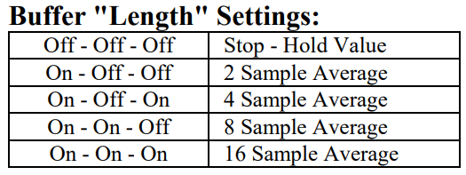
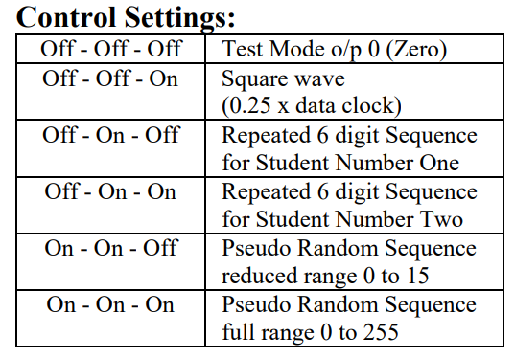

figure 1

figure 2

2. DESIGN

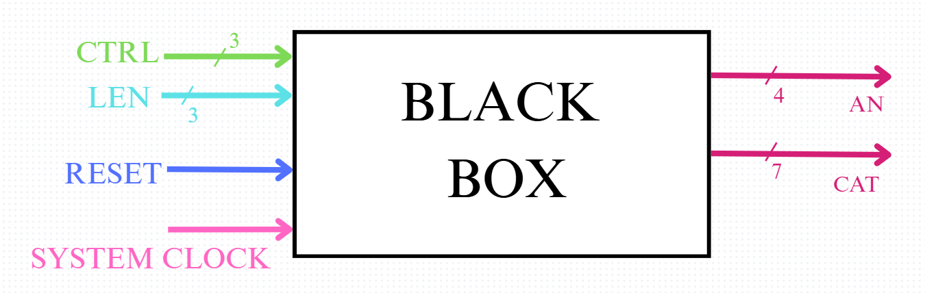
2.1 The Black Box

2.2 Command and Execution Units

2.2.1 Mapping the inputs and outputs on the C.U./E.U.
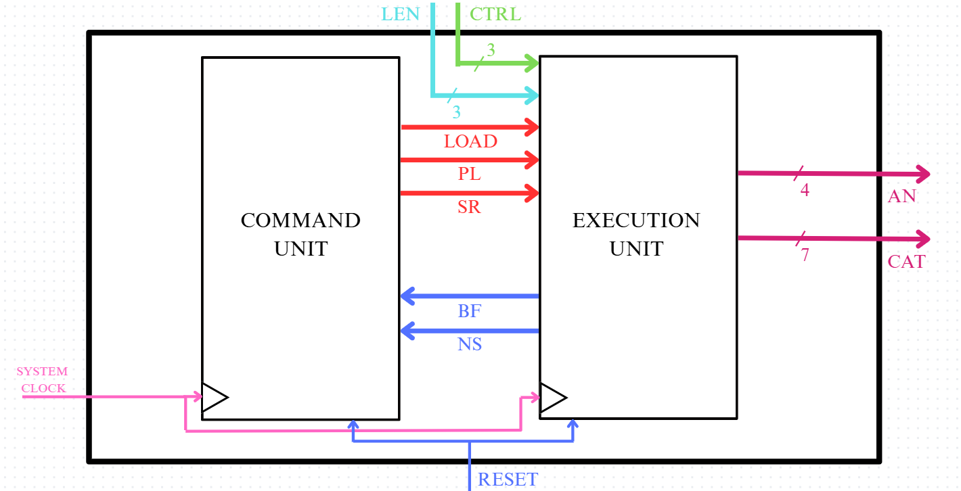

2.2.2 Establishing the resources (E.U.)
1. Data Generator (Implemented by Bucur Bogdan)
The data generator receives as input CTRL and according to its configuration, generates values further transmitted to the data buffer through the VAL signal. It has an incorporated clock divider, generating the data clock. In the case of an invalid CTRL instruction, the component sends out the Cerr signal to the SSD decoder.
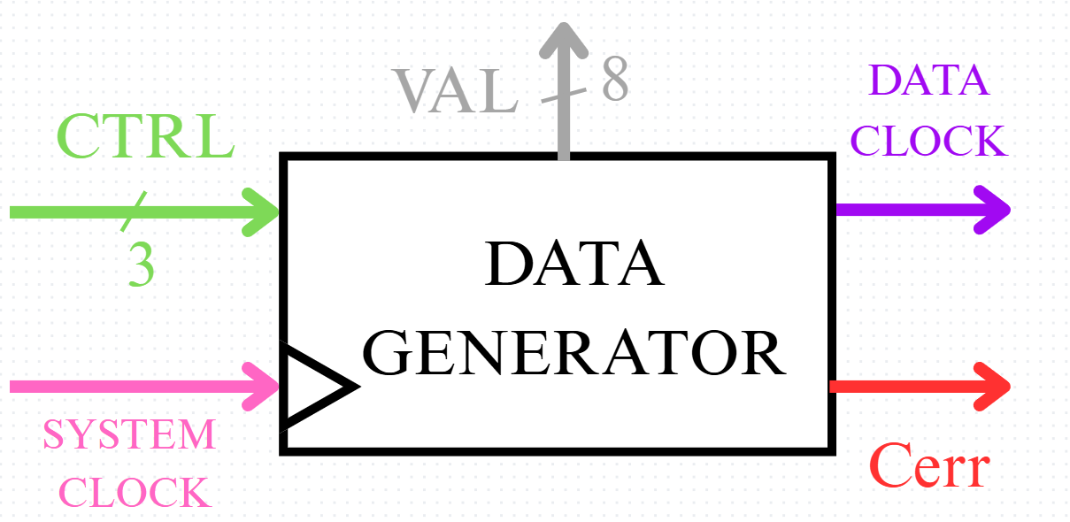
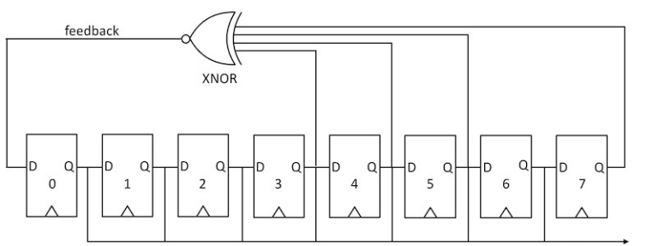
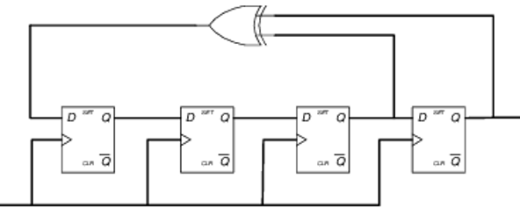
The interior scheme of the data generator uses 2 buffers behaving as a shift register with the 6 digits stored within each, and 2 PRBS generators, on 4 and 8 bits respectively, with the following structures:
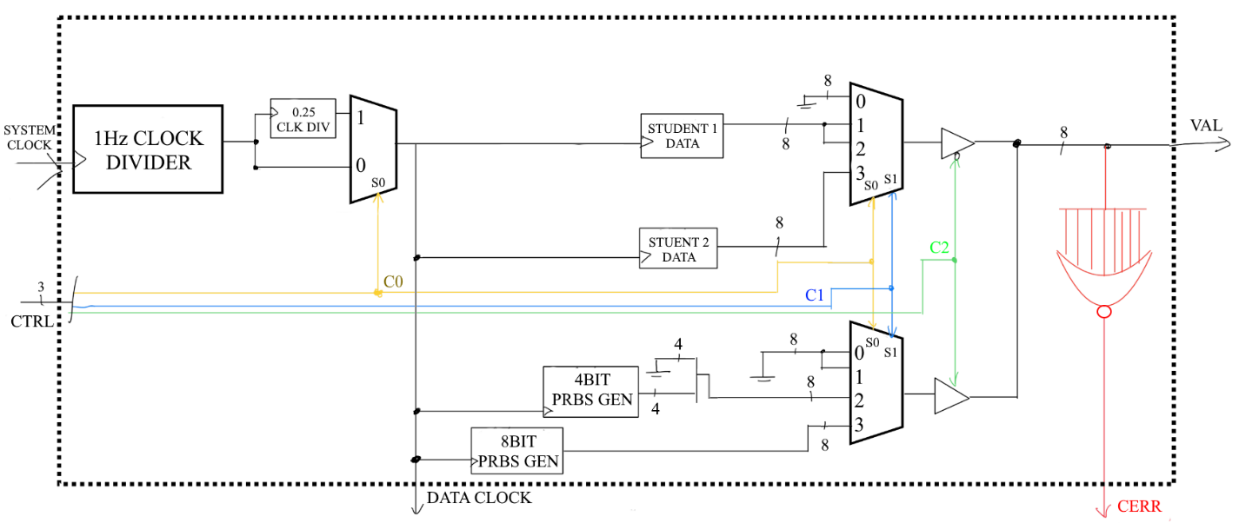
Interior scheme:
2. Data Buffer for 16 values (Implemented by Comșa Darian)
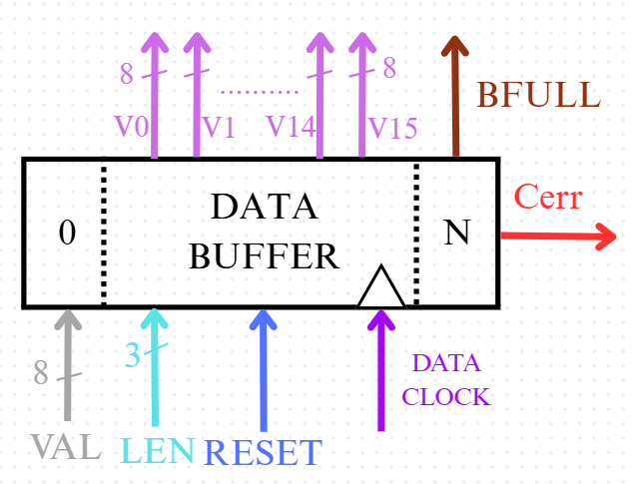
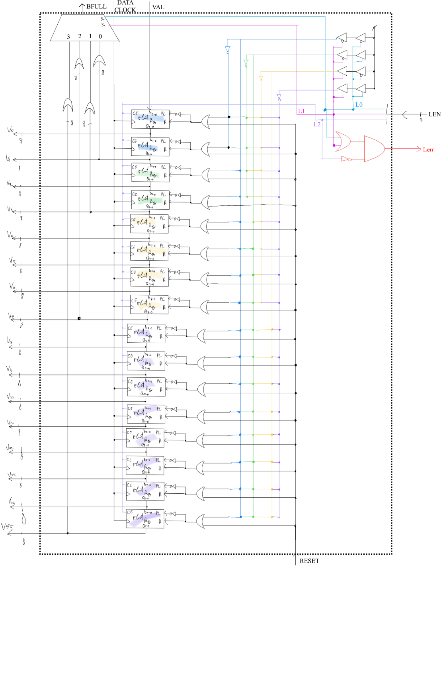
The data buffer stores up to 16 values, depending on LEN. The current total of values it holds is denoted by N (2,4,8,16). If N is lesser than 16, the unused slots are filled with 0s for the simplification of the adder. When the Nth slot receives a value, it sends out Bfull to indicate that the desired sample size is fulfilled. It performs in the regime of a LIFO structure, in one shift right execution receiving VAL on the left end and discarding the Nth value. On each data clock cycle, the data buffer transmits to the adder all stored values. In the case of an invalid LEN instruction, the component sends out the Lerr signal to the SSD decode.
Internal structure:
3. 16 8-bit Values Adder (Implemented by Comșa Darian)
The 8-bit adder is a combinational logic circuit, receiving 16 inputs from the data buffer and outputting the result on 12 bits (largest possible result for the addition of 16 8-bit numbers).
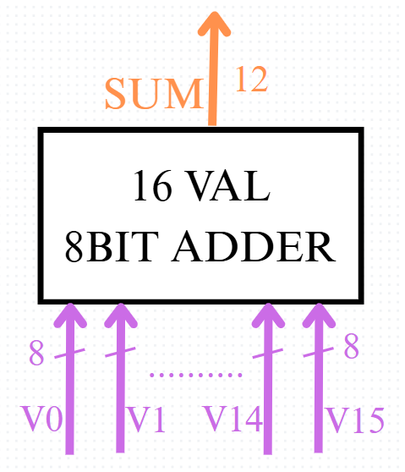
4. Shift Register (Implemented by Bucur Bogdan)
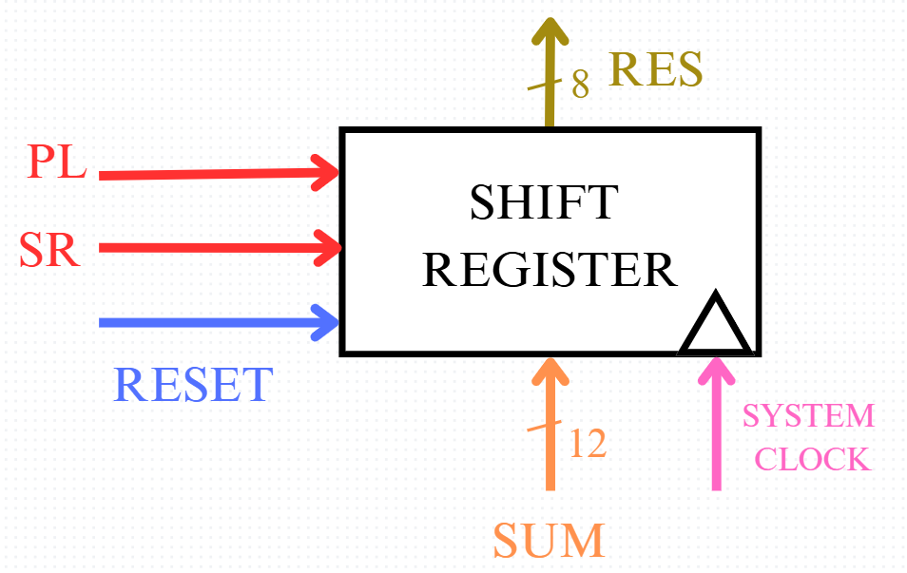
The shift register’s task is to perform, according to LEN, log₂(N) shift right operations to the RES input, and transmits the AVG output to the hold register. Its LOAD and SHIFT functions are enabled by state signals, and the SIN input is internally set to always add 0s to the end. The component uses the system clock for ”instant” division (for the eye of the user).

5. Shift Counter (Implemented by Bucur Bogdan)
The purpose of the Shift Counter is to count how many times the value transmitted into the shift register is being shifted. The output NS, representing the desired amount of shifts dictated by the LEN input (1 to 4), is sent to the state machine to continue the process of the system.
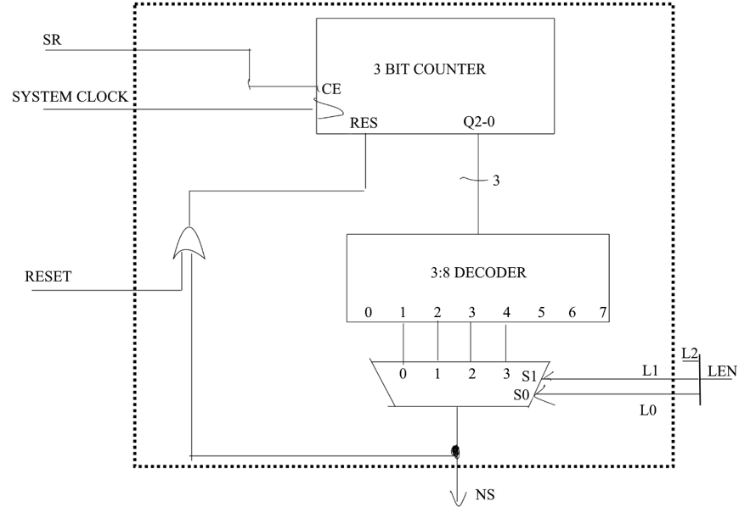
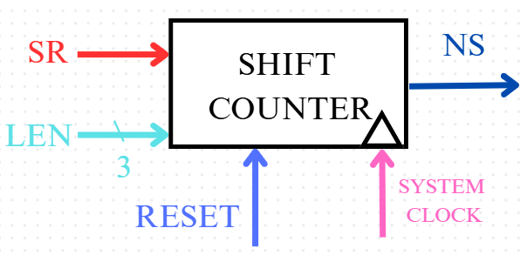
Internal structure:
6. Hold Register (Implemented by Bucur Bogdan)
The hold register stores for display the most recent value computed by the shift register, so there is a value to display constantly while the rest of the system computes the next average. Its LOAD enable is a state signal of the same name.
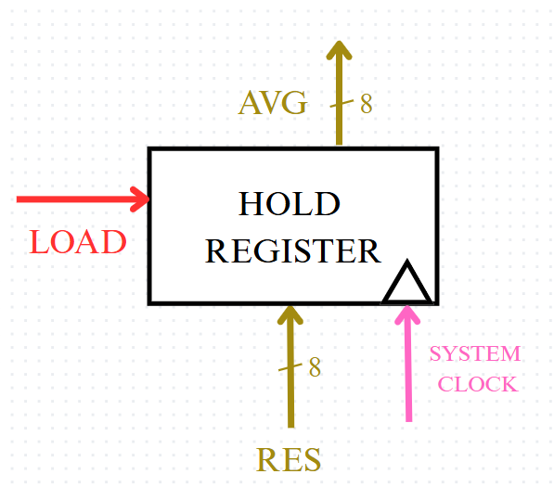
7. SSD Decoder (Implemented by Comșa Darian)
The SSD decoder uses the CADOTE and ANODE outputs to display the most recent value added to the sum (VAL input) and the rolling average result (AVG inout). Two particular messages will be displayed on the SSD in the following situations:
- if the required sample size hasn’t been reached, Bfull will take the `0` value and the SSD will display ”--” on the AVG SSDs ;
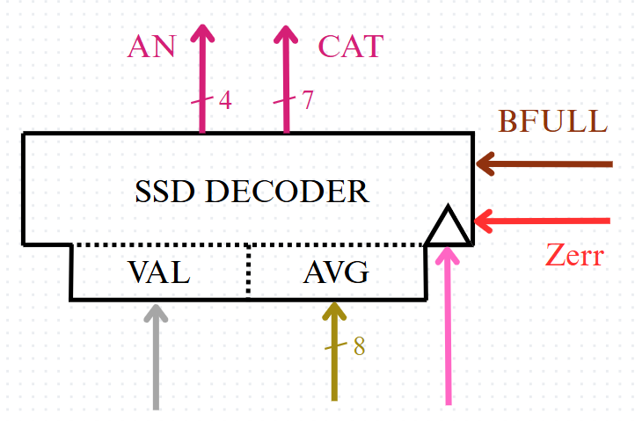
- if there is a CTRL or LEN input error, Zerr will take the `1` value and the SSD will display ”----”.

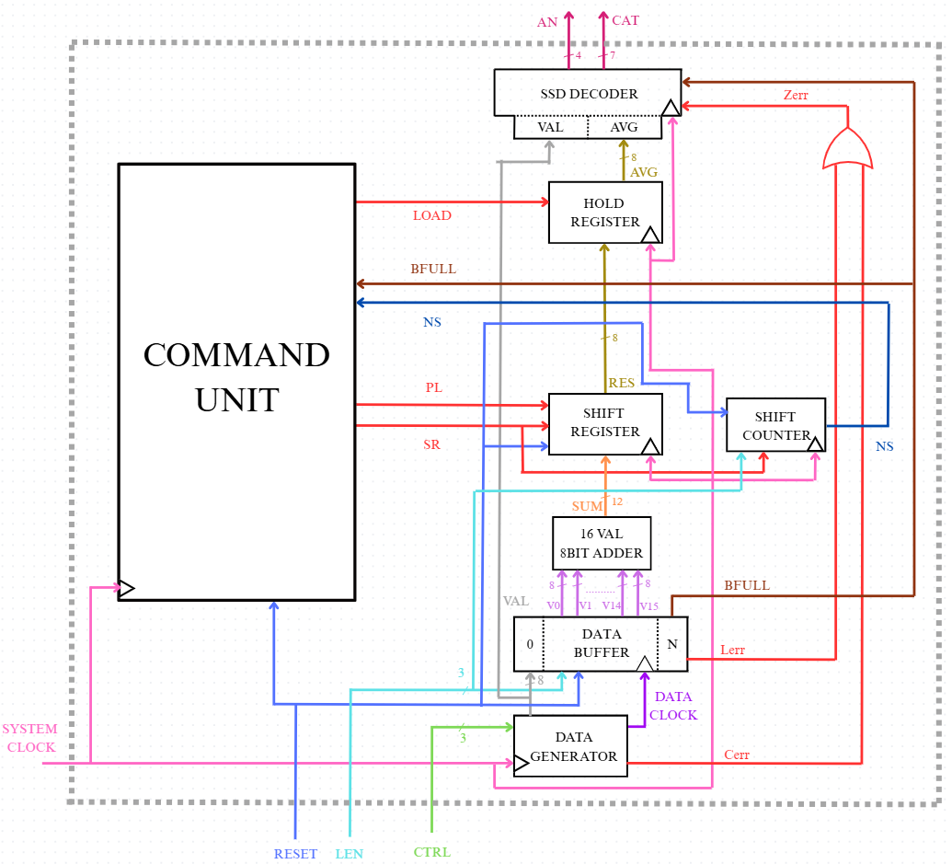
2.2.3 Detailed scheme

2.3 State diagram of Control Unit
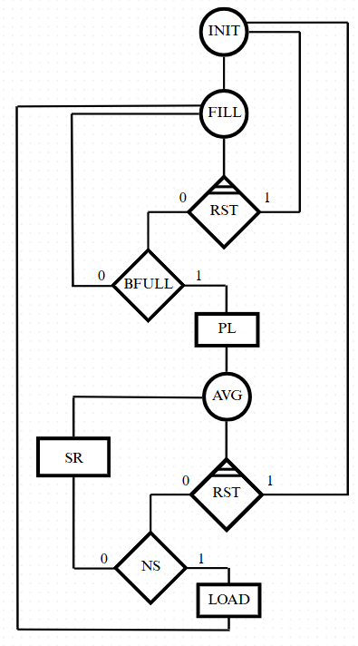

3. USER MANUAL

The usage of the system is very simple:
- Using the first 3 switches (right to left) apply the configuration corresponding to the desired mode of data generation.
- Using the next 3 switches, apply the configuration corresponding to the desired sample size.

- Each number generated is displayed on the left SSDs, and after the sample size selected has been generated, the right SSDs will display the average of the numbers in hexadecimal.


4. DESIGN SOLUTION JUSTIFICATION
The design we developed was chosen in order to ensure a smooth, procedual operation of the system, where every operation commanded at a certain moment of time. The block diagrams we traced facilitate an organized implementation process.
Regarding the way we chose to compute the sum and average of the sample size, we opted to store all possible 16 values at once in order to fix a potential issue where the sample size is changed at unexpected times.

5. FURTHER DEVELOPMENT
Our system could be developed further by enlarging the number of SSDs. Currently, by being limited to only 2 SSDs per number, the numbers can only be displayed in hexadecimal, but with an additional SSD for each value, all numbers in range could be represented in decimal.
Furthermore, the range of values can be expanded by increasing the number of bits per number the system works on.
Additionally, the system could be improved by modifying the control unit and data generator to allow the user to insert their own values.

6. BIBLIOGRAPHY

- Octavian Augustin Creț, Logic Design Course (2024), Technical University of Cluj-Napoca

- Octavian Augustin Creț, Digital Systems Design Course (2025), Technical University of Cluj-Napoca

