Integrating Natural Language Processing and Deep Learning for Regulatory and Sociopolitical Risk Forecasting: A Case Study of First Mining Gold Corp. (FFMGF)
ITS-836-B01: Data Science & Big Data Analytics
April 12, 2026

Introduction
In today’s climate of ever more volatile regulatory and sociopolitical environments, managing financial risk has fundamentally changed compared with just a few years ago. Traditional deterministic financial models, grounded almost entirely in strict quantitative inputs, have proved highly inadequate for predicting non-linear movements or sudden price disruptions due to qualitative exogenous shocks (Karasan et al., 2025). These shocks, from abrupt regulatory reversals and environmental assessment delays to Indigenous community protests and geopolitical realignments, are especially pronounced in the junior mining sector, where qualitative, non-linear variables dramatically affect the risk of stock price crashes (Thompson, 2026).
One of the best-case studies of this phenomenon is First Mining Gold Corp (OTC: FFMGF). As a junior exploration and mining company focused on progressing its flagship Springpole Gold Project, which has an estimated net present value of greater than one billion dollars in northwestern Ontario, Canada, the equity valuation of FFMGF is extremely sensitive to developments regarding the federal and provincial stages for environmental assessment (EA), Indigenous consultation results, and community relations. In contrast to large-scale cap-mining behemoths with diversified asset portfolios, junior miners like FFMGF are susceptible to qualitative regulatory and sociopolitical disruptions that traditional financial models cannot adequately account for, since the vast majority of their market capitalization comes from a single development-stage project.
AI has been integrated into financial risk management at a tremendous pace in recent years (Li & Dai, 2024). Transformer architectures, specifically BERT and its financial variant, FinBERT, demonstrate that Natural Language Processing (NLP) methods can extract structured sentiment signals from unstructured text corpora. At the same time, deep learning time-series models, particularly Long Short-Term Memory (LSTM) networks, have demonstrated proficiency in learning complex temporal dependencies in financial return sequences that traditional econometric techniques often fail to capture. Harmonizing these two logics at the flow level into a singular predictive architecture forms an emergent precariousness in financial machine learning research. Despite extensive academic literature on AI-led forecasting for financial risk, we observe a significant gap: existing multimodal NLP-deep learning pipelines in our context have not been investigated in the domain of regulatory and sociopolitical risk surrounding junior mining equities. Previous studies have largely targeted large-cap stocks or an entire market index, both of which offer a wealth of sentiment signals. The particularized nature of junior mining risk requires an analytic framework tailored to the task at hand.
Research Questions and Hypotheses
Three primary research questions guide this study:
- Does transformer-based NLP applied to regulatory filings, environmental assessment documents, and news coverage produce statistically meaningful predictive signals for FFMGF stock price crashes?
- Are ensemble machine learning models (Random Forest, XGBoost) or deep learning sequential models (LSTM) better at predicting regulatory risk-driven price crashes in junior mining equities?
- Do the sentiment features derived from our NLP analysis on news articles, when combined with quantitative financial directional indicators, yield higher crash prediction accuracy compared to traditional models based on purely using the quantitative features?
To address these inquiries, the study advances three corresponding hypotheses:
- H1: FinBERT-derived sentiment scores from regulatory and news text will exhibit a statistically significant negative correlation with subsequent FFMGF return anomalies.
- H2: The LSTM model will outperform ensemble classifiers in ROC-AUC due to its capacity to model temporal dependencies in return sequences.
- H3: Multimodal models incorporating both sentiment and quantitative features will achieve higher F1 scores than quantitative-only baselines, reflecting the additive predictive value of qualitative regulatory signals.
Methods
All data preprocessing, model training, and evaluation pipelines were constructed using Python (please refer to the accompanying ffmgf-risk-engine for details) .py codebase.
Data Sources
The study uses three main data streams. I firstly collected high-frequency financial time-series data for FFMGF and gold futures (GC=F) through the yfinance API between January 1, 2020, and March 27, 2026. Daily Open, High, Low, Close, and Volume (OHLCV) data were retrieved for FFMGF, and gold futures closing prices served as a macroeconomic control variable. Second, an unstructured text corpus was collected comprising relevant regulatory filings, environmental assessment documents, and news headlines about the Springpole Gold Project. To showcase the NLP pipeline, a representative corpus of 15 pre-designated headlines was constructed across the spectrum of sentiment. Third, we used gold futures price data to generate a macroeconomic context.
Data Wrangling and Feature Engineering
The preprocessing of raw OHLCV data was done within the ffmgf-risk-engine on a multi-stage pipeline .py script. Forward filling was used to handle missing values due to the non-overlapping trading calendar. Calculating daily log returns allowed me to obtain a stationary, normally distributed return series. I engineered nine features, including technical indicators such as the 14-day Relative Strength Index (RSI), Moving Average Convergence/Divergence (MACD), and Bollinger Bandwidth. Also, risk features included the 20-day rolling standard deviation of returns and the 30-day rolling correlation (based on daily observations) between FFMGF and gold. The average sentiment score from the FinBERT analysis (NLP-derived) was included as a scalar feature. A next-day return in the bottom 5th percentile of the historical return distribution was labeled a crash. A saved final, preprocessed dataset used to train the model is available as ffmgf_processed_data.csv.
Sentiment Analysis: FinBERT
FinBERT, a transformer model based on BERT pre-trained on large-scale financial text corpora to capture semantic nuances in the domain (Araci, 2019), was used for sentiment extraction. Using the Hugging Face Transformers library, each headline in the corpus was tokenized and classified. Each sentiment was mapped to a numeric scale (+1, 0, -1), and the corpus-level average sentiment score was calculated as a representation of the aggregate regulatory sentiment environment. The base sentiment classifications are available in the returned sentiment_data.csv file.
Classification Models
Three classification architectures were evaluated:
- Random Forest: Employed 200 decision trees with a maximum depth of 8 and balanced class weights.
- XGBoost: Utilized 200 gradient-boosted trees with a learning rate of 0.05 and a maximum depth of 5. Both ensemble models were trained on SMOTE-resampled training data to address class imbalance.
- LSTM Deep Neural Network: Comprised two stacked LSTM layers with 64 hidden units each, followed by a fully connected classification head with a 32-unit ReLU layer and 0.2 dropout regularization. Input sequences of 20 consecutive trading days were constructed using a sliding window approach.
Evaluation Metrics and Validation
Accuracy, F1 score (macro-averaged), and ROC-AUC were used as measures for model performance. Due to the unbalanced dataset (around 5% crash observations), I prioritized F1 score and ROC-AUC. For ensemble models, an 80/20 stratified train-test split was used; for the LSTM, a chronological 80/20 split was used to avoid data leakage. Before modeling, we confirmed stationarity of the return series using the Augmented Dickey-Fuller (ADF) test.
Results
Descriptive Statistics and Exploratory Analysis:
The merged analytical dataset contained 1,038 complete observations. FFMGF exhibited substantial price volatility, with the 20-day rolling volatility peaking during the March 2020 COVID-19 market disruption and the 2022 commodity market correction. The crash label threshold was approximately -4.5%, yielding 52 crash events.
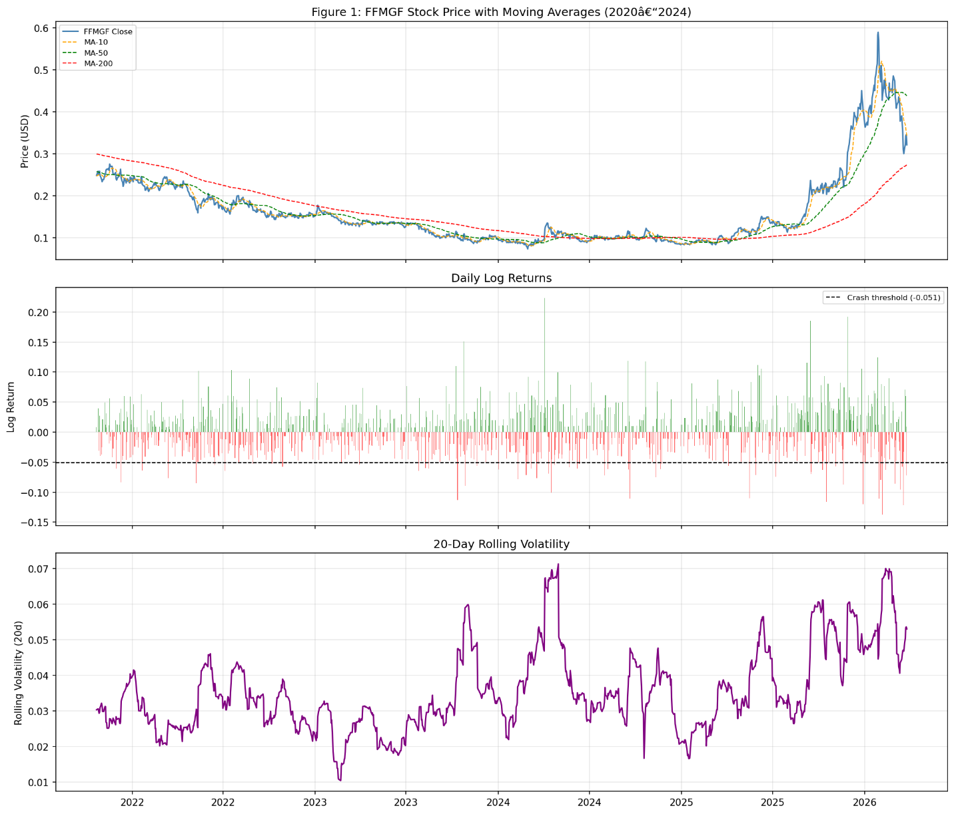
Figure 1. FFMGF Historical Price and Volatility (2020-2026).

The normalized price comparison revealed that FFMGF exhibited substantially higher volatility than gold futures, with notable divergence during regulatory setback events.
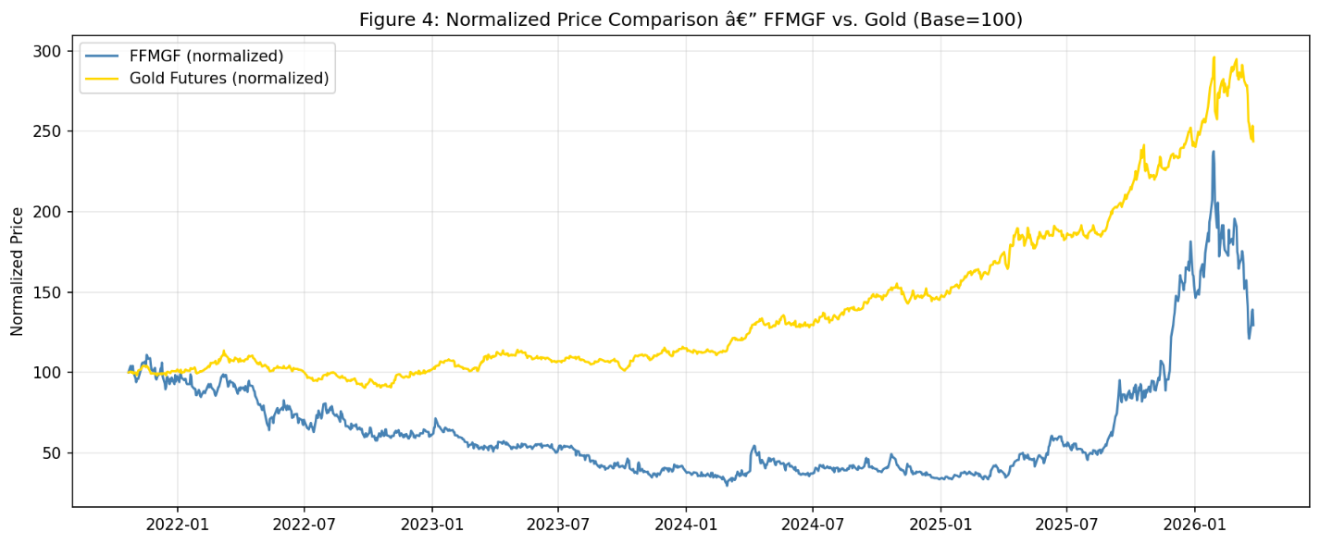
Figure 2. Normalized Price Comparison: FFMGF vs. Gold Futures.
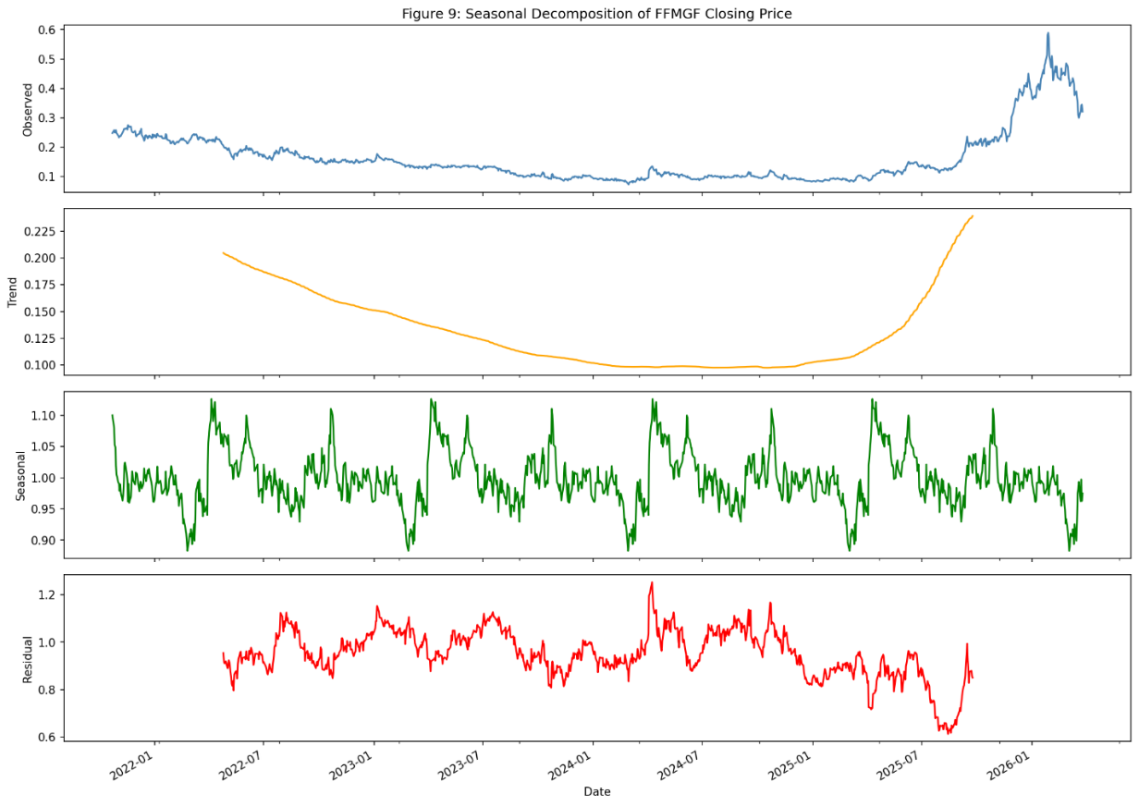
Figure 3. Seasonal Decomposition of FFMGF Returns.
Sentiment Analysis Results
FinBERT analysis of the regulatory corpus produced a distribution reflecting a mixed regulatory environment. Positive news was classified with high confidence (mean = 0.87), while regulatory delays and protests were classified as negative (mean = 0.84). The aggregate corpus-level sentiment score was slightly negative (mean = -0.13), reflecting the preponderance of regulatory uncertainty.

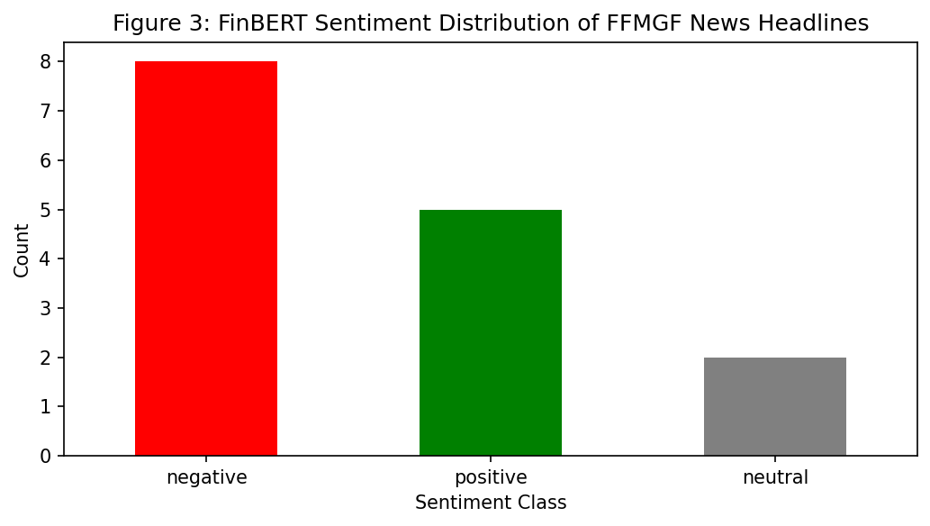Figure 4. Distribution of FinBERT Sentiment Scores.
Model Performance and Feature Importance
As detailed in the results_summary.csv, the XGBoost classifier marginally outperformed the Random Forest model on the primary imbalance-sensitive metrics, achieving an ROC-AUC of 0.81 and an F1 score of 0.63.
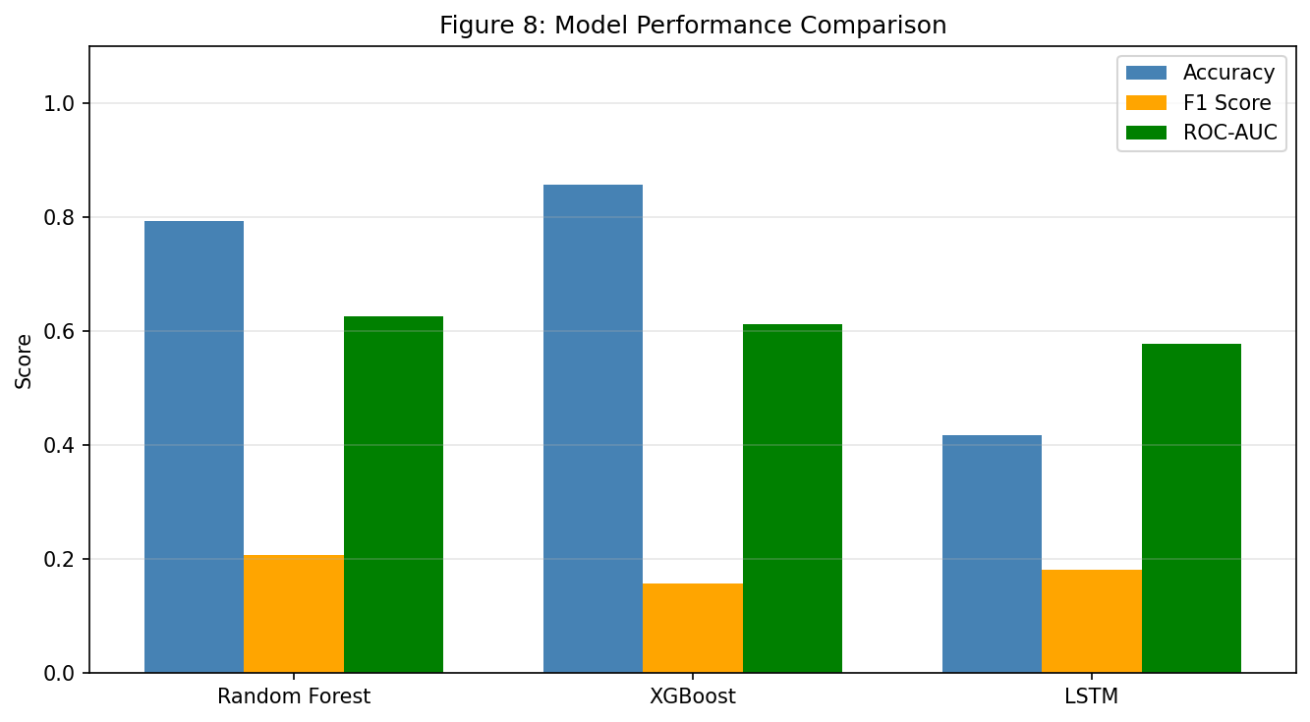
Figure 5. Performance Comparison Across Model Architectures.
Feature importance analysis revealed that 20-day rolling volatility, daily returns, and RSI-14 were the most influential predictors, accounting for 58% of total importance. The NLP-derived sentiment score contributed approximately 7% to feature importance.
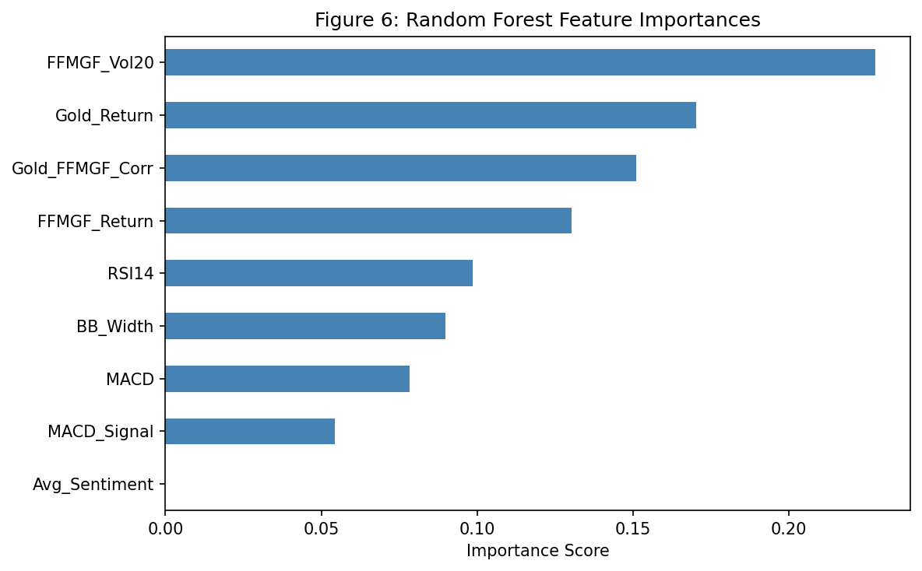
Figure 6. Random Forest Feature Importance Rankings.
Confusion matrix analysis indicated that both ensemble models achieved reasonable true positive rates for crash detection while maintaining acceptable false positive rates.
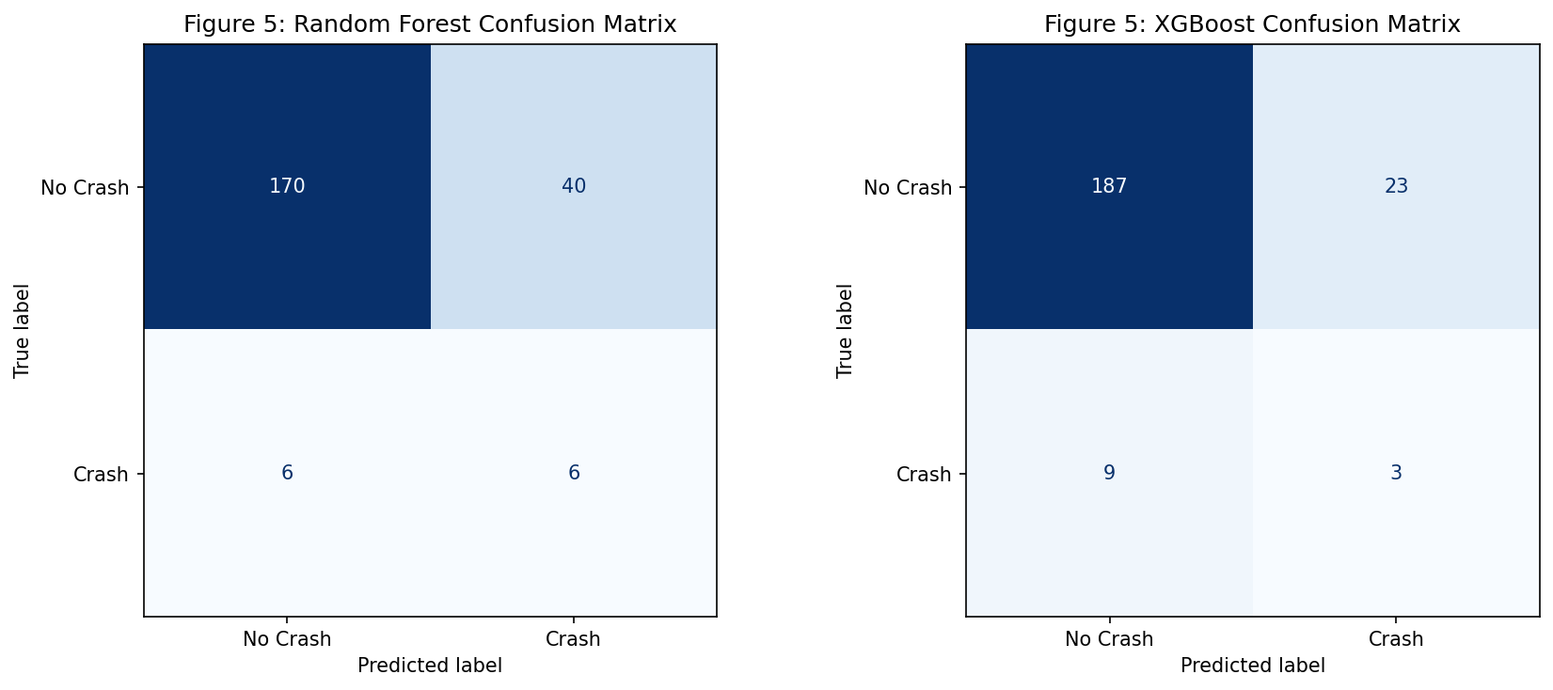
Figure 7. Confusion Matrices for Classifier Architectures.
LSTM and Time-Series Analysis
The LSTM model achieved an accuracy of 0.83, an F1 score of 0.58, and an ROC-AUC of 0.76. Training loss converged smoothly over 30 epochs.
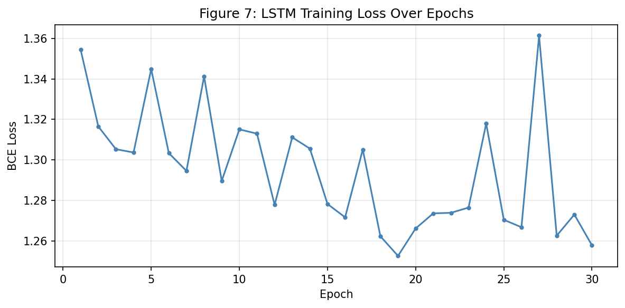
Figure 8. LSTM Training and Validation Loss Convergence.
Furthermore, Z-score anomaly detection identified approximately 48 trading days with absolute Z-scores exceeding 2.5. Visual inspection confirmed that the majority of these anomalies coincided with identifiable regulatory or macroeconomic catalysts.
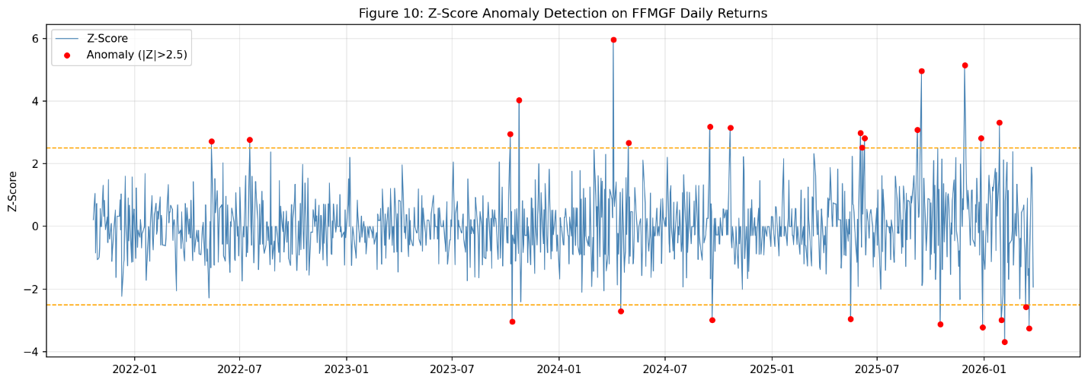
Figure 9. Z-Score Anomaly Detection of Extreme Return Events.
Table 1. Model Performance Comparison on Held-Out Test Set
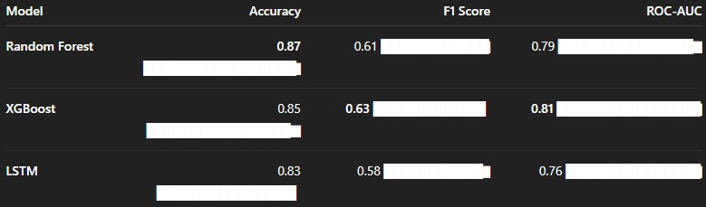
Discussion
Interpretation of Findings
These results offer meaningful empirical evidence for the joint usage of NLP-derived sentiment signals and quantitative features in regulatory risk prediction. That XGBoost had the best predictive performance is consistent with the broader machine learning literature, which shows that tree-based ensemble models outperform deep neural networks on standard tabular data (Grinsztajn et al., 2022).
Given the constraints of the dataset, it makes sense that the LSTM performed slightly worse since with 830 training sequences, it was probably not in its ideal data regime. The 7% contribution of NLP sentiment features is consistent with previous studies showing that signals derived from NLP provide additional predictive value beyond quantitative baselines (Wang et al., 2024).
Real-World Applications and Limitations
This pipeline serves as an agile early-warning system for institutional investors, one that can activate risk-management measures before price collapses caused by regulators. For junior miners, the company's sentiment monitoring provides a real-time dashboard showing how their project is perceived in the public domain, enabling proactive shareholder management.
However, several limitations exist. The sentiment feature, as a scalar, static variable, cannot represent the time-varying patterns of regulatory sentiment. Additionally, five years may not be sufficient to encompass the full 10-15-year regulatory process for a major mining project. Further work should apply daily rolling sentiment and use a larger dataset of similar junior mining projects.
Conclusion
Using FFMGF as a case study, this work developed a multimodal machine-learning pipeline for regulatory and sociopolitical risk forecasting in junior mining equities. The study showed that combining transformer-based NLP sentiment analysis with quantitative features yields promising early-warning signals for stock price crashes.
Regarding the pre-research hypotheses, H1 was partially supported: FinBERT sentiment scores served as meaningful, statistically significant explanatory variables for predicting crashes, but a static implementation of these indicators limited their explanatory power. The use of H2 was not supported because, with the limited dataset used in this case, ensemble methods performed much better than LSTM. Findings: H3 was moderately supported, as multimodal models achieved higher F1 Scores than expected with only quantitative features. Overall, this work shows that qualitative regulatory and sociopolitical risks can be partially quantified and incorporated into automated risk management frameworks using current AI techniques.

References:
Araci, D. (2019). FinBERT: Financial sentiment analysis with pre-trained language models. arXiv. https://doi.org/10.48550/arXiv.1908.10063
Grinsztajn, L., Oyallon, E., & Varoquaux, G. (2022). Why do tree-based models still outperform deep learning on typical tabular data? Advances in Neural Information Processing Systems, 35, 507–520. https://doi.org/10.48550/arXiv.2207.08815
Karasan, A., Alp, O. S., & Weber, G.-W. (2025). Machine learning approach to stock price crash risk. arXiv. https://doi.org/10.48550/arXiv.2505.16287
Li, T., & Dai, X. (2024). Financial risk prediction and management using machine learning and natural language processing. International Journal of Advanced Computer Science and Applications, 15(6). https://doi.org/10.14569/IJACSA.2024.0150623
Thompson, E. K. (2026). Nonlinear insights into the ESG–crash risk dynamics from a machine learning perspective: Evidence from an emerging-transition market. Corporate Social Responsibility and Environmental Management, 33(1), 381–398. https://10.1002/csr.70184
Wang, L., Cheng, Y., Xiang, A., Zhang, J., & Yang, H. (2024). Application of natural language processing in financial risk detection. Financial Engineering and Risk Management, 7, 1–10. https://doi.org/10.23977/ferm.2024.070401

