OPEN COLLECTOR LOGICAL CIRCUITS

1. OBJECTIVES
There will be studied open collector logical circuits and bus designing possibilities using wired function will be analyzed.

2. THEORETICAL CONSIDERATIONS
To connect in parallel several gates, open collector circuits or three state circuits are used.
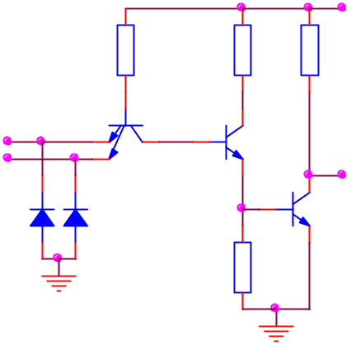
In the electrical scheme of the open collector TTL gates the input level and the level separator used in the creation of the fundamental gate are not be changed. However, the output level has been modified, keeping only the Q₄ transistor (figure 7.1). In this case the collectors of the Q₄ transistors belonging to different circuits can be connected, the junction being connected through a resistance to the supply.
R₁
4K
R₂
1,6K
R_{C}
extern
D₂
D₁
A
B
Q₁
Q₂
Q₄
R₃
1K
y=AB
U_{e}
V_{CC}
Fig.7.1
The common resistance is not included in the integrated structure and it’s calculated by the scheme’s designer depending on the number of the gates connected together (n) and the number of the TTL gates that must be controlled by this common output (N).
The resistance R_{c} is calculated depending on the logical level of the common output, on the current generated by parallel connected gates and on the currents absorbed by the controlled gates.
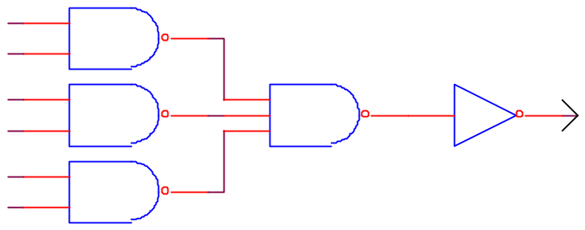
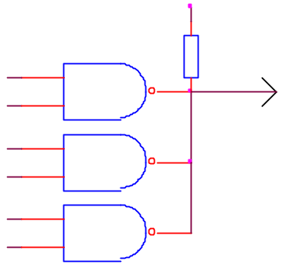
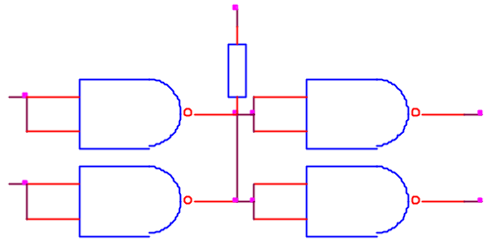
In the case of 1 logical level at the output the result will be:
Fig.7.2
A
B
C
D
E
F
f
a)
A
B
C
D
E
F
V_{CC}
f
R_{C}
b)
c)
V_{I1}
V_{I2}
V_{O2}
V_{O1}
V_{CC}
f
R_{C}
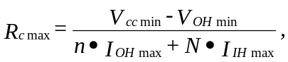
and for 0 logical level the result will be:
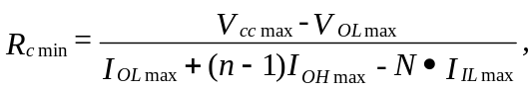
The values of the charge resistances are calculated as following:V_{cc}=5V±5%, I_{OH}=250μA, I_{OL}=16mA, I_{IL}=1.6mA, I_{IH}=40μA, V_{OHmin}=2.4V, V_{OLmax}=0.4V.
To create, for example, the function implemented in figure 7.2 a three level logic is necessary, leading to a great delay. The same function can be implemented with open collector circuits. The function is denoted wired-AND.
The circuit implements the AND function between the outputs of the NAND gates. The whole circuit implements the NOT-AND-OR for the group of variables at the input of the NAND gates.
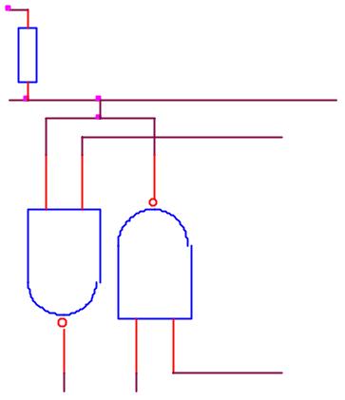
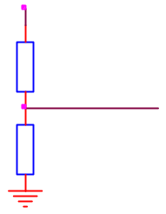
The open-collector and three-state circuits are widely used for bus manufacturing. A circuit connected to a bus works, normally, both as an emitter and a receiver. For this reason, the command inputs have to allow both read and write operations from and on the bus. The word is introduced on the bus using when the RD command signal authorizes the operation. Through a WR command the word is fetched from the bus (figure 7.3.a). If only TTL circuits are connected to the bus, bus-terminators can be used (a group of resistances connected at the bus terminals to adapt against reflections) figure 7.3.b.
V_{CC}
WT
RD
linie
magistrală
a)
V_{CC}
180Ω
linie de date
impedanţă 120Ω
390Ω
b)
Fig.7.3

3. PRACTICAL APPROACH
- The study of the open-collector gate (figure. 7.1) functioning using the circuit from figure 72.c. For a 1 logical state at the output increase R_{c} until V_{OH} decreases under 2.4V. Denote it by R_{cmax} and compare it with the computed one. For 0 logical at the output decrease R_{c} until V_{OL} is greater than 0.4V, denote it by R_{cmin} and compare it with the computed one. Repeat these operations for various charges.
- Verify the truth table of the logical function realized by the circuit in the figure 7.2.b. Study the behavior of the circuit in dynamical regime by applying at the input a rectangular signal. Observe the behavior of the circuit when a capacitance of 2000pF is connected to the output.
- Se realizează circuitul din figura 7.3a şi se analizează comportarea în regim static şi dinamic. Implement the circuit in the figure 7.3a and analyze its dynamical and statical behavior.

4. THE CONTENT OF THE REPORT
  - Brief description of the open-collector circuits.
  - Draw the circuits, the data tables and the graphical representations of the studied characteristics.
  - Draw the charts obtained from the dynamical behavior of the circuits.
  - Remarks related to the difference between the theoretical computed values and the simulated values.

