BUS DESIGN USING THREE STATE CIRCUITS

1. OBJECTIVES
Three state logical circuits will be studied and there will be analyzed the designing possibilities of the buses using this type of circuit.
2. THEORETICAL CONSIDERATIONS
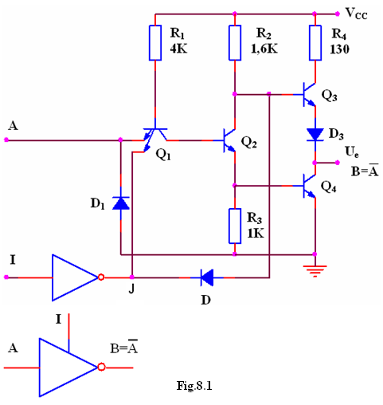
The impediments introduced by the external resistance necessary for open colector circuits are eliminated in the case of three state circuits (TSL - Three State Logic). In the output circuit of a TTL gate always one of the Q₃ or Q₄ transistors is on. If both transistors are off the output circuit is isolated and, seen from outside, the TTL gate presents an high impedance. Circuit has three states: 0 logical state, 1 logical state and high impedance, that leaves the output floating when both transistors are off.
The layout of an TTL inverter with three states is presented in figure 8.1.
Inhibit input I allows for ordinary NOT gate behavior if I=0. If I=1, J=0, D is on, Q₁ is saturated, Q₂ and Q₄ are off, Q₃ is off because through opened D diode its basis potential decreases to 0.7V so the circuit will present at the output an high impedance (HZ).
In dynamic stage, beside the known propagation times t_{PLH} şi t_{PHL} the following parameters appear:
- the time for high impedance establishment starting from 0 logical state t_{LZ}, and from 1 logical state respectively, t_{HZ};
- the time for exiting from high impedance state and going to 0 logical state, t_{ZL}, and going to 1 logical state respectively, t_{ZH}.
Considering these delays the total propagation time through these gates is around 25 ns. This value is larger than the one for usual TTL gates but is much smaller than the value for open collector circuits.
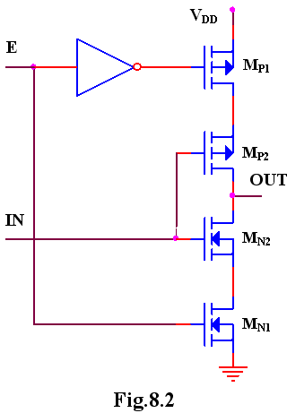
Also, in the case of CMOS gates output circuits that can have high impedance state are available. Such a circuit contains two n channel transistors and two p channel transistors (figure 8.2). A pair of p-n transistors operates with standard NOT function, and the second pair works as on-off switch driven by the enable input E.
If E input is in 1 logical state, M_{N1} and M_{P1} transistors are on and the output can present 1 and 0 logical levels. When E input is in 1 logical state, the output impedance is high (higher than 10¹⁰Ω at 25°C).
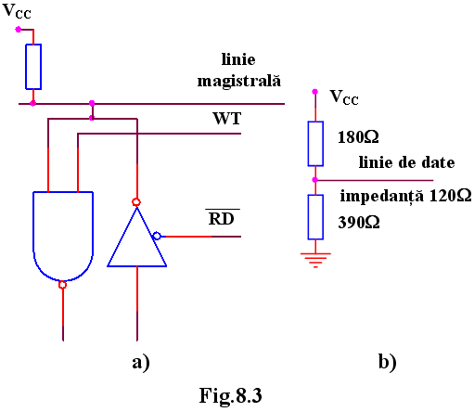
The open-collector and three-state circuits are widely used for bus manufacturing. A circuit connected to a bus works, normally, both as an emitter and a receiver. For this reason, the command inputs have to allow both read and write operations from and on the bus. The word is introduced on the bus using when the RD command signal authorizes the operation. Through a WR command the word is fetched from the bus (figure 8.3.a). If only TTL circuits are connected to the bus, bus-terminators can be used (a group of resistances connected at the bus terminals to adapt against reflections) figure 8.3.b.

3. PRACTICAL APPROACH
- The static parameters and the dynamic behavior of the three state TTL circuits will be studied. For static parameters study, I input is hold at 0V and A input is changed from 0V to 5V. For dynamic parameters study, a 15pF load is used.
- The static parameters and the dynamic behavior of the three state CMOS circuits will be studied. For static parameters study, E input is hold at 5V and IN input is changed from 0V to 5V. For dynamic parameters study, a 15pF load is used.
- The circuits from figures 8.3 will be described and their behavior in static and dynamic stage is analyzed. Both TTL and CMOS circuits will be considered.

4. THE CONTENT OF THE REPORT
  - Brief presentation of three state circuits.
  - Circuits layout, tables with computed values and graphs representing the raised characteristics.
  - The graphs obtained by dynamical behavior analysis of the circuits.
  - Observations on the nature of the differences between the calculated theoretical values and the simulated results.

