CONTINUOUS VOLTAGE SOURCES

1. OBJECTIVES
This laboratory work has as purpose the experimental study of continuous voltage sources.

2. THEORETICAL CONSIDERATIONS
2.1 Filter rectifier
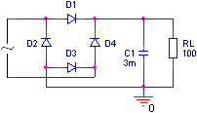
The capacitor stores energy during the time intervals in which the voltage supplied by the rectifier is greater than the voltage between the capacitor’s plates and releases energy during the time intervals in which the voltage supplied by the rectifier is lower than the voltage between the capacitor’s plates.

2.2 Parametric regulator with Zener diode
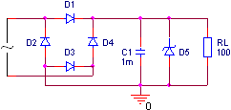
The functionality of the regulator is based on the Zener diode non-linear characteristic that allows large current variations at small reverse polarity voltages applied on the diode.

2.3 Reaction regulator with no error amplifier
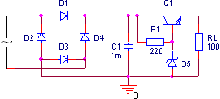
Increasing v_{OUT} voltage will determine the decrease of v_{BE} voltage, that in turn will determine the increase of v_{CE} and as a consequence v_{OUT} voltage will decrease. Similar, the v_{OUT} voltage decrease will determine the increase of v_{BE} voltage, that in turn will determine the decrease of v_{CE} voltage and as a consequence v_{OUT} voltage will increase. The regulator output voltage value is v_{OUT}=v_{Z}-v_{BE}.

3. PRACTICAL APPROACH
The study of the continuous voltage sources will be done using the AIM-Spice simulation program.
  - The circuits’ schematics will be described.
  - Applying at the input a sinusoidal signal of 8V amplitude and 0V offset the output signal will be displayed. The analysis will be made accordingly to different values for the filtering capacitor and for the resistor.

4. THE CONTENT OF THE REPORT
  - Short presentation of the continuous voltage sources.
  - The layouts of the circuit, the tables with the computed values and the graphs of the plotted characteristics.
  - Observations concerning the nature of the differences between the theoretical values and the simulated results.

