INVERTER WITH BIPOLAR TRANSISTOR

1. OBJECTIVES
This laboratory work has as purpose the experimental study of the inverter with bipolar transistor.

2. THEORETICAL CONSIDERATIONS
2.1 Inverter with bipolar transistor
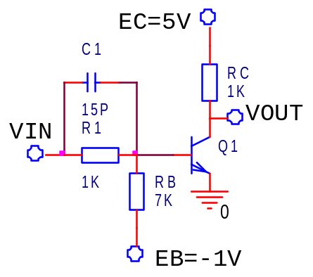
If VIN is 0V, corresponding to 0 logic level, Q1 transistor is off and VOUT voltage will have 5V value, corresponding to 1 logical level. If VIN is 5V, corresponding to 1 logical level, Q1 transistor is on and VOUT voltage will have 0,2V value, corresponding to 0 logic level.

3. PRACTICAL APPROACH
The study of the inverter will be done using the AIM-Spice simulation program.
  - The layout presented in the paper will be described.
  - The static transfer characteristics of the inverter will be displayed.
  - The inverter dynamic behavior will be studied applying at the input a pulse type signal having 5MHz frequency. The analysis will be made accordingly to different values for the C1 capacitor: 1pF, 15pF and 47pF.

4. THE CONTENT OF THE REPORT
  - Short presentation of the inverter characteristics.
  - The layout of the circuit, the tables with the computed values and the graphs of the plotted characteristics.
  - Observations concerning the nature of the differences between the theoretical values and the simulated results.

