TTL INTEGRATED CIRCUITS SERIES

1. OBJECTIVES

This work makes the comparative analysis of different TTL integrated circuits series, by presenting the fundamental gate realized by the respectively technology. There are presented the constructive-functional characteristics and the main static and dynamical parameters of each series.

2. THEORETICAL CONSIDERATIONS

2.1 HIGH SPEED TTL SERIES
High speed TTL series is a variant of the normal series modified in order to obtain smaller propagation times, which is to the prejudice of the power consumption. Thus, the typical propagation times for the high speed series are: t_{pLH} = 5,9ns, t_{pHL} = 6,2ns, and the average propagation time is t_{p} = 6ns, so it stipulates for an improvement with over 40% more than the normal series. At the same time, the power consumption is twice bigger than that corresponding to the normal series which is: P_{C} = 22mW.
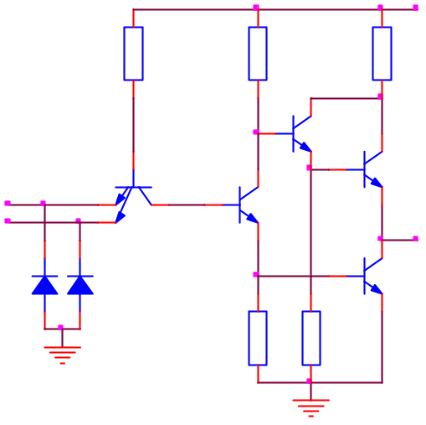
As a structure, the fundamental TTL gate of the high speed series (figure 3.1) is very similar to that of the normal series, highlighting the following modifications. All resistors of high speed TTL gate scheme have smaller values so as the charging and discharging of internal capacities should be made faster, in order to reduce the propagation time. But these actions take place by generating greater currents, which leads to the increasing of the power consumption. High speed gate does not contain the voltage shifting diode, but a compound transistor is used in the upper output region of the complex inverter (Darlington assembly made up of the command transistor Q₅ and the Q₄ transistor), transistor which does not allow Q₄ to enter in saturation, reducing the unblocking time of this transistor.
Q₁
Q₂
Q₄
Q₃
D₂
D₁
Q₅
R₂
760
R₁
2,8K
R₄
58
R₃
470
V_{CC}
A
B
y=AB
U_{e}
R₅
4K
Fig.3.1

2.2 LOW POWER TTL SERIES
Low power TTL series is meant for the applications which require small power consumption. The medium power consumption for this series is reduced to P_{C} = 1mW. The decreasing of the static power consumption was made by increasing the resistors values in the scheme, which led to the decreasing of the charging-discharging currents values. On the other hand the dynamical performances decreased, increasing the values of the propagation times. Thus, the series presents the following typical values for the propagation times: t_{pLH} = 35ns, t_{pHL} = 31ns, t_{p} = 33ns.
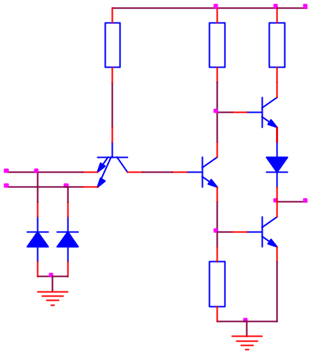
As a construction, the scheme of the low power TTL series (figure 3.2) is identical with that of the standard TTL gate. However, the values of the resistors are increased in average with an order of magnitude.
Q₁
Q₂
Q₃
Q₄
D₂
D₁
D
R₂
20K
R₁
40K
R₄
500
R₃
12K
V_{CC}
A
B
y=AB
U_{e}
Fig.3.2

3. PRACTICAL APPROACH
  - Using the assembly of the standard TTL gate laboratory work, by replacing the standard TTL circuits with specific gates for each studied series, repeat the steps presented in the respective work. Relate the simulated results to the theoretical approach from the work.

4. THE CONTENT OF THE REPORT
  - Short presentation of the TTL circuits series characteristics.
  - The layouts of the circuits, the tables with the computed values and the plots representing the constructed characteristics.
  - The plots obtained in the analysis of the TTL circuits series dynamic characteristics.
  - Remarks upon the nature of the differences between the computed theoretical values and the simulated results.

