NMOS INTEGRATED CIRCUITS

1. OBJECTIVES
In this laboratory work are presented the constructive functional characteristics of the family of NMOS integrated circuits and the main static and dynamic parameters of this family.

2. THEORETICAL CONSIDERATIONS

2.1 The NMOS static inverter

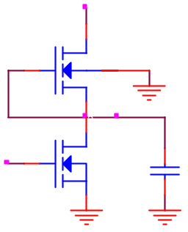
The layout of the NMOS static inverter is given in figure 4.1a.
M₂
V_{o}
C_{P}
V_{i}
V_{DD}
M₁
a)
Fig.4.1
c)
b)
The M₁ transistor is an n channel enhancement mode transistor and has the input characteristic in figure 4.1b, and the M₂ transistor is a depletion mode transistor, having the input characteristic in figure 4.1c. This implies the threshold voltages V_{T} of the two transistors to be different, for M₁ the threshold voltage V_{T1} will be positive, and for M₂, the threshold voltage V_{T2} will be negative.
The circuit presents an inverter obtained with the M₁ transistor, in which M₂ works as an active resistance, replacing a fixed resistance. The external load of this inverter is generally made up also of inputs of NMOS transistors, which have a very large input resistance, therefore the load has practically a character of capacitance.
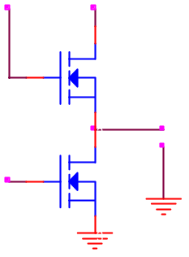
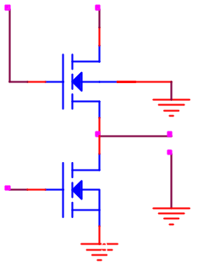
In figure 4.2 are considered two cases of connecting the substrate terminals of the load transistor M₂: the first case corresponding to binding the substrate terminal to the source terminal, and the second to binding the substrate terminal to a fixed potential.
M₂
V_{o}
V_{i}
V_{DD}
M₁
V_{GG}
a)
M₂
V_{o}
V_{i}
V_{DD}
M₁
V_{GG}
b)
Fig.4.2
In case the M₁ transistor conducts, in order to have at the output a potential as close to zero as possible, it is necessary for the transition resistance of the load transistor M₂ to be much greater then the transition resistance of the M₁ transistor. To satisfy the relationship between the transition resistances of the two transistors, the dimensions of the induced channel have to be correspondingly chosen for the M₁ and M₂ transistors, according to the relation: 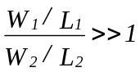.
If the inverter transistor M₁ is in cut-off stage, for the case in figure 4.2a, the output voltage will be:
V_{o} = V_{GG} - V_{T2}
For V_{GG} = V_{DD} = 15V and V_{T} = 4V, it follows that V_{o} = 11V.
In order to have at the output a potential approximately equal to V_{DD}, the voltage applied on the gate of the M₂ transistor should be increased with the value of the threshold voltage V_{T}. In the given example V_{GG} = V_{DD} + V_{T} = 19V.
If the M₁ transistor is in cut-off stage, for the case in figure 4.2b, the output voltage will depend on V_{GG} and the threshold voltage, following a relation that contains also elements (parameters) specific to the intrinsic structure of the basis substrate. For higher threshold voltages, the value of the output voltage will decrease. For this reason, in order to ensure the logical levels at the output, we try to reduce the threshold voltage through technological procedures of fabricating the MOS transistors.

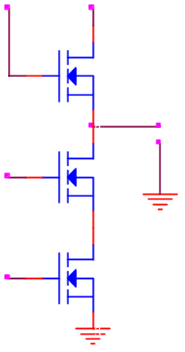
2.2 The static NAND gate
M₃
V_{o}
A
V_{DD}
M₂
V_{GG}
M₁
B
F
Fig.4.3
Figure 4.3 represents the static NAND gate realized with NMOS transistors. It contains two NMOS transistors, M₁ and M₂. On the gate of these transistors we apply the input signals; the transistors are connected in series. As a load resistance we use the M₃ transistor. In order to ensure the logical levels at the output, especially a lower level of the output voltage, sufficiently close to the ground, it is necessary for the active resistance to be 20 times greater then the transition resistance of the input transistors; because of this, the series connection of many transistors is not recommended.
The following values for the logical levels are considered: V_{L} = 0V and V_{H} = V_{DD}.
The functioning of the gate is the following:
- if at both inputs we apply a voltage greater then the threshold voltage V_{T}, more precisely V_{IH} = V_{DD}, both M₁ and M₂ transistors conduct, and at the output the lower voltage level is obtained (V_{L} ≈ 0V)
- if at least at one input a voltage smaller than V_{T} (usually V_{IL}=0V) is applied, the corresponding input transistor goes in cut-off stage and at the output the higher voltage level is obtained. At the output of the gate the NAND logical function is thus obtained:
F = ¬(A∙B)

2.3 The static NOR gate
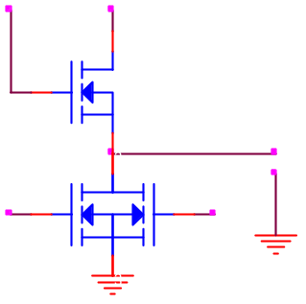
Figure 4.4 represents a NOR gate with NMOS transistors, composed by the parallel connection of the transistors on which the logic signals are applied at input. The load resistance is realized also with a NMOS transistor.
M₃
V_{o}
A
V_{DD}
M₂
V_{GG}
M₁
B
F
Fig.4.4
The functioning of the gate is the following:
- if on both inputs a lower voltage than the threshold voltage V_{T} (V_{IL} = 0V) is applied, the transistors M₁ and M₂ are in cut-off stage and at the output the higher voltage level V_{o} = V_{OH} = V_{DD} is obtained.
- if at least on one input a voltage higher then the threshold voltage V_{T} is applied, so V_{IH} = V_{DD}, that transistor conducts, and at the output the lower voltage level V_{OL} ≈ 0V is obtained.

3. PRACTICAL APPROACH
3.1. Construct, with the aid of the circuit in figure 4.1a, the transfer characteristic of the NMOS inverter for different supplying voltages. Next verify the guaranteed levels for the output, function of the voltage values allowed for the input. Visualize the states of the two transistors if the input is driven with signal between 0V and V_{DD}.
3.2. Modify the threshold voltage of the two transistors and repeat the steps from point 3.1.
3.3. Using the circuit in figure 4.2a construct the transfer characteristic of the NMOS inverter for different transition resistances of the two transistors observing their influence on the behavior of the circuit.
3.4. Analyze the influence of the load on the logical levels of the circuit. Consider a load resistance R_{S} which will be connected to the ground and measure the voltage V_{OH}, then R_{S} will be connected to V_{DD} and measure the voltage V_{OL}.
3.5. Analyze the functioning of the inverter in dynamic regime. For this apply on the input of the circuit impulses with the amplitude equal to V_{DD} and follow the response, measuring the switching times in void and for C_{S}=0,5nF. Analyze the way the power consumption and the switching times are influenced by the supplying voltage variation. Analyze also the variation way of the power consumption function of the working frequency.
3.6. Repeat the steps before for the other gates shown in the laboratory work.

4. THE CONTENT OF THE REPORT
  - Presenting briefly the characteristics of the NMOS circuits.
  - The designs of the circuits, the tables with the computed values and the plots representing the constructed characteristics.
  - The plots obtained in the analyzing of the NMOS circuits dynamic behavior.
  - Remarks upon the nature of the differences between the computed theoretical values and the simulated results.

