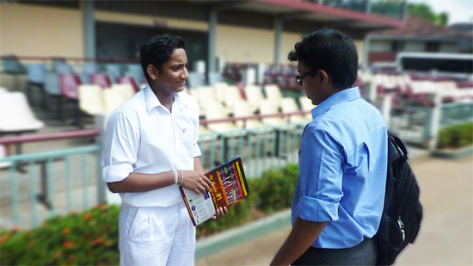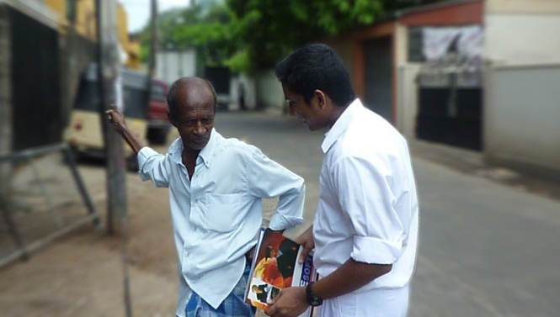

Conducted Survey – Project Hope

**Q:**

War in Sri Lanka is over and it has been about 2 years since. Do you think the government has taken necessary steps to promote life of the war-torn areas?

**A:**

[Translated] yes, I think so. I didn’t got the chance to actually visit those areas. But according to local newspapers and news media, I think government is greatly involved in that reconstruction work

**S:**

Voted positive

< Slightly change the last question >

**Q:**

**A:**

**S:**

Voted positive/negative

< Slightly change the last question >

**Q:**

**A:**

Voted positive/negative

**S:**

< Write here what that guy said > < add “Translated” always >

< Blur the backgrounds of remaining pictures and right click and “change picture” to change the picture. Stick to width of this box >

< Write here what that guy said > < add “Translated” always >

Rite some thing here

This result is calculated out of 10 people voted to answer

Conclusion

Results

[to]Sakuntha , [message] Machan limit the number of boxes to 3. Lets use the other seven pictures to another survy, ok