<https://www.bilibili.com/video/BV1mJ411k7Hd/?spm_id_from=333.788.videocard.0>

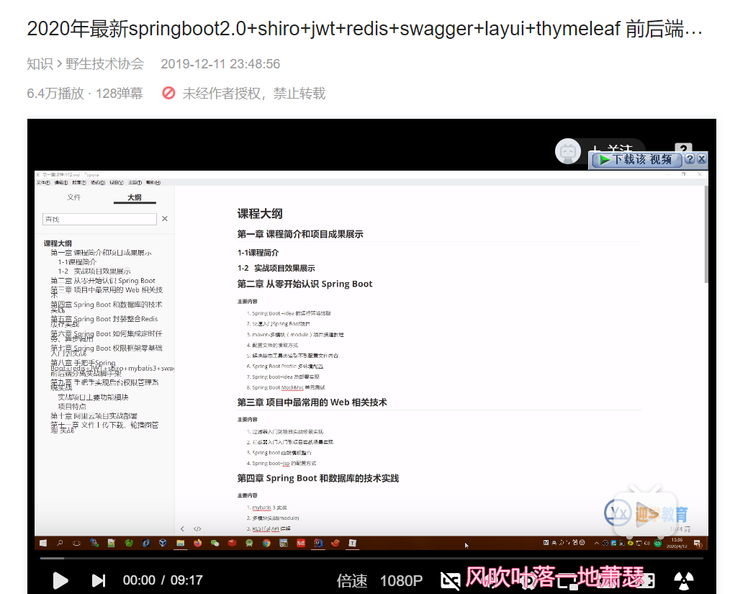

<https://www.bilibili.com/video/BV137411E7pG?from=search&seid=14245004315164318266>

