|  |
| --- |
| [Type the company name] |
| ICTDBS504: Integrate database with website |
| Assessment 1- Semester2 |
|  |
| **Peter Petersen** |
| **4/25/2016** |

|  |
| --- |
|  |

|  |
| --- |
|  |

|  |  |  |  |  |  |  |  |  |  |
| --- | --- | --- | --- | --- | --- | --- | --- | --- | --- |
| **Student Name:** | | | Peter Petersen | | | **Student Number:** | | | 4101833111 |
| **Unit Code/s & Name/s:** | | | ICTDBS504: Integrate database with website | | | | | | |
| **Assessment Description:** | | | Practical Assessment | | | | | | |
| **Assessment Due Date:** | | |  | | **Assessment Received Date:** | | |  | |
| **Student Declaration:** I declare that this assessment is my own work. Any ideas and comments made by other people have been acknowledged as references. I understand that if this statement is found to be false, it will be regarded as misconduct and will be subject to disciplinary action as outlined in the TAFE Queensland Student Rules. I understand that emailing or submitting this assessment electronically confirms my assent to this declaration in lieu of a written signature. | | | | | | | | | |
| **Student Signature:** | |  | | | | **Date: / /** | | | |
| **Assessor Feedback:**  ☐ **Student provided with feedback** | | | | | | | | | |
| **Attempt 1 Satisfactory ☐ Not Satisfactory ☐ Date:      /     /** | | | | | | | | | |
| **Attempt 2 Satisfactory ☐ Not Satisfactory ☐ Date:      /     /** | | | | | | | | | |
| **Assessor Name:** | D. Batchelor | | | **Assessor Signature:** | | |  | | |
| **Note to assessor: Please record any adjustment below that has occurred to this assessment e.g. Oral questions were used to support student’s ability to complete tasks identified.** | | | | | | | | | |
|  | | | | | | | | | |
| **Disclaimer:** TAFE Queensland North (TQN) is collecting the information on this form for assessment purposes. Only authorised Departmental officers have access to this information. Your personal information will not be disclosed to any other third party without your consent, unless authorised or required by law, in accordance with the Information Privacy Act 2009. | | | | | | | | | |

**This section must be completed by the student when the student either posts or hands a completed assessment/assignment to customer service centres. a receipt is only issued for face to face assessments when requested by the student.**

• **RECEIPT**

|  |  |  |
| --- | --- | --- |
| STUDENT TO COMPLETE |  | OFFICE USE ONLY |
| Unit of competency code/s:__________________ |  |  |
| Assessment item/No: ______________________ |  | Date received: / / |
|  |  |  |
| Student’s name: __________________________ |  |  |

**Project**

You should create a new repo called '**assessment1_sem2_yourname** in GITHUB account and save all files in this folder. You should create sub folders as necessary.

**Technical Specifications**

You are required to create an address book web application that stores contact details (First name, last name, phone numbers, email address, Facebook profile) of a user’s contacts.

The web application should have:

* A secure login
* The ability to add contacts.
* The facility to look up contacts by last name
* The ability to update and delete contacts
* Data validation that checks user's input;
* A user friendly GUI.

Task 1

You are required to:

* Identify the data needs of the web application, and outline the following information:
* What data needs to be submitted to the application’s database through the GUI?
* What data needs to be retrieved by the application for display in the GUI?
* Explain how the following programming concepts will be utilised in this web application:
* Authentication and security.
* HTTP.
* Session management.
* stateless/stateful programming.

Task 2 - Develop the application

You are required to develop the web application utilising phpmyadmin, HTML, CSS and PHP.

Task 3 - Write a short brief on your web application

You are required to write a short report on your web application of no more than 5 pages (including screen shots). The report is to cover:

* The web application's functionality.
* The database structure; and
* The php/SQL code you used to interact with the database;

The report is to include screenshots of the GUI and screen shots of the above points.

Task 1

* Identify the data needs of the web application.

The Address Book Web Application will require a Database requiring two tables structures.

1. Table for Users.
2. Table for Contacts/Clients.

* What data needs to be submitted to the applications database through GUI?

The User table structure will consist of four columns:

1. Id
2. Email
3. Name
4. Password

The Contacts/Clients table will have the following:

1. Contact id
2. Contact fname
3. Contact lname
4. Contact nickname
5. Contact cphone
6. Contact hphone
7. Contact wphone
8. Contact facebook
9. Contact address
10. Contact city
11. Contact state
12. Contact zipcode
13. Contact profile
14. Contact notes
15. Contact status

* What data needs to be retrieved by the application for display in the GUI?  
  Contact List Display Output:
* First Name
* Last Name
* Nickname
* Mobile Phone

Contacts Profile Output:

* First Name - Last Name
* Nickname - Cell Phone
* Home Phone - Work Phone
* Address - Facebook ID
* Biography / Notes

Explain how the following programming concepts will be utilised in this web application:

* Authentication and security:

The web application [Address / Phonebook] incorporates a secure Login section that allows the User access to the web application.

The method of Authentication used is when the User signs in with his credentials and they are checked / matched against his details in the database.

When the user clicks login their details are sent to the server. The server checks the username and password against the credentials it has stored. When the Users name and Password are correct the login is successful and a session is created and he is granted access to the application.

If the Users credentials do not match against the php coding he is denied access and then the user is asked to try again.

For added security all passwords are encrypted with MD5.  
[MD5 is an algorithm that is used to verify data integrity through the creation of a 128-bit message digest from data input.]

* HTTP:

Short for Hyper Text Transfer Protocol, (HTTP) is the underlying protocol used by the (World Wide Web). HTTP defines how messages are formatted and transmitted, and what actions Web Servers and Browsers should take in response to various commands. For example, when you enter a URL in your browser, this actually sends an HTTP command to the Web server directing it to fetch and transmit the requested [Web page](http://www.webopedia.com/TERM/W/web_page.html).

* Session Management:

The Web was originally designed to be stateless, that is, not to rely on information about Users being stored between interactions. Sessions are a way to save the state of the application for the User between requests.

Session management is defined as a progression of HTTP request and response actions for the same logged in User. A session usually starts and placed at the start of the Php coding ahead of the HTML coding and recognized as syntax $_SESSION.

The purpose of sessions is to keep information related to the User logged in so they don’t have to enter their information more than once in session duration.

* Stateless / Stateful Programming:

Stateless web architecture is dependent **only** on the input parameters that are supplied.

Stateless means there is no memory of the past. Every transaction is performed as if it were being done for the very first time.

A stateful web architecture relies on **session state** of some kind stored in a particular server to process the request and this plays a part in its behaviour.

Stateful means that there is memory of the past, for example a Login session stores the information so a User can access the Web App without having to login several times in a session.

Task 3

You are required to write a short report on your web application including screen shots.   
The report is to cover

* The Web Application’s Functionality:

This Web Application is a Contact / Client Address Book which stores and displays information of all contacts / clients that are stored on a database.

1. Log in Area – The User enters their credentials to gain access; this information is then checked by the Php code to ensure the information provided matches the databases required Username & Password data.

Figure : Login Area

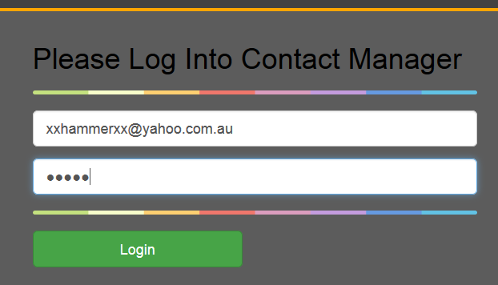

User enters their Credentials

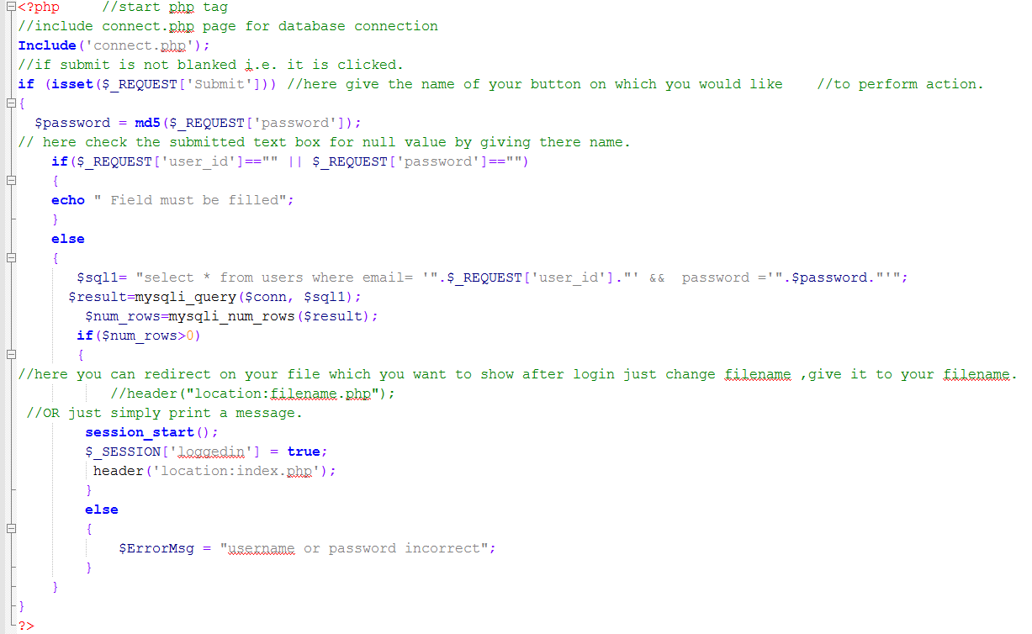

Figure Login Php Code

1. Correct information will create a session verifying a successful login by the User and direct them to the index page, otherwise known as the *“HOME PAGE”*  
   Incorrect information will create an Error message.

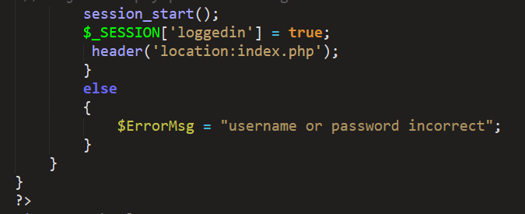

1. A Contact list with every contact entry stored in the database will appear displaying their first & last names – nicknames and mobile phone numbers.

Figure : Home Page

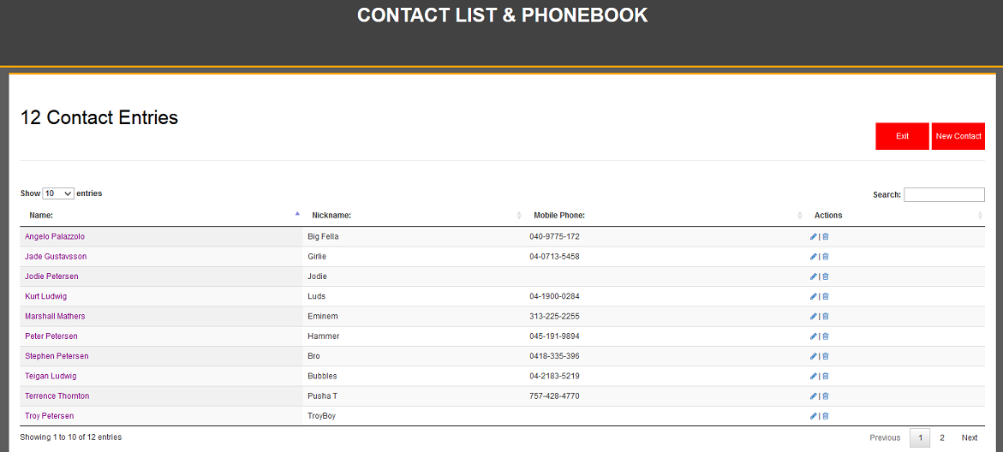

1. On the Home / Main page the User can create another New Contact / client by clicking the corresponding button. This will bring up a new screen displaying ‘Client List’.

Here the User enters all relevant details required and selects Insert Contact to save all the information to the database.   
Or select Cancel to return to Home / Main page.

Figure : Create New Contact

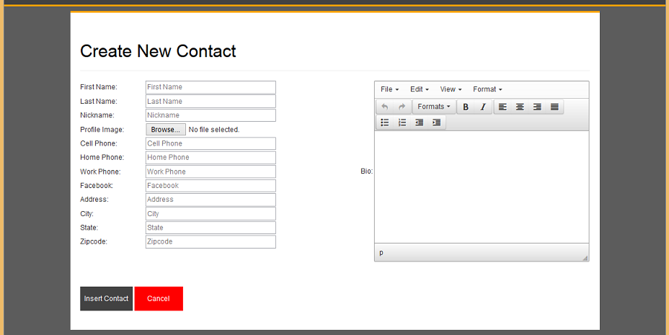

On completion of Create New Contact details the data will be entered into the database and the screen will return back to the “Home Page”.

1. The User can access additional information of every contact / entry by clicking the mouse on their contact name. This will give them access to another screen displaying the contacts profile information including: Name, nickname, cell phone, home phone, work phone, address (linked to Google maps), Facebook link, and profile photograph and biography notes if stored in the database.

Figure : Contacts Profile Area

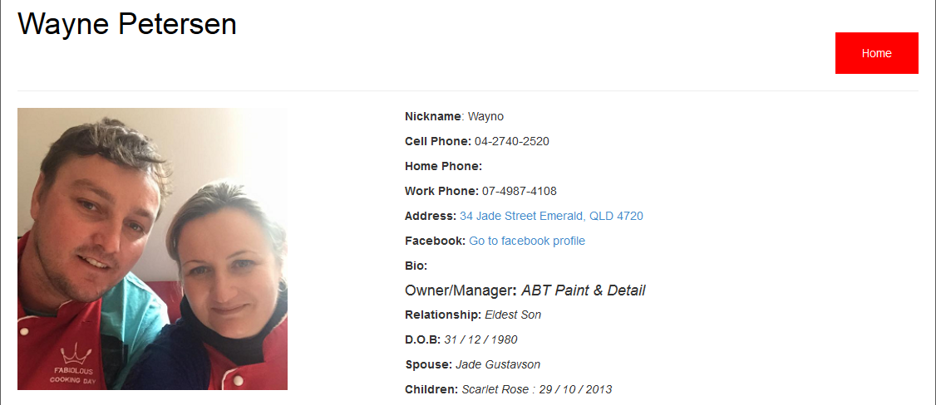

1. Another feature on Home / Main page is the ability to modify or update an individual’s contact / profile information by selecting the adjacent blue pencil icon in the Actions area on the right side of the form.
2. This will open another screen showing the relevant contact’s existing data that is stored in the database. The User then can choose to delete by typing over the information they want changed and then continue to click ‘Update Contact’ this will overwrite and save the contents in both the Database and Contacts Profile Area.

Figure Contacts Update Area

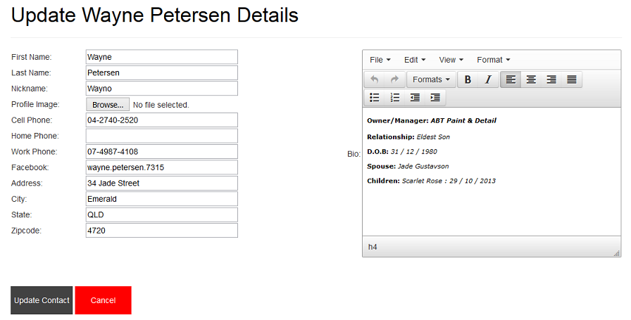

From the “HOME” Page screen you also have the Option to delete any contact / client from your database if you choose to do so by selecting the Blue Trash Can under the Action area opposite the pencil icon. This will automatically remove all the Contacts information from the Address Book and the Database.

1. Selecting the Home button will take the User back to the Home / Main page.
2. Selecting the Cancel button will again return to Home / Main page.
3. Selecting the Exit button will take the User back to the Login screen.

* The Database Structure:

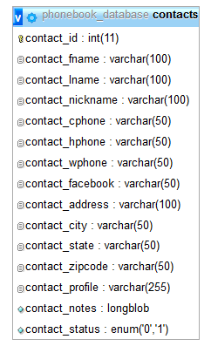

Figure Database Fields

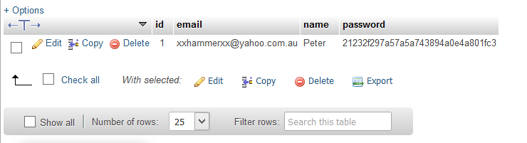

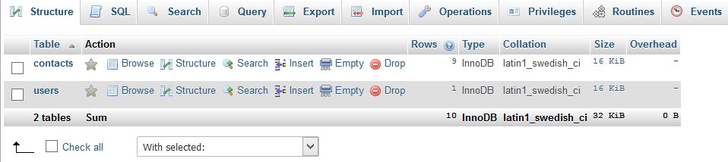

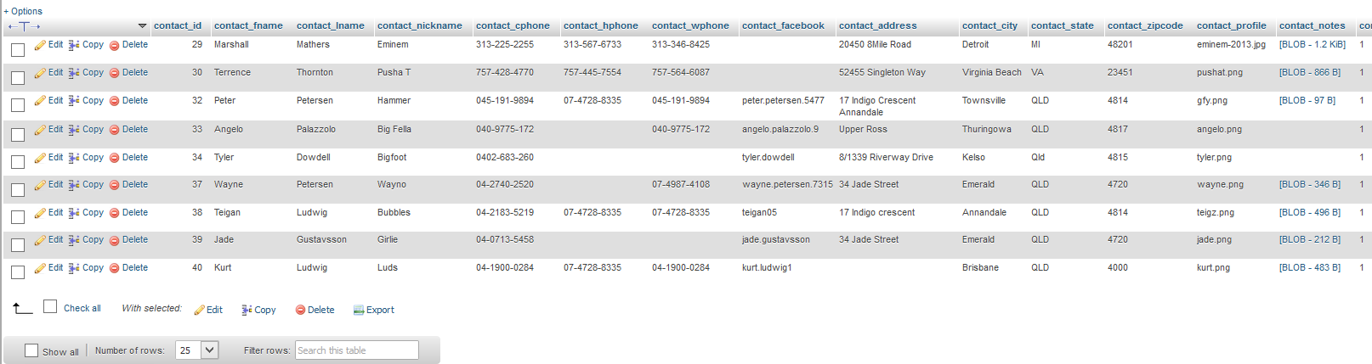

Figure 8: Contact / Client Table

* The Php/Sql codes you used to interact with the database:

Figure : Login Php

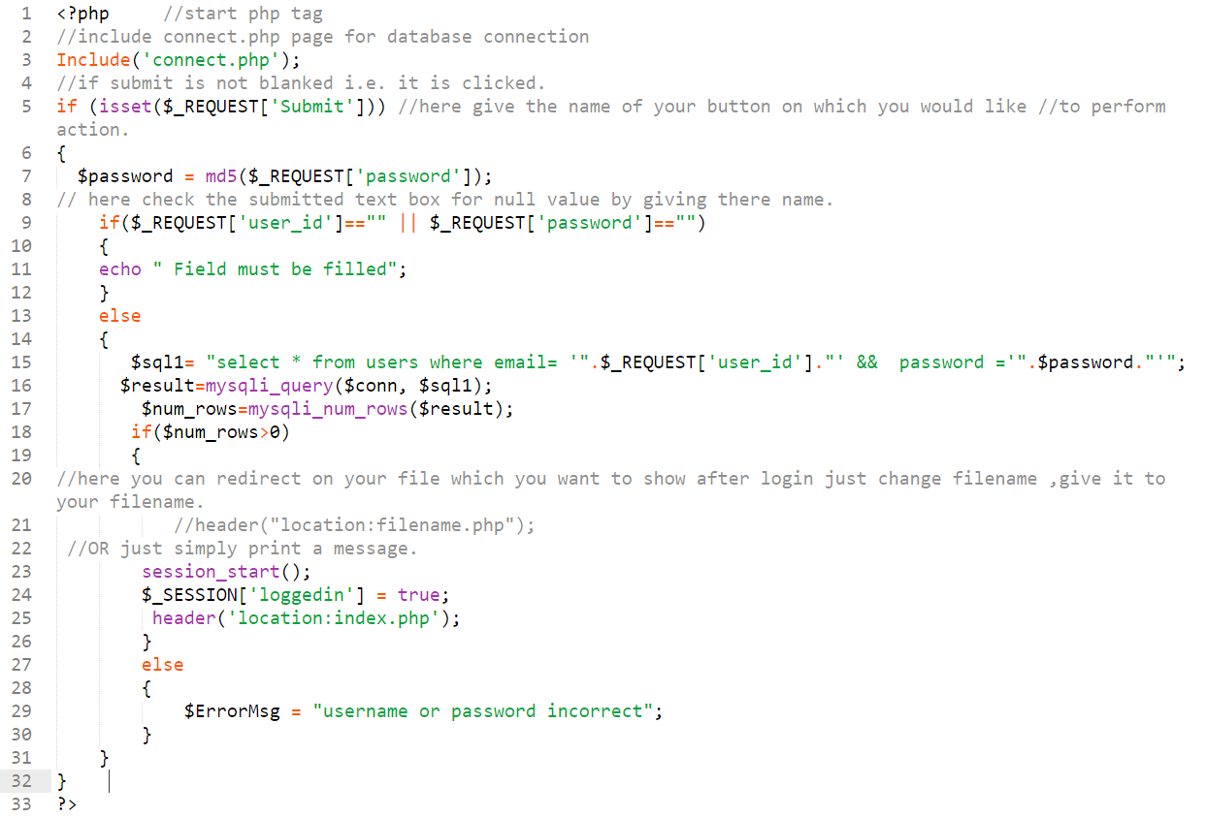

Figure : Connect Php

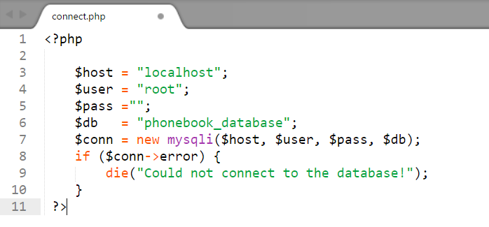

Figure : index php

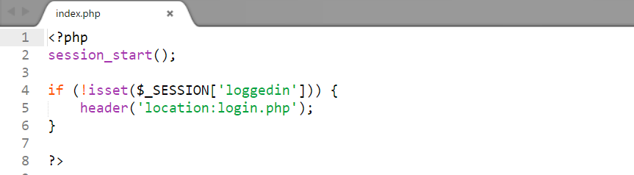

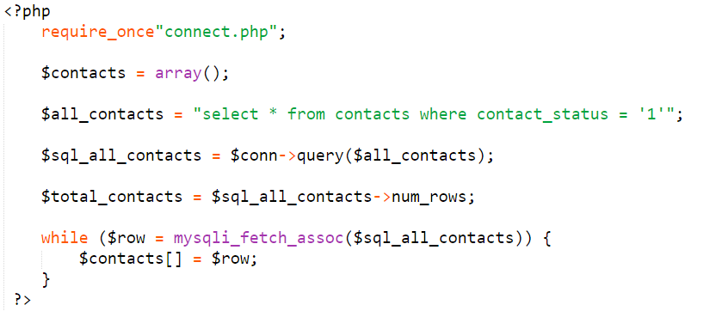

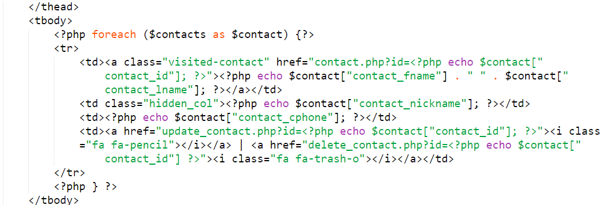

Figure : Logout Php

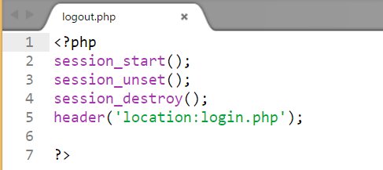

Figure : Contact Php

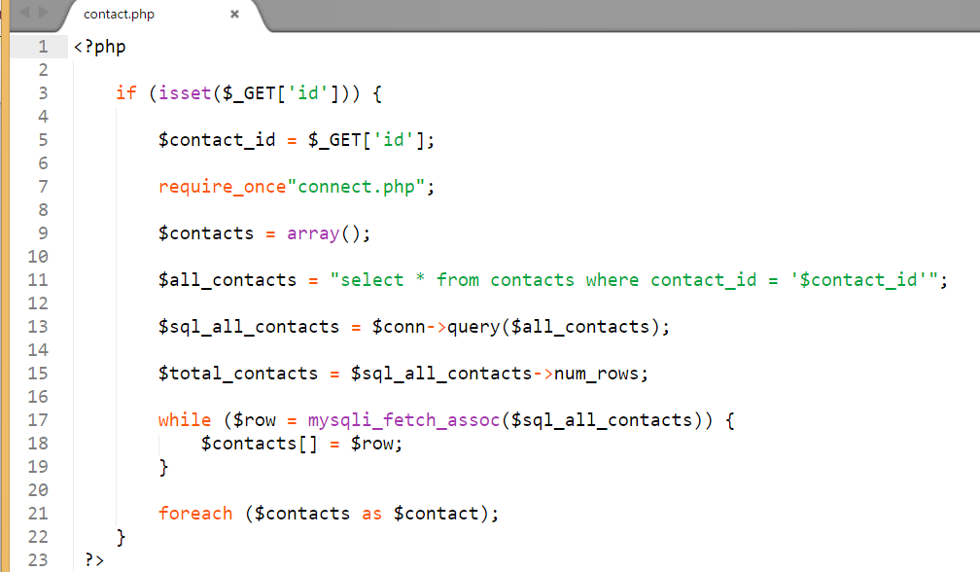

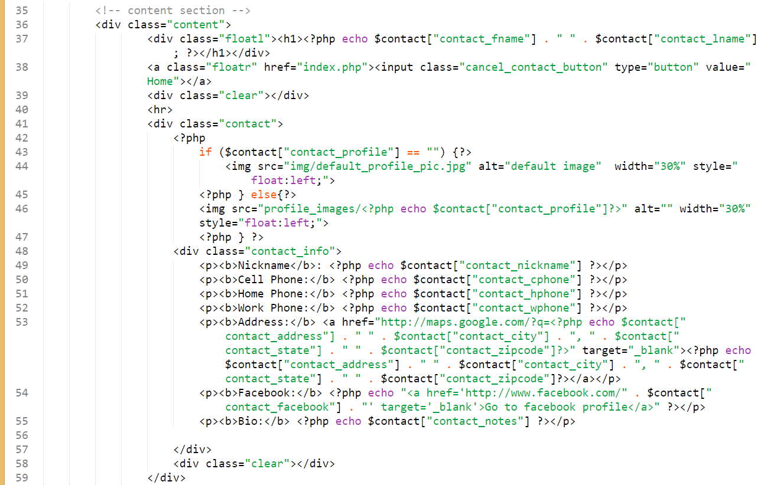

Figure : Delete Php

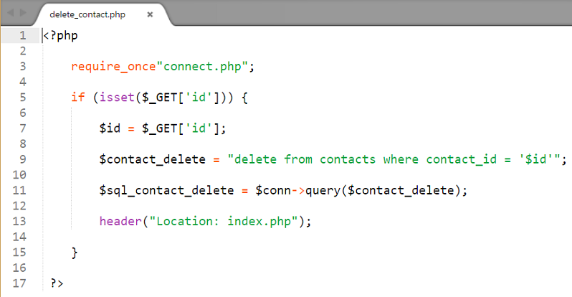

Figure : Inset Contact Php

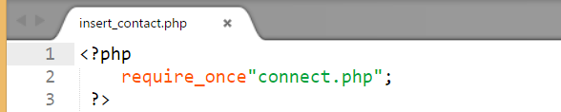

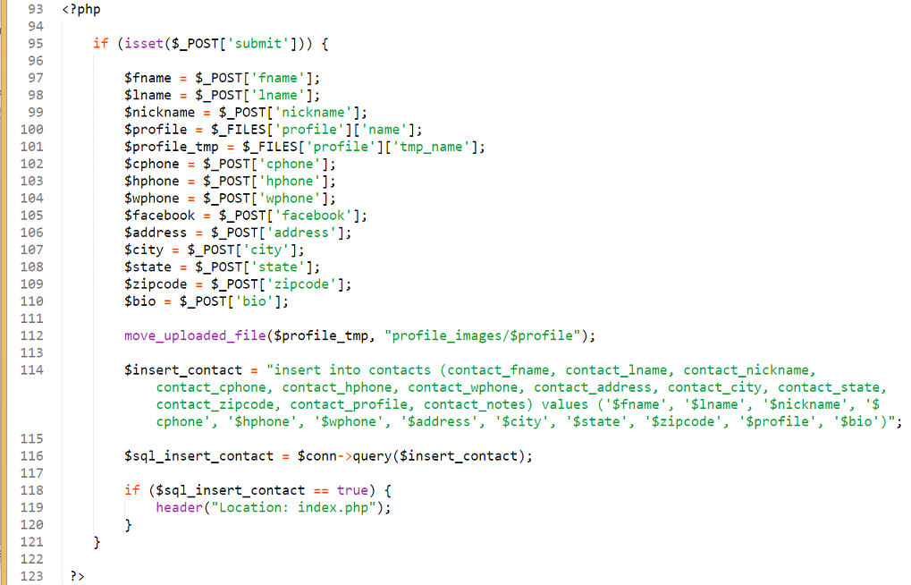

Figure : Update Contact Php

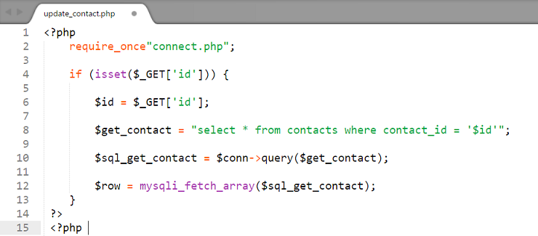

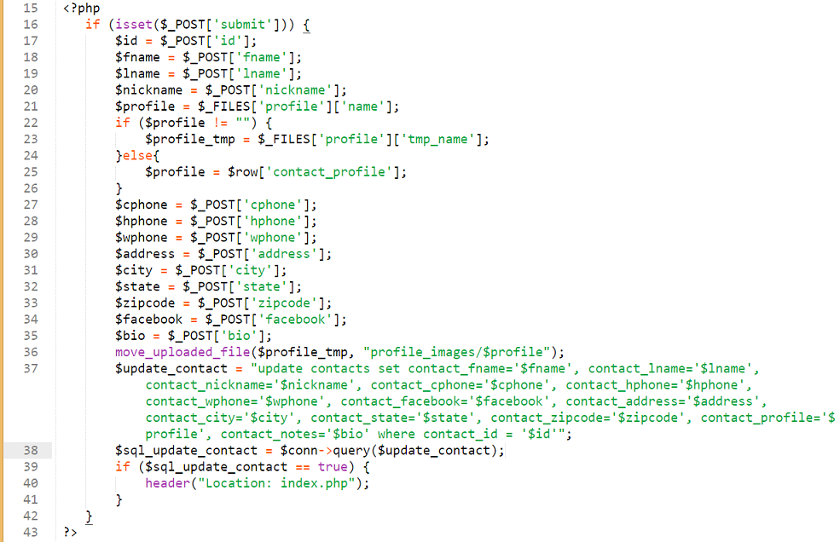

END OF ASSESSMENT