**Book Management System Analysis Document**

1.Introduction 3

1.1 Purpose of the system 3

2.Current system(shortcomings) 3

3.Proposed software architecture 4

3.1 Overview 4

3.2 Functional Requirements 4

3.3 Nonfunctional Requirements 6

3.4 system requirements 6

3.4.1 Hardware requirements. 6

3.4.2 Software requirements 6

3.5 System Model 7

3.5.1 Use Case Model 7

3.5.1.1 overview 7

3.5.1.2 Actor 7

3.5.1.3 log in 8

3.5.1.4 choose the service 8

3.5.1.5 search book 9

3.5.1.6 borrow book 9

3.5.1.7 return book 9

3.5.1.8 order book 10

3.5.1.9 feedback advice 10

3.5.1.10 entry book 11

3.5.1.11 manage book 11

3.5.2 Object Model 12

3.5.2.1 overview 12

3.5.3 Dynamic Model 12

3.5.3.1 log in Sequence Diagram 12

3.5.3.2 choose service Sequence Diagram 13

3.5.3.3 search book Sequence Diagram 13

3.5.3.4 borrow book Sequence Diagram 14

3.5.3.5 return book Sequence Diagram 14

3.5.3.6 order book Sequence Diagram 15

3.5.3.7 entry book Sequence Diagram 15

3.5.3.8 manage book Sequence Diagram 16

1.Introduction

1.1 Purpose of the system

The realization of centralized storage and distribution management can facilitate convenient inquiry and safety control of data, improve the efficiency of equipment use and reduce maintenance cost. The system establishes the real-time updating unified document library, information content of various forms of storage, from the sound, graphics, images and other multimedia information to highly structured documents, discuss the database from e-mail to provide storage model; hierarchical management of documents, real life now, the document can be for the check-in / check-out inspection, version control, across all management content retrieval, audit tracking, document description etc.

2.Current system(shortcomings)

2.1 The data load of the application server is heavier; the server is easy to crash.

2.2 With the increase of the number of readers, the traditional network system is overwhelmed, and a new management method is urgently needed.

2.3 Managers know and have insufficient level. The level of current managers is uneven, and it is easy to cause system abnormality in operation.

2.4 Low hardware configuration

3.Proposed software architecture

3.1 Overview

The book management system is a system of collection, transmission, processing, preservation, maintenance and use of management information, which is composed of people and computers. The use of information to control the behavior of the enterprise; help the enterprise to achieve its planning goals.

This system is mainly used in library, The cost of opening is low, and the required technology can be used in JSP, MYSQL and so on. And based on b/s mode development. The reason is:

1. Convenience for maintenance and upgrading, It is beneficial to improve efficiency.

2. Low cost.

3.2 Functional Requirements

3.2.1 System shall manage users’ information.

3.2.1.1If the readers or workers who want to use this System must enter the ID and Password, System will check whether the ID and Password is recorded in Human Information Base. This is done in the “log in” interface page.

3.2.1.2 If someone who want to join in, System shall record their information.

3.2.2 System shall manage Books.

If book is borrowed or entry, System shall record or change the state of book. And show it in workers’ computers.

3.2.3 System shall record customers’ orders.

3.2.3.1 When the reader orders some books, System shall record the information of the ordering.

3.2.3.2 when the reader wants to cancel the order, System shall calculate the payment reader should pay until now and change the order information.

3.2.4 The System shall support the payment management.

After the reader orders some book, System should calculate the money which the reader should pay, and record the order information in Order Base.

3.2.5 System shall manage the places in the library.

After a reader leaving or coming, System shall change the state of the seat the reader set. And show it in the computers.

3.2.6 System shall manage the advice.

If someone write advice, System shall record the advice in Advice Base, and pass it to manager less than 1 minute.

3.3 Nonfunctional Requirements

3.3.1 ***Guarantee the security of the user's account.*** The reader or worker need to use the account to use the System, so the account must safe.

3.3.2 ***Can be used by many people at the same time.*** The System is used in library, so It must support the use of multiple people at the same time.

3.3.3 ***Increase of efficiency.*** The library always has lots of people use the service, so we need to increase the efficiency to save time.

3.4 system requirements

3.4.1 Hardware requirements: Database storage server, computer.

3.4.2 Software requirements: Inte­­ractive software, Storage software

3.5 System Model

3.5.1 Use Case Model

3.5.1. overview

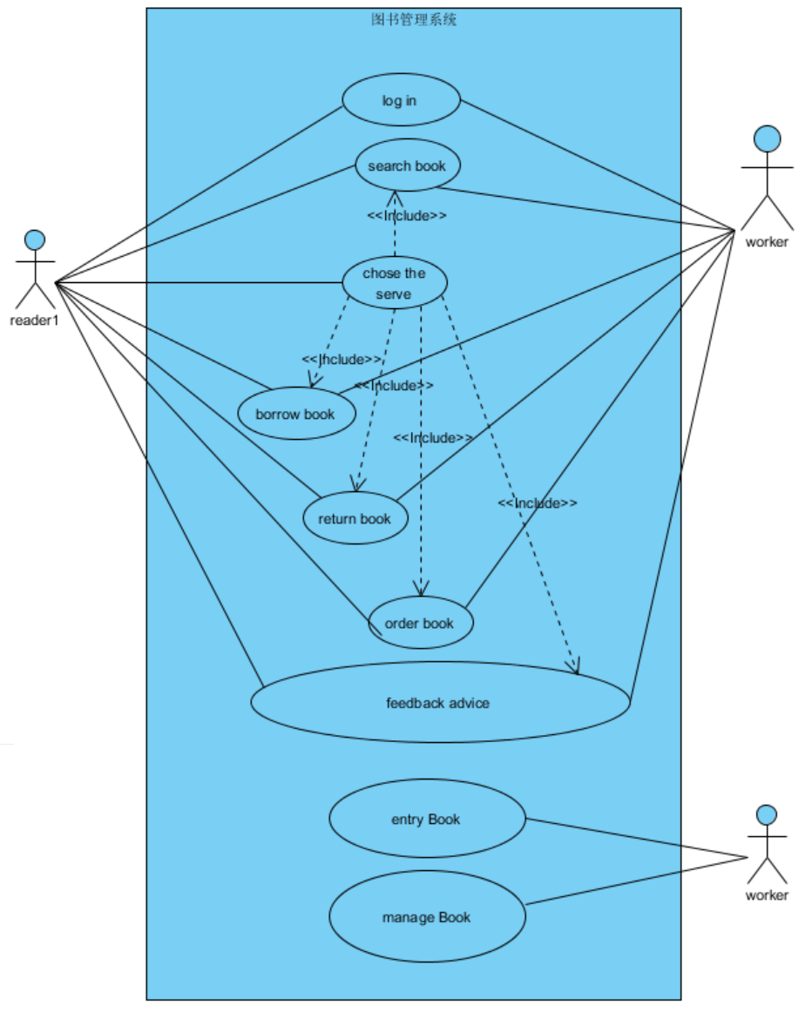3.5.1.2 Actor

We identify the following actors:

**Reader**

The reader is the one who use the System, enjoy the right to use the service.

**Worker**

The worker is the one who manage the System.

3.5.1.3 log in

Use case name: log in

Initiating actor: worker and reader

Preconditions: You must Enter the right ID and Password

Post-conditions: 1. reader will log in the System.

2. the System will know you has logged in.

Flow of event: Actor Steps System Steps

1.write you ID and Password in

the computer, and click "log in"

2.System check ID and Password

in data base

2.1 if right, log in

2.2 if worry, alert “please enter

the right ID and Password”

3.5.1.4 choose the service

Use case name: choose the service

Initiating actor: reader

Preconditions: You must log in.

Post-conditions: you will choose a service or advice for us.

Flow of event: Actor Steps System Steps

1. chose what serve you need, click

"Yes" button

2. System will go to the service page

3.if you need more other services

or you have ideas for us, please click

"Advise now!"

4. System will go to the service page.

3.5.1.5 search book

Use case name: search book

Initiating actor: reader

Preconditions: you must log in.

Post-conditions: You will know the state of books.

Flow of event: Actor Steps System Steps

1. Enter the IBSN

2. System show the state of the book you choose.

3.5.1.6 borrow book

Use case name: borrow book

Initiating actor: reader

Preconditions: You must log in

Post-conditions: 1. You will borrow a book.

. 2. System will change the state of the book you borrow.

Flow of event: Actor Steps System Steps

1. Enter the IBSN

2. System show the state of book

1. chose how long you want

to borrow

4. System will get your order and pass it to Borrow date. And show Borrowing books successfully.

3.5.1.7 return book

Use case name: return book

Initiating actor: reader

Preconditions: log in

Post-conditions: 1. You will return book.

. 2.System will change the state of the book.

Flow of event: Actor Steps System Steps

1. Click "return book"

2. System show all of books you borrow.

1. choice the one you want

to return. click "Yes"

4. System will show the result of returning book.

3.5.1.8 order book

Use case name: order book

Initiating actor: reader

Preconditions: log in

Post-conditions: 1. order base will get your order

. 2. You will get book regularly.

Flow of event: Actor Steps System Steps

1.chose the book you want

to order

2. System will show the page how

long you want to order

3.chose how long you want to

Order

4. System will pass the order to order base.

3.5.1.9 feedback advice

Use case name: feedback advice

Initiating actor: reader

Preconditions: log in

Post-conditions: System will pass your advice to Advice Base.

.

Flow of event: Actor Steps System Steps

1. Write the advice

2. System will show "advice success" and pass it to Advice Base.

3.5.1.10 entry book

Use case name: entry book

Initiating actor: worker

Preconditions: log in

Post-conditions: System will record the information to Book Base.

.

Flow of event: Actor Steps System Steps

1. 1. worker enter the book

Information

2. System will pass the information

to Book Base.

3.5.1.11 manage book

Use case name: manage book

Initiating actor: worker

Preconditions: log in

Post-conditions: change the information of book in the Book Base.

.

Flow of event: Actor Steps System Steps

1. change the information of

book in the Book Base.

2. System will record the information

to Book Base.

3.5.2 Object Model

3.5.2.1 overview

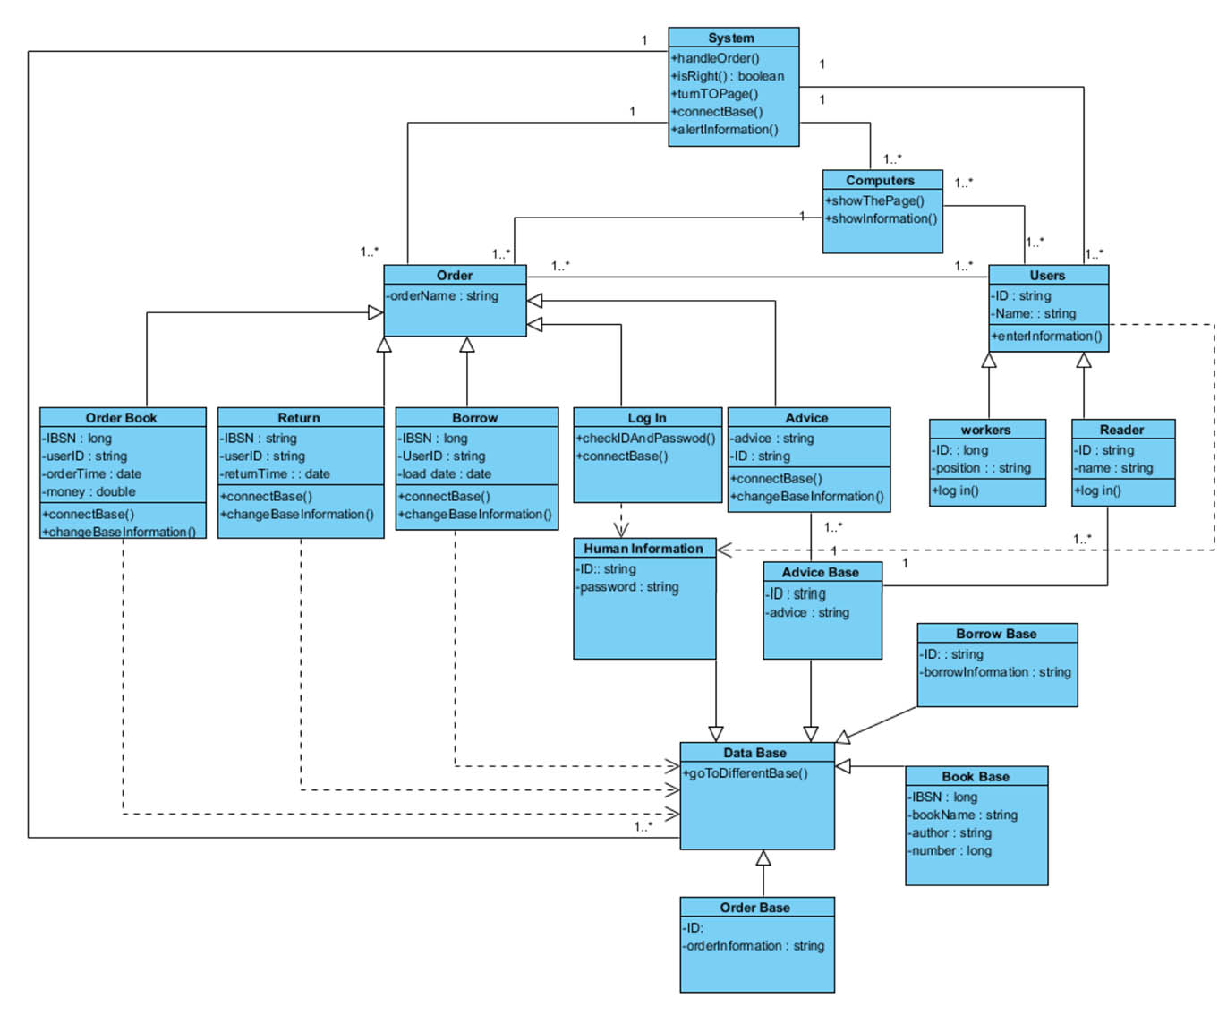

3.5.2.2 System

System control and handle the orders which are ordered by users.

3.5.2.3 Computers

Computer is the interfaces between the users and System

3.5.2.4 order

Order is ordered by users. One can choose service here.

3.5.2.5 search book

Readers can use this to search book

3.5.2.6 borrow book

Readers can borrow book use this service.

3.5.2.7 return book

Readers can return book use this service

3.5.2.8 log in

Users can log in this System once the ID and Password is matched with the Human Base.

3.5.2.9 advice

Readers can use this to write advice.

3.5.2.10 workers

Worker is the one who manage and use the System

3.5.2.11 readers

Reader is the one who use the System and enjoy some service the System prove.

3.5.2.12 Date Base

Date bae include five sub-date bases:1. Human Information Base 2. Order Base 3.Advice Base

4.Borrow Base 5. Book Base

3.5.2.13 Human Information Base

Human Information Base include the users ID and Password.

3.5.2.14 Order Base

Order Base include the orders readers ordered.

3.5.2.15 Advice Base

Advice Base include the advices readers write.

3.5.2.16 Borrow Base

Borrow Base include the borrow information and readers ID.

3.5.2.17 Book Base

Book Base include the book information.

3.5.3 Dynamic Model

3.5.3.1 log in Sequence Diagram

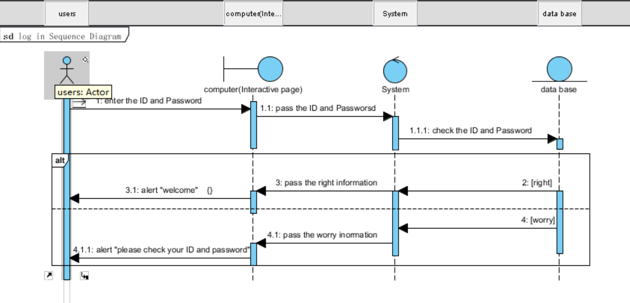

3.5.3.2 choose service Sequence Diagram

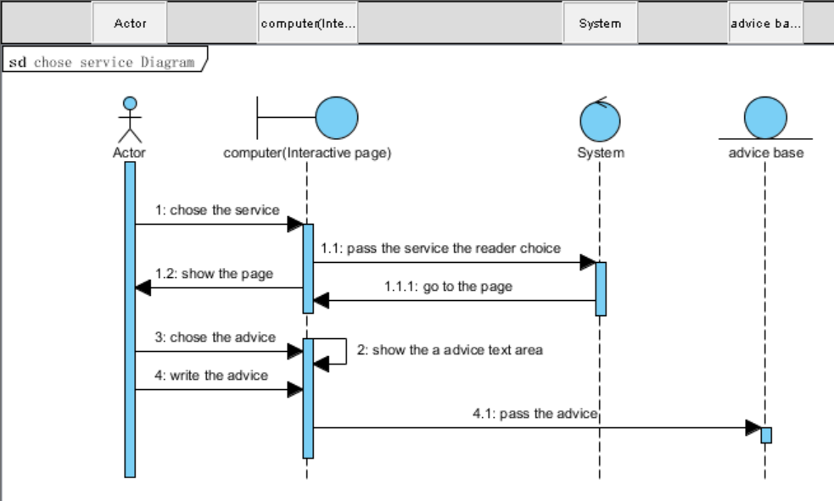

3.5.3.3 search book Sequence Diagram

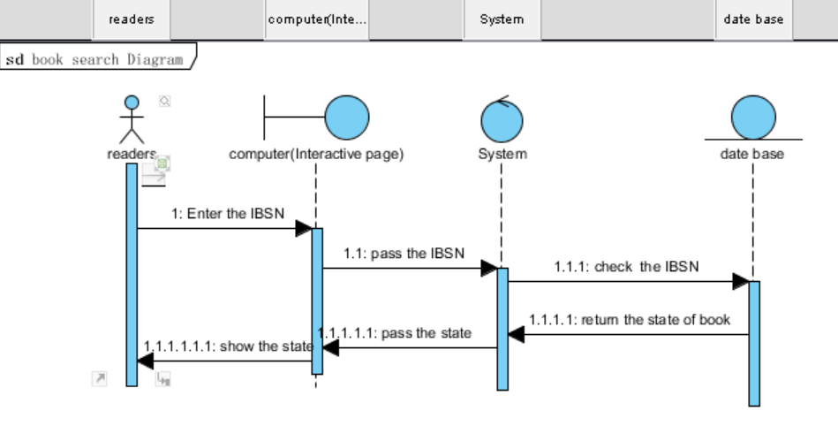

3.5.3.4 borrow book Sequence Diagram

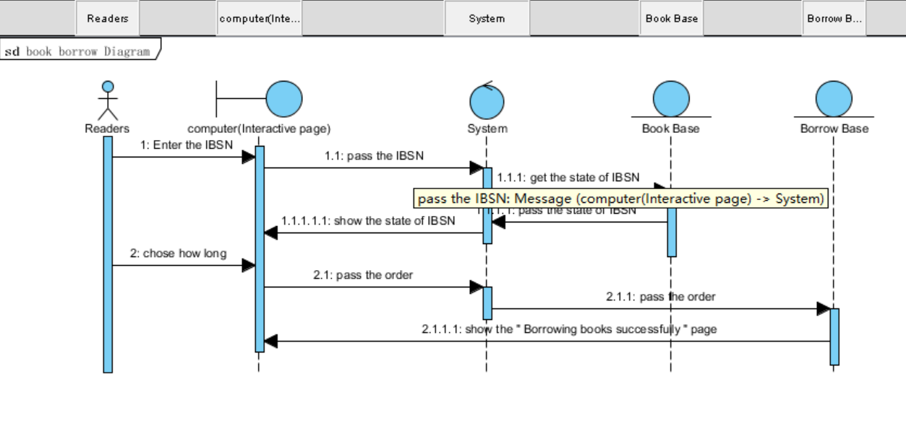

3.5.3.5 return book Sequence Diagram

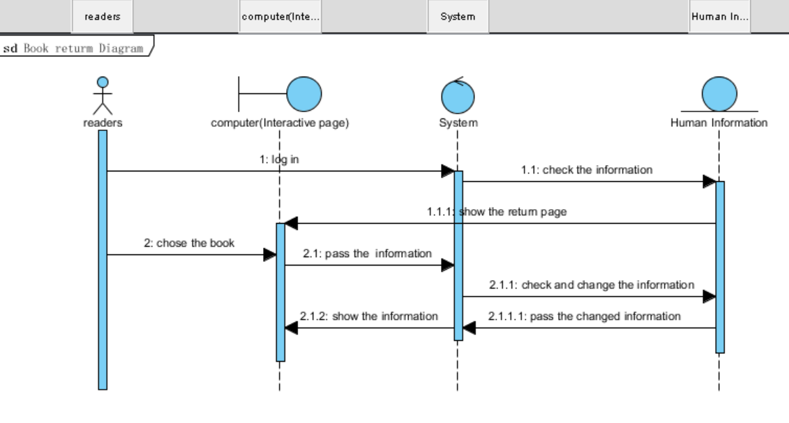

3.5.3.6 order book Sequence Diagram

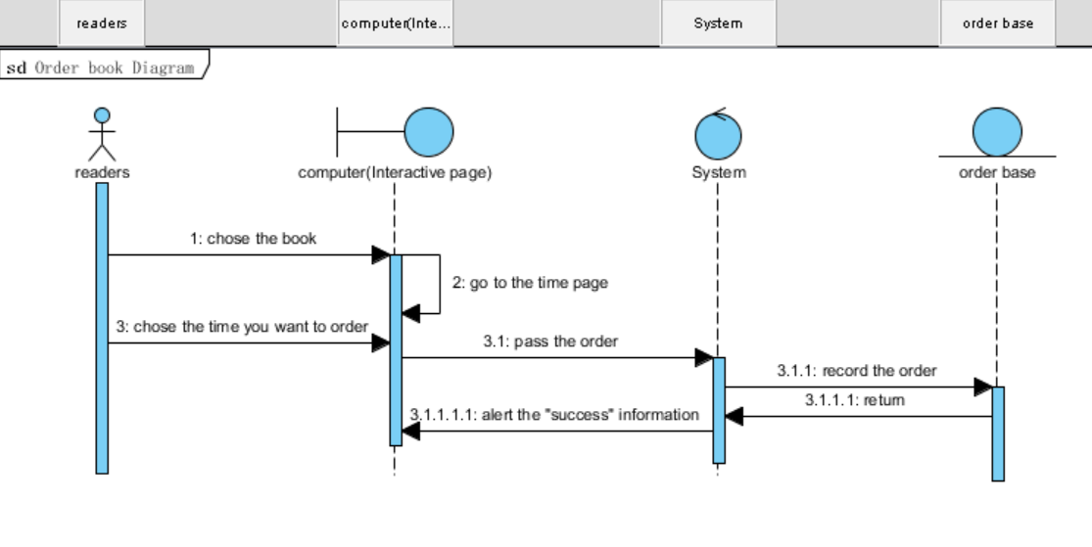

3.5.3.7 entry book Sequence Diagram

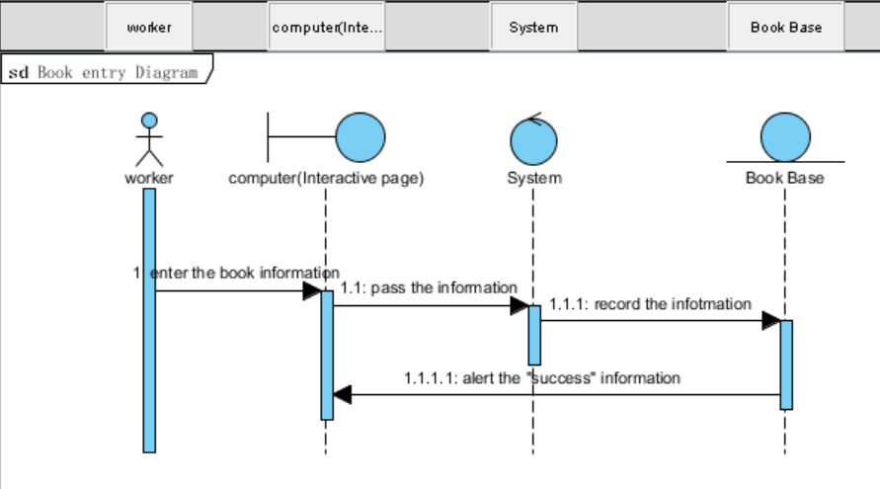

3.5.3.8 manage book Sequence Diagram

