Inflation Pass-Through to Retail Demand in Singapore
Economic Analysis
Author: CHAN JIE

Contents
Executive Summary 2
Economic Background: 3
Empirical Results and Interpretation 5
Limitations 6
Appendix 7
Coding (Python) 9

Executive Summary
1. Business Question
- Does inflation stimulate real business activity in the short run, or does it ultimately hurt firm growth once cost pressures materialize?
2. Industry
- Consumer & Retail (FMCG, supermarkets)
3. Data
- SingStat: CPI (Consumer Price Index), RSI (Retail Sales Index)
- Period: 2017 Nov-2025 Oct
- All variables are transformed into growth rates where appropriate.
4. Methodology
- Ordinary Least Squares (OLS) regression
- Current and lagged inflation variables (0, 3, 6 months)
- Time-series analysis
4. Economic Concepts
- Inflation pass-through
- Demand elasticity
- Marginal revenue
- Cost-push inflation
- Lagged policy transmission

5. Key Findings
- Positive short-term effect of inflation
- Delayed contractionary effect
- Business implications: Firms and policymakers should be aware that: short-term inflation gains may be temporary, and monitor monetary and exchange rate policy to anticipate delayed cost pressures.

Economic Background
- Macro-analyse: how inflation happens in SG?
Post-2021 inflation in Singapore was primarily driven by imported and cost-push pressures in an open economy, reinforced by post-pandemic demand recovery and labor market tightness (Wage-setting dynamics & Philips Curve: low unemployment after reopening, rising nominal wages).
MAS curbs inflation by allowing Singapore dollar to appreciate, which lowers imported costs in a highly open economy, but the inflation-reducing effects materialize with a lag due to gradual price and wage adjustments.

- Pre- vs post-inflation: retail demand comparison
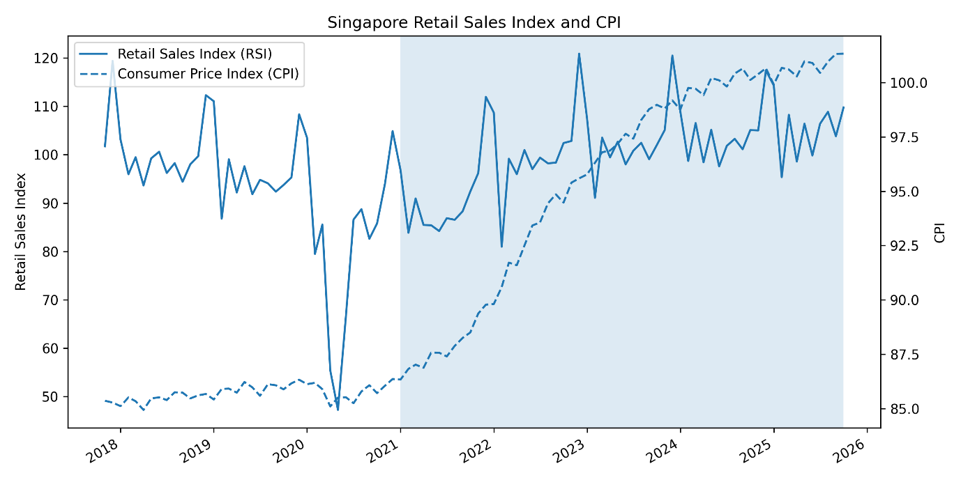
- Pre- vs post-inflation: exchange rate comparison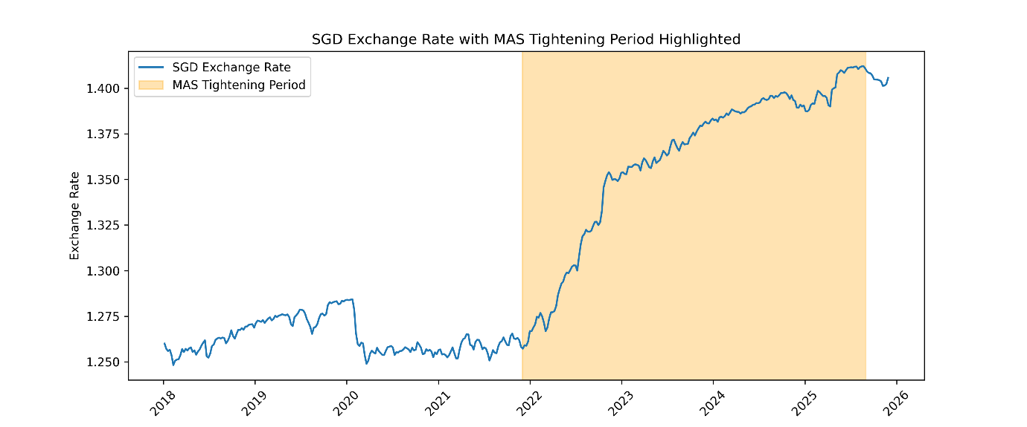

Empirical Results and Interpretation
We use the Ordinary Least Square (OLS) regression model to examine the dynamic impact of inflation on retail sector performance. The dependent variable is RSI growth (retail sales index), while the key explanatory variables are current and lagged CPI inflation (0, 3, 6 months).
As shown in Appendix Table 2, a one-unit increase in current inflation is associated with a significant increase in RSI growth. This relationship between inflation and real sector growth remains robust even when lagged inflation variables are excluded from the model (Appendix Table 1). Unlike the general perception people hold, the result suggests a short-term expansionary effect of CPI on retail demand, which is potentially driven by demand-side pressures where households’ nominal revenue increases outpaced firms’ cost adjustments. This price pass-through benefits firms temporarily.
Next, inflation from three months earlier has a negative and significant effect on RSI growth. This delivers a message: the inflationary pressures reverse over time possibly due to rising production costs and reduced real purchasing power. Inflation exerts a delayed contractionary effect as rising costs, declining real demand and monetary tightening/exchange-rate tightening materialize only after an initial adjustment period.
Looking at the result as a whole, we can review the price elasticity theory in microeconomics. The demand for an essential product may be inelastic in the short term, but over time, consumers can find alternatives or change habits, making the demand more price elastic in a longer period of time. Thus, retail suppliers earn more revenue (benefit from higher price) in the short run, but eventually have to pay off due to increasing production costs and declining real demand in the long run. From a business perspective, this indicates that inflation-led growth is not sustainable.
While the inflation 6 months earlier does not appear to have a meaningful impact on current RSI growth, suggesting that inflation shocks dissipate over time.
In a nutshell, inflation has a short-term positive effect on retail sales growth, followed by a significant medium-term slowdown. This dynamic pattern is consistent with: cost-push inflation mechanisms, lagged policy transmission and adjustment frictions in real output.

Limitations
- Simplified model structure
Focus primarily on inflation and does not include other business-related factors such as interest rates, monetary policy stances, or external demand.

- Data limitations
Results are based on aggregate data, may not fully reflect differences across firm-level.

- Causality (Endogeneity concerns)
Inflation and demand growth may influence each other simultaneously, so the estimates should be interpreted as associations rather than causal effects.

Appendix
Table 1: Baseline model (RSI~CPI)
OLS Regression Results
==============================================================================
Dep. Variable: rsi_growth R-squared: 0.173
Model: OLS Adj. R-squared: 0.163
Method: Least Squares F-statistic: 17.20
Date: Wed, 31 Dec 2025 Prob (F-statistic): 8.15e-05
Time: 01:55:19 Log-Likelihood: -337.38
No. Observations: 84 AIC: 678.8
Df Residuals: 82 BIC: 683.6
Df Model: 1
Covariance Type: nonrobust
==============================================================================
coef std err t P>|t| [0.025 0.975]
------------------------------------------------------------------------------
const -4.5563 2.153 -2.116 0.037 -8.839 -0.273
cpi_growth 2.6886 0.648 4.148 0.000 1.399 3.978
==============================================================================
Omnibus: 76.997 Durbin-Watson: 0.685
Prob(Omnibus): 0.000 Jarque-Bera (JB): 1031.596
Skew: 2.546 Prob(JB): 9.81e-225
Kurtosis: 19.396 Cond. No. 5.06
==============================================================================
Notes:
[1] Standard Errors assume that the covariance matrix of the errors is correctly specified.

Table 2: Lagged model (RSI~CPI LAGS 0, 3, 6)
OLS Regression Results
==============================================================================
Dep. Variable: rsi_growth R-squared: 0.372
Model: OLS Adj. R-squared: 0.345
Method: Least Squares F-statistic: 13.99
Date: Wed, 31 Dec 2025 Prob (F-statistic): 2.92e-07
Time: 01:55:19 Log-Likelihood: -294.34
No. Observations: 75 AIC: 596.7
Df Residuals: 71 BIC: 606.0
Df Model: 3
Covariance Type: nonrobust
==============================================================================
coef std err t P>|t| [0.025 0.975]
------------------------------------------------------------------------------
const -3.4004 2.274 -1.495 0.139 -7.935 1.134
cpi_lag_0 10.5288 1.938 5.433 0.000 6.664 14.393
cpi_lag_3 -8.4828 3.131 -2.710 0.008 -14.725 -2.240
cpi_lag_6 0.1488 1.929 0.077 0.939 -3.697 3.994
==============================================================================
Omnibus: 52.980 Durbin-Watson: 0.823
Prob(Omnibus): 0.000 Jarque-Bera (JB): 385.039
Skew: 1.866 Prob(JB): 2.45e-84
Kurtosis: 13.454 Cond. No. 16.2
==============================================================================
Notes:
[1] Standard Errors assume that the covariance matrix of the errors is correctly specified.

Coding (Python)
#import data
!pip install openpyxl
import pandas as pd
df = pd.read_excel(r"data\retail_pricing.xlsx")
df.head()
#data cleaning&transformation
df = df.rename(columns={'time': 'date'})
df['date'] = (
df['date']
.astype(str)
.str.strip()
.pipe(pd.to_datetime, format='mixed')
)
df = df.sort_values('date')
df.head()
#plotting rsi&cpi against date
import matplotlib.pyplot as plt
import matplotlib.dates as mdates
import pandas as pd

fig, ax1 = plt.subplots(figsize=(10, 5))

# --- RSI (left axis) ---
line1, = ax1.plot(
df['date'],
df['retail_sales_index'],
label='Retail Sales Index (RSI)'
)
ax1.set_ylabel('Retail Sales Index')

# --- CPI (right axis) ---
ax2 = ax1.twinx()
line2, = ax2.plot(
df['date'],
df['CPI'],
linestyle='--',
label='Consumer Price Index (CPI)'
)
ax2.set_ylabel('CPI')

# --- X-axis: show year only ---
ax1.xaxis.set_major_locator(mdates.YearLocator())
ax1.xaxis.set_major_formatter(mdates.DateFormatter('%Y'))

# --- Shade post-inflation period ---
ax1.axvspan(
pd.Timestamp('2021-01-01'),
df['date'].max(),
alpha=0.15
)

# --- Combined legend (KEY PART) ---
lines = [line1, line2]
labels = [l.get_label() for l in lines]
ax1.legend(lines, labels, loc='upper left')

# --- Title & layout ---
plt.title('Singapore Retail Sales Index and CPI')
fig.autofmt_xdate()
plt.tight_layout()
plt.show()
#transforming data into growth rate
df1 = df
df1['rsi_growth'] = df1['retail_sales_index'].pct_change(12) * 100
df1['cpi_growth'] = df1['CPI'].pct_change(12) * 100
df1 = df1.dropna()
df1
#regression-1
import statsmodels.api as sm

X = sm.add_constant(df1['cpi_growth'])
y = df1['rsi_growth']

model = sm.OLS(y, X).fit()
print(model.summary())
#regression-2 (lagged model)
for lag in [0, 3, 6, 9]:
df1[f'cpi_lag_{lag}'] = df1['cpi_growth'].shift(lag)

df1_lag = df1.dropna()

X = sm.add_constant(df1_lag[['cpi_lag_0', 'cpi_lag_3', 'cpi_lag_6']])
y = df1_lag['rsi_growth']

lag_model = sm.OLS(y, X).fit()
print(lag_model.summary())
#plotting exchange rate
import pandas as pd
df2 = pd.read_excel(r"data\S$ Nominal Effective Exchange Rate Index.xlsx")
df2["date"].dtype

import matplotlib.pyplot as plt

# sort data by date
df = df.sort_values("date")

# define MAS tightening period(s)
# For example: May 2021 to May 2023 (adjust according to actual data)
tightening_start = pd.to_datetime("2021-12-01")
tightening_end = pd.to_datetime("2025-09-01")

plt.figure(figsize=(12, 5))
plt.plot(df["date"], df["exchange_rate(usd/sgd)"], label="SGD Exchange Rate")

# highlight tightening period
plt.axvspan(tightening_start, tightening_end, color='orange', alpha=0.3, label="MAS Tightening Period")

plt.ylabel("Exchange Rate")
plt.title("SGD Exchange Rate with MAS Tightening Period Highlighted")
plt.xticks(rotation=45)
plt.legend()
plt.tight_layout()
plt.show()

