CS398 Final Project Report
Name: Lim Hao Jie Sherman
Digipen Email: haojie.lim

Implementation Details:

Binding OpenGL buffer to CUDA
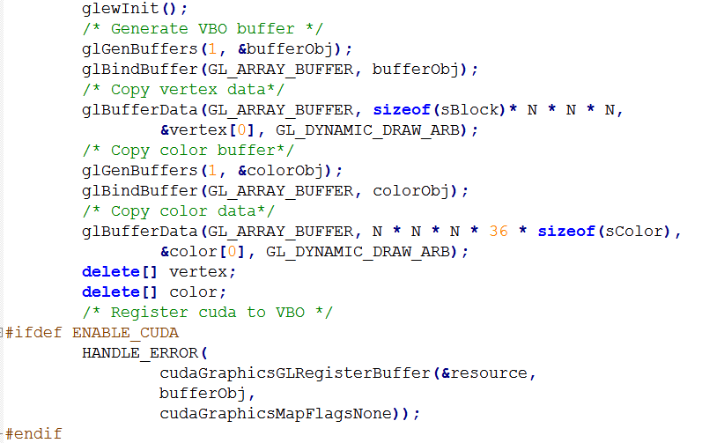

Buffer type is GL_ARRAY_BUFFER, suitable for drawing triangles. CUDA uses this buffer to write triangles from within the kernel.

Mapping and Unmapping the CUDA resouce to VBO
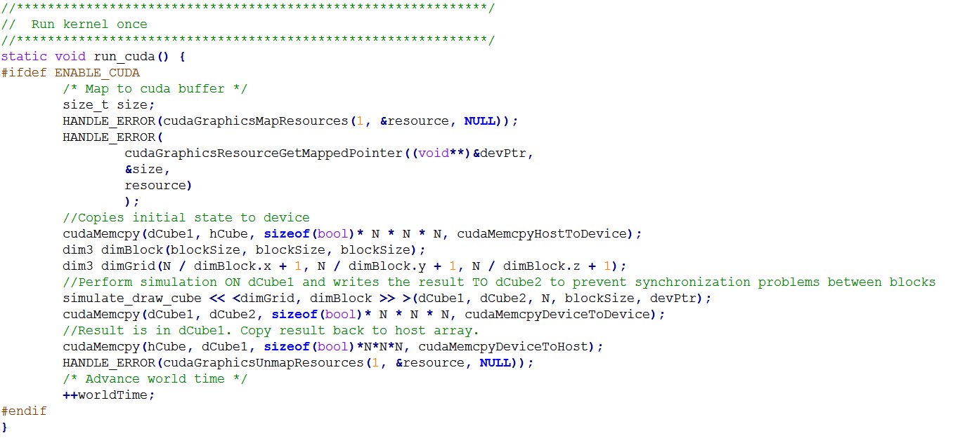
Maps the CUDA resource to the VBO, run the kernel, and unmap the resource to allow OpenGL to render.

Writing the triangles from the kernel into the VBO:
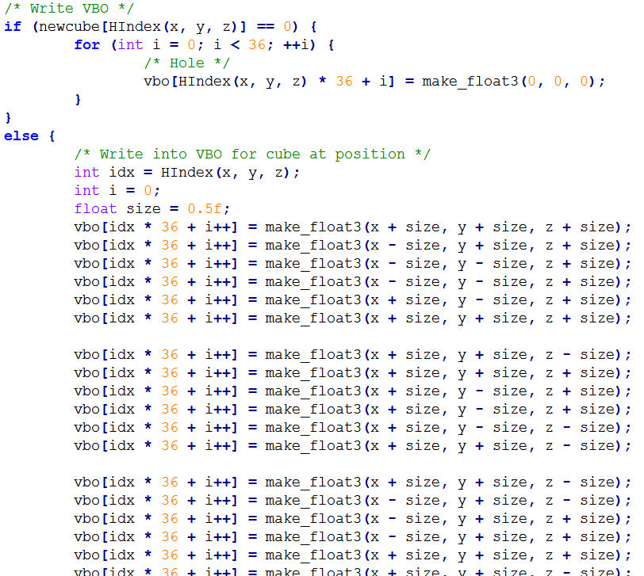

Did not use index buffer, as we might want to adjust cube sizes. Write 6 faces * 6 triangles for each cube.

Rendering the world
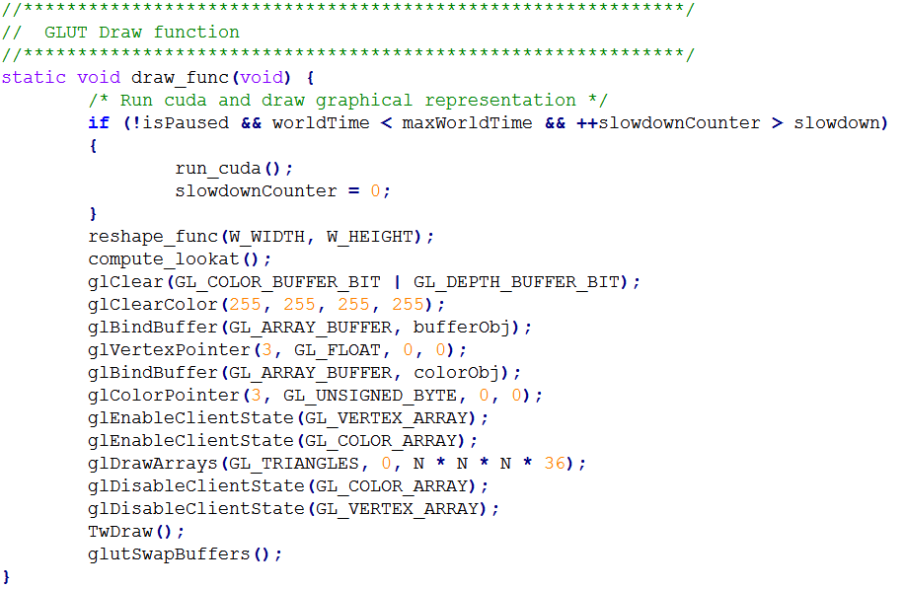

Screenshots

Optimizations
Did not use a second pass of kernel code to write into VBO.

Challenges encountered during the project
Determining the right OpenGL buffer object to use for writing triangles.
Debugging why the CUDA writing the triangles into the wrong location.

