TOPIC: Check whether a Special Build (SB) contains previous SB fix code:

CASE: PMR 05271,49R,000 Check if SB34763 contains the code change for SB34380

STEPS:
    - login to toronto machine: ie. hotellnx119.torolab.ibm.com
    - mkbldtree -name hzy -proj db2_v101fp3 选择 special_34763
    - selview 选择如 hzyhuhzy_db2_v101fp3_linuxamd64_special_34763_hzy
    - 查看SB34380里哪些文件已经被改动（这些文件需要去34673里边查看）
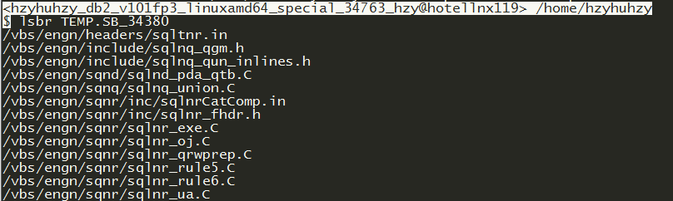
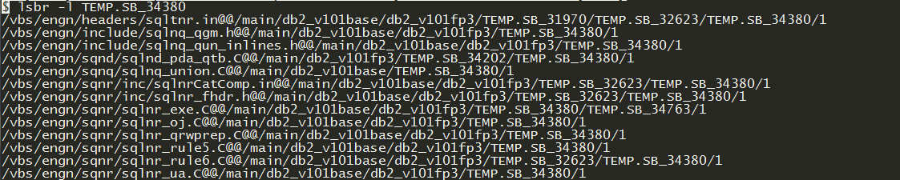
    - 查看SB34380里边具体到哪些行的code被改动了：
5.1 lsbr TEMP.SB_34380
5.2
diff -c /vbs/engn/sqnr/sqlnr_ua.C@@/main/db2_v101base/db2_v101fp3/TEMP.SB_34380/0 /vbs/engn/sqnr/sqlnr_ua.C@@/main/db2_v101base/db2_v101fp3/TEMP.SB_34380/1
    - 返回到SB34763里的看 “lsbr TEMP.SB_34380” 给出的file里是否有对应的change

NOTE: This work can be done by tool “cmpsb”

** USE `cmpsb`, YOU STILL NEED TO DO STEP 1-3 ON YOURSELF

ie. cmpsb 34380

This tool will check if current SB contains code change in SB 34380. If not, it will write out code change to cmp_result.txt

Logic:

- Compare SB 34380 file with current SB corresponding file. If nothing changed, then good
- If changed, then the difference might due to two reasons:
  - SB 34673 doesn't contain code change for SB 34380
  - Code change for SB 34673 modifies the same area of code change for SB 34380
  - The 2nd situation is too complex for machine judge, and the tool just write out the comparison result of SB 34380, and previous SB 34380 ( to see what is code change for SB 34380); the comparison result of SB 34380 and SB 34673 to a text file cmpsb_result.txt to let user judge.

If everything is good (ie. Current SB includes all the code change in previous SB), then you can see the following:

