**Least squares $A^{T}Ax=A^{T}b.$**

$$INCLUDEPICTURE "/Users/xxl12/Library/Group Containers/UBF8T346G9.ms/WebArchiveCopyPasteTempFiles/com.microsoft.Word/linear-regression-gpa.png" \backslash * MERGEFORMATINET$$

**Eigenvalue problem $Ax=λx.$**

**Differential equations $x^{'}\left(t\right)=f(t,x\left(t\right)).$**

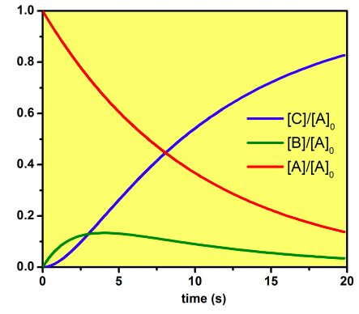

**Fast Fourier Transform $f_{k}=\sum_{j}{f\left(x_{j}\right)e^{-ikx_{j}}}.$**

$$INCLUDEPICTURE "/Users/xxl12/Library/Group Containers/UBF8T346G9.ms/WebArchiveCopyPasteTempFiles/com.microsoft.Word/3311485_orig.gif" \backslash * MERGEFORMATINET$$

**Optimization $\min_{x}{f(x)}.$**

