**POINT OF SALE AND MANAGEMENT SYSTEM OF AFFORDAWASH LAUNDRY SHOP**

A Research Project by

**Bernardo, John Luis E.**

**Calim, Arwyn G.**

**Estrella, Diero Reneel M.**

**Masallo, Lewis Daveriel**

**Santos, Eon Rico M.**

**Segguep, Christian A.**

BSIT – 3C

Submitted to:

**MS. Florie-Anne O. Ribucan**

Instructor

In Partial Fulfillment

of the Requirements in

**IT 303 – System Analysis and Design**

**Description of the Proposed System:**

The research will explore the POS's capabilities, beginning with its capacity to manage daily business transactions. The manager and employee can both access the secure login option. By including information on the products that have that function, the researcher will test and demonstrate whether the system is functioning. The employee may also view all the available goods or services on the system. enabling the employee to sell it to customers. In addition, the system will keep track of each customer transaction with the full time and date. The POS security system will not be covered by the study.

**Business Case**

**Project Name:** Point of Sale and Management System of Affordawash Laundry

Shop

**Date of Project Approval:** November 29, 2022

**Executive Summary**

The Affordawash Laundry Shop is a small business self-service laundry shop and retailer of laundry products located in a busy residential area. It may target busy families and professionals as its primary customer base, offering a cost-effective way to wash and dry their laundry as well as a selection of high-quality laundry products for sale.

The self-service laundry machines are top-of-the-line and easy to use, allowing customers to complete their laundry quickly and efficiently. Additionally, the laundry shop also offers a range of laundry products for sale. These includes detergents, fabric softeners, and stain removers, all of which are carefully selected to provide the best results for the customers.

Affordawash Laundry Shop offers a unique concept of providing laundry services without having an inventory. Customers can simply choose from a list of laundry products, and the employee will take note of their choices without actually stocking the product on site. This allows the shop to keep its costs low and pass on the savings to its customers.

**Reasons**

The Point of Sale and Management System of Affordawash Laundry Shop is a web-based system that is more efficient for employees and manager.

* Improved efficiency with a web-based system, employees can easily access customer information and process transactions.
* This kind of System comes in handy when it comes to storing data, employee records, and transactions.

**Expected benefits**

The expected benefits for Point of Sale and Management System of Affordawash Laundry Shop are:

* Managing the costumer’s transaction and employee’s information
* It is more practical than maintaining manual information that is based on paper.
* Manager and employees should have easier access to important information at all times, from any location.

**Expected downside**

The expected downside for Point of Sale and Management System of Affordawash Laundry Shop are:

* Only the manager and employees have access to it
* Everyone may not always have access to it
* Technical issues

**Timescale**

According to analysis, the project would take three weeks before the actual system implementation.



**Figure 1.0** The Gantt Chart shown above is the planned system for the Point of Sale and Management System of Affordawash Laundry Shop. It shows the percentage of completion and duration, the primary works, and the individuals who were assigned.

**Cost and Benefit Analysis**

For the benefit of the Affordawash Laundry Shop’s management and distribution of information, the proposed system’s cost needs are outlined below. As a result, the plan must be beneficial in practice and show how it benefits both the respondents and the customer.

**Major Risks**

There are several potential risks involved in making a point of sale and management system for a small business laundry shop. Some of the major risks include:

* Cost: Developing a custom point of sale and management system can be expensive, especially for a small business that may not have a large budget for technology.
* Complexity: Point-of-sale and management systems can be complex, and it may be difficult for small business owners or employees to learn how to use them effectively. This can lead to frustration and inefficiency.
* Data security: Any system that stores sensitive customer or financial data is at risk of being hacked or compromised. It is important to ensure that the system is secure, and that customer data is protected.
* Maintenance and support: As with any technology, a point-of-sale and management system will need to be maintained and supported over time. This can be a significant ongoing cost for a small business.

**Recommendations**

There are few suggestions to bear in mind when creating a point of sale and management system for a small business laundry shop:

* Start with a thorough needs assessment: Before beginning development, it is important to carefully assess the specific needs of the small business laundry shop to determine what features and capabilities the point of sale and management system should have. This will help ensure that the system is tailored to the business's specific needs and will be effective in helping them manage their operations.
* Focus on ease of use: The point of sale and management system should be easy to use and understand, even for employees who may not have a lot of experience with technology. This will help ensure that the system is used effectively and efficiently and will minimize frustration and downtime.
* Prioritize data security: As mentioned above, data security is a major concern when it comes to point of sale and management systems. It is important to ensure that the system is secure, and that customer data is protected. This may involve implementing measures such as encryption and regular security updates.
* Plan for ongoing maintenance and support: A point of sale and management system will require ongoing maintenance and support to continue functioning effectively. The small business should plan for this and budget accordingly to ensure that the system is always up-to-date and working properly.

**Modeling Requirements Using Data Flow Diagram (DFD)**

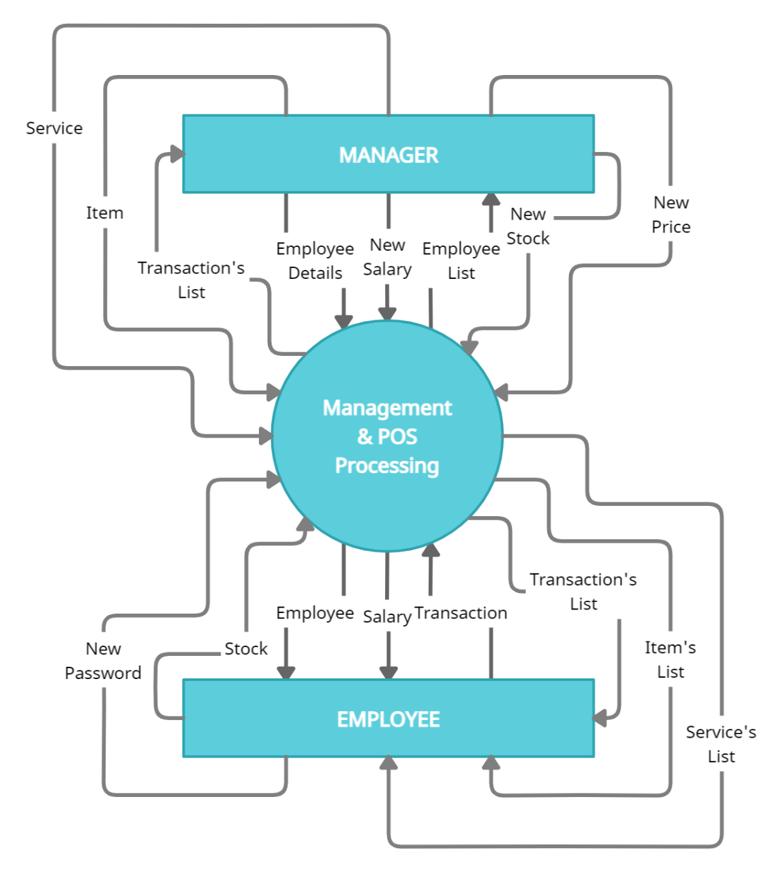

Context Level (DFD Level 0)

**Figure 2.0** Shows the contextual data flow within the system. On this context we have the manager, employee and the system; this context shows what should the system do when the entities interact with it and what features the system can offer for each entity.

Data Flow Diagram Level 1

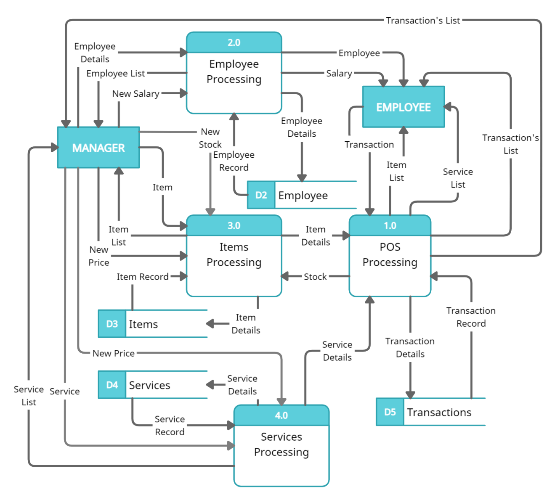

Context Level (DFD Level 0)

**Figure 2.1** Shows the data flows between these processes would be shown using arrows. The DFD would also show the different types of data that are flowing through the system, such as employee records, item records, machine records, and transaction records.

**Presentation of the Proposed System**

**User Interface**



**Figure 3.0** The login form is typically the first thing that users see, and it provides a secure and convenient way for users to access the system.

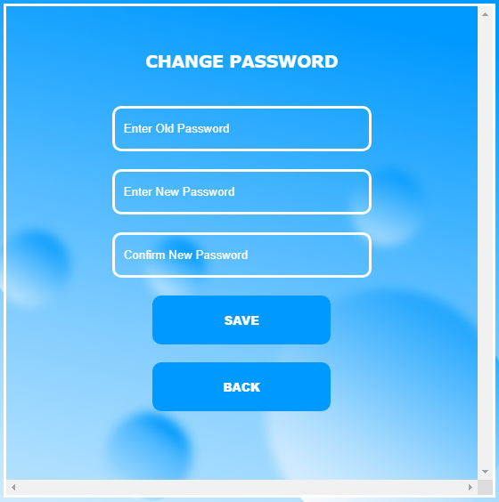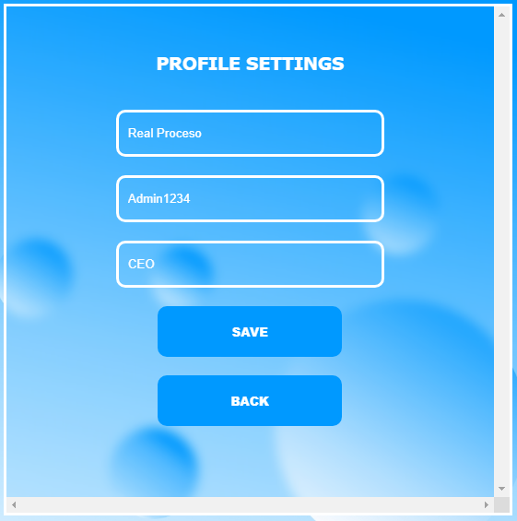

**Figure 3.1 & 3.2** The change password form allows the users to update their password for a particular system or application. While the profile settings form allows the user to update their profile before entering the web.

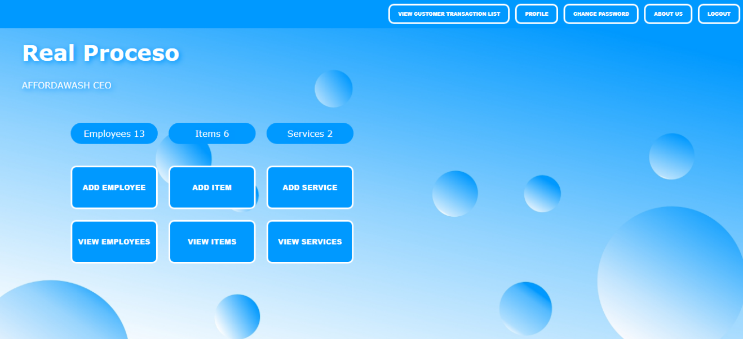

**Figure 4.0** This is the managers dashboard that provide with a quick and easy way to access and manage the information, and to make better decisions and manage the operations more effectively.

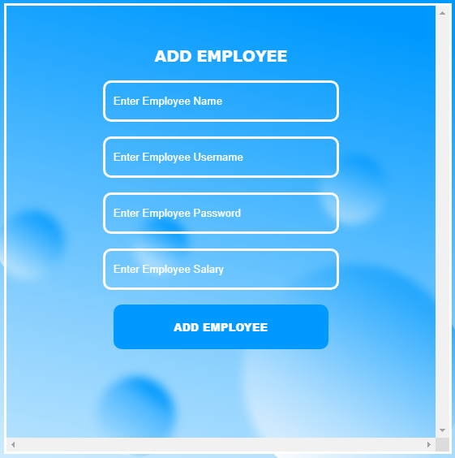

**Figure 4.1** The add employee form allows the manager to enter and submit information about a new employee.

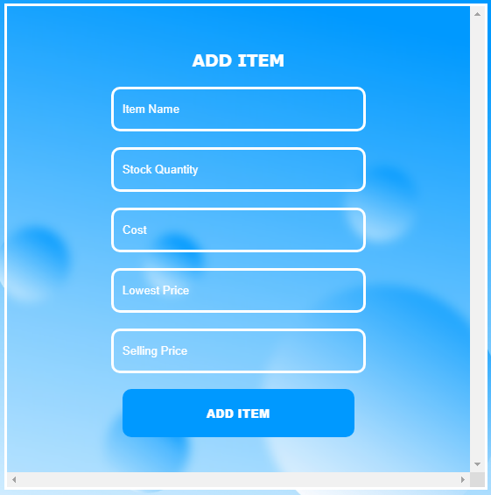

**Figure 4.2** The add item form allows the manager to enter and submit information about a new item.

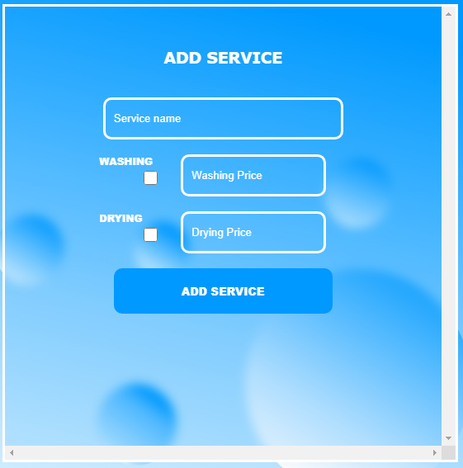

**Figure 4.3** The add service info form allows the manager to enter and submit information about the service information.

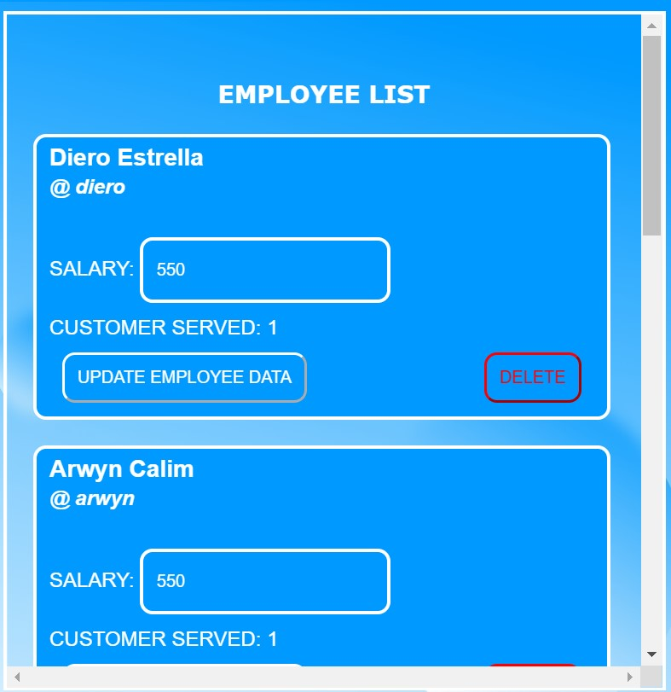

**Figure 4.4** This is the view employees page that provide the employee’s salary and assisted customer count.

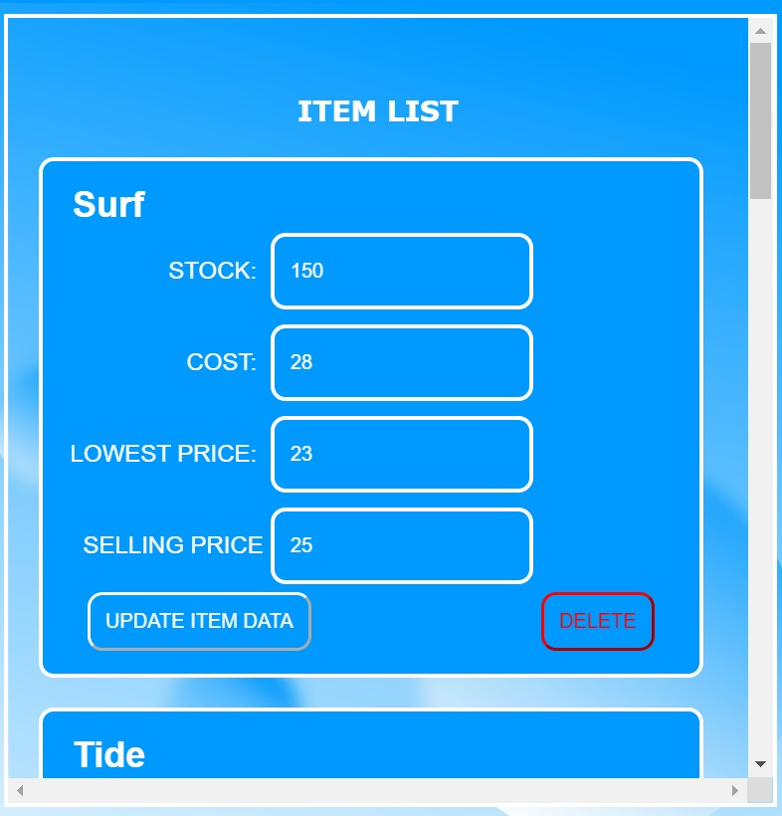

**Figure 4.5** This is the view item page that provide the information about the items added.

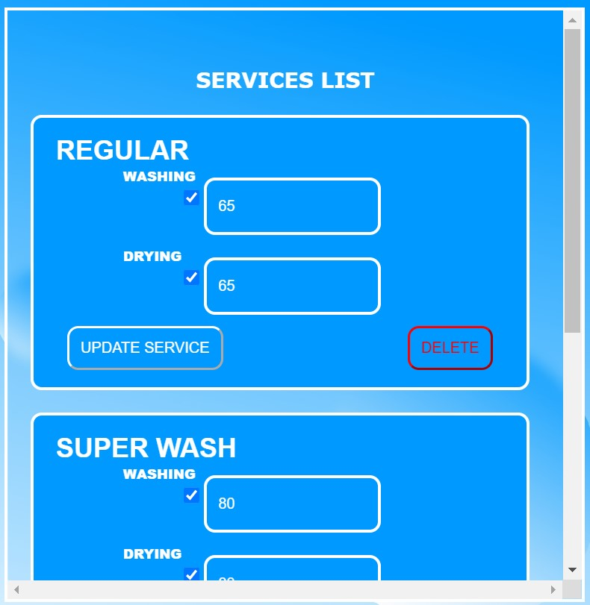

**Figure 4.6** This is the view services page that provide the information about the services added.

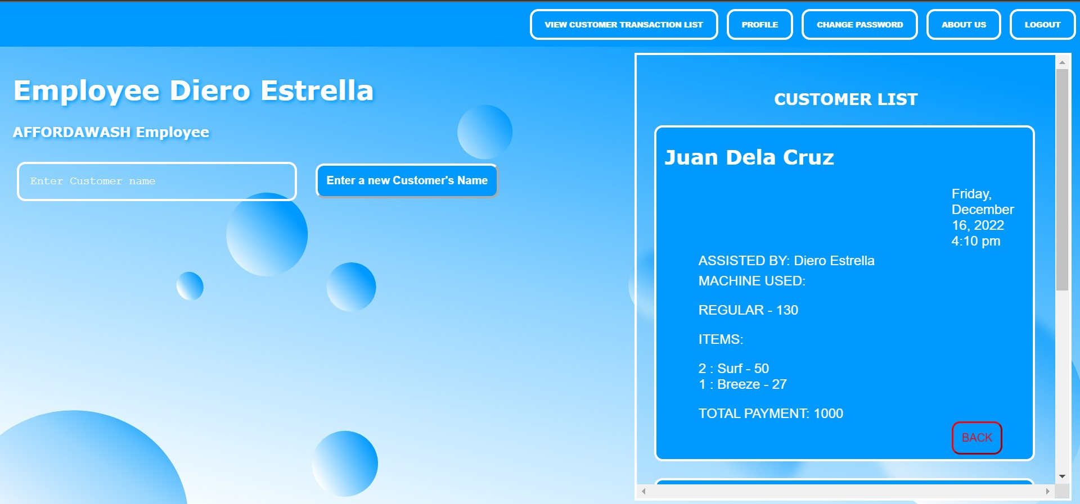

**Figure 5.0** This is the employee’s dashboard that provide with a quick and easy way to access and manage the customer’s information.

**Database Design**

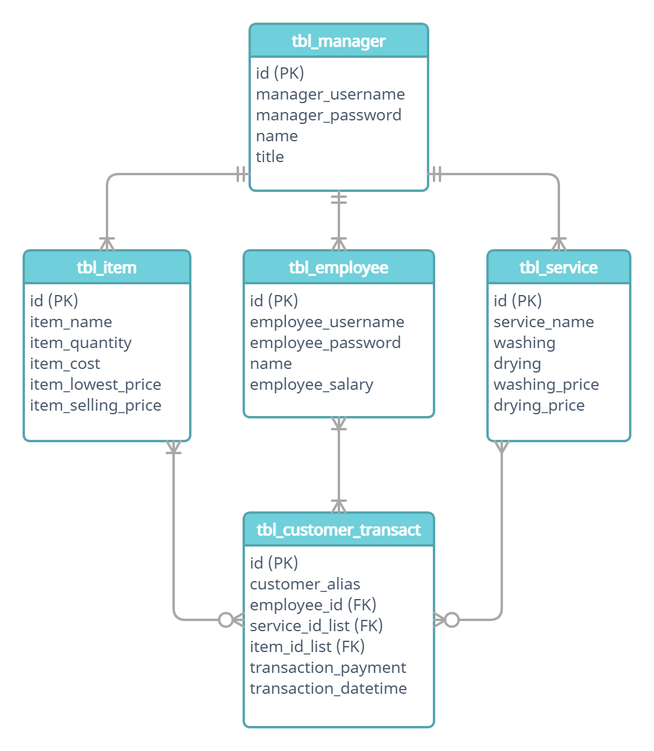

**Figure 6.0** Entity Relationship Diagram (ERD)