CSS Box Model

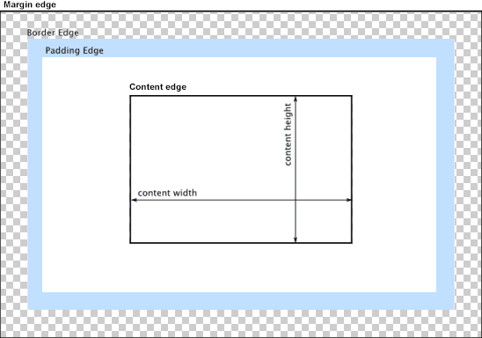

CSS properties:

margin, margin-top, margin-right, margin-bottom, margin-left,
padding, padding-top, padding-right, padding-bottom, padding-left,

box-sizing, background-clip, height, max-height, min-height, width,

border, border-top, border-right, border-bottom, border-left, border-width, border-top-width, border-right-width, border-bottom-width, border-left-width,

