Margin Vs Padding - CSS Properties
Article By Kamal Mettananda on December 21, 2006
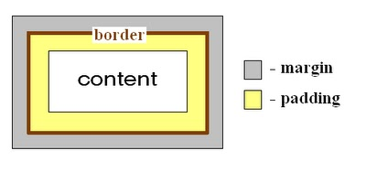
CSS provides two properties named margin and padding for keeping space between HTML Box type elements.
Padding - defines space between border and element content
Margin - defines space between border and other outer elements
(Look at the above diagram)
So when elements needs space between them, better to use margins. When text or an inner element needs space between the parent box and itself go for paddings.
<div style="margin:25px; background:#cccccc; border:#000000 2px dashed;">
Text inside element
</div>
<div style="padding:25px; background:#cccccc; border:#000000 2px dashed;">
Text inside element
</div>

Text inside element
------------------------------------------------------------------------------------------------------------

Text inside element

In the first <div>, space is set between the border and outside elements but in the second one it is between the border and text.

