HTML Page Structure

https://developer.mozilla.org/en-US/docs/Learn/HTML/Introduction_to_HTML/Document_and_website_structure#Enter_HTML5_structural_elements

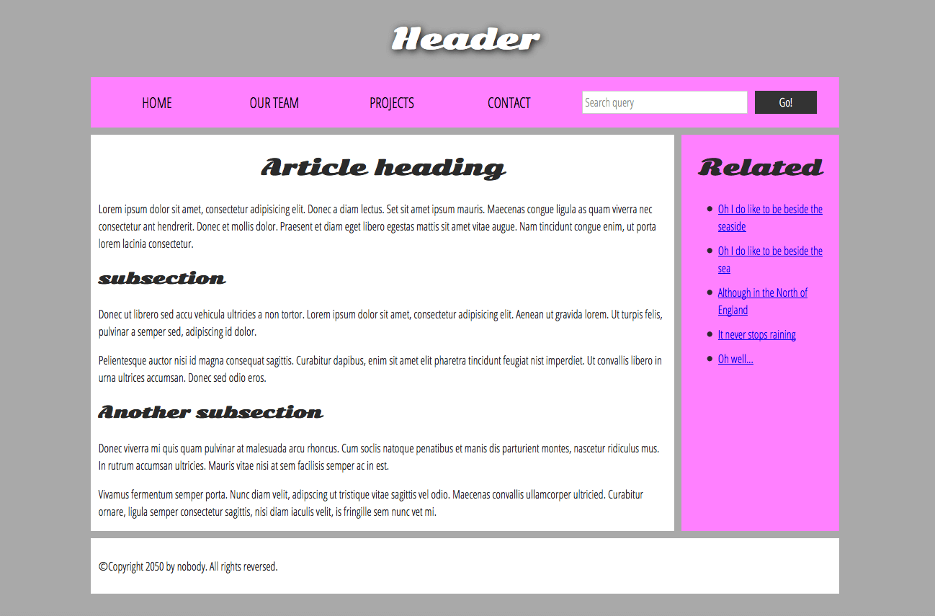

- header: <header>.
- navigation bar: <nav>.
- main content: <main>, with various content subsections represented by <article>, <section>, and <div> elements.
- sidebar: <aside>; often placed inside <main>.
- footer: <footer>.

<!DOCTYPE html>
<html>
<head>
<meta charset="utf-8">

<title>My page title</title>
<link href="https://fonts.googleapis.com/css?family=Open+Sans+Condensed:300|Sonsie+One" rel="stylesheet" type="text/css">
<link rel="stylesheet" href="style.css">

<!-- the below three lines are a fix to get HTML5 semantic elements working in old versions of Internet Explorer-->
<!--[if lt IE 9]>
<script src="https://cdnjs.cloudflare.com/ajax/libs/html5shiv/3.7.3/html5shiv.js"></script>
<![endif]-->
</head>

<body>
<!-- Here is our main header that is used across all the pages of our website -->

<header>
<h1>Header</h1>
</header>

<nav>
<ul>
<li><a href="#">Home</a></li>
<li><a href="#">Our team</a></li>
<li><a href="#">Projects</a></li>
<li><a href="#">Contact</a></li>
</ul>

<!-- A Search form is another commmon non-linear way to navigate through a website. -->

<form>
<input type="search" name="q" placeholder="Search query">
<input type="submit" value="Go!">
</form>
</nav>

<!-- Here is our page's main content -->
<main>

<!-- It contains an article -->
<article>
<h2>Article heading</h2>

<p>Lorem ipsum dolor sit amet, consectetur adipisicing elit. Donec a diam lectus. Set sit amet ipsum mauris. Maecenas congue ligula as quam viverra nec consectetur ant hendrerit. Donec et mollis dolor. Praesent et diam eget libero egestas mattis sit amet vitae augue. Nam tincidunt congue enim, ut porta lorem lacinia consectetur.</p>

<h3>Subsection</h3>

<p>Donec ut librero sed accu vehicula ultricies a non tortor. Lorem ipsum dolor sit amet, consectetur adipisicing elit. Aenean ut gravida lorem. Ut turpis felis, pulvinar a semper sed, adipiscing id dolor.</p>

<p>Pelientesque auctor nisi id magna consequat sagittis. Curabitur dapibus, enim sit amet elit pharetra tincidunt feugiat nist imperdiet. Ut convallis libero in urna ultrices accumsan. Donec sed odio eros.</p>

<h3>Another subsection</h3>

<p>Donec viverra mi quis quam pulvinar at malesuada arcu rhoncus. Cum soclis natoque penatibus et manis dis parturient montes, nascetur ridiculus mus. In rutrum accumsan ultricies. Mauris vitae nisi at sem facilisis semper ac in est.</p>

<p>Vivamus fermentum semper porta. Nunc diam velit, adipscing ut tristique vitae sagittis vel odio. Maecenas convallis ullamcorper ultricied. Curabitur ornare, ligula semper consectetur sagittis, nisi diam iaculis velit, is fringille sem nunc vet mi.</p>
</article>

<!-- the aside content can also be nested within the main content -->
<aside>
<h2>Related</h2>

<ul>
<li><a href="#">Oh I do like to be beside the seaside</a></li>
<li><a href="#">Oh I do like to be beside the sea</a></li>
<li><a href="#">Although in the North of England</a></li>
<li><a href="#">It never stops raining</a></li>
<li><a href="#">Oh well...</a></li>
</ul>
</aside>

</main>

<!-- And here is our main footer that is used across all the pages of our website -->

<footer>
<p>©Copyright 2050 by nobody. All rights reversed.</p>
</footer>

</body>
</html>

HTML layout elements in more detail
It's good to understand the overall meaning of all the HTML sectioning elements in detail — this is something you'll work on gradually as you start to get more experience with web development. You can find a lot of detail by reading our HTML element reference. For now, these are the main definitions that you should try to understand:
- <main> is for content unique to this page. Use <main> only once per page, and put it directly inside <body>. Ideally this shouldn't be nested within other elements.
- <article> encloses a block of related content that makes sense on its own without the rest of the page (e.g., a single blog post).
- <section> is similar to <article>, but it is more for grouping together a single part of the page that constitutes one single piece of functionality (e.g., a mini map, or a set of article headlines and summaries). It's considered best practice to begin each section with a heading; also note that you can break <article>s up into different <section>s, or <section>s up into different <article>s, depending on the context.
- <aside> contains content that is not directly related to the main content but can provide additional information indirectly related to it (glossary entries, author biography, related links, etc.).
- <header> represents a group of introductory content. If it is a child of <body> it defines the global header of a webpage, but if it's a child of an <article> or <section> it defines a specific header for that section (try not to confuse this with titles and headings).
- <nav> contains the main navigation functionality for the page. Secondary links, etc., would not go in the navigation.
- <footer> represents a group of end content for a page.

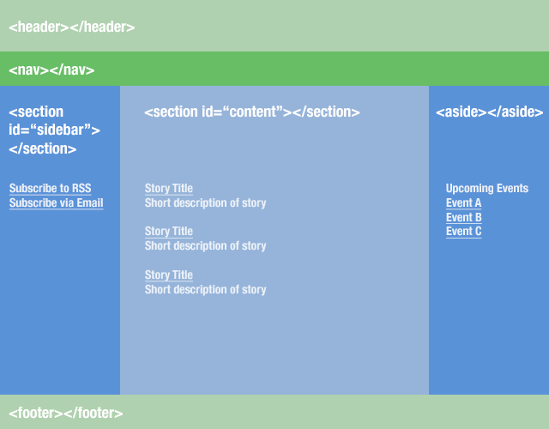

<section id="main">
<article>
<!-- first blog post -->
</article>

<article>
<!-- second blog post -->
</article>

<article>
<!-- third blog post -->
</article>
</section>

<article>
<section id="introduction">
</section>

<section id="content">
</section>

<section id="summary">
</section>
</article>

