Tomcat Setup for EEMS

- Download and install the latest JDK 8 (Windows x64)

The current latest java 8 is http://download.oracle.com/otn-pub/java/jdk/8u161-b12/2f38c3b165be4555a1fa6e98c45e0808/jdk-8u161-windows-x64.exe

- Set your JAVA_HOME environment variable to the new installed JDK 8 home. Run the following command to verify java version:
C:\>java -version
java version "1.8.0_161"
Java(TM) SE Runtime Environment (build 1.8.0_161-b12)
Java HotSpot(TM) 64-Bit Server VM (build 25.161-b12, mixed mode)

- Download the latest Stable tomcat. The latest stable tomcat is 8.5.24 at time the document is written (January 26, 2018).
https://tomcat.apache.org/download-80.cgi#8.5.24

Download windows zip x64 core.

- Install Tomcat

Unzip to C:/TOMCAT_DIR. You should see C:/TOMCAT_DIR/apache-tomcat-8.5.24/conf/server.xml in the end

- Set environment variable TOMCAT_HOME. For example:

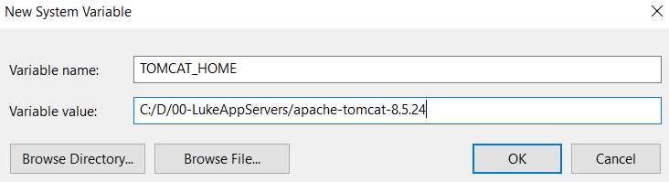
NOTE: Use “/” in path as delimiter. Do not use “\”.

- Setup environment variable
EEMS_HOST=eagandcs # Update for SIT/CAT/PROD
EEMS_CONSOLE_USERS=yz0yj0, lukema # Comma delimited. Space is OK.
EEMS_ENABLE_LDAP_AUTH=false # True for SIT/CAT/PROD
EEMS_KEY=Any string here # Customize to your settings
EEMS_DOMAIN=DEVSUB # Update for SIT/CAT/PROD
EEMS_LDAP_PORT=636 # Update for SIT/CAT/PROD

Other environment variables:
JAVA_HOME=C:/Tools/jdk1.8.0_161 # Customize to your settings
TOMCAT_HOME=C:/TOMCAT_DIR/apache-tomcat-8.5.24 # Customize to your settings

- Enable SSL using a self-signed keystore

  - Generate proprietary keystore

User java keytool to generate a self-signed key:
https://docs.oracle.com/javase/8/docs/technotes/tools/unix/keytool.html

# Valid for 10 years:
keytool -genkey -alias eems -keyalg RSA -keysize 4096 -keystore \ eemskeystore-tmp.jks -validity 3650

NOTE: In the dialog, for “first and last name” use the computer’s hostname.domainname, for example:
first and last name: cat.usps.gov or localhost
password: eemskey
CN: localhost

Sample dialog:

keytool -genkey -alias eems -keyalg RSA -keysize 2048 -keystore eemskeystore.jks

Enter keystore password:
Re-enter new password:
What is your first and last name?
[Unknown]: localhost
What is the name of your organizational unit?
[Unknown]: eems
What is the name of your organization?
[Unknown]: usps.gov
What is the name of your City or Locality?
[Unknown]: Herndon
What is the name of your State or Province?
[Unknown]: VA
What is the two-letter country code for this unit?
[Unknown]: US
Is CN=localhost, OU=eems, O=usps.gov, L=Herndon, ST=VA, C=US correct?
[no]: yes

  - Convert proprietary keystore to industry standard keystore:
keytool -importkeystore -srckeystore eemskeystore-tmp.jks \
-destkeystore eemskeystore.jks -deststoretype pkcs12

  - Create a directory
C:/JavaCAPS/appserver/domains/eems/config

  - Copy the new keystore eemskeystore.jks to

C:/JavaCAPS/appserver/domains/eems/config

  - Modify C:/TOMCAT_DIR/apache-tomcat-8.5.24/conf/server.xml with the follow lines:

<Connector SSLEnabled="true"
scheme="https"
secure="true"
port="8443">
<UpgradeProtocol className="org.apache.coyote.http2.Http2Protocol" />
<SSLHostConfig>
<Certificate certificateKeystoreFile="C:/JavaCAPS/appserver/domains/eems/config/eemskeystore.jks"
certificateKeystorePassword="eemskey"
certificateKeystoreType="PKCS12"
type="RSA" />
</SSLHostConfig>
</Connector>

  - Increase max war file size for tomcat console
Add <multipart-config> to the same level of <Connector> (As sibling of <Connector>)
<multipart-config>
<!-- 104MB max -->
<max-file-size>104857600</max-file-size>
<max-request-size>52428800</max-request-size>
<file-size-threshold>0</file-size-threshold>
</multipart-config>

- Create tomcat console admin and encrypt the admin’s password
Suppose this is console admin’s logon information:
Username: admin
Password: admin1
9.1 Encrypt admin
Use this command to encrypt the password “admin1”
cd C:\TOMCAT_DIR\apache-tomcat-8.5.24\bin>

digest.bat -a sha-256 -h org.apache.catalina.realm.MessageDigestCredentialHandler admin1

admin1:001813b5c53de4c433cfae59bef44158367b67f8203c01e54cc71be6d8d7b2b3$1$bd6063a2b168beb2833036802b267c116a7c290bbab892dac2f96fdf9abe4e6b

9.2 Add that user and encrypted password by editing
C:\TOMCAT_DIR\apache-tomcat-8.5.24\conf\tomcat-users.xml
<?xml version="1.0" encoding="UTF-8"?>
<tomcat-users xmlns="http://tomcat.apache.org/xml"
xmlns:xsi="http://www.w3.org/2001/XMLSchema-instance"
xsi:schemaLocation="http://tomcat.apache.org/xml tomcat-users.xsd"
version="1.0">
…
<role rolename="manager-gui"/>
<user username="admin"
password="001813b5c53de4c433cfae59bef44158367b67f8203c01e54cc71be6d8d7b2b3$1$bd6063a2b168beb2833036802b267c116a7c290bbab892dac2f96fdf9abe4e6b"
roles="manager-gui"/>

</tomcat-users>

9.3 Updated Realm CredentialHandler in apache-tomcat-8.5.24/conf/server.xml
<Realm className="org.apache.catalina.realm.LockOutRealm">
<Realm className="org.apache.catalina.realm.UserDatabaseRealm"
resourceName="UserDatabase">
<CredentialHandler
className="org.apache.catalina.realm.MessageDigestCredentialHandler"
algorithm="sha-256" />
</Realm>
</Realm>

9.4 Verify admin user
9.4.1 Start tomcat by going to

cd C:\TOMCAT_DIR\apache-tomcat-8.5.24\bin> startup.bat

9.4.2 Tomcat admin console:
https://localhost:8443/

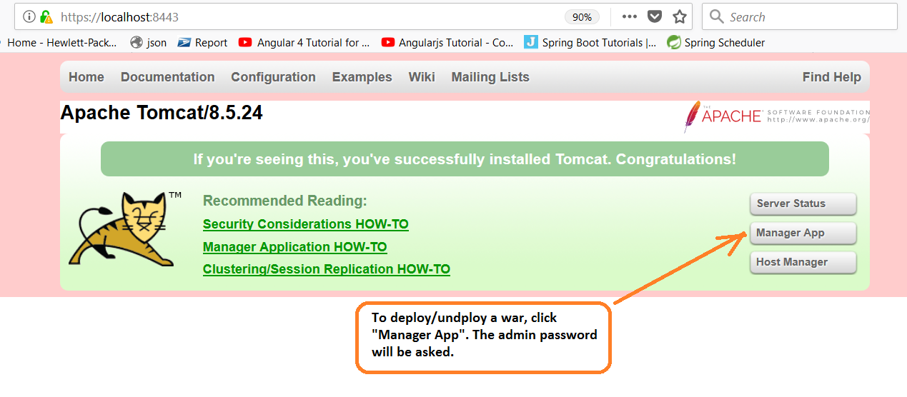

9.4.3 Stop tomcat by going to

cd C:\TOMCAT_DIR\apache-tomcat-8.5.24\bin> shutdown.bat

- Build JNDI Connection Pool
10.1 The encryptor code is in SVN:
https://svn/jmcs/eems/branches/enhancements/rel1/niagara/modules/EemsJndiEncyptDecrypt

10.2 Build encryptor
Checkout the code and build jar:
cd c:/workspace/EemsJndiEncyptDecrypt
mvn clean package
This will create a jar file target/EemsJndiEncyptDecrypt-0.0.1.jar. Copy this file to C:\TOMCAT_DIR\apache-tomcat-8.5.24\lib

10.3 Create a system environment variable EEMS_KEY with a value. Once in a while, this value should be changed and database passwords need to be re-encrypted and the JNDI config need to be updated with the newly encrypted passwords.
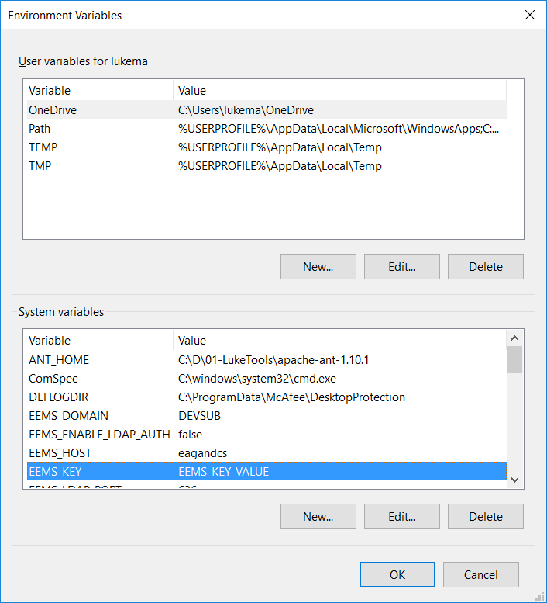

10.4 Encrypt a password
cd C:\TOMCAT_DIR\apache-tomcat-8.5.24\lib>
java -cp EemsJndiEncyptDecrypt-0.0.1.jar gov.usps.eems.encdec.Encryptor my-password
output: 4c3b4ccb65c7f31ede94c20d502f5e1b
The output is encrypted password.

10.5 Edit C:\TOMCAT_DIR\apache-tomcat-8.5.24\conf\server.xml <GlobalNamingResources> element:

<GlobalNamingResources>

<Resource name="UserDatabase" auth="Container"
type="org.apache.catalina.UserDatabase"
description="User database that can be updated and saved"
factory="org.apache.catalina.users.MemoryUserDatabaseFactory"
pathname="conf/tomcat-users.xml" />

<Resource name="jdbc/eems"
global="jdbc/eems"
auth="Container"
type="javax.sql.DataSource"
factory="gov.usps.eems.jndi.EncryptedDataSourceFactory"
driverClassName="oracle.jdbc.OracleDriver"
url="jdbc:oracle:thin:@(Description=(Failover=ON)(Address_List=(Load_Balance=ON)(address=(protocol=tcp)(host=eagnmnmed5a3)(port=1521))(address=(protocol=tcp)(host=eagnmnmed5a4)(port=1521)))(Connect_data=(service_name=deems.usps.gov)(SERVER=DEDICATED)))"
username="eems"
password="encrypted-password-for-eems-here"
validationQuery="select 'jdbc/eems ' || sysdate from dual"
maxTotal="5"
maxActive="5"
minIdle="2"
maxWait="10000"
initialSize="2">
</Resource>

<Resource name="jdbc/uws"
global="jdbc/uws"
auth="Container"
type="javax.sql.DataSource"
factory="gov.usps.eems.jndi.EncryptedDataSourceFactory"
driverClassName="oracle.jdbc.OracleDriver"
url="jdbc:oracle:thin:@(Description=(Failover=ON)(Address_List=(Load_Balance=ON)(address=(protocol=tcp)(host=eagnmnmed10e)(port=1521))(address=(protocol=tcp)(host=eagnmnmed10f)(port=1521)))(Connect_data=(service_name=tefms.usps.gov)(SERVER=DEDICATED)))"
username="uws"
password=" encrypted-password-for-uws-here"
validationQuery="select 'jdbc/uws ' || sysdate from dual"
maxTotal="5"
maxActive="5"
minIdle="2"
maxWait="10000"
initialSize="2">
</Resource>

<Resource name="jdbc/eemsDB"
global="jdbc/eemsDB"
auth="Container"
type="javax.sql.DataSource"
factory="gov.usps.eems.jndi.EncryptedDataSourceFactory"
driverClassName="oracle.jdbc.OracleDriver"
url="jdbc:oracle:thin:@(DESCRIPTION=(LOAD_BALANCE=on)(ADDRESS=(PROTOCOL=TCP)(HOST=eagnmnmed111.usps.gov)(PORT=1521))(CONNECT_DATA=(SERVICE_NAME=dnav.usps.gov)(FAILOVER_MODE=(TYPE=SELECT)(METHOD=BASIC)(RETRIES=180)(DELAY=5))))"
username="fmsplng"
password=" encrypted-password-for- fmsplng-here"
validationQuery="select 'jdbc/eemsDB ' || sysdate from dual"
maxTotal="5"
maxActive="5"
minIdle="2"
maxWait="10000"
initialSize="2">
</Resource>

</GlobalNamingResources>

10.6 Edit C:\TOMCAT_DIR\apache-tomcat-8.5.24\conf\context.xml add <ResourceLink> elements

<?xml version="1.0" encoding="UTF-8"?>
<Context>
<WatchedResource>WEB-INF/web.xml</WatchedResource>
<WatchedResource>${catalina.base}/conf/web.xml</WatchedResource>

<!-- Uncomment this to disable session persistence across Tomcat restarts -->
<Manager pathname="" />

<ResourceLink name="jdbc/eems"
global="jdbc/eems"
auth="Container"
type="javax.sql.DataSource" />
<ResourceLink name="jdbc/uws"
global="jdbc/uws"
auth="Container"
type="javax.sql.DataSource" />
<ResourceLink name="jdbc/eemsDB"
global="jdbc/eemsDB"
auth="Container"
type="javax.sql.DataSource" />

</Context>

Note: Uncomment this line
<Manager pathname="" />

10.7 You need to connect to USPS VPN in order to connect to USPS databases. If you see connection error when you start tomcat, first check if you are connected to USPS VPN.

- EEMS Source code url:
https://svn/jmcs/eems/branches/enhancements/rel1/niagara/modules/EEMS_Tomcat

- Deploy eems.war to tomcat
You can use tomcat admin console -> Manager App to deploy/undeploy eems.war. Or you can deploy eems.war to C:\TOMCAT_DIR\apache-tomcat-8.5.24\wabapps manually

