Xiaoxu Na

Gen-Prediction Lab

1. Genscan

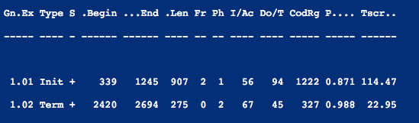

* 1. 2 exons
  2. Initial exon: 339 1245

Terminal exon: 2420 2694

* 1. Initial exon: 0.871

Terminal exon: 0.988

* 1. They are both on strand +.

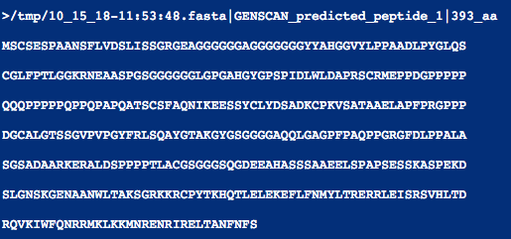

M,S,C,S,E,S

1. HMMgene
   1. 2 exons

firstex 320 1226

lastex 2401 2675

firstex 0.744

lastex 0.971

* 1. Both on strand +
  2. No, they are different.

1. NetGene2
   1. HMMgene: 1227

Genscan: 1246

* 1. 1227/0.95

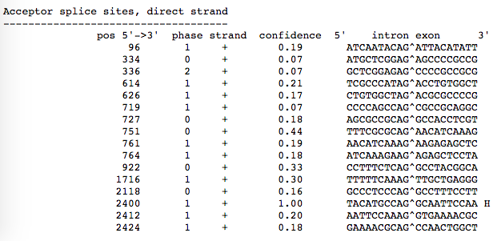

* 1. Genscan: 338, 2419

HMMgene: 319, 2400

* 1. 2400
  2. 1.00