Project 4

Darknet and yolo Results:

layer filters size input output

0 conv 32 3 x 3 / 1 608 x 608 x 3 -> 608 x 608 x 32 0.639 BFLOPs

1 conv 64 3 x 3 / 2 608 x 608 x 32 -> 304 x 304 x 64 3.407 BFLOPs

2 conv 32 1 x 1 / 1 304 x 304 x 64 -> 304 x 304 x 32 0.379 BFLOPs

3 conv 64 3 x 3 / 1 304 x 304 x 32 -> 304 x 304 x 64 3.407 BFLOPs

4 res 1 304 x 304 x 64 -> 304 x 304 x 64

5 conv 128 3 x 3 / 2 304 x 304 x 64 -> 152 x 152 x 128 3.407 BFLOPs

6 conv 64 1 x 1 / 1 152 x 152 x 128 -> 152 x 152 x 64 0.379 BFLOPs

7 conv 128 3 x 3 / 1 152 x 152 x 64 -> 152 x 152 x 128 3.407 BFLOPs

8 res 5 152 x 152 x 128 -> 152 x 152 x 128

9 conv 64 1 x 1 / 1 152 x 152 x 128 -> 152 x 152 x 64 0.379 BFLOPs

10 conv 128 3 x 3 / 1 152 x 152 x 64 -> 152 x 152 x 128 3.407 BFLOPs

11 res 8 152 x 152 x 128 -> 152 x 152 x 128

12 conv 256 3 x 3 / 2 152 x 152 x 128 -> 76 x 76 x 256 3.407 BFLOPs

13 conv 128 1 x 1 / 1 76 x 76 x 256 -> 76 x 76 x 128 0.379 BFLOPs

14 conv 256 3 x 3 / 1 76 x 76 x 128 -> 76 x 76 x 256 3.407 BFLOPs

15 res 12 76 x 76 x 256 -> 76 x 76 x 256

16 conv 128 1 x 1 / 1 76 x 76 x 256 -> 76 x 76 x 128 0.379 BFLOPs

17 conv 256 3 x 3 / 1 76 x 76 x 128 -> 76 x 76 x 256 3.407 BFLOPs

18 res 15 76 x 76 x 256 -> 76 x 76 x 256

19 conv 128 1 x 1 / 1 76 x 76 x 256 -> 76 x 76 x 128 0.379 BFLOPs

20 conv 256 3 x 3 / 1 76 x 76 x 128 -> 76 x 76 x 256 3.407 BFLOPs

21 res 18 76 x 76 x 256 -> 76 x 76 x 256

22 conv 128 1 x 1 / 1 76 x 76 x 256 -> 76 x 76 x 128 0.379 BFLOPs

23 conv 256 3 x 3 / 1 76 x 76 x 128 -> 76 x 76 x 256 3.407 BFLOPs

24 res 21 76 x 76 x 256 -> 76 x 76 x 256

25 conv 128 1 x 1 / 1 76 x 76 x 256 -> 76 x 76 x 128 0.379 BFLOPs

26 conv 256 3 x 3 / 1 76 x 76 x 128 -> 76 x 76 x 256 3.407 BFLOPs

27 res 24 76 x 76 x 256 -> 76 x 76 x 256

28 conv 128 1 x 1 / 1 76 x 76 x 256 -> 76 x 76 x 128 0.379 BFLOPs

29 conv 256 3 x 3 / 1 76 x 76 x 128 -> 76 x 76 x 256 3.407 BFLOPs

30 res 27 76 x 76 x 256 -> 76 x 76 x 256

31 conv 128 1 x 1 / 1 76 x 76 x 256 -> 76 x 76 x 128 0.379 BFLOPs

32 conv 256 3 x 3 / 1 76 x 76 x 128 -> 76 x 76 x 256 3.407 BFLOPs

33 res 30 76 x 76 x 256 -> 76 x 76 x 256

34 conv 128 1 x 1 / 1 76 x 76 x 256 -> 76 x 76 x 128 0.379 BFLOPs

35 conv 256 3 x 3 / 1 76 x 76 x 128 -> 76 x 76 x 256 3.407 BFLOPs

36 res 33 76 x 76 x 256 -> 76 x 76 x 256

37 conv 512 3 x 3 / 2 76 x 76 x 256 -> 38 x 38 x 512 3.407 BFLOPs

38 conv 256 1 x 1 / 1 38 x 38 x 512 -> 38 x 38 x 256 0.379 BFLOPs

39 conv 512 3 x 3 / 1 38 x 38 x 256 -> 38 x 38 x 512 3.407 BFLOPs

40 res 37 38 x 38 x 512 -> 38 x 38 x 512

41 conv 256 1 x 1 / 1 38 x 38 x 512 -> 38 x 38 x 256 0.379 BFLOPs

42 conv 512 3 x 3 / 1 38 x 38 x 256 -> 38 x 38 x 512 3.407 BFLOPs

43 res 40 38 x 38 x 512 -> 38 x 38 x 512

44 conv 256 1 x 1 / 1 38 x 38 x 512 -> 38 x 38 x 256 0.379 BFLOPs

45 conv 512 3 x 3 / 1 38 x 38 x 256 -> 38 x 38 x 512 3.407 BFLOPs

46 res 43 38 x 38 x 512 -> 38 x 38 x 512

47 conv 256 1 x 1 / 1 38 x 38 x 512 -> 38 x 38 x 256 0.379 BFLOPs

48 conv 512 3 x 3 / 1 38 x 38 x 256 -> 38 x 38 x 512 3.407 BFLOPs

49 res 46 38 x 38 x 512 -> 38 x 38 x 512

50 conv 256 1 x 1 / 1 38 x 38 x 512 -> 38 x 38 x 256 0.379 BFLOPs

51 conv 512 3 x 3 / 1 38 x 38 x 256 -> 38 x 38 x 512 3.407 BFLOPs

52 res 49 38 x 38 x 512 -> 38 x 38 x 512

53 conv 256 1 x 1 / 1 38 x 38 x 512 -> 38 x 38 x 256 0.379 BFLOPs

54 conv 512 3 x 3 / 1 38 x 38 x 256 -> 38 x 38 x 512 3.407 BFLOPs

55 res 52 38 x 38 x 512 -> 38 x 38 x 512

56 conv 256 1 x 1 / 1 38 x 38 x 512 -> 38 x 38 x 256 0.379 BFLOPs

57 conv 512 3 x 3 / 1 38 x 38 x 256 -> 38 x 38 x 512 3.407 BFLOPs

58 res 55 38 x 38 x 512 -> 38 x 38 x 512

59 conv 256 1 x 1 / 1 38 x 38 x 512 -> 38 x 38 x 256 0.379 BFLOPs

60 conv 512 3 x 3 / 1 38 x 38 x 256 -> 38 x 38 x 512 3.407 BFLOPs

61 res 58 38 x 38 x 512 -> 38 x 38 x 512

62 conv 1024 3 x 3 / 2 38 x 38 x 512 -> 19 x 19 x1024 3.407 BFLOPs

63 conv 512 1 x 1 / 1 19 x 19 x1024 -> 19 x 19 x 512 0.379 BFLOPs

64 conv 1024 3 x 3 / 1 19 x 19 x 512 -> 19 x 19 x1024 3.407 BFLOPs

65 res 62 19 x 19 x1024 -> 19 x 19 x1024

66 conv 512 1 x 1 / 1 19 x 19 x1024 -> 19 x 19 x 512 0.379 BFLOPs

67 conv 1024 3 x 3 / 1 19 x 19 x 512 -> 19 x 19 x1024 3.407 BFLOPs

68 res 65 19 x 19 x1024 -> 19 x 19 x1024

69 conv 512 1 x 1 / 1 19 x 19 x1024 -> 19 x 19 x 512 0.379 BFLOPs

70 conv 1024 3 x 3 / 1 19 x 19 x 512 -> 19 x 19 x1024 3.407 BFLOPs

71 res 68 19 x 19 x1024 -> 19 x 19 x1024

72 conv 512 1 x 1 / 1 19 x 19 x1024 -> 19 x 19 x 512 0.379 BFLOPs

73 conv 1024 3 x 3 / 1 19 x 19 x 512 -> 19 x 19 x1024 3.407 BFLOPs

74 res 71 19 x 19 x1024 -> 19 x 19 x1024

75 conv 512 1 x 1 / 1 19 x 19 x1024 -> 19 x 19 x 512 0.379 BFLOPs

76 conv 1024 3 x 3 / 1 19 x 19 x 512 -> 19 x 19 x1024 3.407 BFLOPs

77 conv 512 1 x 1 / 1 19 x 19 x1024 -> 19 x 19 x 512 0.379 BFLOPs

78 conv 1024 3 x 3 / 1 19 x 19 x 512 -> 19 x 19 x1024 3.407 BFLOPs

79 conv 512 1 x 1 / 1 19 x 19 x1024 -> 19 x 19 x 512 0.379 BFLOPs

80 conv 1024 3 x 3 / 1 19 x 19 x 512 -> 19 x 19 x1024 3.407 BFLOPs

81 conv 255 1 x 1 / 1 19 x 19 x1024 -> 19 x 19 x 255 0.189 BFLOPs

82 yolo

83 route 79

84 conv 256 1 x 1 / 1 19 x 19 x 512 -> 19 x 19 x 256 0.095 BFLOPs

85 upsample 2x 19 x 19 x 256 -> 38 x 38 x 256

86 route 85 61

87 conv 256 1 x 1 / 1 38 x 38 x 768 -> 38 x 38 x 256 0.568 BFLOPs

88 conv 512 3 x 3 / 1 38 x 38 x 256 -> 38 x 38 x 512 3.407 BFLOPs

89 conv 256 1 x 1 / 1 38 x 38 x 512 -> 38 x 38 x 256 0.379 BFLOPs

90 conv 512 3 x 3 / 1 38 x 38 x 256 -> 38 x 38 x 512 3.407 BFLOPs

91 conv 256 1 x 1 / 1 38 x 38 x 512 -> 38 x 38 x 256 0.379 BFLOPs

92 conv 512 3 x 3 / 1 38 x 38 x 256 -> 38 x 38 x 512 3.407 BFLOPs

93 conv 255 1 x 1 / 1 38 x 38 x 512 -> 38 x 38 x 255 0.377 BFLOPs

94 yolo

95 route 91

96 conv 128 1 x 1 / 1 38 x 38 x 256 -> 38 x 38 x 128 0.095 BFLOPs

97 upsample 2x 38 x 38 x 128 -> 76 x 76 x 128

98 route 97 36

99 conv 128 1 x 1 / 1 76 x 76 x 384 -> 76 x 76 x 128 0.568 BFLOPs

100 conv 256 3 x 3 / 1 76 x 76 x 128 -> 76 x 76 x 256 3.407 BFLOPs

101 conv 128 1 x 1 / 1 76 x 76 x 256 -> 76 x 76 x 128 0.379 BFLOPs

102 conv 256 3 x 3 / 1 76 x 76 x 128 -> 76 x 76 x 256 3.407 BFLOPs

103 conv 128 1 x 1 / 1 76 x 76 x 256 -> 76 x 76 x 128 0.379 BFLOPs

104 conv 256 3 x 3 / 1 76 x 76 x 128 -> 76 x 76 x 256 3.407 BFLOPs

105 conv 255 1 x 1 / 1 76 x 76 x 256 -> 76 x 76 x 255 0.754 BFLOPs

106 yolo

Loading weights from yolov3.weights...Done!

Enter Image Path: data/horses.jpg

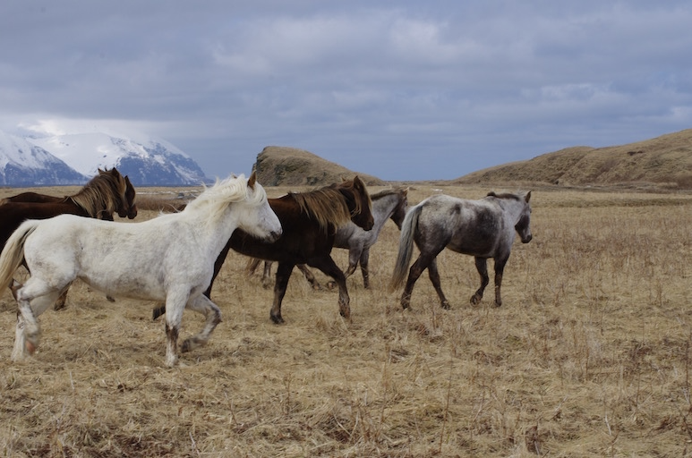

data/horses.jpg: Predicted in 30.658394 seconds.

horse: 100%

horse: 100%

horse: 96%

horse: 95%

Enter Image Path: data/dog.jpg

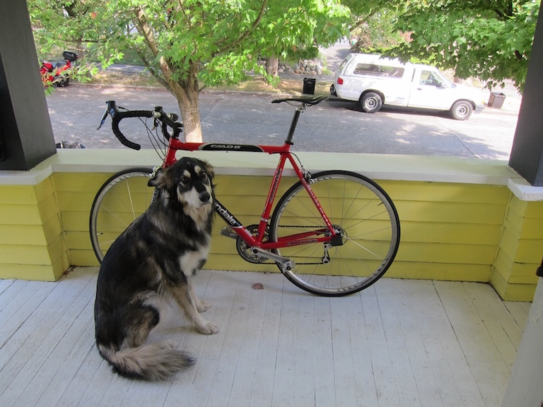

data/dog.jpg: Predicted in 31.444300 seconds.

bicycle: 99%

truck: 92%

dog: 100%