Xiaoxu Na

Project 2 Date Due : February 7, 2019

Please read chapter 1 from “Programming Computer Vision with Python, Jan Erik Solem’s book citycity

Show your results using Exercises (page 26)

1. Take an image and apply Gaussian blur like in Figure 1-9. Plot the image contours
for increasing values of σ. What happens? Can you explain why?

The bigger the sigma is, the more blurred the picture is.

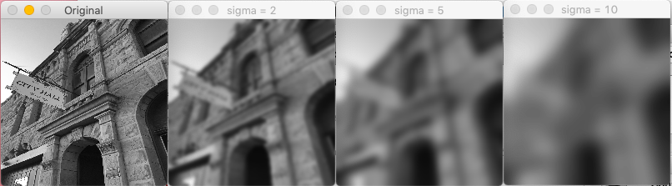

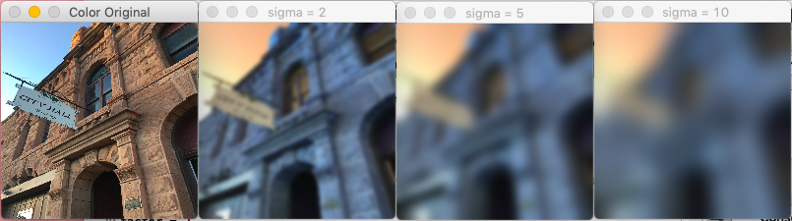

2. Implement an unsharp masking operation (http://en.wikipedia.org/wiki/Unsharp_
masking) by blurring an image and then subtracting the blurred version from the
original. This gives a sharpening effect to the image. Try this on both color and
grayscale images.

The snapshot was done with the parameter as below:
sigma =2, factor = 2
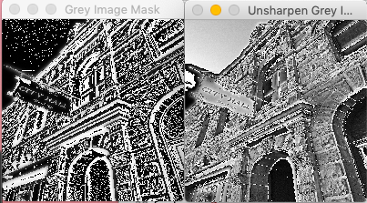

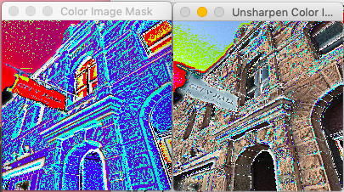

OR
Please read chapter 10 from ‘Learning OpenCV 3 COMPUTER VISION IN C++ WITH THE OPENCV LIBRARY’, and write a report of this assignment, contains result, screenshots of displayed image and your analysis.

10.1. Load an image with interesting textures. Smooth the image in several ways using
cv::smooth() with smoothtype=cv::GAUSSIAN.
a. Use a symmetric 3 × 3, 5 × 5, 9 × 9, and 11 × 11 smoothing window size and
display the results.
b. Are the output results nearly the same by smoothing the image twice with a
5 × 5 Gaussian filter as when you smooth once with two 11 × 11 filters? Why
or why not?
10.3. Load an interesting image, and then blur it with cv::smooth() using a Gaussian
filter.
a. Set param1=param2=9. Try several settings of param3 (e.g., 1, 4, and 6). Display
the results.
b. Set param1=param2=0 before setting param3 to 1, 4, and 6. Display the results.
Are they different? Why?
c. Use param1=param2=0 again, but this time set param3=1 and param4=9.
Smooth the picture and display the results.
d. Repeat Exercise 3c but with param3=9 and param4=1. Display the results.
e. Now smooth the image once with the settings of Exercise 3c and once with
the settings of Exercise 3d. Display the results.
f. Compare the results in Exercise 3e with smoothings that use
param3=param4=9 and param3=param4=0 (i.e., a 9 × 9 filter). Are the results the
same? Why or why not?

