CPSC 7374 –Spring,2019 Name: Xiaoxu Na
Exam 1

Task 1 (10 pts. total)
a. Digital image processing concerns digitally processing images that are generally obtained from a continuous world. Describe the two “discretizations” of continuous images that allow them to be processed digitally.

Image discretization involves two separate processes: discretization of the spatial domain (sampling) and discretization of the image range (quantization). Both operations correspond to a discretization of a quantity, but in different domains.
Sampling corresponds to a discretization of the space. A digital image f[m,n] described in a 2D discrete space is derived from an analog image f(x,y) in a 2D continuous space through a sampling process that is frequently referred to as digitization. The 2D continuous image f(x,y) is divided into N rows and M columns. The intersection of a row and a column is termed a pixel. The value assigned to the integer coordinates [m,n] with {m=0,1,2,...,M-1} and {n=0,1,2,...,N-1} is f[m,n]. The value assigned to every pixel is the average brightness in the pixel rounded to the nearest integer value. The process of representing the amplitude of the 2D signal at a given coordinate as an integer value with L different gray levels is usually referred to as amplitude quantization or simply quantization.

b. When images are discretized, certain artifacts or degradations often result. Briefly describe the two major artifacts associated with each of the two discretizations in Part a. (5 pts.)

In general, aliasing artifacts are due to under-sampling or poor reconstruction. Specifically, in graphics, aliasing includes spatial aliasing and temporal aliasing. The minimum sampling rate for band limited function is called Nyquist rate.
For quantization, artifacts are due to limited intensity resolution. Frame buffers have limited number of bits per pixel, or physical devices have limited dynamic range.

Task 2 (10 pts.)
a. What is the Nyquist criterion?
The sampling that we choose for an image should satisfy the Nyquist criterion. The sampling frequency should be at least double the highest spatial frequency found in the image. f_{s} = 2f_{max}.

b. What specific artifacts result when the Nyquist criterion is not met?
If we sample an image coarsely, such that the Nyquist criterion is not met, then the image may suffer from the effects of aliasing.

c. In real-world imaging systems, how can these artifacts be avoided?
Consequently, the sampling process is normally preceded by anti-aliasing. This is a filtering operation designed to remove frequencies that exceed half the sampling rate achieved by the analogue to digital converter (ADC).

Task 3 (10 pts. total)
Consider the grayscale image below.

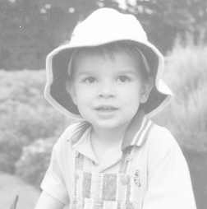

a. To the right of the image, sketch a reasonable approximate histogram. (5 pts.)
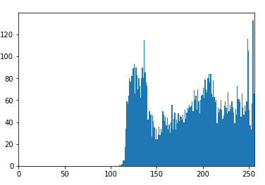
b. Using the histogram in Part a., what gray-level mapping technique might be effectively used to enhance this image? You may also plot the mapping function. Explain your answer. (5 pts.)
Contrast enhancement - In some digital images, the features of interest occupy only a relatively narrow range of the gray scale. One might use a point operation to expand the contrast of the features of interest so that they occupy a larger portion of the displayed gray-level range. In the above example, the image histogram only occupies the intensity over 100. Thus, simply using the mapping equation of [(gray value – MIN gray value )/(MAX gray value – MIN gray value)]* 255, where Min non zero gray value in the case above = 109, the Max gray value = 255. Thus, in this case, the mapping equation is (gray value-109)/146*255. Using linear mapping and the opencv has the histogram equalization works as well.
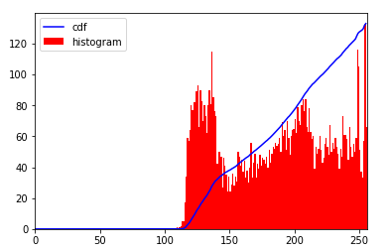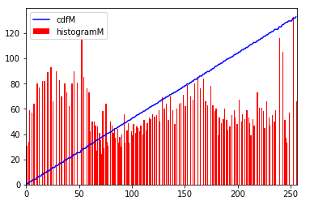
The result image is the right one.
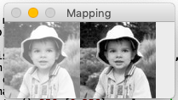

Task 4 (10 pts. total)
(a) Consider a 10 × 10 pixel 3-bit (8 gray levels) image with gray level histogram shown below Calculate Histogram Equalized Value .Show your work.

Gray level # of pixels Cumulative hist. Hist. Equalized values_
0 14 14 round(0.07*14) = 1
1 10 24 round(0.07*24) = 2
2 23 47 round(0.07*47) = 3
3 0 47 round(0.07*47) = 3
4 10 57 round(0.07*57) = 4
5 18 75 round(0.07*75) = 5
6 20 95 round(0.07*95) = 7
7 5 100 round(0.07*100) = 7
scaling factor = (8-1)/(10 * 10) = 0.07

Task 5 ( 10 points)Below are three spatial filters. Briefly ( in one to three words) describe the general function of each filter( what each filter does)
(a) (b) (c)

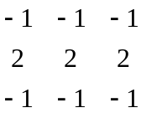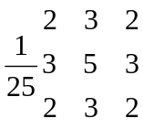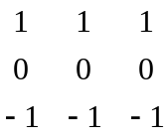
a) The matrix is a line detection kernel. The result of applying the line detection operator, using the horizontal convolution kernel shown in a may detect the horizontal lines.
b) The matrix is a Gaussian filter kernel. The filter-smoothing operator is a 2-D convolution operator that is used to blur images and remove detail and noise.
c) The matrix is a Prewitt gradient vertical edge detector kernel. The operator calculates the gradient of the image intensity at each point, giving the direction of the largest possible increase from light to dark and the rate of change in that direction.

(d) What characteristic of an image is necessary for successful application of Laplacian edge detection?

Because Laplacian edge kernels are approximating a second derivative measurement on the image, they are very sensitive to noise. To counter this, the image is often Gaussian smoothed before applying the Laplacian filter. This pre-processing step reduces the high frequency noise components prior to the differentiation step.

Task 6 ( 10 points)“Median filtering may reduce the number of occupied bins in a histogram. It will never increase the numbers of occupied bins” . Is this true? Explain your reasoning. (10 points)
No, it is not correct. Although median filtering is to select the middle-ranked value from a sorted neighborhood as our output value, as for a 3 * 3 neighborhood, the middle value is the fifth in the list of sorted grey levels, therefore usually for an n * n neighborhood with n odd, the middle value is at position n²/2 + 1. Median filtering replaces the pixel value with the median of its neighborhood values. The median is calculated by first sorting all the pixel values from the surrounding neighborhood into numerical order, and then replacing the pixel being considered with the middle pixel value. However, if the neighborhood under consideration contains an even number of pixels, the average of the two middle pixel values is used. Thus, a new bin in the histogram may be created if it is not a bin in the original histogram.
Task 7 (10 points)
The original image was convolved using Sobel masks . Gradient component along the x axis and gradient component along y-axis was calculated.
The gradient magnitude is given by

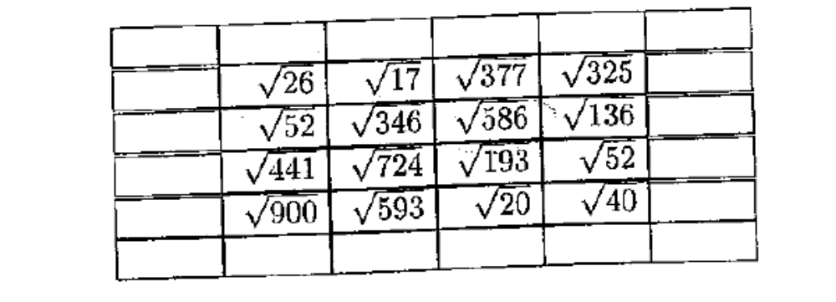
The gradient orientation is given by

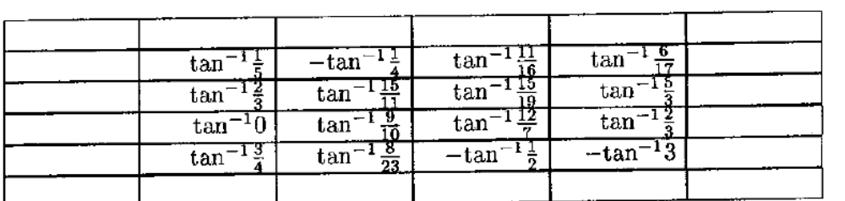
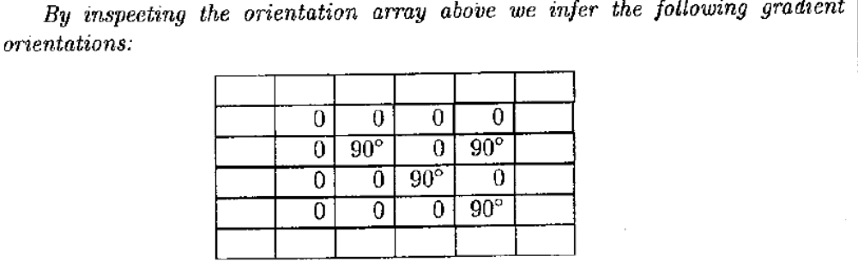

Find horizontal and vertical edge pixels. Justify your answers
-
-

A pixel is a horizontal edge pixel if the magnitude of its gradient is a local maximum when compared with its vertical neighbors and its orientation is 0 degree. Thus the pixels marked with “-” above are horizontal edges. A pixel is a vertical edge if its orientation is 90 degree and its magnitude is a local maximum in the horizontal direction. Consequently, no vertical edge is found.

Task 8 : How we can implement Low past filter in Frequency domain

The most simple low pass filter is the ideal low pass. It suppresses all frequencies higher than the cut-off frequency and leaves smaller frequencies unchanged. Better results can be achieved with a Gaussian shaped filter function. The advantage is that the Gaussian has the same shape in the spatial and Fourier domains and therefore does not incur the ringing effect in the spatial domain of the filtered image. A commonly used discrete approximation to the Gaussian is the Butterworth filter. Applying this filter in the frequency domain shows a similar result to the Gaussian smoothing in the spatial domain. One difference is that the computational cost of the spatial filter increases with the standard deviation (i.e. with the size of the filter kernel), whereas the costs for a frequency filter are independent of the filter function. Hence, the spatial Gaussian filter is more appropriate for narrow low pass filters, while the Butterworth filter is a better implementation for wide low pass filters.

Task 9: If you add noise to an image and do Fast Fourier transform what will see in a noise spectra image? Comment on spectra of both images (original and noise image). What kind of filter you are going to implement to remove the noise in frequency domain? Define this filter with equation.

If noise is added, then the spectrum may not be as clear as the spectrum of the original image. The noise may show up as spikes away from original in DFT, depending on how much noise is added. A bandpass attenuates very low and very high frequencies, but retains a middle range band of frequencies. Bandpass filtering can be used to enhance edges (suppressing low frequencies) while reducing the noise at the same time (attenuating high frequencies). Bandpass filters are a combination of both lowpass and highpass filters. They attenuate all frequencies smaller than a frequency Do and higher than a frequency D1, while the frequencies between the two cut-offs remain in the resulting output image. We obtain the filter function of a bandpass by multiplying the filter functions of a lowpass and of a highpass in the frequency domain, where the cut-off frequency of the lowpass is higher than that of the highpass. If we call the transform of the original image A and a fully attenuating highpass filter H, then the transform of the highpassed image B(u,v) = A(u,v)*H(u,v). Therefore we can create any linear combination C = aA + bB = aA + b(A*H) = A(a + bH) and therefore we can create our sharpening filter H'(u,v) = (a + bH(u,v)).

Task 10 Can you think of a way to use the Hough transform to identify any kind of shape with a distinct perimeter? Explain how.

Step 1: Decide the number of bins will be used to quantize parameters (ϕ, p). If the input image is M * N and that m = min {M, N}. We shall allow p to take values up to p_{max} = |m/2|, in steps of 1, so that K = p_{max}. We allow ϕ to take values from 0° to 359° in steps of 1°, so that L =360.
Step 2: Create an empty accumulator array A of size K * L.
Step 3: Consider every black pixel in the image with coordinates (x_{i}, y_{i}) and for every value of ϕ we allow, compute the corresponding value of p using p = x_{i} cos ϕ + y_{i} sin ϕ.
Step 4: For every value of p_{l} that is computed, corresponding to angle ϕ = l, identify the bin to which it belongs in the accumulator array A as k = |p_{l}|.
Step 5: Increase the cell of the accumulator array by 1: A(l+1, k+1) = A(l+1, k+1) +1. We assumed that the elements of the accumulator array are identified by indices l and k that take values 1, 2, ..., L and 1, 2, …, K, respectively.
Step 6: Identify the peaks in the accumulator array. The coordinates of these peaks yield the parameters of the straight lines in the image. If I lines are expected to be found, then I strong peaks are expected.
Step 7: Use the number of lines to estimate the shape. By de-houghing the result and overlaying it on the originals, we may confirm the result.

