**CS 4824 / ECE 4424, Homework 2 (Written Portion), Due: Feb. 26, 2021**

**Question 1 (Comparing Classifiers) [6 points]**

Consider a scenario where you are supposed to determine if a person has heart diseases or not based on the following attributes: blood pressure, body weight, age, number of cigarettes consumed in a week, and type of job (which can take four values: business, healthcare, engineering, or education).

1. If you had to choose between KNN and decision trees, which one would you prefer and why?
2. Assume you are using logistic regression for this task. How would you modify the features (as given above) before learning the model? (note: not all features need modification)

**Question 2 (Comparing Classifiers) [8 points]**

Answer the following questions based on different datasets that are provided with each question. Give a brief explanation for your choice.

1. Figure 1 shows a dataset of two classes whose points are shown in blue and red color on a 2-dimensional Cartesian coordinate axis (which are the two features). Among kNN, Naïve Bayes and decision trees, which classifier would have the **best** performance? Justify your answer.

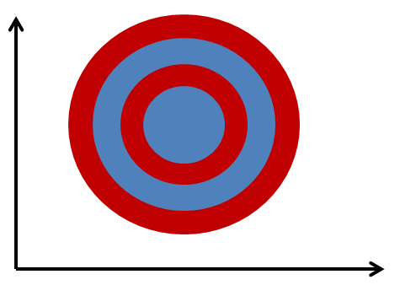

Figure 1

1. For the dataset in Figure 2, among KNN, Naïve Bayes and Perceptron, which classifier would have the **worst** performance?

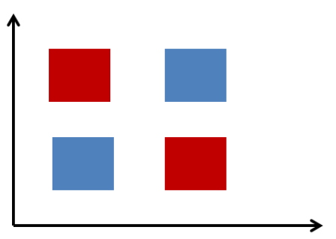

Figure 2

**Question 3 (Comparing Classifiers) [5 points]**

If the training set is such that every combination of attribute values is present in the training data and each combination is either labeled C1 or C2 (e.g., positive or negative), which of the following classification techniques can be used to learn a model with perfect classification (zero errors) on the training set? Briefly explain your answer.

* 1. Decision Trees
  2. Logistic Regression
  3. Naïve Bayes
  4. Perceptron