Exercise 1: Multi-armed Bandits

Prof: Robert Platt

Date: September 24th, 2021

Name: Guanang Su

Question 1.

|  |  |  |  |  |  |
| --- | --- | --- | --- | --- | --- |
|  |  |  |  |  |  |
|  |  |  |  |  |  |
|  |  |  |  |  |  |
|  |  |  |  |  |  |

1:

2:

3:

4:

5:

A4 and A5 were definitely occur, others (A1, A2 and A3) could possibly have occurred.

Question 2.

Question 3.

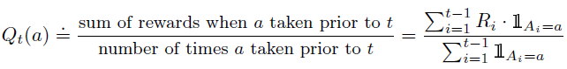

Question 4.

Question 5.

Question 6.

Question 7.

