Project Proposal

on

K-Merchandise Nepal

Manisha kc

00174628

22C

[Caseymansa@gmail.com](mailto:Caseymansa@gmail.com)

Computing Project

Level 5 Diploma in Computing

Softwarica College of IT and E-Commerce

Kathmandu, Nepal

April 9th,2019

Submitted to:

Sudeep Bajimaya

Module leader

Contents

**Keywords and abbreviations** 4

**1.** **Introduction**: 5

1.1 Introduction: 5

1.2 Background of the project: 5

1.3 Problem Statement: 5

1.4 Description of the project: 5

1.5 Features of the project: 6

1.6 Overview of the project 6

**2** **Scope of the project:** 7

2.1 Scope: 7

2.2 Limitations: 7

2.3 Aim: 7

2.4 Objectives: 7

2.5 Overview of the scope: 7

**3** **Development methodology** 8

3.1 Description of the methodology chosen: 8

3.2 Design pattern: 9

3.3 Architecture: 10

**4** **Project planning:** 11

4.1 Work Breakdown Structure (WBS) 11

4.2 Milestones 12

4.3 Gantt Chart 14

**5** **Risk Management** 16

**6** **Configuration Management** 17

**7** **Conclusion:** 18

**8** **References** 19

Table of Figures

Figure 1Waterfall method 8

Figure 2 MVC architecture 9

Figure 3 Client-Server Architecture 10

Figure 4 WBS of K-merchandise Nepal 11

Figure 5 Scheduling 14

Figure 6 Gantt chart 15

Figure 7 Tree Structure of folder. 17

Keywords and abbreviations

WBS: Work Breakdown Structure

Agile: Flexible

MVC: Model, View and controller

Consequence: result

Chapter:1

# **Introduction**:

# Introduction:

K-Merchandise Nepal is an online website based on Korean merchandise and blogging which consist of news and reports along with online shopping facilities for its users. This website will act a source of information for the focused users that wants to shop and learn more about Korean music and products. Viewers will be able to get the latest Korean music news on celebrities, fashion, bands and much more focusing fans inside Nepal. User’s will be able to make purchase while listening to music while using the website.

## Background of the project:

It will be the first Korean Merchandise website of Nepal which will provide the users with quality news and merchandise inside the country. This website will be focused to provide users with information along with online shopping benefits. There is no any Nepali official website up to date that focuses on bringing such products to Nepal. So, this project aims to be the first and only website that will come up with such objectives.

## Problem Statement:

With the arising popularity of Korean music and movies in Nepal the number of people wanting to buy their products has increased a lot. But there is no platform which is specially designed for this sector. So, people are finding it hard to find trust worthy sellers of products to make purchase. This website will provide as a base for the buyers to get more involved with Korean products and music.

## Description of the project:

Korean Merchandise website will be designed using HTML, CSS, PHP and javascript as its programming language. For its database I have used MySQL as it fulfils the requirement of the project and is easy to maintain. I have used Xamp to run the web server. Using these resources will help me create this project.

## Features of the project:

The features of the project are as follows:

* List of different categories of items based on the gender, accessories, devices will be provided.
* Allow users to comment their opinions via comment box.
* Fast and regular delivery system service.
* Products can be viewed based on their price, popularity or rate.
* Provide users with facility of listening to music while shopping.
* Allow users to get description of each item.
* Allows users to rate the product and delivery facility.
* Allows the admin to remove hatred or harmful comments.
* Allows the users to report comments.

## Overview of the project

In conclusion K-Merchandise Nepal is a website that will provide its users with online shopping facilities along with blogs, music, news and other various media. It will provide users with delivery service and will allow the users to register, login, comment, report or delete the account.

Chapter 2

# **Scope of the project:**

## Scope:

Since this will be the first kind of website which will be built towards Korean products from Nepal it will attract a greater number of users. It will be used an example for future references. People will buy products from the website instead of going to different shops searching for the Korean products of their choice. This will help to save their time by deducting the amount of time for research and purchasing the good. This will create a new development competition between other locally based shops.

## Limitations:

* Lack of trust from customers.
* Users will not be able to negotiate price or try the clothes before making the purchase.
* Since there is use of huge number of pictures, the website might be slow.
* Many users trying to access the website during the same time can cause the server to go crash.

## Aim:

* To build a web-based application to show different Korean Merchandise easily with delivery facility.
* To design an application which is cost effective, user friendly and informative.
* To build a dynamic website for recording user’s information and their purchase.

## Objectives:

The objectives of this project are:

* To finish the website on time and within resources.
* Website that can be used by everyone and is user friendly.
* To add more products for upcoming years.
* To provide the users with best visual experience.
* To get a greater number of buyers by the end of the year.
* To gain confidence of the customers.
* To make process of searching and finding products easier and convenient for the customer.
* Allow users to interact with each other.
* To provide job opportunity for many delivery employees.
* To send products outside Kathmandu valley and to other rural area.

## Overview of the scope:

K-Merchandise Nepal is the first website from Nepal that will be dedicated in bringing Korean news and products to the country. The resources and time were allocated for this project and will be used to bring the whole project together. This website will have lots of features that will influence other websites in the future. Xampp, MySQL, and many other software will be used to create this project.

Chapter:3

# **Development methodology**

The software development methodology is a framework that is used to plan and control the process of developing an information system. (portal, 2019) There are different types of methodology. Some of them are follows:

* Waterfall Methodology
* Dynamic System Methodology
* Scrum Methodology
* Join Application Development Methodology
* Agile Software Development Methodology

## Description of the methodology chosen:

The methodology I have decided to use for K-Merchandise is Waterfall Methodology for the system development.

In waterfall methodology each phase must be completed before the next phase can begin and there is no overlapping in the phases. (Sharma, 2016).

The whole process of developing software is divided into different phases. The phases are given below:

Figure 1Waterfall method

Advantages of using waterfall methodology:

* It is easy to use and understand since it follows
* Since the project is small it is better to use waterfall methodology.
* It allows early design changes
* It is more suited for milestone focused development. (Powell-Morse, 2016)

So, for this project I have decided to use waterfall method as it is straightforward and logical approach to product development. It is easier to plan resources in waterfall than in other models like agile or dynamic model.

## Design pattern:

A design pattern systematically names, motivates, and explains a general design that addresses a recurring design problem in object-oriented systems. It is a description or template that describes the problem, the solution, when to apply the solution, and its consequences in different situations.

For this project I have decided to use MVC architecture.

MVC stands for Model, View and Controller. It is an architectural pattern that relates to the UI/Interaction layer of an application. It consists of a data model, presentation information, and control information.  It allows users to design, implement, and test each portion separately and keep the code organized.

* Model:

Model represents shape of the data and the business logic.

* View:

View displays the data to the user and allows users to modify them.

* Controller:

Controller handles the user request with response.

Using MVC will help rapid and parallel development of web application. It will help users find requirements faster and will allow to add functionality with ease. It will help in more efficient code and will help in reusing the code for faster applications.

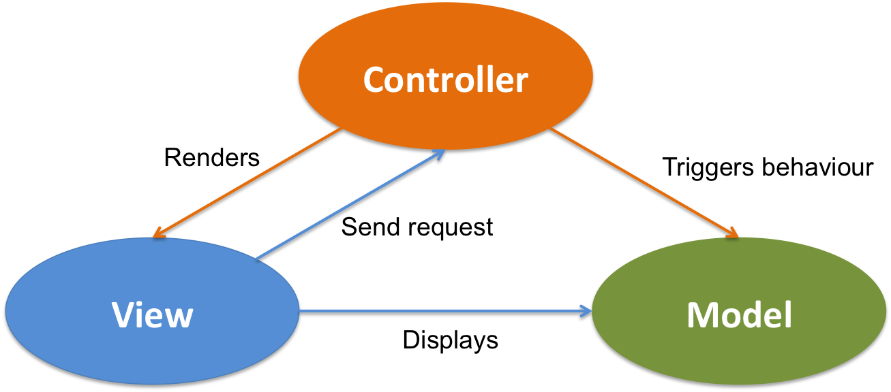

Figure 2 MVC architecture

## Architecture:

Architecture can be defined as a framework that provides guidance to help make use of resources on an organization wide or company wide basis. It provides organization with decision making guidance regarding application development life cycle. (Mochal, 2003)

There are various types of architecture. Some of them are as follows:

* Client-Server
* Component based.
* Data-centric
* Blackboard
* Peer-to-Peer

I have chosen Client-Server architecture to development this system.

Client-Server architecture is a computer network which allows many clients to communicate from a centralized server. The server hosts, distributes and controls major resources and services used by clients. Such structural designs are made up of one or more client systems connected to the main servers through a network.

Client-server architecture features:

* Since every computer shares centralized server there is no need of configuring resource on each individual computer on the network.
* New resources can be added to the network without any interruptions to the network.

Since it is more reliable and provides more security features, I choose Client-Server architecture.

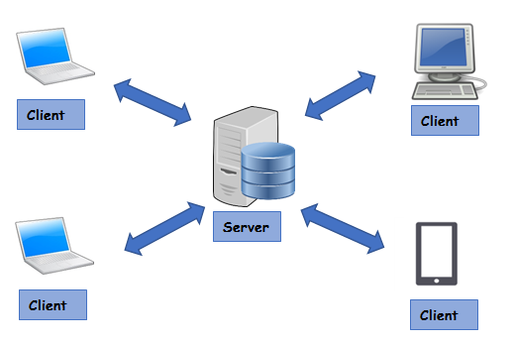

Figure 3 Client-Server Architecture

Chapter:4

# **Project planning:**

The project is planned to be finished within 107days in total. Within these 107 days we must perform different tasks to bring up this project. Those process along with their duration are provided below:

## Work Breakdown Structure (WBS)

WBS is a deliverable oriented hierarchical decomposition of the work to be executed by the project team. (Knowledge, 2009). WBS visually defines the scope into manageable chunks that a project team can understand, as each level of the work breakdown structure provides further definition and detail.

We use work breakdown structure for many purposes:

* It defines and organizes the project work.
* It can help determine the potential risks of a project.
* It helps in communication between stalk holders.
* It allows for more accurate estimation of cost, risk and time.

The WBS of this project is:

Figure 4 WBS of K-merchandise Nepal

## Milestones

Milestone can be defined as the reference point for events or decisions that are going to be take place within a project. It has fixed starting and end date which is used to measure and observe the progress of the project toward its goal.

The importance of milestones is provided below:

* It marks critical decision points
* It is an indicators of project progress
* It can be used as means of communication between stakeholders

|  |  |  |  |  |
| --- | --- | --- | --- | --- |
| S.No | Project task | Starting Date | Ending date | Number of days |
| 1 | Proposal | 8/04/19 | 23/04/19 | 12 days |
| * Risk analysis * Configuration management | 8/04/19  17/04/19 | 16/04/19  23/04/19 | 8 days  7 days |
| 2 | Analysis | 24/04/19 | 21/05/19 | 28 days |
| * Requirement * Feasibility study * Use Case * Brain storming * Architecture | 24/04/19  2/05/19  8/05/19  10/05/19  18/05/19 | 1/05/19  7/05/19  9/05/19  17/05/19  21/05/19 | 8 days  6 days  2 days  8 days  4 days |
| 3 | Design | 22/05/19 | 15/06/19 | 25 days |
| * Structural Model * Database Design * Behavioural Model | 22/05/19  27/05/19  6/06/19 | 26/05/19  5/06/19  15/06/19 | 5 days  10 days  10 days |
| 4 | Implementation | 16/06/19 | 5/07/19 | 20 days |
| * Coding * System Implementation | 16/06/19  4/07/19 | 3/07/19  5/07/19 | 18 days  2 days |
| 5 | Testing | 6/07/19 | 12/07/19 | 7 days |
| * Integration Testing * Unit Testing | 6/07/19  10/07/19 | 9/07/19  12/07/19 | 4 days  3 days |
| 6 | Other Project Issues | 13/07/19 | 23/07/19 5:00 PM | 11 days |
| * Installation * Maintenance | 13/07/19  15/07/19 | 14/07/19  23/07/19 | 2 days  9 days |

In this project, tasks are divided into 6 parts:

* **Proposal:**

Proposal gives idea to enhance specific aspects of a business. This stage will take 12 days to complete. The tasks are further divided into two parts risk analysis (8 days) and configuration management (7 days).

* **Analysis:**

Analysis process is a very complex process that will determine all the required features and details of the project so, I allocated 28 days for this project. The tasks are further divided into requirement(8days), feasibility study(6days), use case(2days), brain storming(8days) and architecture(4days).

* **Design:**

I allocated 25 days for this task as it takes a lot of time to create a suitable base for the project. In this task, the structural model will be created in 5 days where the main structure of the project, functional and non-functional requirements are designed. Database design and behavioural model will take 10 days each.

* **Implementation:**

This phase includes coding and system implementation which will take total of 20 days. Coding will take 18 days while implementation will only take 2 days.

* **Testing:**

Testing will take 7 days. It is subdivided into integration testing (4 days) and unit testing (3days). In integration testing functions are combined and tested. In unit testing functions of the system are individually tested.

* **Other project issues:**

This task will take 11 days. In this phase installation (2days) and maintenance (9days) is taken care of.

## Gantt Chart

Gantt chart is a visual representation of the project plan based on the time. It is used to plan, schedule and execute the project. It is a very useful chart that allows viewers to visualize entire project timeline from start to finish.

For making this chart I used Project Libre software. The gantt chart is provided below:

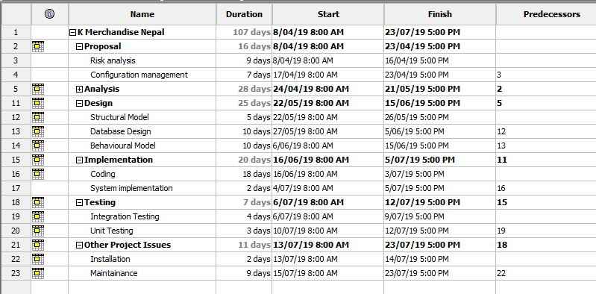

Figure 5 Scheduling

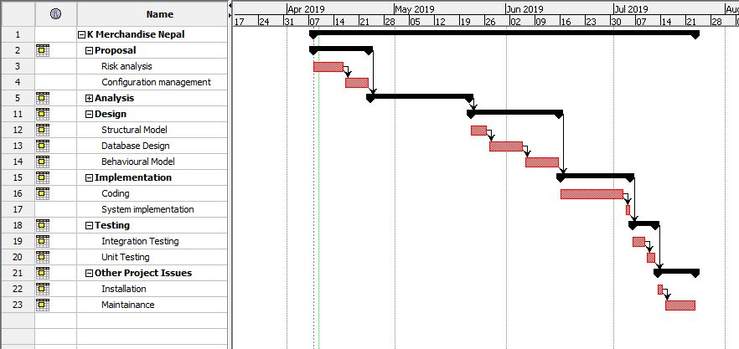

Figure 6 Gantt chart

Chapter:5

# **Risk Management**

Risk management can be defined as the process of forecasting threats and evaluating and controlling them to minimize their impact. (Rouse, 2016) Every risk has its own impact on different users. Some have greater impact and likelihood, the risks with huge impact and likelihood should be given the priority.

The risks along with its impact and like hood are given value to identify their priority. The risk with the highest value is considered threatful and should be solved right away.in this way the risk is classified, and their solution measures are discussed.

The impact of risk is calculated by multiplying the likelihood of the risk with its consequences.

*Impact = Likelihood * Consequences*

|  |  |
| --- | --- |
| **Likelihood** | **Value** |
| Low | 1 |
| Medium | 2 |
| High | 3 |

Fig: Risk likelihood and its value

|  |  |
| --- | --- |
| Consequence | Value |
| Very Low | 1 |
| Low | 2 |
| Medium | 3 |
| High | 4 |
| Very High | 5 |

Fig: Risk consequence and its value

|  |  |  |  |  |  |
| --- | --- | --- | --- | --- | --- |
| S.No | Risk | Likelihood | Consequence | Impact | Actions to be taken |
| 1 | Unauthorized access | 3 | 4 | 12 | Use of strong password. |
| 2 | Hard disk failure | 2 | 4 | 8 | Backup data. |
| 3 | Natural Disasters | 1 | 4 | 4 | Backup data.  Safe placement of hardware and software |
| 4 | Software and hardware failure | 2 | 3 | 6 | Regular update of the software.  Use of new technologies. |
| 5 | Lack of communication | 3 | 2 | 6 | Good communication between co- workers. |
| 6 | Schedule risk | 2 | 1 | 2 | Estimating the right time and stick to the schedule. |
| 7 | Employee risk | 2 | 4 | 8 | Training to the staffs.  Keep track of employee’s activities |
| 8 | Sudden growth of requirements | 2 | 2 | 4 | Making space for modification |

Chapter:6

# **Configuration Management**

Configuration management system is a process of creating and maintaining uniformity of a product’s physical and logical assets in an operational environment. Administrators, technicians and software developers can use configuration management tools to verify the effect a change to one configuration item has on other systems. (Rouse, 2016)

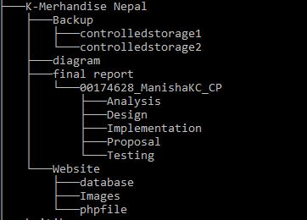

Figure 7 Tree Structure of folder.

For this project I have created a folder named “00174628_ManishaKC_CP” in my git hub account where my user name is Manisha KC (<https://github.com/xxttdaeseyobae> ). In this folder I have created different sub folders that will held other different data and information. The sub folders are:

* Analysis
* Design
* Implementation
* Proposal
* Testing

This subfolder will consist of information regarding the whole project. These folders will be updated as the project progresses.

Chapter:7

# **Conclusion:**

Based on this proposal all the objectives and requirements of the project will be kept into consideration while developing the website. Mentioned development method and architecture will be used to complete this project on time. The planned proposal has been successfully completed.

Chapter: 8

# **References**

Knowledge, P. M. (2009). *work breakdown structure*. Retrieved from work breakdown structure: https://www.workbreakdownstructure.com/

Mochal, T. (2003, August 4). *Development architecture*. Retrieved from Techrepublic: https://www.techrepublic.com/article/development-architecture-saves-time-in-the-development-life-cycle/

portal. (2019). *It Info Portal*. Retrieved from It Info Portal: http://www.itinfo.am/eng/software-development-methodologies/

Powell-Morse, A. (2016, December 8). *water fall method*. Retrieved from airbrake: https://airbrake.io/blog/sdlc/waterfall-model

Rouse, M. (2016, August). *techtarget*. Retrieved from configuration management: https://searchitoperations.techtarget.com/definition/configuration-management-CM

Sharma, L. ( 2016, April 17). *Waterfall Method*. Retrieved from Tools QA : https://www.toolsqa.com/software-testing/waterfall-model/