Chapter 3. Design

Introduction  
Design is the third phase that comes after analysis phase in system development methodology.

Design is a work process which has a user perspective and drives development based on your specific customers’ needs.

Methods and approaches differ depending on what you are developing but whether that involves processes in the healthcare sector or product development at a company we can say with certainty that design will help you to find new solutions.

The design process varies between different projects and design fields. Most designers have their own description of the design process but mostly these resemble each other.

Structural modelling:

Class diagram:  
Class diagram is a static diagram that visualizes and describes the different aspects of the system. They are widely used as it is the main building blocks of an application. It describes various kinds of objects and its static relationship.   
Purpose of class diagram:

1. It is the base for deployment of the application.
2. It analyses and design the static view of an application i.e. (it contains classes and object, inheritance and interface).

(OPTIONAL) (use flowchart)

Behaviour modelling

Activity diagram

Sequence diagram

Data modelling

Data dictionary

|  |  |  |  |  |
| --- | --- | --- | --- | --- |
| Name | Data type | Constraints | Nullable | Documentation |
| UserID | int | PK | No |  |
| Username | varchar |  | Yes |  |
| Email | Varchar |  | Yes |  |
| Address | Varchar |  | Yes |  |
| Phone | Int |  | Yes |  |
| Password | Varchar |  | Yes |  |

Product

|  |  |  |  |  |
| --- | --- | --- | --- | --- |
| Name | Data type | Constraints | Nullable | Documentation |
| ProductID | Int | PK | No |  |
| ProductName | Varchar |  | Yes |  |
| Product_Price | Integer |  | Yes |  |
| Product_Quantity | Integer |  | Yes |  |

Purchase

|  |  |  |  |  |
| --- | --- | --- | --- | --- |
| Name | Data type | Constraints | Nullable | Documentation |
| PurchaseID |  |  |  |  |
|  |  |  |  |  |
|  |  |  |  |  |

Event

|  |  |  |  |  |
| --- | --- | --- | --- | --- |
| Name | Data type | Constraints | Nullable | Documentation |
| EventID | int | PK | No |  |
| EventName | varchar |  | Yes |  |
|  |  |  |  |  |

E.R. Diagram:

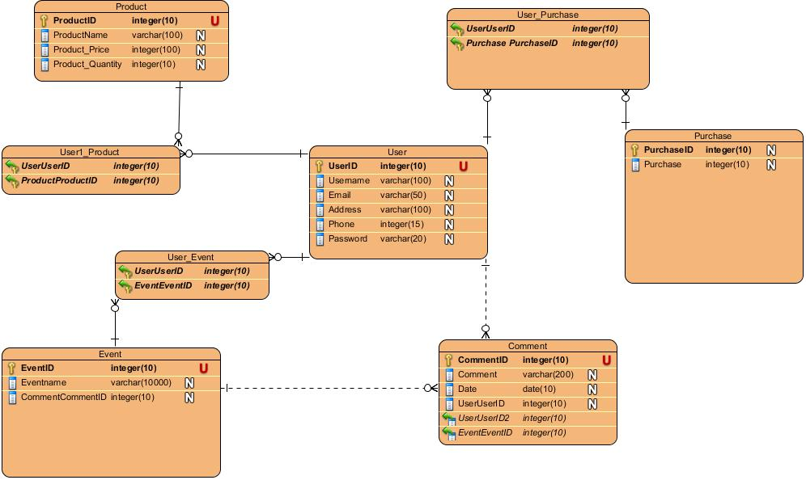

Prototype Design

