**ECE579_Project3**

Xin Xu

1. **kNN**

**Code:**

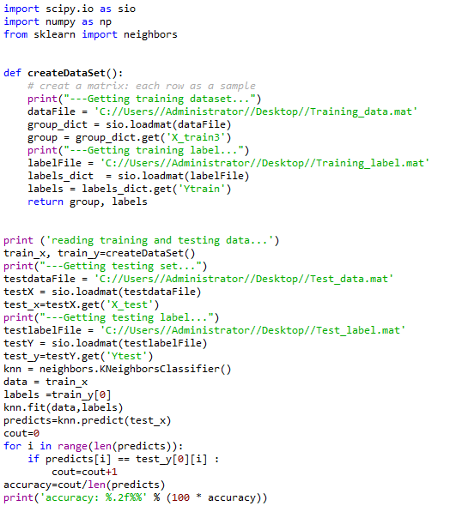

**Outcome:**

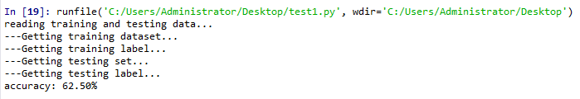

1. **Naive Bayes**

**Code:**

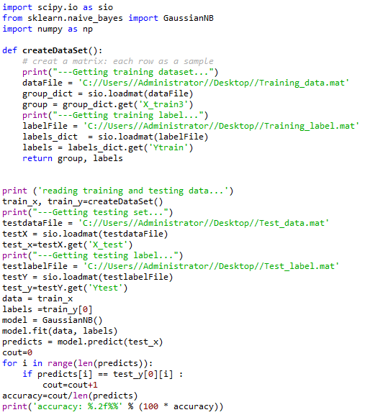

**Outcome:**

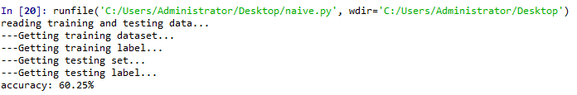

1. **Random Forest**

**Code:**

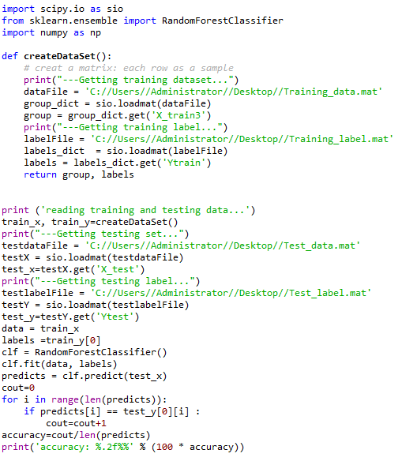

**Outcome:**

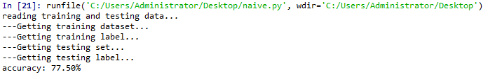

1. **Decision Tree**

**Code:**

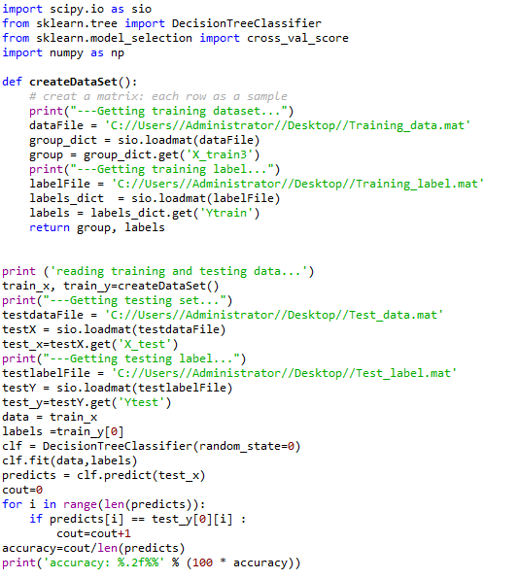

**Outcome:**

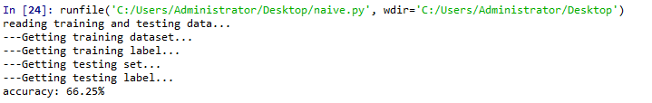

1. **SVM**

**Code:**

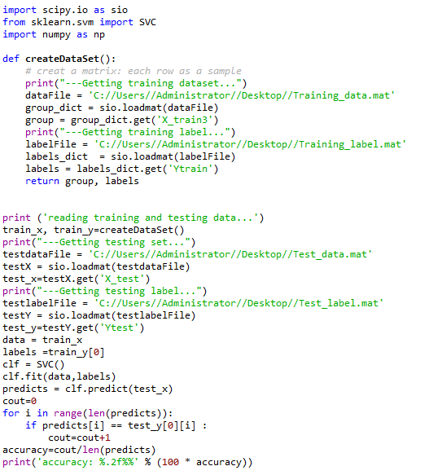

**Outcome:**

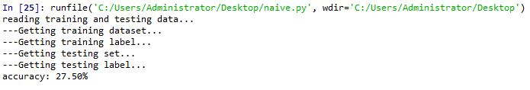

|  |  |
| --- | --- |
| ML/DL Type | Success Rate |
| kNN | 62.50% |
| SVM | 27.50% |
| Random Forest | 77.50% |
| Decision Tree | 66.25% |
| Naive Bayes | 60.25% |

In general, Random Forest is the best of my five techniques.