**ECE579_Project5**

Xin Xu

1. **Random Forest**

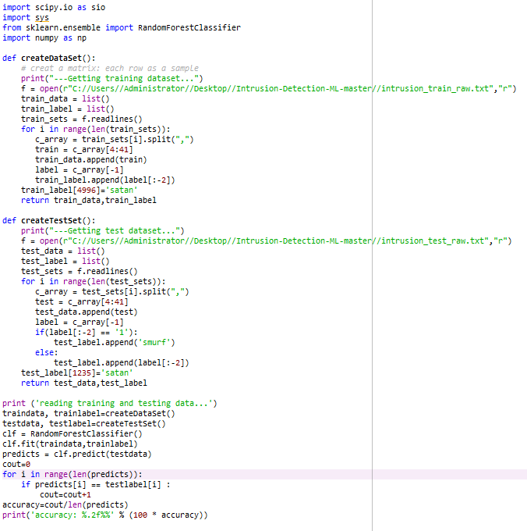

The result is :

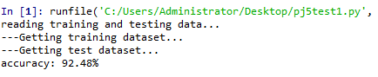

1. **Decision Tree**

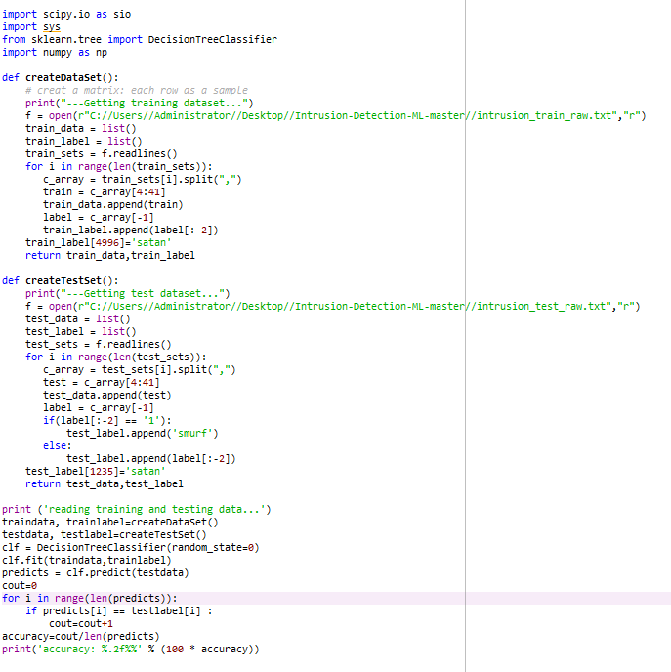

The result is:

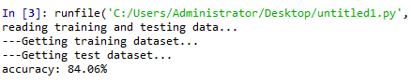

1. **SVM**

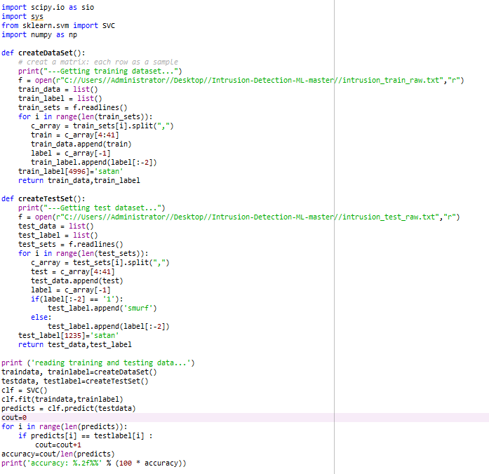

The result is:

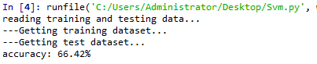

1. **kNN**

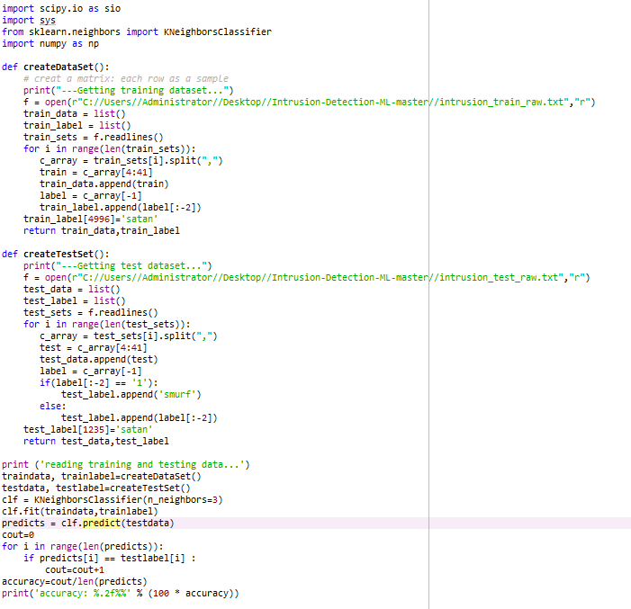

The result is

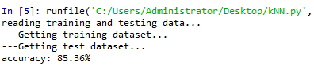

1. **Ensemble**

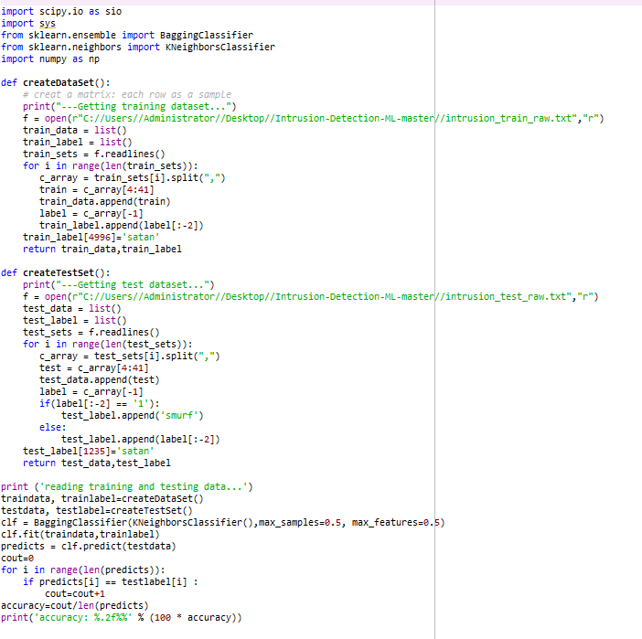

The result is:

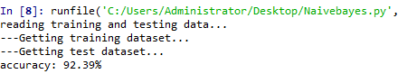

The success rates of 5 ML techniques:

|  |  |
| --- | --- |
| ML/DL Type | Success Rate |
| Random Forest | 92.48% |
| Decision Tree | 84.06% |
| SVM | 66.42% |
| kNN | 85.36% |
| Ensemble | 92.39% |