Notes:

Left click on game object to displays menu, click on menu to explore more.

Right click to hide on menu and information prompted to hide it.

At the moment data retrieve only one retrieves one set of data as supposed to quarrying the database for a specific dataset

Yellow lines indicate linkages between different objects but haven’t been fully implemented yet.

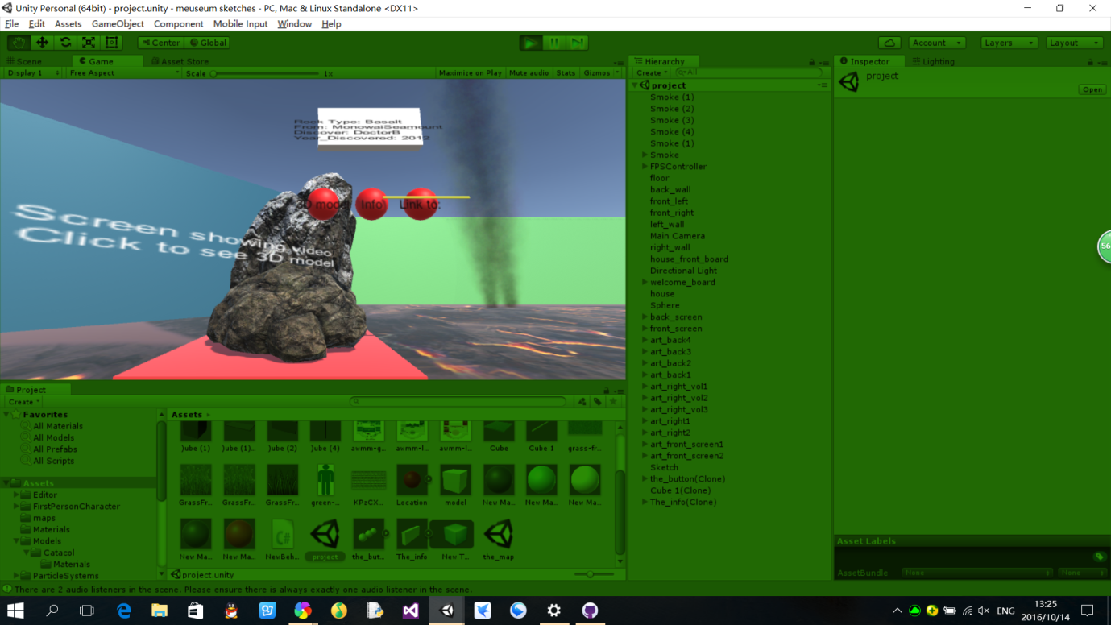

Click on the screen to explore 3d model, which have all Volcanoes in New Zealand, the most recent erupted volcanoes should be show in red, the other showing yellow. When users click on the blue screen which playing video, a 3D model should pop up. Instead of fully implement idea, we create another scene to store the 3D model. However, the change scene on click function does not fully implemented as well.

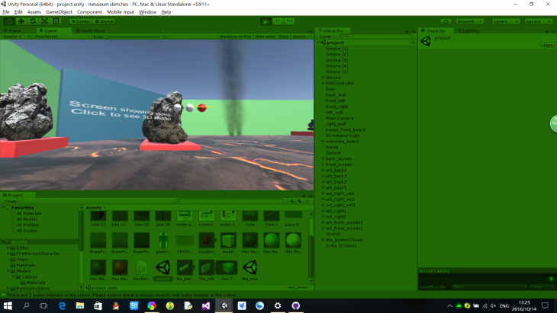

The function that query the volcano name, city located, and last eruption is not fully implemented. Ideally, when we click on each location point in the screen, the relative information about the volcanoes will be shown.

